STATE GOVERNMENT OF OSUN, NIGERIA.

REPORT OF

THE

AUDITOR-GENERAL

FOR

LOCAL GOVERNMENTS

ON THE ACCOUNTS OF

BOLUWADURO LOCAL GOVERNMENT

OTAN AYEGBAJU

FOR THE YEAR ENDED

31ST DECEMBER, 2020.

**TABLE OF CONTENTS**

|  |  |  |
| --- | --- | --- |
|  | **DETAILS** | **PAGE** |
| 1 | TITLE PAGE | **1** |
| 2 | TABLE OF CONTENTS | **2** |
| 3 | LIST OF ABBREVIATIONS | **3** |
| 4 | STATEMENT OF RESPONSIBILITY FOR THE PREPARATION OF FINANCIAL STATEMENTS | **4** |
| 5 | STATEMENT OF RESPONSIBILITY OF THE AUDITOR-GENERAL | **5** |
| 6 | AUDIT CERTIFICATE | **6** |
| 7 | BASIS OF AUDIT OPINION | **7** |
| 8 | STATEMENT OF COMPLIANCE | **8** |
| 9 | STATEMENT OF ACCOUNTING POLICIES | **9-11** |
| 10 | GENERAL COMMENTS | **12-13** |
| 11 | **COMMENTS ON FINANCIAL STATEMENTS**   1. STATEMENT OF FINANCIAL PERFORMANCE 2. STATEMENT OF FINANCIAL POSITION | **14-18** |
| 12 | **AGGREGATE GENERAL PURPOSE FINANCIAL STATEMENTS**   1. CONSOLIDATED STATEMENT OF FINANCIAL POSITION. 2. CONSOLIDATED STATEMENT OF FINANCIAL PERFORMANCE. 3. CONSOLIDATED STATEMENT OF CASH FLOW. 4. CONSOLIDATED STATEMENT OF COMPARISON OF FINANCIAL OPERATIONS. 5. CONSOLIDATED STATEMENT OF NET ASSETS AND EQUITY 6. NOTES TO THE ACCOUNT | **19-33** |
| 13 | **FISCAL OPERATION REPORT**  i STATISTICAL AND ACCOUNTING RATIOS  ii NON-FINANCIAL DISCLOSURE | **34-35** |
| 14 | MANAGEMENT LETTER | **36-42** |
| 15 | LIST OF PROJECTS EXECUTED IN THE LOCAL GOVERNMENTS | **43-44** |

**LIST OF ABBREVIATIONS**

1. AGLG - AUDITOR-GENERAL FOR LOCAL GOVERNMENTS
2. AO - AREA OFFICE/ADMINISTRATIVE OFFICE
3. FAAC - FEDERATION ACCOUNTS ALLOCATION COMMITTEE
4. F.M - FINANCIAL MEMORANDUM
5. FOR - FISCAL OPERATION REPORT
6. GPFS - GENERAL PURPOSE FINANCIAL STATEMENTS
7. IGR - INTERNALLY GENERATED REVENUE
8. ISSAI - INTERNATIONAL STANDARDS OF SUPREME AUDIT INSTITUTIONS
9. IPSAS - INTERNATIONAL PUBLIC SECTOR ACCOUNTING STANDARD
10. JAAC - JOINT ACCOUNTS ALLOCATION COMMITTEE
11. LGA - LOCAL GOVERNMENT AREA
12. LCDA -LOCAL COUNCIL DEVELOPMENT AREA
13. LGSC - LOCAL GOVERNMENT SERVICE COMMISSION
14. LGSPB - LOCAL GOVERNMENTS STAFF PENSION BOARD
15. LGLB - LOCAL GOVERNMENT LOANS BOARD
16. NCOA - NATIONAL CHART OF ACCOUNTS
17. NBV - NET BOOK VALUE
18. MLGCA- MINISTRY OF LOCAL GOVERNMENT AND CHIEFTAINCY AFFAIRS
19. PPE - PROPERTY, PLANTS AND EQUIPMENT
20. PSE - PUBLIC SECTOR ENTITIES
21. PHCB - PRIMARY HEALTH CARE BOARD
22. VAT - VALUE ADDED TAX

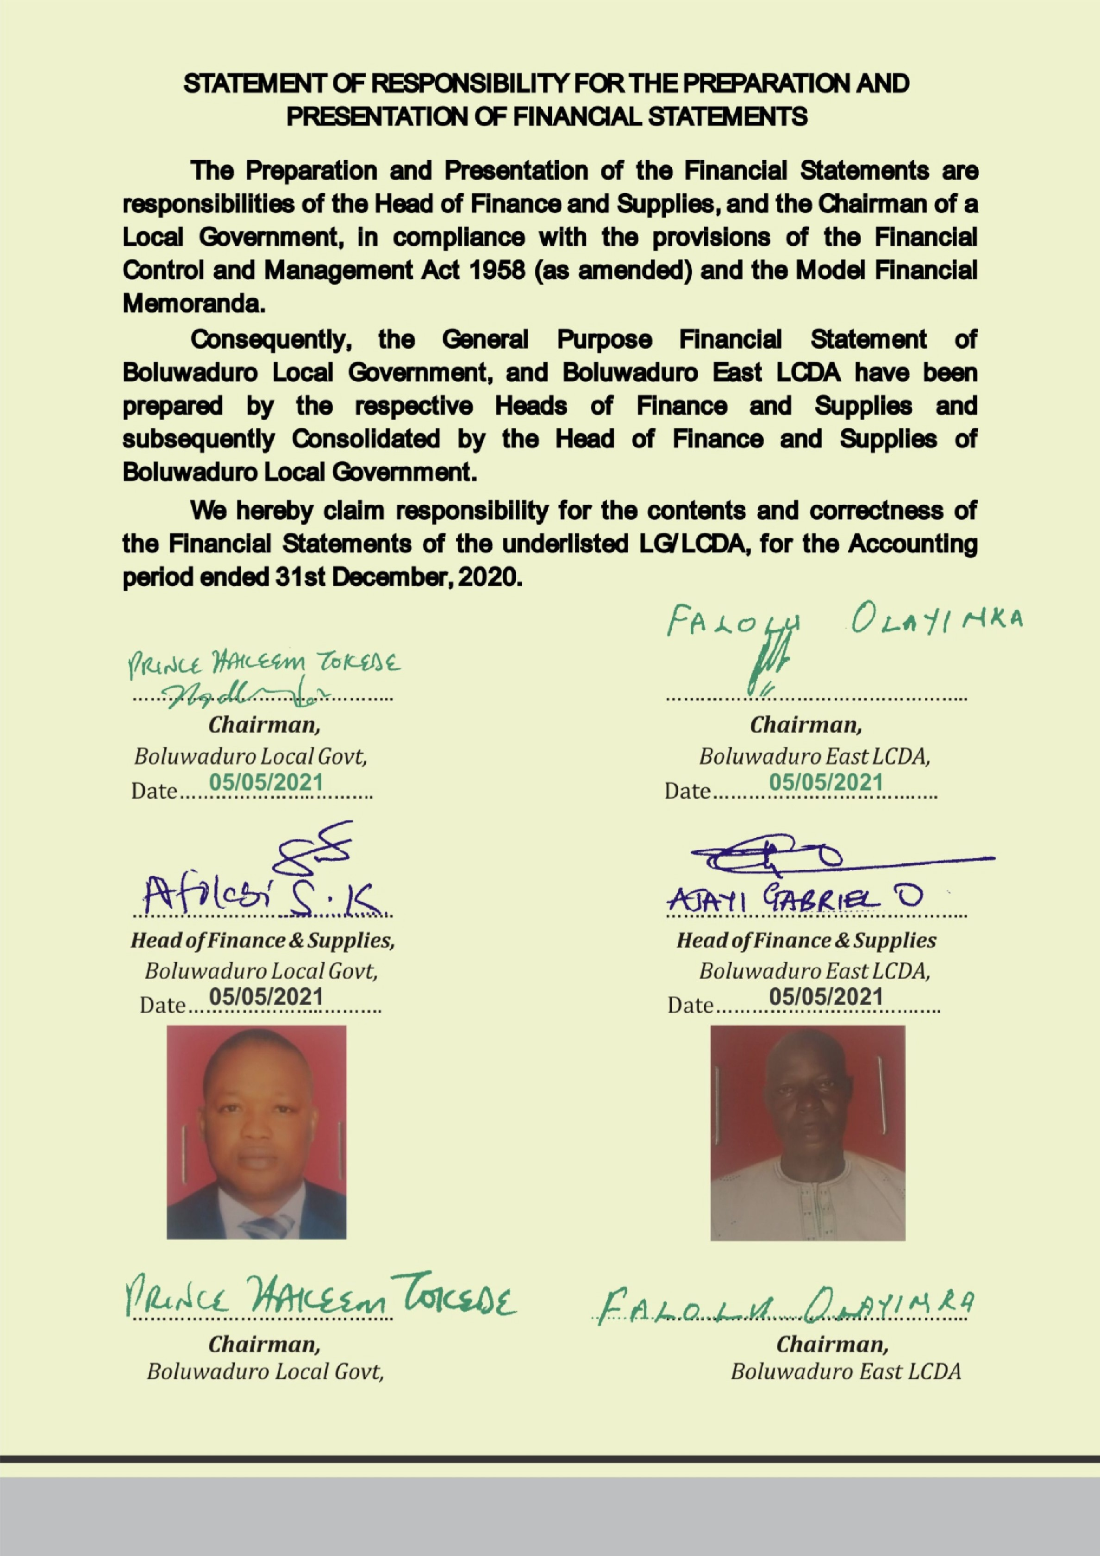

**STATEMENT OF FINANCIAL RESPONSIBILITY**

The preparation and fair presentation of Financial Statements of Local Governments, the State Joint Local Government Accounts, and offices administering elements of Local Governments Fund is the direct responsibility of the Heads of Finance and Supply in the Local Governments, the Accountant of the Ministry of Local Governments, and Directors of Finance in the Offices of the Local Governments, respectively, in compliance with the provisions of Finance Control and Management Act 1958 (as amended), the Model Financial Memoranda (1991 as amended), the Laws of Osun State 2002 (as amended) and with the provisions of the Constitution of the Federal Republic of Nigeria, 1999.

In the State of Osun, the Heads of Finance of main Local Governments are responsible for the consolidation of the respective Financial Statements with the subsidiary LCDAs, Area/Administrative offices, as may be applicable.

However, both the Head of Finance and Chairman of a Local Government, (the Accounting Officer) are responsible for establishing and maintaining a system of internal control designed to provide reasonable assurance that the transactions and Financial Statements give a fair presentation of the financial operations of the Local Government.

The acknowledgment of responsibility for the preparation of Financial Statement signed by Heads of Finance and Chairmen of the respective Local Governments are attached to individual report.

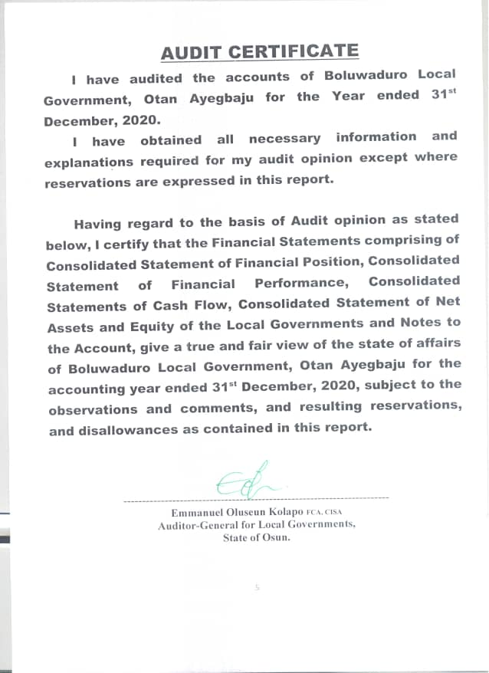

**STATEMENT OF RESPONSIBILITY OF THE AUDITOR-GENERAL.**

It is my responsibility to Audit the accounts of the Local Governments, the State Joint Local Government Account, and all offices of the Local Government as stipulated by the Laws of Osun State and the Financial Memoranda; and to form an independent opinion based on the Audit of the Financial Statements and accompany notes submitted by the Head of Finance and Supply of Local Governments, the Head of Accounts in the Ministry of Local Governments and various Institutions and all agencies, handling projects and programmes funded by Local Governments in the state.

**BASIS OF AUDIT OPINION**

In the course of auditing the accounts of Local Governments in the State of Osun, I have complied with the requirement and stipulations of the International Standards on Auditing, the Generally Acceptable Auditing Standards, International Standards of Supreme Audit Institutions (ISSAI,) Laws of Osun State, International Public Sector Accounting Standards and Audit Guide of the Office of the Auditor-General for Local Governments, Osun State.

I have conducted Financial and Compliance audit on the Finances of Local Governments and JAAC. Projects and Programmes were reasonably evaluated and verified on the principle of Performance Auditing. All items of Revenue and Expenditure were captured in the course of the Audit and Audit Tests were conducted on procedures, transactions and balances. Consequently 100% Substantive Test was done on all items of Revenue and Expenditure; and Assets and Liabilities, and appropriate Audit Tests of Control were conducted on procedures and transactions.

Where paucity of available Audit resources warranted sampling, objective statistical sampling techniques were applied to ensure representativeness, completeness, relevance, and timeliness in the determination of sampling elements. This ensured reliability of Audit Opinion, giving due recognition to principle of materiality. For example, multi-layered and structural sampling method was applied for verification of numbers and Emoluments of Teaching and Non-Teaching staff of the State Universal Basic Education Board (SUBEB), Staffers of Local Governments and the State Primary Health Care Board.

**STATEMENT OF COMPLIANCE**

The Accounting Policies have been consistently applied on preparation of the Financial Statements of Boluwaduro Local Government in the year under review. These have been prepared on the basis of Historical Cost and in accordance with IPSAS Accruals and other applicable standards. The Cash Flow Statement was prepared using the Direct Method. The basis of measurement is Naira and kobo which is the functional and reporting currency of the Federal Republic of Nigeria of which Osun State and Boluwaduro Local Governments are constituents.

The accounts of Boluwaduro Local Government have been audited and reported upon.

Audit noted some instances of non-compliance in the Local Governments, with the due process in revenue collection and payment procedure contrary to the provision of Financial Memoranda and relevant Guidelines. The associated internal control weaknesses have been addressed. The inspection reports (letters of Internal Control weaknesses) for the year 2020 have been issued and forwarded to the appropriate quarters for responses and compliance as required.

The queries were replied and appropriate recommendations were made as contained in the Management letter included.

**STATEMENT OF ACCOUNTING POLICIES**

1. **Basis of Preparation (IPSAS 1)**

The General Purposes Financial Statements were prepared under the historical cost convention and in accordance with IPSAS Accrual Basis and other applicable standards and conventions as may be defined by relevant Statutes.

1. **Accounting Period**

The accounting year (fiscal year) to which the report relates is 1st January to 31st December, 2020.

1. **Reporting Currency**

The General Purposes Financial Statements are prepared in the Nigerian Naira (NGN).

1. **Principal Statements in the General Purposes Financial Statements**
2. Statements of Financial Performance. (Aggregate and Consolidated)
3. Statements of Financial Position. (Aggregate and Consolidated)
4. Statements of Cash flow.(Aggregate and Consolidated)
5. Statementsof Comparison of Budgeted and Actual Amounts (Aggregate and Consolidated)
6. Statements of Changes in Net Asset/Equity. (Aggregate and Consolidated)
7. Notes to the GPFS.
8. Financial Statement of Joint Accounts Allocation Committee (JAAC)
9. **Consolidation Policy- IPSAS 6**

The Heads of Finance of the 69 Local Governments, LCDAs, and A/Cs and A/Os are required to prepare their individual GPFS at the end of the financial year on Accrual Basis of Accounting.

Each Local Government is a creation of the Constitution and none is subservient to the other. However in this situation, there are subsidiary entities such as LCDAs and Area offices, which are consolidated with the main Local Government. Consequentrly, the Heads of Finance of the 30 main Local Governments consolidate the GPFS of their respective main Local Government with the subsidiary LCDAs, AOs, and Ad. Os.

***The duty of the Auditor-General for Local Governments is not to prepare or consolidate Local Governments’ accounts, but to Audit and Aggregate the prepared Financial Statements in line with the Fiscal Operation Report Guideline.***

1. **Statement of Cash Flow** was prepared using the direct method (IPSAS 2) and it consists of Operating, Investing and Financing activities.
2. **Inventories (IPSAS 12) -** Inventories were measured initially at cost, and subsequently measured using the FIFO method.
3. **PROPERTY, PLANT & EQUIPMENT (PPE) – IPSAS 17**

All PPEs were stated at historical cost less accumulated depreciation and impairment losses.

1. **DEPRECIATION**

The cost of PPE shall be written off, from the time they are brought into use, on a straight line basis over their expected useful lives less any estimated residual value as follows:

1. Furniture & Fittings - 20%
2. Motor Vehicle - 20%
3. Plant & Equipment - 20%
4. Infrastructural Asset - 10%
5. Building - 2%
6. Office Equipment - 20%
7. **REVALUATION**
8. The Assets’ residual values and useful lives are reviewed at the end of the year.
9. **IMPAIRMENT**

Test for Impairment are done on Property, Plants and Equipments, where it is suspected that Impairment has occurred.

1. **INVESTMENT PROPERTIES – IPSAS 16**

The Investment properties are measured initially at cost, including transaction costs. Subsequent to initial recognition, investment properties are measured using the cost model and are depreciated the same way as PPE.

1. **INDEPENDENT REVENUE FROM NON-EXCHANGE TRANSACTION (IPSAS 23)**
2. Fees; taxes and fines: The Local Government recognised revenue from fees, taxes, and fines when the event occured, and the asset recognition criteria are met.
3. **OTHER REVENUE**

Other Revenues are proceeds that arise outside the Ordinary course of governmental busineess. These include:

1. Gain on disposal of Property, Plant and Equipment

2. Dsiposal of Investment such as Shares, bond etc

Gain on disposal is recognized at the date of control of the asset is passed to the buyer and is determined after deducting the carrying value of the Asset at that time.

1. **UNREMITTED DEDUCTION**

Unremitted deductions are monies owned to the third parties such as tax authorities, associations and other Government Agencies. These include tax deductions and other deductions at source

This amount shall be stated in GPFS at their repayment value, which shall be treated as current liabilities in the Statement of Financial Position.

**16. RESERVE**

Reserves shall be classified under Equity in the Statement of Financial Position which includes Accumulated Surplus/Deficit and the Additional Reserve.

**17. CONTIGENT LIABILITY IPSAS 19**

Contigent liabilities are only disclosed in the Notes to GPFS. Contingent liability is possible obligation arising from past events whose exigencies will be confirmed only by uncertain future event(s) or present obligation arising from the past events that are not recognized because of either an outflow of economic benefit is not probable or this amount of obligation.

**GENERAL COMMENT**

I have audited the accounts of Boluwaduro Local Government, Otan Ayegbaju for the financial year ended 31st December 2020, as required by Cap 72, Part 10 of the Laws of Osun State 2002, (as amended).

**AUTHORITY FOR DISBURSEMENTS FROM JAAC ACCOUNT:** Disbursements from JAAC accounts were made in consonance with the prescriptions of the House of Assembly while monthly distributions were collectively decided by the Chairmen of Oriade Local Government and other Chairmen, all of whom were members of the Joint Account Allocation Committee.

**FULL ADOPTION OF IPSAS ACCRUALS:** 2020 GPFS reports were prepared in compliance with IPSAS Accrual which was fully adopted by Local Governments in the State of Osun in 2017.

The previous accounting training on conversion to IPSAS Accruals, severally sponsored by the EU/SLOGOR, LGSC, SUBEB in collaboration with Office of the Auditor-General for Local Governments, with the approval of Mr. Governor, for upgrades and re-training in 2020 have collectively enhanced the proficiency of operators of Local Government accounts in the State

**SCOPE OF AUDIT COVERAGE**: The Audit scope has 100% coverage on all aspects of Revenue and Expenditure, as well as verification of Assets and Liabilities including JAAC Accounts. Revenue covered included all Allocations and VAT from the Federation Accounts and other dependent and Independent Revenue sources of the Local Governments while Expenditure covered included all Capital and Recurrent Expenditure Items in all Local Governments, and LCDAs, all centrally executed Projects and programmes of Local Governments, and Statutory remittances to Traditional Councils.

**BUDGET PREPARATION / EXECUTION**

The Budget for 2020 for Oriade Local Governments was prepared in compliance with new National Chart of Accounts. The 2020 Budget was an improvement on the previous Budget of 2019 as some of the obvious shortcomings observed by the Audit have been addressed.

**PROCUREMENT PRACTICES**

Osun State Public Procurement Law 2015 has been in force in line with global best practice. Procurement Officers was posted to the Local Governments and performed his duties. The Audit observed that the Offices need to be strengthened to further assist in promoting sound and transparent procurement practices in the Local Governments.

**VALUATION AND REVALUATION OF ASSETS**

The Office of the Auditor-General for Local Governments embarked on verification exercise on valuation and Revaluation of Assets during the year. This involved Constitution of a standing multi-disciplinary team comprising seasoned and qualified professionals in the fields of valuation, engineering, town planning, medicine, etc. and others as were necessary. Consequently, the realism of the values of non-current asset is enhanced for the year under review. The verification exercise is continuous and value of the Local Governments non-current Assets is being updated monthly.

**INTERNALLY REVENUE GENERATION AND FINANCIAL VIABILITY**

The Total Internally Revenue generated by the Local Government for 2020 was N4,613,770.00 representing 0.33% the Total Revenue. More efforts at blocking leakages coupled with adequate research by the relevant unit of the Auditor-General for Local Government on comparative revenue advantages of individual Local Government’s office will assist in curbing this unwholesome situation.

**INTERNAL CONTROL WEAKNESS IN THE LOCAL GOVERNMENT AND RELATED AGENCIES**

At the conclusion of the Audit, 39 nos of Audit Queries were issued in respect of 2020 Accounts, involving a total sum of N3,993,528.28.

Queries were issued in respect of irregularities observed in fund management by beneficiary agencies of transfers from Local Governments fund and this had been forwarded to the respective Accounting Officers for response.

The identified internal control weaknesses, the inherent risks, the management Responses and Audit Recommendations are highlighted in Management Letter contained in this Report.

**COMMENTS ON FINANCIAL STATEMENTS**

1. **STATEMENT OF FINANCIAL PERFORMANCE**

**Share of FAAC and VAT:** To ensure completeness of Revenue, the total Allocation received from the Federation Account in respect of Boluwaduro Local Government as contained in JAAC Account was confirmed from the Accountant General of the State and further reference was made to data released by office of Accountant General of the Federation. The total sum of N983,783,840.14 was Share of FAAC and VAT amounted to N389,362,354.73.

THE CONCEPT OF **DEPENDENT REVENUE.** The term IndependentRevenue or synonymous with Internally Generated Revenue in the IPSAS. However, the term Dependent Revenue is used in proportion in the Report as it depicts the items of Revenue other than Internally Generated Revenue (IGR), i.e. the revenue over which the reporting entirely has no control on its generation or collection.

Essentially the proportion of Dependent Revenue is a measure of the extent of its vulnerability or dependently of the Local Government on finances from sources over which it has no control.

**EXPENDITURE:** As part of the disclosure requirements, expenditures that were Jointly incurred at JAAC level were separately disclosed from those expended at each Local Government Level.

**SUMMARY OF REVENUE FROM JAAC**

|  |  |  |  |  |  |  |  |  |  |  |
| --- | --- | --- | --- | --- | --- | --- | --- | --- | --- | --- |
| **LOCAL GOVERNMENT** | **STATUTORY ALLOCATION** | **VAT** | **EX RATE GAIN** | **FEDERAL GOVT INTERVENTION** | **EXCESS BANK** | **FOREX EQUALISATION** | **ECO** | **ADD FUND FRM SOLID MIN** | **NON-OIL EXCESS REVENUE** | **TOTAL** |
| Boluwaduro | 883,679,700.50 | 389,362,354.73 | 28,670,279.89 | 24,013,520.80 | 727,685.62 | 12,823,624.56 | 19,927,887.05 | 1,482,019.34 | 12,459,122.38 | 1,373,146,194.87 |

**INDEPENDENT REVENUE FROM NON-EXCHANGE TRANSACTION (IPSAS 23)**

Fees; taxes and fines: The Local Government recognised revenue from fees, taxes, and fines when the event occurs, and the asset recognition criteria are met. The Local Government earned and recognised. #4,613,770.00.

**SALARIES AND WAGES – N717,917,221.03**

Salaries and Wages which amounted to N717,917,221.03 comprised of salaries of Staff of the Local Governments, Teaching and Non-Teaching Staff of SUBEB, staff of Local Government Loans Board and the Primary Health Care Board. Salary Payment was centralised in the State of Osun for the year 2020.

**COMMENTS ON ITEMS OF FINANCIAL POSITION**

**CASH AND CASH EQUIVALENTS – #6,030,437.38**

The Aggregate closing cash and cash equivalents amounted to **₦6,030,437.38** for the Local Governments. The Bank Statements and Bank Reconciliation Statements of all Local Governments and Local Government Development Areas as at 31st December, 2020 were verified/examined to ascertain the bank balances. This balance does not include the balance in JAAC account which essentially should be a zero-balance account. Moreover any undistributed amount in the JAAC Account is treated as Receivable to the Local Governments.

**RECEIVABLES - ₦116,179,010.19**

A total sum of N116,179,010.19k was standing as Receivables as at 31st December, 2020. The Receivables include, Revenue Recognised in December 2020 but received in January, 2020 from Joint Allocation Account Committee (JAAC).

**INVENTORIES - ₦1,071,053.03**

The sum of ₦1,071,053.03represents inventories valued at historical cost in the Local Governments as at 31st December, 2020. These include unallocated stores both expendable and non-expendable; and consumable items.

**INVESTMENTS - ₦67,587,416.92**

All the Investments are classified as held-for-sale, while Equity Method is adopted in Recognition and Measurement. Most of the investments were in unquoted companies except for the Preference shares.

**PROPERTY, PLANT AND EQUIPMENT(PPE)**

Items of Property, Plant and Equipment or other Non -Current Assets are stated at Historical Cost Less accumulated Depreciation. Depreciation on Non - Current Assets are calculated to write off cost on valuation in a straight-line basis over the expected useful life on the assets, as follows:

**Particulars Rate%**

Fixture and fitting 20

Motor Vehicle 20

Plant and Equipment 20

Infrastructural Asset 10

Buildings 2

Office Equipment 20

There is need to make adequate provision for depreciation. Accounting for PPE is an area of Audit emphasis where there seems to be a gap in knowledge exhibited by the operators of the Account vis-à-vis expectation.

**PAYABLES - ₦405,640,478.23**

These comprised largely of commitments all over the Local Governments such as allowances, sundry overheads, and unpaid salary and wages, arrears of salaries, unremitted deductions etc. outstanding as at 31stDecember 2020.

**INVESTMENT PROPERTY - ₦5,486,250.00**

The carrying amount of Investment Properties of the Local Governments stood at N5,486,250.00 in the Statement of Financial Position. However, there is no restriction on title or property pledge as securities for liabilities. Straight Line Method of depreciation was applied.

**LONG – TERM BORROWINGS - ₦827,196,914.29**

These are the cumulative amount of various outstanding loans obtained from different sources to finance the under-listed projects:

* 1. Construction of over 10 kilometers of roads, (tagged 10KM roads/Local Government), across all the main Local Governments across the state.
  2. Environmental Projects – includes channelization, chlorination, etc aimed at preserving lives and environments
  3. Intervention Projects including Grading, access to rural areas, etc..
  4. Repayment of Bail Out

**UNREMITTED DEDUCTIONS - ₦145,049,562.75**

These include deductions received from Joint Accounts Allocation Committee (JAAC) and deposits which ought to have been remitted to the appropriate quarters on or before 31st December, 2020. The management of the Local Councils are hereby advised to ensure that all deposits/deductions received are remitted promptly to avert the possibility of unnecessary accumulation of liabilities on Councils financial position

DISCLOSURES: In the statement of Financial Performance the amounts jointly expended by the Local Government is separated from the amount spent in individual Local Government.

**TRANSFER FROM MAIN COUNCILS TO LOCAL COUNCIL DEVELOPMENT AREAS:**

Transfer from main councils to the tune of #75,810,999.15 was made to the Local Council Development Areas and Area Offices in the period under review and was set off in the Consolidated Account.

**BOLUWADURO LOCAL GOVERNMENT, OTAN-AYEGBAJU**

**CONSOLIDATED STATEMENT OF FINANCIAL POSITION AS AT 31ST DECEMBER 2020**

|  |  |  |  |  |
| --- | --- | --- | --- | --- |
| **FINANCIAL POSITION** | | | | |
| **PARTICULAR** |  | **BOLUWADURO** | **BOLUWADURO EAST LCDA** | **BOLUWADURO CONSOLIDATED** |
| **ASSETS** | **NOTE** |  |  |  |
| **Current Assets** |  |  |  |  |
| **Cash & Cash Equivalents** | **1** | 4,091,067.86 | 1,938,369.52 | 6,030,437.38 |
| **Receivables** | **2** | 116,179,010.19 |  | 116,179,010.19 |
| **Prepayment/Advance** | **3** | 2,950,000.00 |  | 2,950,000.00 |
| **Inventories** | **4** | 642,631.82 | 428,421.21 | 1,071,053.03 |
| **Total Current Asset** |  | 123,863,709.87 | 2,366,790.73 | 126,230,500.60 |
| **Non Current Asset:** |  |  |  | - |
| **Long Term Loan Granted** |  |  |  | - |
| **Investments** | **5** | 54,837,416.92 | 12,750,000.00 | 67,587,416.92 |
| **Property, Plant & Equipment** | **6** | 1,031,112,597.63 | 399,197,868.62 | 1,430,310,466.25 |
| **Investment Property** | **7** | 3,176,250.00 | 2,310,000.00 | 5,486,250.00 |
| **Biological Asset** | **8** |  |  | - |
| **Assets Under Construction(WIP)** | **9** |  |  | - |
| **Total Non-Current Asset** |  | 1,089,126,264.55 | 414,257,868.62 | 1,503,384,133.17 |
| **Total Asset** |  | 1,212,989,974.42 | 416,624,659.35 | 1,629,614,633.77 |
| **LIABILITIES** |  |  |  | - |
| **Current Liabilities:** |  |  |  | - |
| **Deposit** |  |  |  | - |
| **Unremitted Deductions** | **10** | 139,861,976.59 | 5,187,586.16 | 145,049,562.75 |
| **Short Term Loan & Debts** | **11** |  |  | - |
| **Payables** | **12** | 338,378,141.53 | 67,262,336.70 | 405,640,478.23 |
|  |  |  |  | - |
| **Short Term Provisions** |  |  |  | - |
| **Total Current Liability** |  | 478,240,118.12 | 72,449,922.86 | 550,690,040.98 |
| **Non Current Liabilities:** |  |  |  | - |
| **Long Term Borrowing** | **13** | 778,226,683.21 | 48,970,231.08 | 827,196,914.29 |
| **Total Liabilities** |  | 1,256,466,801.33 | 121,420,153.94 | 1,377,886,955.27 |
| **Net Assets** |  | (43,476,826.91) | 295,204,505.41 | 251,727,678.50 |
| **Financed by** |  |  |  | - |
| **Reserve** | **14** | 133,134,743.89 | 188,775,117.26 | 321,909,861.15 |
| **Net Surplus/Deficit** | **15** | (176,611,570.80) | 106,429,388.15 | (70,182,182.65) |
| **Total** |  | (43,476,826.91) | 295,204,505.41 | 251,727,678.50 |

**BOLUWADURO LOCAL GOVERNMENT, OTAN-AYEGBAJU**

**CONSOLIDATED STATEMENT OF FINANCIAL PERFORMANCE AS AT 31ST DECEMBER 2020**

|  |  |  |  |  |
| --- | --- | --- | --- | --- |
| **PERFORMANCE** | | | | |
| **PARTICULAR** | **NOTE** | **BOLUWADURO** | **BOLUWADURO EAST LCDA** | **BOLUWADURO CONSOLIDATED** |
| **Government Share of FAAC(Statutory Revenue)** | **16** | 883,679,700.50 |  | 883,679,700.50 |
| **Government Share of VAT** | **17** | 389,362,354.73 |  | 389,362,354.73 |
| **Additional Fund** | **18** | 1,482,019.34 |  | 1,482,019.34 |
| **Revenue Furniture Allowance** | **19** |  |  | - |
| **Ex Rate Gain** | **20** | 28,670,279.89 |  | 28,670,279.89 |
| **Augmentation** | **21** |  |  | - |
| **Federal Govt Intervention Fund** | **22** | 24,013,520.80 |  | 24,013,520.80 |
| **ECO** | **23** | 19,927,887.05 |  | 19,927,887.05 |
| **Solid Minerals** | **24** |  |  | - |
| **Non-Oil Revenue** | **25** | 12,459,122.38 |  | 12,459,122.38 |
| **Distributable from Goods & Valuables** | 26 |  |  | - |
| **Forex Equalisation** | **27** | 12,823,624.56 |  | 12,823,624.56 |
| **10% IGR** | **28** |  |  | - |
| **Excess Bank Charges** | **29** | 727,685.62 |  | 727,685.62 |
| **Aids & Grants** | 30 |  |  | - |
| **Overpayment Recovery** | 31 |  |  | - |
| **Sub-Total Dependent Revenue** |  | 1,373,146,194.87 | - | 1,373,146.87 |
| **Transfer from Main Council** | **32** |  | 75,810,999.15 | - |
| **Tax Revenue** | **33** | 185,000.00 | 58,400.00 | 243,400.00 |
| **Non-Tax Revenue** | **34** | 1,682,315.00 | 2,688,055.00 | 4,370,370.00 |
| **Other Income** |  |  |  |  |
| **Sub-Total Independent Revenue** |  | 1,867,315.00 | 2,746,455.00 | 4,613,770.00 |
| **Total Revenue** |  | 1,375,014,509.87 | 78,557,454.15 | 1,377,759,964.87 |
| **EXPENDITURE** |  |  |  | - |
| **JOINTLY EXPENDED** |  |  |  | - |
| **Salaries & Wages** | **35** | 717,917,221.03 |  | 717,917,221.03 |
| **Social Benefits** | **36** | 300,000.00 |  | 300,000.00 |
| **Overhead Cost** | **37** | 18,954,956.72 |  | 18,954,956.72 |
| **Grants & Social Contribution** | **38** | 30,533,494.01 |  | 30,533,494.01 |
| **Transfer to Other Agencies** | **39** | 442,736,128.03 |  | 442,736,128.03 |
| **Allowances** | **40** | 271,588.28 |  | 271,588.28 |
| **Public Debt Charge** |  |  |  | - |
| **L/GOVERNMENT EXPENDITURE** |  |  |  | - |
| **Social Benefits** | **41** | 4,395,540.97 | 4,652,500.00 | 9,048,040.97 |
| **Overhead Cost** | **42** | 41,463,029.72 | 9,537,388.41 | 51,000,418.13 |
| **Grants & Social Contribution** | **43** | 75,782,074.43 | 34,734,978.91 | 110,517,053.34 |
| **Depreciation** | **44** | 133,337,460.02 | 51,543,512.62 | 184,880,972.64 |
| **Transfer to LCDA** | **45** | 75,810,999.15 |  | - |
| **Allowances** | **46** | 30,908,262.76 | 10,417,100.00 | 41,325,362.76 |
| **Impairment** | **47** |  |  | - |
| **Tax Expenses** |  |  |  |  |
| **Bail-Out Repayment** |  |  |  | - |
| **Audit Fees** | **48** |  |  | - |
| **Stabilization Fund** | **49** |  |  | - |
| **Revenue Refunded** |  |  |  |  |
| **Total Expenditures** |  | 1,572,410,755.12 | 110,885,479.94 | 1,607,485,235.91 |
| **Net Surplus/Deficit** | **50** | (197,397,245.25) | (32,328,025.79) | (229,725,271.04) |
| **Net Surplus/Deficit 31/12/2019** |  | 20,785,674.45 | 138,757,413.94 | 159,543,088.39 |
| **Net Surplus/Deficit 31/12/2020** | **51** | (176,611,570.80) | 106,429,388.15 | (70,182,182.65) |

**BOLUWADURO LOCAL GOVERNMENT, OTAN-AYEGBAJU**

**CONSOLIDATED STATEMENT OF CASHFLOW AS AT 31ST DECEMBER 2020**

|  |  |  |  |  |
| --- | --- | --- | --- | --- |
| **CASHFLOW STATEMENT** | | | | |
| **OPERATING ACTIVITIES** | **NOTE** | **BOLUWADURO** | **BOLUWADURO EAST LCDA** | **BOLUWADURO CONSOLIDATED** |
| **INFLOW** |  |  |  |  |
| **Statutory Revenue(JAAC)** | **52** | 930,278,580.55 |  | 930,278,580.55 |
| **Value Added Tax** | **53** | 343,914,093.02 |  | 343,914,093.02 |
| **Additional Fund** | **54** | 1,482,019.34 |  | 1,482,019.34 |
| **Furniture Allowance** |  |  |  | - |
| **Exchange Rate Gain** | **55** | 28,022,575.04 |  | 28,022,575.04 |
| **Others(Augmentation** |  |  |  | - |
| **Federal Govt Intervention Fund** | **56** | 24,013,520.80 |  | 24,013,520.80 |
| **Excess Crude Oil** | **57** | 19,927,887.05 |  | 19,927,887.05 |
| **Solid Minerals** | **58** |  |  | - |
| **Non-Oil Revenue** | **59** | 12,459,122.38 |  | 12,459,122.38 |
| **Distributable Good & Valuable** |  |  |  | - |
| **Forex Equalisation** | **60** | 11,672,436.00 |  | 11,672,436.00 |
| **10% IGR** |  |  |  | - |
| **Excess Bank Charges** | **61** | 727,685.62 |  | 727,685.62 |
| **Sub Total Dependent Revenue** |  | 1,372,497,919.80 |  | 1,372,497,919.80 |
| **Transfer from Main Council** | **62** |  | 75,810,999.15 | - |
| **Tax Revenue** | **63** | 185,000.00 | 58,400.00 | 243,400.00 |
| **Non-Tax Revenue** | **64** | 1,682,315.00 | 2,688,055.00 | 4,370,370.00 |
| **Aids and Grants** | **65** |  |  | - |
| **Overpayment Recovery** |  |  |  | - |
| **Other Income** | **66** |  |  |  |
| **Sub Total Independent Revenue** |  | 1,867,315.00 | 2,746,455.00 | 4,613,770.00 |
| **Total Inflow Operating Activities** |  | **1,374,365,234.80** | **78,557,454.15** | **1,377,111,689.80** |
| **OUTFLOW** |  |  |  | - |
| **Salaries & Wages** | **67** | 642,662,473.95 |  | 642,662,473.95 |
| **Overheads Cost** | **68** | 58,180,926.21 | 9,437,388.41 | 67,618,314.62 |
| **Allowances** | **69** | 31,157,235.35 | 10,417,100.00 | 41,574,335.35 |
| **Social Benefits** | **70** | 4,695,540.97 | 4,652,500.00 | 9,348,040.97 |
| **Social Contributions** | **71** | 106,315,568.44 | 34,734,978.91 | 141,050,547.35 |
| **Inventories** | **72** | 505,000.00 | 100,000.00 | 605,000.00 |
| **Transfer to LCDA** | **73** | 75,810,999.15 |  | - |
| **Transfer to Other Govt Agencies** | **74** | 405,779,466.64 |  | 405,779,466.64 |
| **Total Outflow from Operating Activities** |  | **1,325,107,210.71** | **59,341,967.32** | **1,308,638,178.88** |
| **Net Cashflow from Operating Activities** |  | **49,258,024.09** | **19,215,486.83** | **68,473,510.92** |
| **INVESTING ACTIVITIES** |  |  |  | - |
| **Total Inflow from Investing Activities** |  |  |  | - |
| **CashFlow from Investing Activities:** |  |  |  | - |
| **Administrative Sector** | **75** |  |  | - |
| **Economic Sector** | **76** | 4,122,500.00 | 25,750,000.00 | 29,872,500.00 |
| **Total Outflow from Investing Activites** |  | 4,122,500.00 | 25,750,000.00 | 29,872,500.00 |
| **Net Cashflow from Investing Activities** |  | (4,122,500.00) | (25,750,000.00) | (29,872,500.00) |
| **Inflow from Financing Activities** |  |  |  | - |
| **Bank Overdraft** | **77** |  |  | - |
| **Total Inflow from Financing Activities** |  |  |  |  |
| **OUTFLOW(REPAYMENT)** |  |  |  | - |
| **Bail-Out Repayment** | **78** | 13,671,440.90 |  | 13,671,440.90 |
| **10km Road** | **79** | 24,829,571.12 |  | 24,829,571.12 |
| **Water Project** | **80** |  |  | - |
| **Enviromental Sanitation Loan** | **81** | 3,886,086.72 |  | 3,886,086.72 |
| **Loan Repayment (Inherited)** | **82** |  |  | - |
| **Bank Loan** | **83** |  |  | - |
| **Intervention Loan** | **84** | 3,937,850.32 |  | 3,937,850.32 |
| **Total Outflow from Financing Activities** |  | **46,324,949.06** | **-** | **46,324,949.06** |
| **Net Cashflow from Financing Activities** | **85** | **(46,324,949.06)** | **-** | **(46,324,949.06)** |
| **Cash and Cash Equivalent for the year** |  | **(1,189,424.97)** | **(6,534,513.17)** | **(7,723,938.14)** |
| **Cash and Cash Equivalent 01/01/2020** |  | **5,281,492.83** | **8,472,882.69** | **13,754,375.52** |
| **Cash and Cash Equivalent 31/12/2020** | **86** | **4,092,067.86** | **1,938,369.52** | **6,030,437.38** |

**BOLUWADURO LOCAL GOVERNMENT, OTAN-AYEGBAJU**

**CONSOLIDATED STATEMENT OF COMPARISON OF BUDGET AND ACTUAL AS AT 31ST DECEMBER 2020**

|  |  |  |  |  |  |  |  |  |  |  |
| --- | --- | --- | --- | --- | --- | --- | --- | --- | --- | --- |
|  |  | **BOLUWADURO** | | | **BOLUWADURO EAST** | | | **BOLUWADURO CONSOLIDATED** | | |
| **PARTICULAR** | **NOTE** | **ACTUAL** | **FINAL BUDGET** | **VARIANCE** | **ACTUAL** | **FINAL BUDGET** | **VARIANCE** | **ACTUAL** | **FINAL BUDGET** | **VARIANCE** |
| **Government Share of FAAC(Statutory Revenue)** |  | 883,679,700.50 | 654,767,937.75 | 228,911,762.25 | - | 218,255,979.25 | (218,255,979.25) | **883,679,700.50** | **873,023,917.00** | **10,655,783.50** |
| **Government Share of VAT** |  | 389,362,354.73 | 248,171,880.00 | 141,190,474.73 | - | 82,723,960.00 | (82,723,960.00) | **389,362,354.73** | **330,895,840.00** | **58,466,514.73** |
| **Additional Fund** |  | 1,482,019.34 | - | 1,482,019.34 | - | - | - | **1,482,019.34** | **-** | **1,482,019.34** |
| **Exchange Rate Gain** |  | 28,670,279.89 |  | 28,670,279.89 |  | - | - | **28,670,279.89** |  | **28,670,279.89** |
| **Forex Equalisation** |  | 12,823,624.56 | 288,000,000.00 | (275,176,375.44) | - | 96,000,000.00 | (96,000,000.00) | **12,823,624.56** | **384,000,000.00** | **(371,176,375.44)** |
| **Augmentation** |  | - | - | - | - | - | - | **-** | **-** | **-** |
| **ECO** |  | 19,927,887.05 | 47,775,000.00 | (27,847,112.95) | - | - | - | **19,927,887.05** | **47,775,000.00** | **(27,847,112.95)** |
| **Federal Govt Intervention Fund** |  | 24,013,520.80 |  | 24,013,520.80 | - | - | - | **24,013,520.80** | **-** | **24,013,520.80** |
| **Non-Oil Revenue** |  | 12,459,122.38 |  | 12,459,122.38 | - | - | - | **12,459,122.38** | **-** | **12,459,122.38** |
| **Excess Bank Charges** |  | 727,685.62 |  | 727,685.62 | - | - | - | **727,685.62** | **-** | **727,685.62** |
| **Sub-Total Dependent Revenue** |  | **1,373,146,194.87** | **1,238,714,817.75** | **134,431,377.12** | **-** | **396,979,939.25** | **(396,979,939.25)** | **1,373,146,194.87** | **1,635,694,757.00** | **(262,548,562.13)** |
| **Transfer from Main Council** |  | **-** | **-** | **-** | **75,810,999.15** | **-** | **75,810,999.15** |  |  |  |
| **Tax Revenue** |  | 185,000.00 | 532,500.00 | (347,500.00) | 58,400.00 | 177,500.00 | (119,100.00) | **243,400.00** | **710,000.00** | **(466,600.00)** |
| **Non-Tax Revenue** |  | 1,682,315.00 | 33,017,550.21 | (31,335,235.21) | 2,688,055.00 | 11,005,850.07 | (8,317,795.07) | **4,370,370.00** | **44,023,400.28** | **(39,653,030.28)** |
| **Other Income** |  |  |  | - |  |  | - | **-** | **-** | **-** |
| **Sub-Total Independent Revenue** |  | **1,867,315.00** | **33,550,050.21** | **(31,682,735.21)** | **2,746,455.00** | **11,183,350.07** | **(8,436,895.07)** | **4,613,770.00** | **44,733,400.28** | **(40,119,630.28)** |
| **Total Revenue** |  | **1,375,013,509.87** | **1,272,264,867.96** | **102,748,641.91** | **78,557,454.15** | **408,163,289.32** | **(329,605,835.17)** | **1,377,759,964.87** | **1,680,428,157.28** | **(226,857,193.26)** |
| **EXPENDITURE** |  |  |  |  |  |  |  | **-** | **-** | **-** |
| **JOINTLY EXPENDED** |  |  |  |  |  | - |  | **-** | **-** | **-** |
| **Salaries & Wages** |  | 717,917,221.03 | 292,122,412.50 | (425,794,808.53) | - | 97,374,137.50 | 97,374,137.50 | **717,917,221.03** | **389,496,550.00** | **(328,420,671.03)** |
| **Social Benefits** |  | 300,000.00 | 61,500,000.00 | 61,200,000.00 | - | 20,500,000.00 | 20,500,000.00 | **300,000.00** | **82,000,000.00** | **81,700,000.00** |
| **Overhead Cost** |  | 18,954,956.72 | 772,083,514.25 | 753,128,557.53 | - | 57,361,171.42 | 57,361,171.42 | **18,954,956.72** | **829,444,685.67** | **810,489,728.95** |
| **Grants & Social Contribution** |  | 30,533,494.01 | 49,593,755.07 | 19,060,261.06 | - | 16,531,251.69 | 16,531,251.69 | **30,533,494.01** | **66,125,006.76** | **35,591,512.75** |
| **Transfer to Other Agencies** |  | 442,736,128.03 | - | (442,736,128.03) | - | - | - | **442,736,128.03** | **-** | **(442,736,128.03)** |
| **Allowances** |  | 271,588.28 | 33,204,247.50 | 32,932,659.22 | - | 11,068,082.50 | 11,068,082.50 | **271,588.28** | **44,272,330.00** | **44,000,741.72** |
| **Stationaries** |  | - | - | - |  |  | - | **-** | **-** | **-** |
| **Public Debt Charge** |  | - | - | - |  |  | - | **-** | **-** | **-** |
| **L/GOVERNMENT EXPENDITURE** |  |  |  | - |  |  | - | **-** | **-** | **-** |
| **Social Benefits** |  | 4,395,540.97 | 61,500,000.00 | 57,104,459.03 | 4,652,500.00 | 20,500,000.00 | 15,847,500.00 | **9,048,040.97** | **82,000,000.00** | **72,951,959.03** |
| **Overhead Cost** |  | 41,463,029.72 | 313,248,641.78 | 271,785,612.06 | 9,537,388.41 | 104,416,713.93 | 94,879,325.52 | **51,000,418.13** | **417,665,355.71** | **366,664,937.58** |
| **Grants & Social Contribution** |  | 75,782,074.43 | 53,384,003.79 | (22,398,070.64) | 34,734,978.91 | 17,794,667.53 | (16,940,311.38) | **110,517,053.34** | **71,178,671.32** | **(39,338,382.02)** |
| **Depreciation** |  | 133,337,460.02 | 18,609,765.00 | (114,727,695.02) | 51,543,512.62 | 6,203,255.00 | (45,340,257.62) | **184,880,972.64** | **24,813,020.00** | **(160,067,952.64)** |
| **Transfer to LCDA** |  | 75,810,999.15 | - | (75,810,999.15) | - |  | - |  |  |  |
| **Unpaid Contract** |  | - | - | - | - |  | - | **-** | **-** | **-** |
| **Legal Fees** |  | - |  | - | - |  | - | **-** | **-** | **-** |
| **Allowances** |  | 30,908,262.76 | 33,204,247.50 | 2,295,984.74 | 10,417,100.00 | 11,068,682.50 | 651,582.50 | **41,325,362.76** | **44,272,930.00** | **2,947,567.24** |
| **Stationaries** |  |  |  | - |  |  | - | **-** | **-** | **-** |
| **Assets Devaluation** |  |  |  | - |  |  | - | **-** | **-** | **-** |
| **Impairment** |  |  |  | - |  |  | - | **-** | **-** | **-** |
| **Tax Expenses** |  |  |  | - |  |  | - | **-** | **-** | **-** |
| **Bail-Out Repayment** |  |  |  | - |  |  | - | **-** | **-** | **-** |
| **Audit Fees** |  |  |  | - |  |  | - | **-** | **-** | **-** |
| **Stabilization Fund** |  |  |  | - |  |  | - | **-** | **-** | **-** |
| **Disposal of Assets** |  |  |  | - |  |  | - | **-** | **-** | **-** |
| **Revenue Refunded** |  |  |  | - |  |  | - | **-** | **-** | **-** |
| **Total Expenditures** |  | **1,572,410,755.12** | **1,688,450,587.39** | **116,039,832.27** | **110,885,479.94** | **362,817,962.07** | **251,932,482.13** | **1,683,296,235.06** | **2,051,268,549.46** | **367,972,314.40** |
| **Net Surplus/Deficit** |  | **(197,397,245.25)** | **(416,185,719.43)** | **218,789,474.18** | **(32,328,025.79)** | **45,345,327.25** | **(77,673,353.04)** | **(229,725,271.04)** | **(370,840,392.18)** | **141,115,121.14** |
| **Net Surplus/Deficit 31/12/2019** |  | 20,785,674.45 | 882,100,430.00 | (861,314,755.55) | 138,757,413.94 | (3,472,146,811.00) | 3,610,904,224.94 | 159,543,088.39 | (2,590,046,381.00) | 2,749,589,469.39 |
| **Net Surplus/Deficit 31/12/2020** |  | **(176,611,570.80)** | **465,914,710.57** | **(642,526,281.37)** | **106,429,388.15** | **(3,426,801,483.75)** | **3,533,230,871.90** | **(70,182,182.65)** | **(2,960,886,773.18)** | **(2,890,704,590.53)** |

**BOLUWADURO LOCAL GOVERNMENT, OTAN-AYEGBAJU**

**CONSOLIDATED STATEMENT OF NET ASSET/EQUITY AS AT 31ST DECEMBER 2020**

|  |  |  |  |  |  |  |  |  |  |
| --- | --- | --- | --- | --- | --- | --- | --- | --- | --- |
| **PARTICULAR** | **BOLUWADURO** | | | **BOLUWADURO EAST LCDA** | | | **BOLUWADURO CONSOLIDATED** | | |
|  | **RESERVE** | **ACCUMULATED SURPLUS** | **TOTAL** | **RESERVE** | **ACCUMULATED SURPLUS** | **TOTAL** | **RESERVE** | **ACCUMULATED SURPLUS** | **TOTAL** |
| **OPENING BALANCE AS AT 1/1/2020** | **133,134,743.89** | **20,785,674.45** | **153,920,418.34** | **188,775,117.26** | **138,757,413.94** | **327,532,531.20** | **321,909,861.15** | **159,543,088.39** | **481,452,949.54** |
| **Adjusted Reserve** |  | **-** | **-** |  | **-** | **-** | **-** | **-** | **-** |
| **Adjusted Balance** | **133,134,743.89** | **20,785,674.45** | **153,920418.34** | **188,775,117.26** | **138,757,413.94** | **327,532,531.20** | **321,909,861.15** | **159,543,088.39** | **481,452,949.54** |
| **NET SURPLUS FOR THE YEAR** | **-** | **197,397,245.25** | **197,397,245.25** | **-** | **(32,328,025.79)** | **(32,328,025.79)** | **-** | **229,725,271.04** | **(229,725,271.04)** |
| **CLOSING BALANCE AS AT 31/12/2020** | **133,134,743.89** | **176,611,570.80** | **43,476,826.91** | **188,775,117.26** | **106,429,388.15** | **295,204,505.41** | **321,909,861.15** | **(70,182,182.65)** | **251,727,678.50** |

**NOTES TO THE ACCOUNTS**

**NOTE 1 CASH & CASH EQUIVALENTS**

UNITED BANK FOR AFRICA 4,272,999.99

MICRO FINANCE BANK 28,017.01

**TOTAL 6,030,437.38**

**NOTE 2 RECEIVABLES**

JAAC 116,179,010.19

**NOTE 3 PREPAYMENT/ADVANCES**

HOUSING LOAN 2,250,000.00

VEHICLE LOAN 700,000.00

**TOTAL 2,950,000.00**

**NOTE 4 INVENTORIES**

FINANCE MATERIALS 1,017,053.03

**NOTE 5 INVESTMENTS**

OMOLUABI 13,132,942.00

KAJOLA INTEGRATED 9,523,810.00

OSICOL 267,000.00

PREFERENCE SHARES 28,333,333.33

OTHERS 16,330,331.59

**TOTAL 67,587,416.92**

**NOTE 6 PROPERTY,PLANT & EQUIPMENT**

BUILDING 595,846,790.81

INFRASTRUCTURAL FACILITIES 225,957,273.18

PLANTS & MACHINERY 507,827,485.66

MOTOR VEHICLE 87,532,595.80

EQUIPMENTS 10,800,234.40

FURNITURE & FITTINGS 2,346,086.40

**1,430,310,466.25**

**NOTE 7 - INVESTMENT PROPERTY**

OPEN MARKET 3,291,750.00

LOCK UP STALL ----------------

SHOPPING COMPLEX 2,194,500.00

**5,486,250.00**

**NOTE 8 - BIOLOGICAL ASSETS**

**NOTE 9 - NIL**

**NOTE 10 - UNREMITTED DEDUCTION**

BAL AS AT 1ST JAN 2020 140,618,634.04

UNPAID DEDUCTIONS 4,430,928.71

**145,049,562.75**

**NOTE 11 - NIL**

**NOTE 12 - PAYABLE**

PAYABLE 405,663,216.63

**NOTE 13 - LONG TERM LOAN**

BAL B/F 876,256,151.53

10 KM (24,829,571.12)

INTERVENTION (3,927,850.32)

ENVIRONMENTAL (3,886,086.72)

BAIL-OUT (13,671,440.90)

DECEMBER PAYABLES (2, 734, 288.18)

**827,196,914.29**

**NOTE 14 RESERVES**

BAL B/F 321,909,861.15

**NOTE 15 - ACCUMULATED SURPLUS/(DEFICIT)**

NET DEFICIT(1ST JAN 2020) (229,725,271.04)

ADDITIONAL DEFICIT FOR THE YEAR 159,543,088.39

**(70,182,182.65)**

**NOTE 16 - STATUTORY ALLOCATION**

JAAC 883,679,700.50

**NOTE 17 - VAT**

VAT 389,362,354.73

**NOTE 18 - ADDITIONAL FUND**

ADDITIONAL FUND 1,482,019.34

**NOTE 19 – REVENUE FURNITURE ALLOWANCE**

REVENUE FURNITURE ALLOWANCE NIL

**NOTE 20 - EXCHANGE RATE GAIN**

EXCHANGE RATE GAIN 28,670,279.89

**NOTE 21 - FEDERAL GOVT INTERVENTION FUND**

FEDERAL GOVT INTERVENTION FUND 24,013,520.00

**NOTE 22 - ECO**

ECO 19,927,887.05

**NOTE 24 - NON-OIL REVENUE**

NON-OIL REVENUE 12,459,122.38

**NOTE 25 – DISTRIBUTABLR FROM GOODS & VALUABLES - NIL**

**NOTE 26 - FOREX EQUALISATION**

FOREX EQUALISATION 12,823,624.56

**NOTE 28 - EXCESS BANK CHARGES**

EXCESS BANK CHARGES 727,685.62

**NOTE 29 - DEPENDENT REVENUE**

JAAC 883,679,700.50

VAT 389,362,354.73

ADDITIONAL FUND 1,482,019.34

EXCHANGE RATE GAIN 28,670,279.89

FEDERAL GOVT INTERVENTION FUND 24,013,520.80

ECO 19,927,887.05

NON-OIL REVENUE 12,459,122.38

FOREX EQUALISATION 12,823,624.56

EXCESS BANK CHARGES 727,685.62

**1,373,146,192.87**

**NOTE 30 - TAX REVENUE**

COMMUNITY TAX 243,400.00

**NOTE 31 - NON-TAX REVENUE**

LICENSE FEES 4,370,370.00

**NOTE 32 – OTHER INCOME**

**NOTE 33 - INDEPENDENT REVENUE**

TAX REVENUE 243,400.00

NON-TAX REVENUE 4,370,370.00

TOTAL **4,613,770.00**

**NOTE 34 - TOTAL REVENUE**

DEPENDENT REVENUE 1,373,146,194.87

INDEPENDENT REVENUE 4,613,770.00

**1,377,759,964.87**

**NOTE 35 - SALARY & WAGES**

LOCAL GOVT STAFF 296,503,484.99

TEACHING & NON-TEACHING STAFF: ELEMENTARY 199,736,772.87

MIDDLE 71,930,800.00

LOCAL GOVT STAFF LOANS BOARD 803,604.83

LOCAL GOVERNMENT PENSION BOARD 1,094,377.13

PHC STAFF 147,848,180.80

**717,917,221.03**

**NOTE 36 - SOCIAL BENEFITS**

HUMAN RESOURCES 100,000.00

TRAINING & WORKSHOPS 200,000.00

**300,000.00**

**NOTE 37 OVERHEAD**

GENERAL EXPENSES **18,954,956.72**

**NOTE 38 - GRANTS & CONTRIBUTION**

GRADING 30,533,494.01

**NOTE 39 - TRANSFER TO OTHER AGENCIES**

TRADITIONAL COUNCIL 42,737,005.41

TRAINING FUND 8,347,401.03

SUBEB 51,741,560.24

OMEAL 21,481,092.00

OYES 40,000,000.00

OHIS 6,895,089.78

ORAMP 11,079,423.09

SUBEB(ADMIN) 407,600.04

PENSION 206,479,316.67

SUBEB(CONTRACT) 271,388.28

LOCAL STATUTORY DEDUCTIONS 33,135,417.05

AUDIT FEES 19,960,834.44

**442,736,128.03**

**NOTE 40 - ALLOWANCE**

O’ CLEAN ALLOWANCE 271,588.28

**NOTE 41 - PUBLIC DEBT CHARGES**

**LOCAL GOVERNMENT EXPENDITURE**

**NOTE 42 - SOCIAL BENEFITS**

TRAINING & WORKSHOP 4,395,540.97

FINANCIAL ASSISTANCE 4,652,500.00

**9,048,040.97**

**NOTE 43 - OVERHEAD COST**

REPAIR & MAINTENANCE 49,323,483.57

GENERAL EXPENSES 1,576,934.56

IMPREST 100,000.00

**51,000,418.13**

**NOTE 44 - GRANT & SOCIAL CONTRIBUTION**

EMPOWERMENT PROGRAMMES 12,000,000.00

ILEYA GIFT & OTHERS 2,891,999.99

EASTER CELEBRATION 6,541,684.45

RAMADAN 7,433,681.44

CHRISTMAS CELEBRATION 16,000,000.00

ELECTRIFICATION 49,687.46

GRADING 18,000,000.00

CLEANING OF DEBRIS 2,000,000.00

SENSITISATION & TRAINING 27,600,000.00

PALLIATIVE MATERIAL(COVID 19) 18,000,000.00

**110,517,053.34**

**NOTE 45 - DEPRECIATION**

BUILDING 11,897,383.48

INFRASTRUCTURAL FACILITIES 25,106,363.75

BIOLOGICAL ASSETS -

PLANT & MACHINERY 122,738,121.41

MOTOR VEHICLE 21,883,148.80

OFFICE EQUIPMENT 2,669,433.60

FURNITURE & FITTINGS 586,521.60

**184,880,972.64**

**NOTE 46 - ALLOWANCE**

COMMITTEE ALLOWANCE 21,596,951.04

CASUAL ALLOWANCE 15,583,896.99

O TECHNICAL 4,144,514.73

**41,325,362.76**

**NOTE 47 - IMPAIRMENT COST**

IMPAIRMENT NIL

**NOTE 48 - STABILISATION FUND**

STABILIZATION FUND NIL

**NOTE 49 - REVENUE REFUNDED**

REVENUE REFUNDED NIL

**NOTE 50-51 - NET SURPLUS/DEFICIT**

TOTAL REVENUE 1,377,759,964.87

TOTAL EXPENDITURE 1,607,485,235.91

NET SURPLUS/DEFICIT (229,725,271.04)

NET SURPLUS/DEFICIT 1/1/2020 (159,543,088.39)

NET SURPLUS/DEFICIT **(70, 182, 182.65)**

**BOLUWADURO LOCAL GOVERNMENT, OTAM-AYEGBAJU**

**STATUTORY FISCAL OPERATIONS REPORT FOR THE YEAR ENDED 31ST DECEMBER, 2020**

**STATEMENT OF CASHFLOW RATIO**

1. FEDERAL STATUTORY ALLOCATION + STATE STATUTORY ALLOCATION: TOTAL REVENUE

1,372,497,919.80 X 100

1,377,111,689.80 1 = **99.67%**

2. TOTAL INDEPENDENT REVENUE = TOTAL REVENUE

4,613,770.00 * 100

1,377,111,689.80 1 = **0.33%**

3. PERSONNEL: TOTAL RECURRENT EXPENDITURE

642,662,473.95 * 100

1,308,638,178.88 1 = **49.20%**

**STATEMENT OF FINANCIAL POSITION RATIO**

4. CURRENT RATIO = CURRENT ASSETS = 126,230,500.60

CURRENT LIABILITIES 550,690,040.98 = **0.23:1**

5. TOTAL ASSET: TOTAL LIABILITIES = 1,629,614,633.77

1,377,886,955.27 = **1.18:1**

6. EQUITY : TOTAL ASSET = 251,727,678.50

1,629,614,633.77 = **0.15:1**

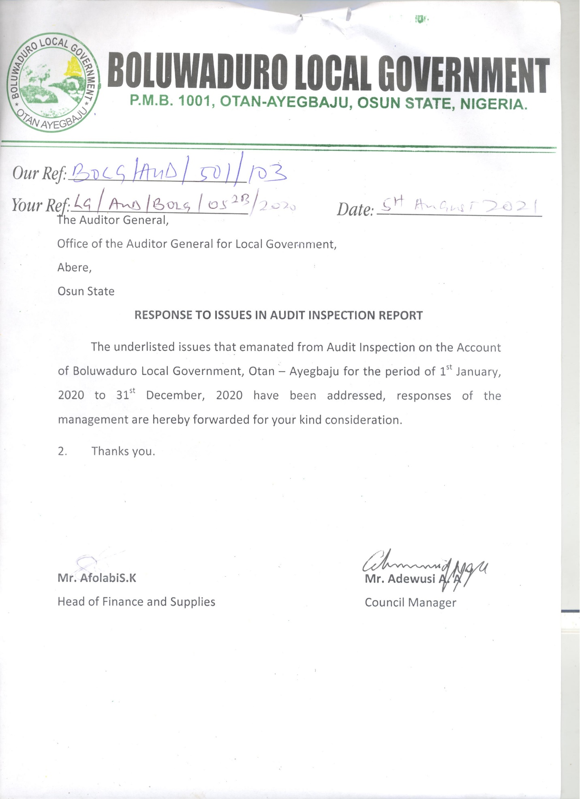

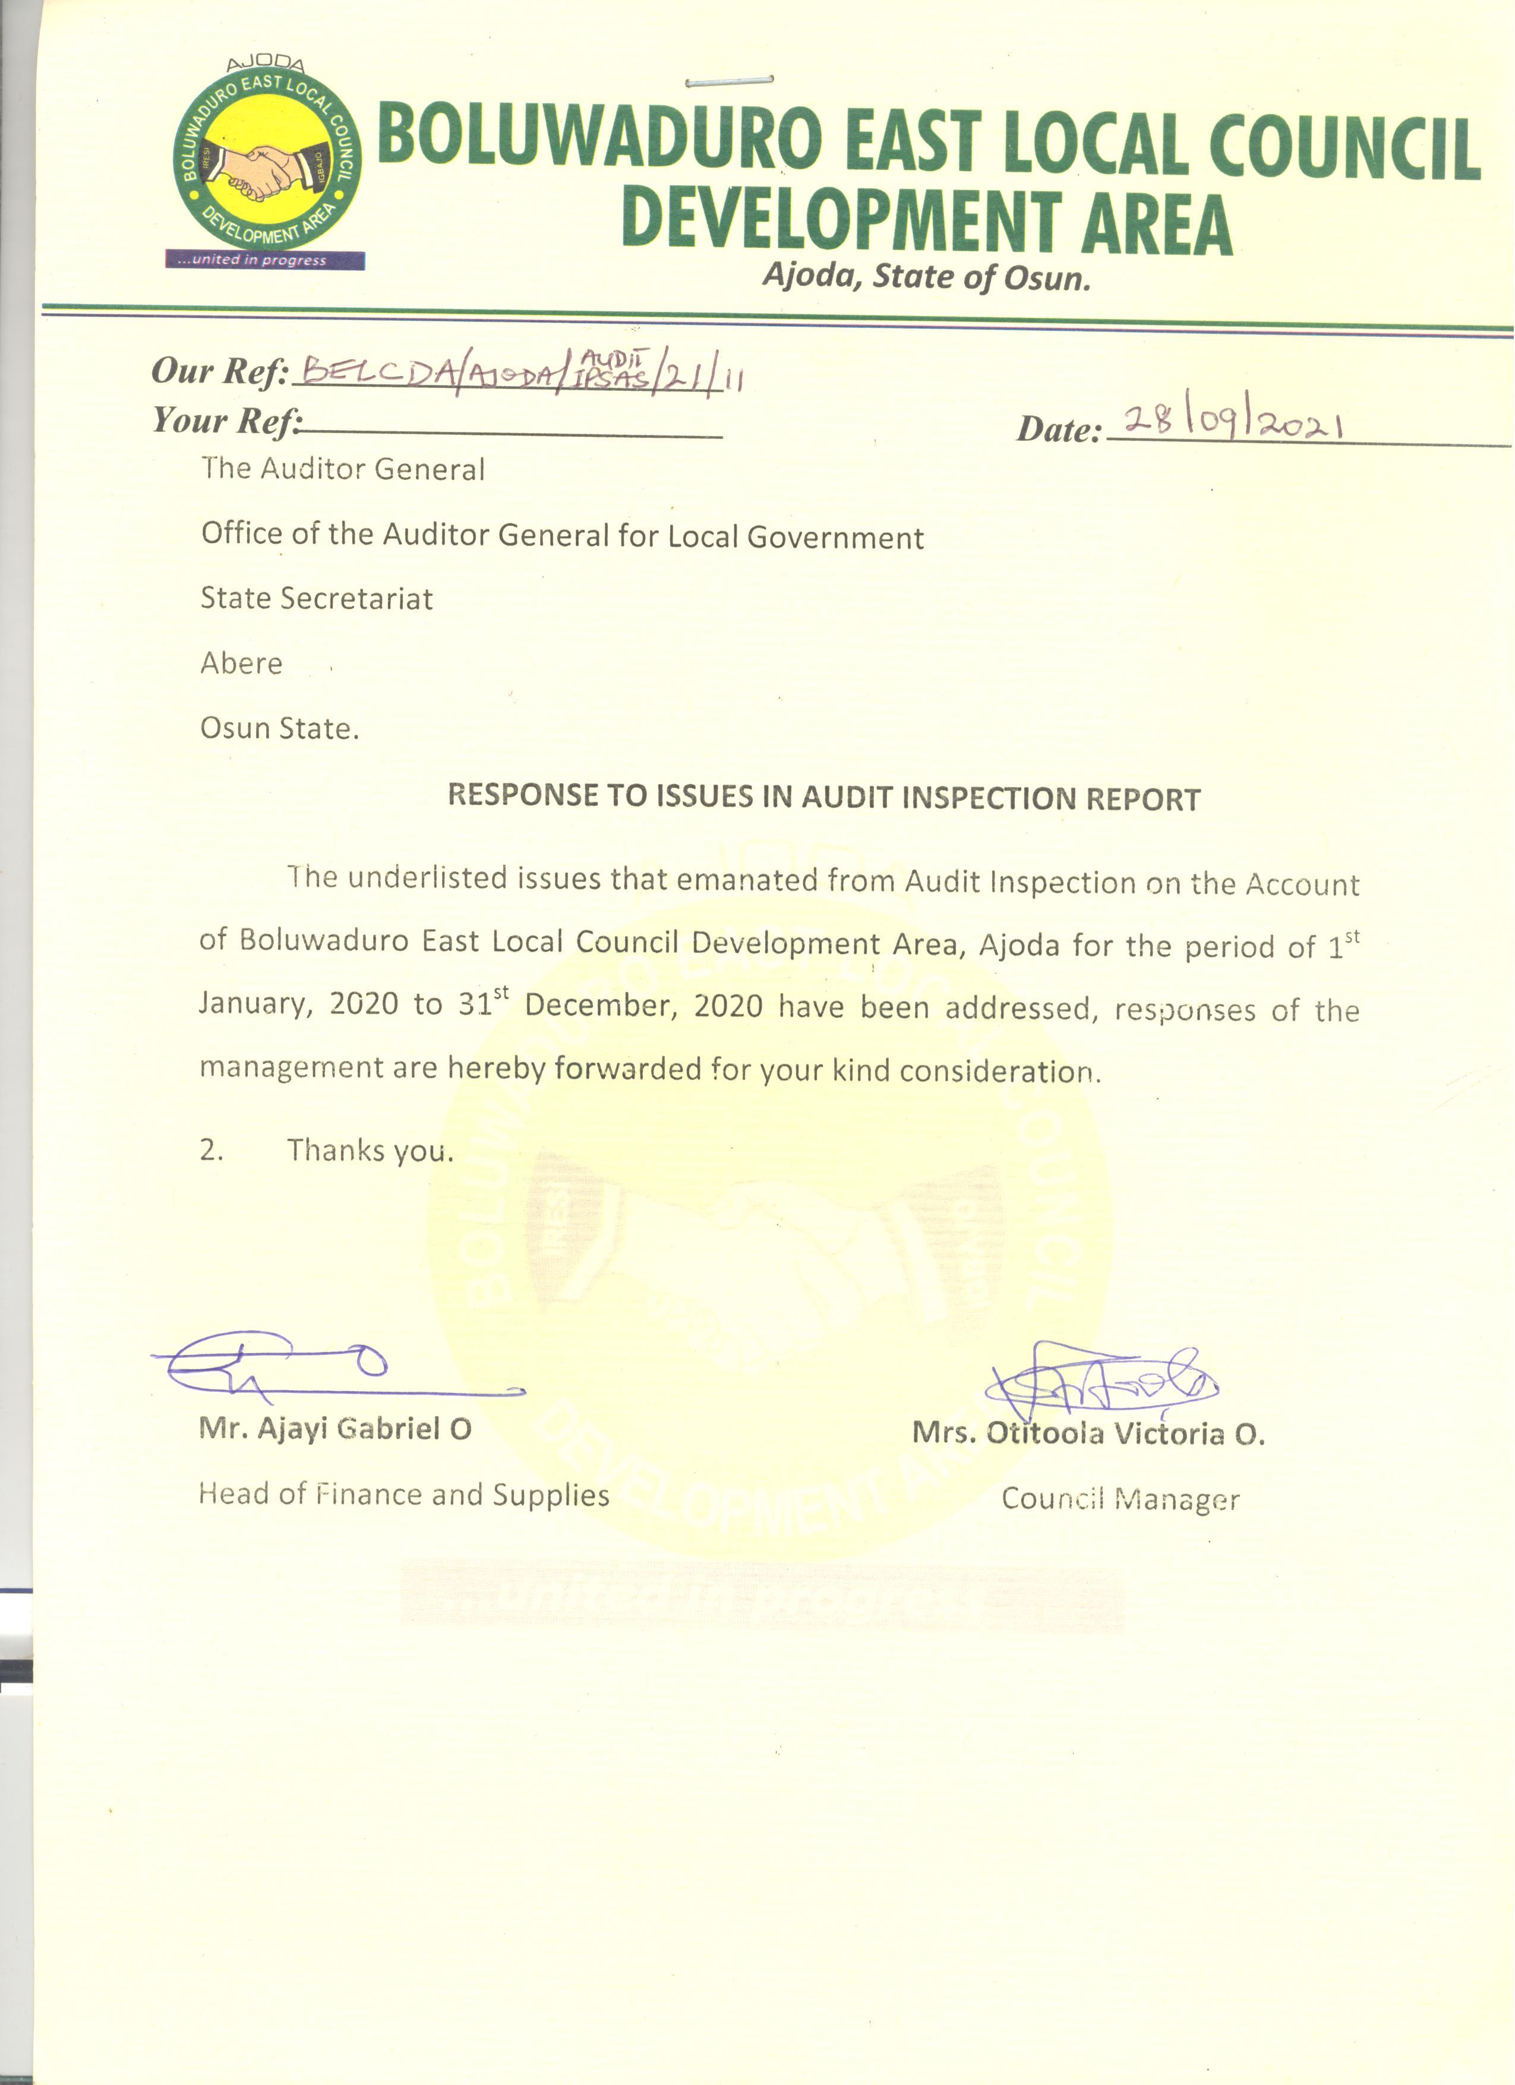

**MANAGEMENT LETTER**

**BOLUWADURO LOCAL GOVERNMENT, OTAN AYEGBAJU**

**OBSERVATIONS AND INTERNAL CONTROL REVIEW FOR THE FINANCIAL YEAR ENDED 31ST DECEMBER, 2020**

**1. EXPENDITURE NOT SUPPORTED BY PROPER RECORD OR ACCOUNT AMOUNTING TO (N100,000.00):** It was observed that expenditure to the tune of One Hundred thousand Naira (N100,000.00) was released for obtaining five (5) customized plates number for the Local Government official vehicles, purchase of Tyres and repairs of Toyota Corolla.

Audit Inspection revealed that there were no necessary documents like invoice and receipts attached to the payment voucher to authenticate the genuineness of the payment contrary to the provision of Financial Memoranda 14:17 which states that, “An official printed receipt must be obtained and attached to the payment voucher in respect of a payment to Government, another Local Government or Commercial firm. If the printed receipt covers more than one payment voucher, reference to the number of the payment voucher to which the receipt is attached, shall be entered on the other voucher”.

***RISK:***

*Payments made without supporting documents could imply non-execution of all or part of the services/purchases, or conceal inflation of prices.*

***MANAGEMENT RESPONSE:*** *It was an oversight and the receipt were eventually produced.*

***RECOMMENDATION:***

*The recipient/authorizing officer should ensure that all supporting documents were collected while incurring the expenditure.*

**2. DOUBTFUL EXPENDITURE TO THE TUNE OF (N300,000.00):** It was observed during the Audit Inspection that the Local Government claimed to have embarked on Computer Based Tests training for Secondary School Graduate and an enlarged meeting of Youths across the nooks and crannies of Boluwaduro Local Government, Otan-Ayegbaju for the sum of Three Hundred Thousand naira only (N300,000.00). It could not have been held because the period claimed for the commencement of the training was when Covid-19 was at its peak in Nigeria where people were lockdown at home.

Moreover, the enlarged meeting of Youths across the nooks and crannies of the Local Government could not have been held which made the payment doubtful.

***RISK:***

*The implication of this expenditure was that the services might not have been performed, thus the public fund might have been diverted for personal purposes.*

***MANAGEMENT RESPONSE:*** *The effect of the work done had been eroded with the passage of time before inspection was done supporting evidences such as sub-receipts, photographs, video tapes would be presented.*

***RECOMMENDATION:***

*The recipients must attach all necessary supporting evidence such as sub-receipts, evidence of participation, or video coverage to prove genuineness of the expenditure. However, such occurrences should be guided against in the future by notifying Audit at the instance of the exercise.*

**BOLUWADURO EAST LCDA, AJODA**

**OBSERVATIONS AND INTERNAL CONTROL REVIEW FOR THE FINANCIAL YEAR ENDED 31ST DECEMBER, 2020**

**1.** **UNCLAIMED ALLOWANCES TOTALLING N190,000.00**:It was observed that the recipients had not shown any sign of receiving this monthly allowance of One Hundred and Ninety Thousand (N190,000.00). No sub receipt attached to the payment voucher. This is contrary to Financial Memoranda 14:13 which states that, “Payment shall as far as possible, be made to the person to whom it is due, payment for a third party shall only be made on production of a written authority from the person to whom payment is due, such authority being attached to the payment voucher after payment”.

***RISK:***

*This was an indication that purported items might not have been purchased thereby resulting to loss of Local Government fund.*

***MANAGEMENT RESPONSE:***

*Action had been taken.*

***RECOMMENDATION:***

*An official printed receipt must be obtained and attached to the payment voucher as this proved the authenticity that the expenditure was carried out.*

**2.** **UNRETIRED IMPREST AND EXPENDITURE NOT CHECKED AND PASSED:** It was observed that the sum of One Hundred and Twenty Thousand (N120,000.00) was released as imprest to various agencies of Government but the imprest holders did not retire the imprest collected by them contrary to Financial Memoranda 14:27 and FM 40:10 which state that, “Imprest shall be retired when the purpose for which the imprest was granted is completed or as such intervals as are prescribed when the imprest is approved. However, all imprest shall automatically be retired at the end of each financial year” and “Before any payment is made, a prepayment audit of vouchers and supporting documents shall be made by the Internal Auditor on all payments made properly authorized and correctly charged to the stated sub-head or account and that sufficient funds are available to meet it.

***RISK:***

*Government Fund might not have been used for official purpose.*

***MANAGEMENT RESPONSE:*** *It was an oversight and the receipts were eventually presented.*

***RECOMMENDATION:***

*Proper recording of petty cash should be done and all payments must be retired immediately and presented for audit verification.*

**3.** **ACCUMULATED BANK CHARGES TO THE TUNE OF #214,810.46:** It was observed with dismay that the bank charges accumulated to the tune of Two Hundred and Fourteen Thousand, Eight Hundred and Ten Naira, Forty-Six Kobo (#214,810.46) by the Local Government as at 31st December, 2020. It should be noted that Payment Vouchers should be raised at the end of the month for any charge shown in the bank statement that has not been brought to account in the Cash book and it shall entered at once into the Cash book for the next month in compliance with provision of the Financial Memoranda 19:27.

***MANAGEMENT RESPONSE:***

*The payment vouchers had been raised.*

***RECOMMENDATION:***

*The Head of Finance should raise and process payment voucher to wipe off the accumulated bank charges. Also the Bank Reconciliation Statement should be re-prepared with necessary and proper documentation as required.*

**INTERNAL AUDITOR’S REPORT**

1. The Internal Control mechanism is not effective. The stakeholders on markets should be encouraged to improve on the IGR of the Council. The Revenue collectors should be checked always to avoid diversion of funds generated.

**2.** Despite the fact that the Internal Control unit is doing well, the markets activities need to be reviewed to generate more while the Rate Section and Revenue collectors need to be monitored thoroughly.

**LIST OF PROJECTS EXECUTED BY BOLUWADURO LOCAL GOVERNMENT, OTAN AYEGBAJU [JANUARY – DECEMBER 2020]**

|  |  |  |  |  |  |  |  |
| --- | --- | --- | --- | --- | --- | --- | --- |
| **S/N** | **DESCRIPTION** | **LOCATION** | **MODE OF EXECUTION** | **PROJECT COST (#)** | **AMOUNT RELEASED (#)** | **BALANCE** | **REMARKS** |
| 1 | Construction of District Court | Otan Ayegbaju | Direct Labour | 14,331,377.90 | 5,600,000.00 | 8,731,337.40 |  |
| 2. | Demolition landscaping and beautification of Owa’s Palace | Otan Ayegbaju | Direct Labour | 13,323,435.00 | 2,500,000.00 | 10,823,435.00 |  |
| 3 | Extension of Electricity along Prof. Olu Aina way | Otan Ayegbaju | Direct Labour | 3,000,000.00 | 3,000,000.00 | - |  |
| 4 | Extension of Electricity along Sasala road | Otan Ayegbaju | Dierct Labour | 2,943,000.00 | 2,943,000.00 | - |  |
| 5 | Renovation of DSS Office | Otan Ayegbaju | Direct Labour | 2,300,000.00 | 1,300,000.00 | 1,000,000.00 |  |
| 6 | Asphaltic spot patching and Ikotun road | Otan Ayegbaju | Direct Labour | 1,950,000.00 | 1,950,000.00 | - |  |
|  | **TOTAL** |  |  | **37,847,812.90** | **17,293,000.00** | **20,554,812.90** |  |

**LIST OF PROJECTS EXECUTED BY BOLUWADURO EAST LOCAL COUNCIL DEVELOPMENT AREA, AJODA [JANUARY – DECEMBER 2020]**

|  |  |  |  |  |  |  |  |
| --- | --- | --- | --- | --- | --- | --- | --- |
| **S/N** | **DESCRIPTION** | **LOCATION** | **MODE OF EXECUTION** | **PROJECT COST (N)** | **AMOUNT RELEASED (N)** | **BALANCE (N)** | **REMARKS** |
| 1 | Purchase of fairly used corolla for the office of CM | Secretariat | Direct labour | 2,000,000.00 | 1,000,000.00 | Nil | Completed |
| 2 | Purchase And Replacement Of Stolen Incoming Cables (500mm XPLE) At Kiriji Substation, Igbajo | Kiriji Substation, Igbajo | Direct labour | 580,000.00 | 580,000.00 | Nil | Completed |
| 3 | Fillings of potholes with hardcore and laterite of Igbajo township roads | Igbajo | Direct labour | 700,000.00 | 700,000.00 | Nil | Completed |
| 4 | Payment for the commencement of construction of ultra-modern permanent site complex (7 blocks of building with 36 offices, 38 toilet units and a big hall), Ajoda | Permanent site, Ajoda | Direct labour | 5,000,000.00 | 5,000,000.00 | Nil | Completed |
| 5 | 2nd Payment for the commencement of construction of ultra-modern permanent site complex (7 blocks of building with 36 offices, 38 toilet units and a big hall), Ajoda | Permanent site, Ajoda | Direct labour | 5,000,000.00 | 5,000,000.00 | Nil | Completed |
| 6 | Grading of rural, farm settlement roads and laterite fillings of badly eroded parts of the roads (45km) in Igbajo | Igbajo villages and farm settlements | Direct labour | 3,000,000.00 | 3,000,000.00 | Nil | Completed |
| 7 | Grading of rural, farm settlement roads and laterite fillings of badly eroded parts of the roads in Iresi and Ikinfin (38km) | Iresi villages Ikinfin and farm settlements | Direct labour | 3,000,000.00 | 3,000,000.00 | Nil | Completed |
| 8 | Construction of 1.4m x 1.4m x 9m box culvert on Aginrinmodo stream, Nil Igbajo | Igbajo | Direct labour | 1,900,000.00 | 1,900,000.00 | Nil | Completed |
| 9 | Payment for procurement of 120Nos of 2-seater reading tables and chairs for the pupils of Oluresi Elementary School, Iresi | Iresi | Direct labour | 1,050,000.00 | 1,050,000.00 | Nil | Completed |
| 10 | Clearing and opening of new rural roads to access farms and farm settlements in Igbajo and Iresi | Igbajo and Iresi | Direct labour | 2,000,000.00 | 2,000,000.00 | Nil | Completed |
| 11 | Payment for the hardcore and laterite fillings of approaches of the newly constructed box culvert on Aginrinmodo stream, Igbajo | Igbajo | Direct labour | 550,000.00 | 550,000.00 | Nil | Completed |
| 12 | Complete Reconstruction Of A Block Of 4 Classrooms (34m X 12m) At C&S Elementary School, Igbajo | Igbajo | Direct labour | 4,900,000.00 | 1,400,000.00 | Nil | Completed |
|  |  |  |  | **29,680,000.00** | **29,680,000.00** | **NIL** | Completed |