STATE GOVERNMENT OF OSUN, NIGERIA.

REPORT OF

THE

AUDITOR-GENERAL

FOR

LOCAL GOVERNMENTS

ON THE ACCOUNTS OF

EDE SOUTH LOCAL GOVERNMENT

OKE-IRESI

FOR THE YEAR ENDED

31ST DECEMBER, 2020.

**TABLE OF CONTENTS**

|  |  |  |
| --- | --- | --- |
|  | **DETAILS** | **PAGE** |
| 1 | TITLE PAGE | **1** |
| 2 | TABLE OF CONTENTS | **2** |
| 3 | LIST OF ABBREVIATIONS | **3** |
| 4 | STATEMENT OF RESPONSIBILITY FOR THE PREPARATION OF FINANCIAL STATEMENTS | **4** |
| 5 | STATEMENT OF RESPONSIBILITY OF THE AUDITOR-GENERAL | **5** |
| 6 | AUDIT CERTIFICATE | **6** |
| 7 | BASIS OF AUDIT OPINION | **7** |
| 8 | STATEMENT OF COMPLIANCE | **8** |
| 9 | STATEMENT OF ACCOUNTING POLICIES | **9-11** |
| 10 | GENERAL COMMENTS | **12-13** |
| 11 | **COMMENTS ON FINANCIAL STATEMENTS**   1. STATEMENT OF FINANCIAL PERFORMANCE 2. STATEMENT OF FINANCIAL POSITION | **14-18** |
| 12 | **AGGREGATE GENERAL PURPOSE FINANCIAL STATEMENTS**   1. CONSOLIDATED STATEMENT OF FINANCIAL POSITION. 2. CONSOLIDATED STATEMENT OF FINANCIAL PERFORMANCE. 3. CONSOLIDATED STATEMENT OF CASH FLOW. 4. CONSOLIDATED STATEMENT OF COMPARISON OF FINANCIAL OPERATIONS. 5. CONSOLIDATED STATEMENT OF NET ASSETS AND EQUITY 6. NOTES TO THE ACCOUNT | **19-34** |
| 13 | **FISCAL OPERATION REPORT**  i STATISTICAL AND ACCOUNTING RATIOS  ii NON-FINANCIAL DISCLOSURE | **35-36** |
| 14 | MANAGEMENT LETTER | **37-43** |
| 15 | LIST OF PROJECTS EXECUTED IN THE LOCAL GOVERNMENTS | **44** |

**LIST OF ABBREVIATIONS**

1. AGLG - AUDITOR-GENERAL FOR LOCAL GOVERNMENTS
2. AO - AREA OFFICE/ADMINISTRATIVE OFFICE
3. FAAC - FEDERATION ACCOUNTS ALLOCATION COMMITTEE
4. F.M - FINANCIAL MEMORANDUM
5. FOR - FISCAL OPERATION REPORT
6. GPFS - GENERAL PURPOSE FINANCIAL STATEMENTS
7. IGR - INTERNALLY GENERATED REVENUE
8. ISSAI - INTERNATIONAL STANDARDS OF SUPREME AUDIT INSTITUTIONS
9. IPSAS - INTERNATIONAL PUBLIC SECTOR ACCOUNTING STANDARD
10. JAAC - JOINT ACCOUNTS ALLOCATION COMMITTEE
11. LGA - LOCAL GOVERNMENT AREA
12. LCDA -LOCAL COUNCIL DEVELOPMENT AREA
13. LGSC - LOCAL GOVERNMENT SERVICE COMMISSION
14. LGSPB - LOCAL GOVERNMENTS STAFF PENSION BOARD
15. LGLB - LOCAL GOVERNMENT LOANS BOARD
16. NCOA - NATIONAL CHART OF ACCOUNTS
17. NBV - NET BOOK VALUE
18. MLGCA- MINISTRY OF LOCAL GOVERNMENT AND CHIEFTAINCY AFFAIRS
19. PPE - PROPERTY, PLANTS AND EQUIPMENT
20. PSE - PUBLIC SECTOR ENTITIES
21. PHCB - PRIMARY HEALTH CARE BOARD
22. VAT - VALUE ADDED TAX

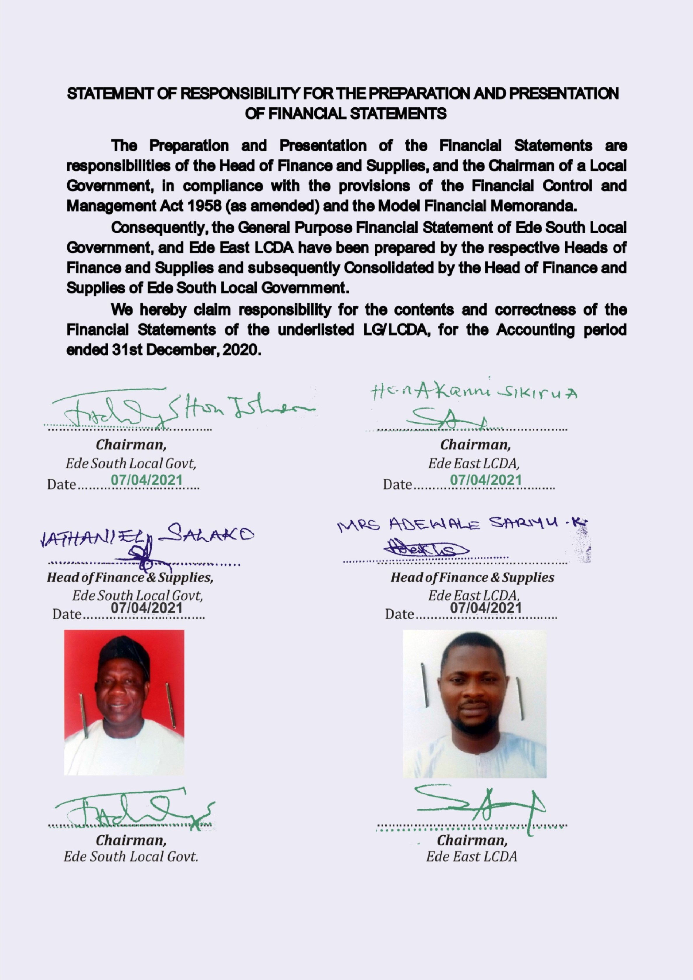

**STATEMENT OF FINANCIAL RESPONSIBILITY**

The preparation and fair presentation of Financial Statements of Local Governments, the State Joint Local Government Accounts, and offices administering elements of Local Governments Fund is the direct responsibility of the Heads of Finance and Supply in the Local Governments, the Accountant of the Ministry of Local Governments, and Directors of Finance in the Offices of the Local Governments, respectively, in compliance with the provisions of Finance Control and Management Act 1958 (as amended), the Model Financial Memoranda (1991 as amended), the Laws of Osun State 2002 (as amended) and with the provisions of the Constitution of the Federal Republic of Nigeria, 1999.

In the State of Osun, the Heads of Finance of main Local Governments are responsible for the consolidation of the respective Financial Statements with the subsidiary LCDAs, Area/Administrative offices, as may be applicable.

However, both the Head of Finance and Chairman of a Local Government, (the Accounting Officer) are responsible for establishing and maintaining a system of internal control designed to provide reasonable assurance that the transactions and Financial Statements give a fair presentation of the financial operations of the Local Government.

The acknowledgment of responsibility for the preparation of Financial Statement signed by Heads of Finance and Chairmen of the respective Local Governments are attached to individual report.

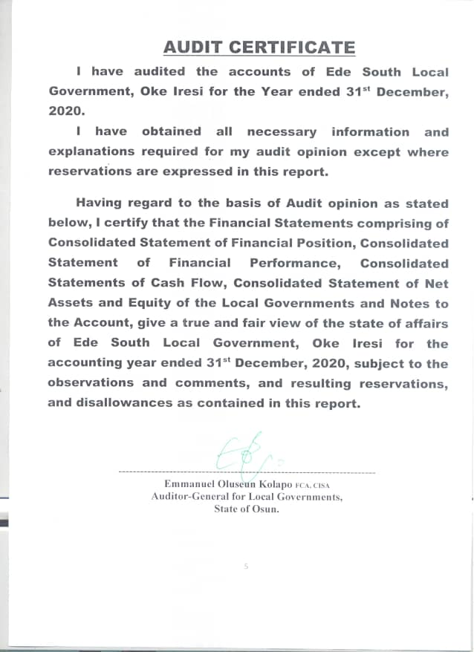

**STATEMENT OF RESPONSIBILITY OF THE AUDITOR-GENERAL.**

It is my responsibility to Audit the accounts of the Local Governments, the State Joint Local Government Account, and all offices of the Local Government as stipulated by the Laws of Osun State and the Financial Memoranda; and to form an independent opinion based on the Audit of the Financial Statements and accompany notes submitted by the Head of Finance and Supply of Local Governments, the Head of Accounts in the Ministry of Local Governments and various Institutions and all agencies, handling projects and programmes funded by Local Governments in the state.

**BASIS OF AUDIT OPINION**

In the course of auditing the accounts of Local Governments in the State of Osun, I have complied with the requirement and stipulations of the International Standards on Auditing, the Generally Acceptable Auditing Standards, International Standards of Supreme Audit Institutions (ISSAI,) Laws of Osun State, International Public Sector Accounting Standards and Audit Guide of the Office of the Auditor-General for Local Governments, Osun State.

I have conducted Financial and Compliance audit on the Finances of Local Governments and JAAC. Projects and Programmes were reasonably evaluated and verified on the principle of Performance Auditing. All items of Revenue and Expenditure were captured in the course of the Audit and Audit Tests were conducted on procedures, transactions and balances. Consequently 100% Substantive Test was done on all items of Revenue and Expenditure; and Assets and Liabilities, and appropriate Audit Tests of Control were conducted on procedures and transactions.

Where paucity of available Audit resources warranted sampling, objective statistical sampling techniques were applied to ensure representativeness, completeness, relevance, and timeliness in the determination of sampling elements. This ensured reliability of Audit Opinion, giving due recognition to principle of materiality. For example, multi-layered and structural sampling method was applied for verification of numbers and Emoluments of Teaching and Non-Teaching staff of the State Universal Basic Education Board (SUBEB), Staffers of Local Governments and the State Primary Health Care Board.

**STATEMENT OF COMPLIANCE**

The Accounting Policies have been consistently applied on preparation of the Financial Statements of Ede South Local Government in the year under review. These have been prepared on the basis of Historical Cost and in accordance with IPSAS Accruals and other applicable standards. The Cash Flow Statement was prepared using the Direct Method. The basis of measurement is Naira and kobo which is the functional and reporting currency of the Federal Republic of Nigeria of which Osun State and Ede South Local Governments are constituents.

The accounts of Ede South Local Government have been audited and reported upon.

Audit noted some instances of non-compliance in the Local Governments, with the due process in revenue collection and payment procedure contrary to the provision of Financial Memoranda and relevant Guidelines. The associated internal control weaknesses have been addressed. The inspection reports (letters of Internal Control weaknesses) for the year 2020 have been issued and forwarded to the appropriate quarters for responses and compliance as required.

The queries were replied and appropriate recommendations were made as contained in the Management letter included.

**STATEMENT OF ACCOUNTING POLICIES**

1. **Basis of Preparation (IPSAS 1)**

The General Purposes Financial Statements were prepared under the historical cost convention and in accordance with IPSAS Accrual Basis and other applicable standards and conventions as may be defined by relevant Statutes.

1. **Accounting Period**

The accounting year (fiscal year) to which the report relates is 1st January to 31st December, 2020.

1. **Reporting Currency**

The General Purposes Financial Statements are prepared in the Nigerian Naira (NGN).

1. **Principal Statements in the General Purposes Financial Statements**
2. Statements of Financial Performance. (Aggregate and Consolidated)
3. Statements of Financial Position. (Aggregate and Consolidated)
4. Statements of Cash flow.(Aggregate and Consolidated)
5. Statementsof Comparison of Budgeted and Actual Amounts (Aggregate and Consolidated)
6. Statements of Changes in Net Asset/Equity. (Aggregate and Consolidated)
7. Notes to the GPFS.
8. Financial Statement of Joint Accounts Allocation Committee (JAAC)
9. **Consolidation Policy- IPSAS 6**

The Heads of Finance of the 69 Local Governments, LCDAs, and A/Cs and A/Os are required to prepare their individual GPFS at the end of the financial year on Accrual Basis of Accounting.

Each Local Government is a creation of the Constitution and none is subservient to the other. However in this situation, there are subsidiary entities such as LCDAs and Area offices, which are consolidated with the main Local Government. Consequentrly, the Heads of Finance of the 30 main Local Governments consolidate the GPFS of their respective main Local Government with the subsidiary LCDAs, AOs, and Ad. Os.

***The duty of the Auditor-General for Local Governments is not to prepare or consolidate Local Governments’ accounts, but to Audit and Aggregate the prepared Financial Statements in line with the Fiscal Operation Report Guideline.***

1. **Statement of Cash Flow** was prepared using the direct method (IPSAS 2) and it consists of Operating, Investing and Financing activities.
2. **Inventories (IPSAS 12) -** Inventories were measured initially at cost, and subsequently measured using the FIFO method.
3. **PROPERTY, PLANT & EQUIPMENT (PPE) – IPSAS 17**

All PPEs were stated at historical cost less accumulated depreciation and impairment losses.

1. **DEPRECIATION**

The cost of PPE shall be written off, from the time they are brought into use, on a straight line basis over their expected useful lives less any estimated residual value as follows:

1. Furniture & Fittings - 20%
2. Motor Vehicle - 20%
3. Plant & Equipment - 20%
4. Infrastructural Asset - 10%
5. Building - 2%
6. Office Equipment - 20%
7. **REVALUATION**
8. The Assets’ residual values and useful lives are reviewed at the end of the year.
9. **IMPAIRMENT**

Test for Impairment are done on Property, Plants and Equipments, where it is suspected that Impairment has occurred.

1. **INVESTMENT PROPERTIES – IPSAS 16**

The Investment properties are measured initially at cost, including transaction costs. Subsequent to initial recognition, investment properties are measured using the cost model and are depreciated the same way as PPE.

1. **INDEPENDENT REVENUE FROM NON-EXCHANGE TRANSACTION (IPSAS 23)**
2. Fees; taxes and fines: The Local Government recognised revenue from fees, taxes, and fines when the event occured, and the asset recognition criteria are met.
3. **OTHER REVENUE**

Other Revenues are proceeds that arise outside the Ordinary course of governmental busineess. These include:

1. Gain on disposal of Property, Plant and Equipment

2. Dsiposal of Investment such as Shares, bond etc

Gain on disposal is recognized at the date of control of the asset is passed to the buyer and is determined after deducting the carrying value of the Asset at that time.

1. **UNREMITTED DEDUCTION**

Unremitted deductions are monies owned to the third parties such as tax authorities, associations and other Government Agencies. These include tax deductions and other deductions at source

This amount shall be stated in GPFS at their repayment value, which shall be treated as current liabilities in the Statement of Financial Position.

**16. RESERVE**

Reserves shall be classified under Equity in the Statement of Financial Position which includes Accumulated Surplus/Deficit and the Additional Reserve.

**17. CONTIGENT LIABILITY IPSAS 19**

Contigent liabilities are only disclosed in the Notes to GPFS. Contingent liability is possible obligation arising from past events whose exigencies will be confirmed only by uncertain future event(s) or present obligation arising from the past events that are not recognized because of either an outflow of economic benefit is not probable or this amount of obligation.

**GENERAL COMMENTS**

I have audited the accounts of Ede South Local Government, Oke-Iresi for the financial year ended 31st December 2020, as required by Cap 72, Part 10 of the Laws of Osun State 2002, (as amended).

**AUTHORITY FOR DISBURSEMENTS FROM JAAC ACCOUNT:** Disbursements from JAAC accounts were made in consonance with the prescriptions of the House of Assembly while monthly distributions were collectively decided by the Chairmen of Ede South Local Government and other Chairmen, all of whom were members of the Joint Account Allocation Committee.

**FULL ADOPTION OF IPSAS ACCRUALS:** 2020 GPFS were prepared in compliance with IPSAS Accrual which was fully adopted by Local Governments in the State of Osun in 2017.

The previous accounting training on conversion to IPSAS Accruals, severally sponsored by the EU/SLOGOR, LGSC, SUBEB in collaboration with Office of the Auditor-General for Local Governments, with the approval of Mr. Governor, for upgrades and re-training in 2020 have collectively enhanced the proficiency of operators of Local Government accounts in the State

**SCOPE OF AUDIT COVERAGE**: The Audit scope has 100% coverage on all aspects of Revenue and Expenditure, as well as verification of Assets and Liabilities including JAAC Accounts. Revenue covered included all Allocations and VAT from the Federation Accounts and other dependent and Independent Revenue sources of the Local Governments while Expenditure covered included all Capital and Recurrent Expenditure Items in all Local Governments, and LCDAs, all centrally executed Projects and programmes of Local Governments, and Statutory remittances to Traditional Councils.

**BUDGET PREPARATION / EXECUTION**

The Budget for 2020 for Oriade Local Governments was prepared in compliance with new National Chart of Accounts. The 2020 Budget was an improvement on the previous Budget of 2019 as some of the obvious shortcomings observed by the Audit have been addressed.

**PROCUREMENT PRACTICES**

Osun State Public Procurement Law 2015 has been in force in line with global best practice. Procurement Officers was posted to the Local Governments and performed his duties. The Audit observed that the Offices need to be strengthened to further assist in promoting sound and transparent procurement practices in the Local Governments.

**VALUATION AND REVALUATION OF ASSETS**

The office of the Auditor-General for Local Governments embarked on verification exercise on valuation and Revaluation of Assets during the year. This involved Constitution of a standing multi-disciplinary team comprising seasoned and qualified professionals in the fields of valuation, engineering, town planning, medicine, etc. and others as were necessary. Consequently, the realism of the values of non-current asset is enhanced for the year under review. The verification exercise is continuous and value of the Local Governments non-current Assets is being updated monthly.

**INTERNALLY REVENUE GENERATION AND FINANCIAL VIABILITY**

Of concern to the Audit is the paltry amount of revenue that was generated in the Financial Year 2020. Audit examination showed that none of the Local Governments improved significantly on their revenue drive. The Total Internally Revenue generated by the Local Government for 2020 was N7,438,839.00 representing 0.54% the Total Revenue. More efforts at blocking leakages coupled with adequate research by the relevant unit of the Auditor-General for Local Government on comparative revenue advantages of individual Local Government’s office will assist in curbing this unwholesome situation.

**INTERNAL CONTROL WEAKNESS IN THE LOCAL GOVERNMENT AND RELATED AGENCIES**

At the conclusion of the Audit, 57 nos of Audit Queries were issued in respect of 2020 Accounts, involving a total sum of N40,433,052.00.

Queries were issued in respect of irregularities observed in fund management by beneficiary agencies of transfers from Local Governments fund and this had been forwarded to the respective Accounting Officers for response.

The identified internal control weaknesses, the inherent risks, the management Responses and Audit Recommendations are highlighted in Management Letter contained in this Report.

**COMMENTS ON FINANCIAL STATEMENTS**

1. **STATEMENT OF FINANCIAL PERFORMANCE**

**Share of FAAC and VAT:** To ensure completeness of Revenue, the total Allocation received from the Federation Account in respect of Ede South Local Government as contained in JAAC Account was confirmed from the Accountant General of the State and further reference was made to data released by office of Accountant General of the Federation. The total sum of N975,571,969.47 was Share of FAAC and VAT amounted to N396,358,024.58.

THE CONCEPT OF **DEPENDENT REVENUE.** The term IndependentRevenue or synonymous with Internally Generated Revenue in the IPSAS. However, the term Dependent Revenue is used in proportion in the Report as it depicts the items of Revenue other than Internally Generated Revenue (IGR), i.e. the revenue over which the reporting entirely has no control on its generation or collection.

Essentially the proportion of Dependent Revenue is a measure of the extent of its vulnerability or dependently of the Local Government on finances from sources over which it has no control.

**EXPENDITURE:** As part of the disclosure requirements, expenditures that were Jointly incurred at JAAC level were separately disclosed from those expended at each Local Government Level.

**SUMMARY OF REVENUE FROM JAAC**

|  |  |  |  |  |  |  |  |  |  |  |
| --- | --- | --- | --- | --- | --- | --- | --- | --- | --- | --- |
| **LOCAL GOVERNMENT** | **STATUTORY ALLOCATION** | **VAT** | **EX RATE GAIN** | **FEDERAL GOVT INTERVENTION** | **EXCESS BANK** | **FOREX EQUALISATION** | **ECO** | **ADD FUND FRM SOLID MIN** | **NON-OIL EXCESS REVENUE** | **TOTAL** |
| Ede South | 876,327,568.72 | 396,358,024.58 | 28,424,046.79 | 23,807,282.02 | 721,435.94 | 12,713,489.58 | 19,756,737.51 | 1,469,291.01 | 12,352,117.90 | 1,371,929,994.05 |

**INDEPENDENT REVENUE FROM NON-EXCHANGE TRANSACTION (IPSAS 23)**

Fees; taxes and fines: The Local Government recognised revenue from fees, taxes, and fines when the event occurs, and the asset recognition criteria are met. The Local Government earned and recognised. #53,576,509.03.

**SALARIES AND WAGES – N787,886,191.80**

Salaries and Wages which amounted to N787,886,191.80 comprised of salaries of Staff of the Local Governments, Teaching and Non-Teaching Staff of SUBEB, staff of Local Government Loans Board and the Primary Health Care Board. Salary Payment was centralised in the State of Osun for the year 2020.

**COMMENTS ON ITEMS OF FINANCIAL POSITION**

**CASH AND CASH EQUIVALENTS – #17,120,345.68**

The Aggregate closing cash and cash equivalents amounted to **₦17,120,345.68** for the Local Governments. The Bank Statements and Bank Reconciliation Statements of all Local Governments and Local Government Development Areas as at 31st December, 2020 were verified/examined to ascertain the bank balances. This balance does not include the balance in JAAC account which essentially should be a zero-balance account. Moreover any undistributed amount in the JAAC Account is treated as Receivable to the Local Governments.

**RECEIVABLES - ₦128,841,766.84**

A total sum of N128,841,766.84k was standing as Receivables as at 31st December, 2020. The Receivables include, Revenue Recognised in December 2020 but received in January, 2020 from Joint Allocation Account Committee (JAAC).

**INVENTORIES - ₦1,021,450.00**

The sum of ₦1,021,450.00represents inventories valued at historical cost in the Local Governments as at 31st December, 2020. These include unallocated stores both expendable and non-expendable; and consumable items.

**INVESTMENTS - ₦75,145,184.33**

All the Investments are classified as held-for-sale, while Equity Method is adopted in Recognition and Measurement. Most of the investments were in unquoted companies except for the Preference shares.

**PROPERTY, PLANT AND EQUIPMENT(PPE)**

Items of Property, Plant and Equipment or other Non -Current Assets are stated at Historical Cost Less accumulated Depreciation. Depreciation on Non - Current Assets are calculated to write off cost on valuation in a straight-line basis over the expected useful life on the assets, as follows:

**Particulars Rate%**

Fixture and fitting 20

Motor Vehicle 20

Plant and Equipment 20

Infrastructural Asset 10

Buildings 2

Office Equipment 20

There is need to make adequate provision for depreciation. Accounting for PPE is an area of Audit emphasis where there seems to be a gap in knowledge exhibited by the operators of the Account vis-à-vis expectation.

**PAYABLES - ₦874,904,843.43**

These comprised largely of commitments all over the Local Governments such as allowances, sundry overheads, and unpaid salary and wages, arrears of salaries, unremitted deductions etc. outstanding as at 31stDecember 2020.

**INVESTMENT PROPERTY - ₦1,023,820,700.00**

The carrying amount of Investment Properties of the Local Governments stood at N1,023,820,700.00 in the Statement of Financial Position. However, there is no restriction on title or property pledge as securities for liabilities. Straight Line Method of depreciation was applied.

**LONG – TERM BORROWINGS - ₦1,283,798,885.78**

These are the cumulative amount of various outstanding loans obtained from different sources to finance the under-listed projects:

* 1. Construction of over 10 kilometers of roads, (tagged 10KM roads/Local Government), across all the main Local Governments across the state.
  2. Environmental Projects – includes channelization, chlorination, etc aimed at preserving lives and environments
  3. Intervention Projects including Grading, access to rural areas, etc..
  4. Repayment of Bail Out

**UNREMITTED DEDUCTIONS - ₦191,954,057.61**

These include deductions received from Joint Accounts Allocation Committee (JAAC) and deposits which ought to have been remitted to the appropriate quarters on or before 31st December, 2020. The management of the Local Councils are hereby advised to ensure that all deposits/deductions received are remitted promptly to avert the possibility of unnecessary accumulation of liabilities on Councils financial position

DISCLOSURES: In the statement of Financial Performance the amounts jointly expended by the Local Government is separated from the amount spent in individual Local Government.

**TRANSFER FROM MAIN COUNCILS TO LOCAL COUNCIL DEVELOPMENT AREAS:**

Transfer from main councils to the tune of #46,137,670.03 was made to the Local Council Development Areas and Area Offices in the period under review and was set off in the Consolidated Account.

**IMPAIRMENT - #35,500,000.00**

The impairment for the year stood at #35,500,000.00 which was beyond budgetary provision but observed to have been largely incurred due to the End-SARS Protest.

**EDE SOUTH LOCAL GOVERNMENT, OKE-IRESI**

**CONSOLIDATED STATEMENT OF FINANCIAL POSITION AS AT 31ST DECEMBER 2020**

|  |  |  |  |  |
| --- | --- | --- | --- | --- |
| **FINANCIAL POSITION** | | | | |
| **PARTICULAR** |  | EDE SOUTH | EDE EAST LCDA | EDE SOUTH CONSOLIDATED |
| **ASSETS** | **NOTE** |  |  |  |
| **Current Assets** |  |  |  |  |
| **Cash & Cash Equivalents** | **1** | 14,607,936.23 | 2,512,409.45 | 17,120,345.68 |
| **Receivables** | **2** | 116,200,349.29 | 12,641,417.55 | 128,841,766.84 |
| **Prepayment/Advance** | **3** | 4,150,000.00 |  | 4,150,000.00 |
| **Inventories** | **4** | 204,550.00 | 816,900.00 | 1,021,450.00 |
| **Total Current Asset** |  | 135,162,835.52 | 15,970,727.00 | 151,133,562.52 |
| **Non Current Asset:** |  |  |  | - |
| **Long Term Loan Granted** |  |  |  | - |
| **Investments** | **5** | 62,395,184.33 | 12,750,000.00 | 75,145,184.33 |
| **Property, Plant & Equipment** | **6** | 8,348,971,341.74 | 71,080,526.37 | 8,420,051,868.11 |
| **Investment Property** | **7** | 1,017,987,740.00 | 5,832,960.00 | 1,023,820,700.00 |
| **Biological Asset** | **8** |  |  | - |
| **Assets Under Construction(WIP)** | **9** |  |  | - |
| **Total Non-Current Asset** |  | 9,429,354,266.07 | 89,663,486.37 | 9,519,017,752.44 |
| **Total Asset** |  | 9,564,517,101.59 | 105,634,213.37 | 9,670,151,314.96 |
| **LIABILITIES** |  |  |  | - |
| **Current Liabilities:** |  |  |  | - |
| **Deposit** |  |  |  | - |
| **Unremitted Deductions** | **10** | 188,960,179.45 | 2,993,878.16 | 191,954,057.61 |
| **Short Term Loan & Debts** | **11** |  |  | - |
| **Payables** | **12** | 797,003,846.90 | 77,900,996.53 | 874,904,843.43 |
|  |  |  |  | - |
| **Short Term Provisions** |  |  |  | - |
| **Total Current Liability** |  | 985,964,026.35 | 80,894,874.69 | 1,066,888,901.04 |
| **Non Current Liabilities:** |  |  |  | - |
| **Long Term Borrowing** | **13** | 1,157,005,542.96 | 126,793,342.82 | 1,283,798,885.78 |
| **Total Liabilities** |  | **2,142,969,569.31** | **207,688,217.51** | **2,350,657,786.82** |
| **Net Assets** |  | 7,421,547,532.28 | (102,054,004.14) | 7,319,493,528.14 |
| **Financed by** |  |  |  | - |
| **Reserve** | **14** | 8,979,244,988.19 | (342,730,127.43) | 8,636,514,860.76 |
| **Net Surplus/Deficit** | **15** | (1,557,697,455.91) | 240,676,123.29 | (1,317,021,332.62) |
| **Total** |  | **7,421,547,532.28** | **(102,054,004.14)** | **7,319,493,528.14** |

**EDE SOUTH LOCAL GOVERNMENT, OKE-IRESI**

**CONSOLIDATED STATEMENT OF FINANCIAL PERFORMANCE AS AT 31ST DECEMBER 2020**

|  |  |  |  |  |
| --- | --- | --- | --- | --- |
| **PERFORMANCE** | | | | |
| **PARTICULAR** | **NOTE** | **EDE SOUTH** | **EDE EAST LCDA** | **EDE SOUTH CONSOLIDATED** |
| **Government Share of FAAC(Statutory Revenue)** | **16** | 876,327,568.72 |  | 876,327,568.72 |
| **Government Share of VAT** | **17** | 396,358,024.58 |  | 396,358,024.58 |
| **Additional Fund** | **18** | 1,469,291.01 |  | 1,469,291.01 |
| **Revenue Furniture Allowance** | **19** |  |  | - |
| **Ex Rate Gain** | **20** | 28,424,046.79 |  | 28,424,046.79 |
| **Augmentation** | **21** |  |  | - |
| **Federal Govt Intervention Fund** | **22** | 23,807,282.02 |  | 23,807,282.02 |
| **ECO** | **23** | 19,756,737.51 |  | 19,756,737.51 |
| **Solid Minerals** | **24** |  |  | - |
| **Non-Oil Revenue** | **25** | 12,352,117.90 |  | 12,352,117.90 |
| **Distributable from Goods & Valuables** | 26 |  |  | - |
| **Forex Equalisation** | **27** | 12,713,489.58 |  | 12,713,489.58 |
| **10% IGR** | **28** |  |  | - |
| **Excess Bank Charges** | **29** | 721,435.94 |  | 721,435.94 |
| **Aids & Grants** | 30 |  |  | - |
| **Overpayment Recovery** | 31 |  |  | - |
| **Sub-Total Dependent Revenue** |  | 1,371,929,994.05 | - | 1,371,929,994.05 |
| **Transfer from Main Council** | **32** |  | 46137670.03 | 46,137,670.03 |
| **Tax Revenue** | **33** | 74,400.00 | 70,950.00 | 145,350.00 |
| **Non-Tax Revenue** | **34** | 5,248,864.00 | 2,044,625.00 | 7,293,489.00 |
| **Other Income** | **35** |  |  |  |
| **Sub-Total Independent Revenue** |  | 5,323,264.00 | 2,115,575.00 | 7,438,839.00 |
| **Total Revenue** |  | 1,377,253,258.05 | 48,253,245.03 | - |
| **EXPENDITURE** |  |  |  | - |
| **JOINTLY EXPENDED** |  |  |  | - |
| **Salaries & Wages** | **36** | 787,886,191.80 |  | 787,886,191.80 |
| **Social Benefits** | **37** | 300,000.00 |  | 300,000.00 |
| **Overhead Cost** | **38** | 18,949,956.72 |  | 18,949,956.72 |
| **Grants & Social Contribution** | **39** | 29,641,494.02 |  | 29,641,494.02 |
| **Transfer to Other Agencies** | **40** | 476,830,351.58 |  | 476,830,351.58 |
| **Allowances** | **41** | 271,388.28 |  | 271,388.28 |
| **Stationaries** |  |  |  | - |
| **Public Debt Charge** |  |  |  | - |
| **L/GOVERNMENT EXPENDITURE** |  |  |  | - |
| **Social Benefits** | **42** | 851,500.00 | 1,474,500.00 | 2,326,000.00 |
| **Overhead Cost** | **43** | 19,848,584.40 | 27,019,717.28 | 46,868,301.68 |
| **Grants & Social Contribution** | **44** | 33,255,827.98 | 9,967,900.00 | 43,223,727.98 |
| **Depreciation** | **45** | 561,295,828.15 | 9,627,790.18 | 570,923,618.33 |
| **Transfer to LCDA** | **46** | 46,137,670.03 |  | - |
| **Allowances** | **47** | 9,269,500.00 | 11,868,582.45 | 21,138,082.45 |
| **Impairment** | **48** | 35,500,000.00 |  | 35,500,000.00 |
| **Tax Expenses** |  |  |  |  |
| **Bail-Out Repayment** |  |  |  | - |
| **Audit Fees** | **49** |  |  | - |
| **Stabilization Fund** | **50** |  |  | - |
| **Revenue Refunded** |  |  |  |  |
| **Total Expenditures** |  | 2,020,038,292.96 | 59,958,489.91 | 2,033,859,112.84 |
| **Net Surplus/Deficit** | **51** | (642,785,034.91) | (11,705,244.88) | (654,490,279.79) |
| **Net Surplus/Deficit 31/12/2019** |  | **(914,912,421.00)** | **252,381,368.17** | **(662,531,052.83)** |
| **Net Surplus/Deficit 31/12/2020** | **52** | **(1,557,697,45.91)** | **240,676,123.29** | **(1,317,021,332.62)** |

**EDE SOUTH LOCAL GOVERNMENT, OKE-IRESI**

**CONSOLIDATED STATEMENT OF CASHFLOW AS AT 31ST DECEMBER 2020**

|  |  |  |  |  |
| --- | --- | --- | --- | --- |
| **OPERATING ACTIVITIES** | **NOTE** | **EDE SOUTH** | **EDE EAST LCDA** | **EDE SOUTH CONSOLIDATED** |
| **INFLOW** |  |  |  |  |
| **Statutory Revenue(JAAC)** | **53** | 919,194,803.26 |  | 919,194,803.26 |
| **Value Added Tax** | **54** | 350,280,957.65 |  | 350,280,957.65 |
| **Additional Fund** | **55** | 1,469,291.01 |  | 1,469,291.01 |
| **Furniture Allowance** |  |  |  | - |
| **Exchange Rate Gain** | **56** | 27,781,904.72 |  | 27,781,904.72 |
| **Others(Augmentation** |  |  |  | - |
| **Federal Govt Intervention Fund** | **57** | 23,807,282.02 |  | 23,807,282.02 |
| **Excess Crude Oil** | **58** | 19,756,737.51 |  | 19,756,737.51 |
| **Solid Minerals** | **59** |  |  | - |
| **Non-Oil Revenue** | **60** | 12,352,117.90 |  | 12,352,117.90 |
| **Distributable Good & Valuable** |  |  |  | - |
| **Forex Equalisation** | **61** | 11,573,179.35 |  | 11,573,179.35 |
| **10% IGR** |  |  |  | - |
| **Excess Bank Charges** | **62** | 721,435.94 |  | 721,435.94 |
| **Sub Total Dependent Revenue** |  | 1,366,937,709.36 |  | 1,366,937,709.36 |
| **Transfer from Main Council** | **63** |  | 46,137,670.03 | - |
| **Tax Revenue** | **64** | 74,400.00 | 70,950.00 | 145,350.00 |
| **Non-Tax Revenue** | **65** | 5,248,864.00 | 2,044,625.00 | 7,293,489.00 |
| **Aids and Grants** | **66** |  |  | - |
| **Overpayment Recovery** |  |  |  | - |
| **Other Income** | **67** |  |  |  |
| **Sub Total Independent Revenue** |  | 5,323,264.00 | 2,115,575.00 | 7,438,839.00 |
| **Total Inflow Operating Activities** |  | **1,372,260,973.36** | **48,253,245.03** | **1,374,376,548.36** |
| **OUTFLOW** |  |  |  | - |
| **Salaries & Wages** | **68** | 712,731,444.72 |  | 712,731,444.72 |
| **Overheads Cost** | **69** | 32,773,480.83 | 26,019,717.28 | 58,793,198.11 |
| **Allowances** | **70** | 9,518,272.59 | 11,868,582.45 | 21,386,855.04 |
| **Social Benefits** | **71** | 1,151,500.00 | 1,474,500.00 | 2,626,000.00 |
| **Social Contributions** | **72** | 34,091,155.15 | 6,478,900.00 | 40,570,055.15 |
| **Inventories** | **73** | 29,560,166.65 | 4,022,900.00 | 33,583,066.65 |
| **Transfer to LCDA** | **74** | 46,137,670.03 |  | - |
| **Audit Fee** | **75** |  |  | - |
| **Transfer to Other Govt Agencies** | **76** | 444,230,925.84 |  | 444,230,925.84 |
| **Total Outflow from Operating Activities** |  | **1,310,194,615.81** | **49,864,599.73** | **1,313,921,545.51** |
| **Net Cashflow from Operating Activities** |  | **62,066,357.55** | **(1,611,354.70)** | **60,455,002.85** |
| **INVESTING ACTIVITIES** |  |  |  | - |
| **Total Inflow from Investing Activities** |  |  |  | - |
| **CashFlow from Investing Activities:** |  |  |  | - |
| **Administrative Sector** | **77** | 4,000,000.00 | 1,250,000.00 | 5,250,000.00 |
| **Economic Sector** | **78** | 3,988,000.00 | 1,000,000.00 | 3,388,000.00 |
| **Investment** |  |  |  |  |
| **Total Outflow from Investing Activites** |  | 7,988,000.00 | 2,250,000.00 | 10,238,000.00 |
| **Net Cashflow from Investing Activities** |  | (7,988,000.00) | (2,250,000.00) | (10,238,000.00) |
| **Inflow from Financing Activities** |  |  |  | - |
| **Bank Overdraft** | **79** |  |  | - |
| **Total Inflow from Financing Activities** |  |  |  | - |
| **OUTFLOW(REPAYMENT)** |  |  |  | - |
| **Bail-Out Repayment** | **80** | 13,671,440.90 |  | 13,671,440.90 |
| **10km Road** | **81** | 30,491,874.75 |  | 30,491,874.75 |
| **Water Project** | **82** |  |  | - |
| **Environmental Sanitation Loan** | **83** | 4,371,847.56 |  | 4,371,847.56 |
| **Loan Repayment (Inherited)** | **84** |  |  | - |
| **Bank Loan** | **85** |  |  | - |
| **Intervention Loan** | **86** | 14,269,347.54 |  | 14,269,347.54 |
| **Total Outflow from Financing Activities** |  | **62,804,510.75** | **-** | **62,804,510.75** |
| **Net Cashflow from Financing Activities** | **87** | **(62,804,510.75)** | **-** | **(62,804,510.75)** |
| **Cash and Cash Equivalent for the year** |  | **(8,726,153.20)** | **(3,861,354.70)** | **(12,587,507.90)** |
| **Cash and Cash Equivalent 01/01/2020** |  | **23,334,089.43** | **6,373,764.15** | **29,707,853.58** |
| **Cash and Cash Equivalent 31/12/2020** | **88** | **14,607,936.23** | **2,512,409.45** | **17,120,345.68** |

**EDE SOUTH LOCAL GOVERNMENT, OKE-IRESI**

**CONSOLIDATED STATEMENT OF COMPARISON OF BUDGET AND ACTUAL AS AT 31ST DECEMBER 2020**

|  |  |  |  |  |  |  |  |  |  |  |
| --- | --- | --- | --- | --- | --- | --- | --- | --- | --- | --- |
|  |  | **EDE SOUTH** | | | **EDE EAST LCDA** | | | **EDE SOUTH CONSLIDATED** | | |
| **PARTICULAR** | **NOTE** | **ACTUAL** | **FINAL BUDGET** | **VARIANCE** | **ACTUAL** | **FINAL BUDGET** | **VARIANCE** | **ACTUAL** | **FINAL BUDGET** | **VARIANCE %** |
| **Government Share of FAAC(Statutory Revenue)** | **17** | 876,327,568.72 | 1,151,179,900.51 | (274,852,331.79) | - | 767,453,267.00 | (767,453,267.00) | **876,327,568.72** | **1,918,633,167.51** | **(1,042,305,598.79)** |
| **Government Share of VAT** | **18** | 396,358,024.58 | 329,432,329.20 | 66,925,695.38 | - | 219,621,552.80 | (219,621,552.80) | **396,358,024.58** | **549,053,882.00** | **(152,695,857.42)** |
| **Additional Fund** | **19** | 1,469,291.01 |  | 1,469,291.01 | - | - | - | **1,469,291.01** | **-** | **1,469,291.01** |
| **Revenue Furniture Allowance** | **20** | - |  | - | - | - | - | **-** | **-** | **-** |
| **Ex Rate Gain** | **21** | 28,424,046.79 |  | 28,424,046.79 | - | - | - | **28,424,046.79** | **-** | **28,424,046.79** |
| **Augmentation** | **22** | - |  | - | - | - | - | **-** | **-** | **-** |
| **Federal Govt Intervention Fund** | **23** | 23,807,282.02 | 90,015,253.20 | (66,207,971.18) | - | - | - | **23,807,282.02** | **90,015,253.20** | **(66,207,971.18)** |
| **ECO** | **24** | 19,756,737.51 |  | 19,756,737.51 | - | 60,010,168.80 | (60,010,168.80) | **19,756,737.51** | **60,010,168.80** | **(40,253,431.29)** |
| **Solid Minerals** | **25** | - |  | - | - | - | - | **-** | **-** | **-** |
| **Non-Oil Revenue** | **26** | 12,352,117.90 |  | 12,352,117.90 | - | - | - | **12,352,117.90** | **-** | **12,352,117.90** |
| **Distributable from Goods & Valuables** | 27 | - |  | - | - | - | - | **-** | **-** | **-** |
| **Forex Equalisation** | **28** | 12,713,489.58 |  | 12,713,489.58 | - | - | - | **12,713,489.58** | **-** | **12,713,489.58** |
| **10% IGR** | **29** | - |  | - | - | - | - | **-** | **-** | **-** |
| **Excess Bank Charges** | **30** | 721,435.94 |  | 721,435.94 | - | - | - | **721,435.94** | **-** | **721,435.94** |
| **Aids & Grants** | 31 | - |  | - | - | - | - | **-** | **-** | **-** |
| **Overpayment Recovery** | 32 | - |  | - | - | - | - | **-** | **-** | **-** |
| **Sub-Total Dependent Revenue** |  | **1,371,929,994.05** | **1,570,627,482.91** | **(198,698,388.86)** | **-** | **1,047,084,988.60** | **(1,047,084,988.60)** | **1,371,929,994.05** | **2,617,712,471.51** | **1,245,782,477.46** |
| **Transfer from Main Council** | **35** |  |  | **-** | **46,137,670.03** |  | **46,137,670.03** | **-** |  | **-** |
| **Tax Revenue** | **33** | 74,400.00 | 14,104,200.00 | (14,029,800.00) | 70,950.00 | 9,402,800.00 | (9,331,850.00) | **145,350.00** | **23,507,000.00** | **(23,361,650.00)** |
| **Non-Tax Revenue** | **34** | 5,248,864.00 | 19,070,215.80 | (13,821,351.80) | 2,044,625.00 | 12,713,477.20 | (10,668,852.20) | **7,293,489.00** | **31,783,693.00** | **(24,490,204.00)** |
| **Other Income** |  |  |  | - |  |  | - | **-** | **-** | **-** |
| **Sub-Total Independent Revenue** |  | **5,323,264.00** | **33,174,415.80** | **(27,851,151.80)** | **2,115,575.00** | **22,116,277.20** | **(20,000,702.20)** | **7,438,839.00** | **55,290,693.00** | **(47,851,854.00)** |
| **Total Revenue** |  | **1,377,253,258.05** | **1,603,801,898.71** | **(226,548,640.66)** | **48,253,245.03** | **1,069,201,265.80** | **(1,020,948,020.77)** | **1,425,506,503.08** | **2,673,003,164.51** | **(1,347,496,661.43)** |
| **EXPENDITURE** |  | - |  |  | - |  |  | **-** | **-** | **-** |
| **JOINTLY EXPENDED** |  | - |  |  | - |  |  | **-** | **-** | **-** |
| **Salaries & Wages** | **36** | 787,886,191.80 | 636,204,528.00 | (151,681,663.80) |  | 424,136,352.00 | 424,136,352.00 | **787,886,191.80** | **1,060,340,880.00** | **(575,818,015.80)** |
| **Social Benefits** | **37** | 300,000.00 |  | (300,000.00) |  |  | - | **300,000.00** | **-** | **(300,000.00)** |
| **Overhead Cost** | **38** | 18,949,956.72 |  | (18,949,956.72) |  |  | - | **18,949,956.72** | **-** | **(18,949,956.72)** |
| **Grants & Social Contribution** | **39** | 29,641,494.02 |  | (29,641,494.02) |  |  | - | **29,641,494.02** | **-** | **(29,641,494.02)** |
| **Transfer to Other Agencies** | **40** | 476,830,351.58 |  | (476,830,351.58) |  |  | - | **476,830,351.58** | **-** | **(476,830,351.58)** |
| **Allowances** | **41** | 271,388.28 |  | (271,388.28) |  |  | - | **271,388.28** | **-** | **(271,388.28)** |
| **Stationaries** | **41B** |  |  | - | - |  | - | **-** | **-** | **-** |
| **Public Debt Charge** |  |  |  | - | - |  | - | **-** | **-** | **-** |
| **L/GOVERNMENT EXPENDITURE** |  |  |  | - | - |  | - | **-** | **-** | **-** |
| **Social Benefits** | **42** | 851,500.00 | 50,519,676.71 | 49,668,176.71 | 1,474,500.00 | 33,679,784.48 | 32,205,284.48 | **2,326,000.00** | **84,199,461.19** | **81,873,461.19** |
| **Overhead Cost** | **43** | 19,848,584.40 | 198,573,746.44 | 178,725,162.04 | 27,019,717.28 | 132,382,497.63 | 105,362,780.35 | **46,868,301.68** | **330,956,244.07** | **284,087,942.39** |
| **Grants & Social Contribution** | **44** | 33,255,827.98 | 135,725,233.39 | 102,469,405.41 | 9,967,900.00 | 90,483,488.93 | 80,515,588.93 | **43,223,727.98** | **226,208,722.32** | **182,984,994.34** |
| **Depreciation** | **45** | 561,295,828.15 |  | (561,295,828.15) | 9,627,790.18 |  | (9,627,790.18) | **570,923,618.33** | **-** | **(570,923,618.33)** |
| **Transfer to LCDA** | **46** | 46,137,670.03 |  | (46,137,670.03) |  |  | - | **-** | **-** | **-** |
| **Unpaid Contract** | **47** | - |  | - | - |  | - | **-** | **-** | **-** |
| **Legal Fees** | **48** | - |  | - | - |  | - | **-** | **-** | **-** |
| **Allowances** | **49** | 9,269,500.00 | 26,930,820.00 | 17,661,320.00 | 11,868,582.45 | 17,953,880.00 | 6,085,297.55 | **21,138,082.45** | **44,884,700.00** | **23,746,617.55** |
| **Stationaries** | **50** | - |  | - | - |  | - | **-** | **-** | **-** |
| **Assets Devaluation** | **51** | - |  | - | - |  | - | **-** | **-** | **-** |
| **Impairment** | **52** | 35,500,000.00 |  | (35,500,000.00) | - |  | - | **35,500,000.00** | **-** | **(35,500,000.00)** |
| **Tax Expenses** | **53** |  |  | - |  |  | - | **-** | **-** | **-** |
| **Bail-Out Repayment** |  | - |  | - | - |  | - | **-** | **-** | **-** |
| **Audit Fees** |  |  |  |  |  |  |  |  |  |  |
| **Stabilization Fund** |  |  |  | - |  |  | - | **-** | **-** | **-** |
| **Disposal of Assets** |  |  |  | - |  |  | - | **-** | **-** | **-** |
| **Revenue Refunded** |  |  |  | - |  |  | - | **-** | **-** | **-** |
| **Total Expenditures** |  | **2,020,038,292.96** | **1,047,954,004.55** | **(972,084,288.41)** | **59,958,489.91** | **698,636,003.03** | **638,677,513.12** | **2,079,996,782.87** | **1,746,590,007.58** | **(333,406,775.29)** |
| **Net Surplus/Deficit** | **54** | **(642,785,034.91)** | **555,847,894.16** | **1,198,632,929.07** | **(11,705,244.88)** | **370,565,262.77** | **382,270,507.65** | **(654,490,279.79)** | **926,413,156.93** | **1,580,903,436.72** |
| **Net Surplus/Deficit 31/12/2019** |  | (914,912,421.00) | 1,806,926,441.10 | 2,721,838,862.10 | 252,381,368.17 | 406,289,637.00 | 153,908,268.83 | (662,531,052.83) | 2,213,216,078.10 | 2,875,747,130.93 |
| **Net Surplus/Deficit 31/12/2020** | **55** | **(1,557,697,455.91)** | **2,362,774,335.26** | **3,920,471,791.17** | **240,676,123.29** | **776,854,899.77** | **536,178,776.48** | **(1,317,021,332.62)** | **3,139,629,235.03** | **4,456,650,567.65** |

**EDE SOUTH LOCAL GOVERNMENT, OKE-IRESI**

**CONSOLIDATED STATEMENT OF NET ASSET/EQUITY AS AT 31ST DECEMBER 2020**

|  |  |  |  |  |  |  |  |  |  |  |  |
| --- | --- | --- | --- | --- | --- | --- | --- | --- | --- | --- | --- |
| **PARTICULAR** | **EDE SOUTH** | | | **EDE EAST LCDA** | | | | **EDE SOUTH CONSOLIDATED** | | | |
|  | **RESERVE** | **ACCUMULATED SURPLUS** | **TOTAL** | **RESERVE** | **ACCUMULATED SURPLUS** | **TOTAL** | **RESERVE** | | **ACCUMULATED SURPLUS** | **TOTAL** |
| **OPENING BALANCE AS AT 1/1/2020** | **8,979,244,988.19** | **(914,912,421.00)** | **8,064,332,567.19** | **(342,730,127.43)** | **252,381,368.17** | **(90,348,759.26)** | **8,636,514,860.76** | | **(662,531,052.83)** | **7,973,983,807.93** |
| **Adjusted Reserve** |  |  |  |  |  |  |  | | **-** |  |
| **Adjusted Balance** | **8,979,244,988.19** | **(914,912,421.00)** | **8,064,332,567.19** | **(342,730,127.43)** | **252,381,368.17** | **(90,348,759.26)** | **8,636,514,860.76** | | **(662,531,052.83)** | **7,973,983,807.93** |
| **NET SURPLUS FOR THE YEAR** | **-** | **(642,785,034.91)** | **(642,785,034.91)** | **-** | **(11,705,244.88)** | **(11,705,244.88)** | **-** | | **(654,490,279.79)** | **(654,490,279.79)** |
| **CLOSING BALANCE AS AT 31/12/2020** | **8,979,244,988.19** | **(1,557,697,455.91)** | **7,421,547,532.28** | **(342,730,127.43)** | **240,676,123.29** | **(102,054,004.14)** | **8,634,993,869.03** | | **(1,317,021,332.62)** | **7,319,493,528.14** |

**EDE SOUTH LOCAL GOVERNMENT, OKE IRESI**

**[NOTES TO THE ACCOUNT]**

**NOTE 1**

**CASH AND CASH EQUIVALENT #**

Unity Bank 2,337,891.61

First Bank 349.65

Microfinance Bank 1,825,270.18

Polaris Bank 12,927,982.87

Wema Bank 28,851.37

17,120,345.68

**NOTE 2 - RECEIVABLES**

#

JAAC 80,982,247.61

VAT 46,077,066.93

Forex Equalization 1,140,3210.23

Exchange Rate Gain 642,142.07

**128,841,766.84**

NOTE 3

PREPAYMENT/ADVANCES #

Housing Loan 3,450,000.00

Vehicle Loan 700,000.00

4,150,000.00

NOTE 4

INVENTORIES #

Finance Materials 1,021,450.00

NOTE 5

INVESTMENT #

Omoluabi 13,132,942.00

Kajola integrated 9,523,810.00

Osicol 267,000.00

Preference shares 28,333,333.83

Others 23,888,099.00

75,145,184.33

NOTE 6

PROPERTY, PLANTS AND EQUIPMENT #

Building 4,354,371,976.05

Infrastructural facilities 4,017,915,501.93

Plant & machinery 6,711,840.00

Motor vehicles 22,431,600.00

Equipment 17,077,459.09

Furniture & fittings 1,543,491.04

8,420,051,868.11

NOTE 7

INVESTMENT PROPERTY #

Staff Quarters 145,600,000.00

Open Market 92,400,000.00

Lock Up Stall 72,020,000.00

Shopping Complex 540,820,700.00

1,023,820,700.00

NOTE 8

BIOLOGICAL ASSETS #

Poultry NIL

NOTE 10

UNREMITTED DEDUCTION #

Balance as at 1st January, 2020 186,383,065.88

Unpaid Deductions 5,570,991.73

191,954,057.61

NOTE 11

#

Bank Loan NIL

NOTE 12

#

Payables 874,904,843.43

NOTE 13

LONG-TERM LOAN #

B/F 1,349,337,684.41

10km (30,491,874.45)

Intervention (14,269,347.54)

Environment (4,371,847.56)

Water -

Bailout (13,671,440.90)

December Payables (Bailout) (2,734,288.18)

1,283,798,885.78

NOTE 14

RESERVES #

B/F 8,636,514,860.76

NOTE 15

ACCUMULATED SURPLUS/DEFICIT #

Net Surplus/Deficit for the year (654,490,279.79)

Net Surplus (1st January 2020) (662,531,052.83)

Net Surplus/Deficit 31/12/2020 (1,317,021,332.62)

NOTE 16

STATUTORY ALLOCATION #

JAAC 876,327,568.72

NOTE 17

#

Value Added Tax (VAT) 396,358,024.58

NOTE 18

#

Additional Fund 1,469,291.01

NOTE19

#

Revenue Furniture Allowance NIL

NOTE 20

#

Ex-Rate Gain 28,424,046.79

NOTE 21

Federal Government Intervention Fund 23,807,282.02

NOTE 22

#

ECO 19,756,737.51

NOTE 23

Solid Minerals NIL

NOTE 24

#

Non-Oil Revenue 12,352,117.90

NOTE 25

Distributable from Good & Valuables NIL

NOTE 26

#

Forex-Equalisation 12,713,489.58

NOTE 27

10% IGR NIL

NOTE 28

#

Excess Bank Charges 721,435.94

NOTE 29

DEPENDED REVENUE #

JAAC 876,327,568.72

VAT 396,358,024.58

Additional Fund 1,469,291.01

Ex Rate Gain 28,424,046.79

Federal Government Intervention Fund 23,807,282.02

ECO 19,756,737.51

Non-Oil Revenue 12,352,117.90

Forex Equalisation 12,713,489.58

Excess Bank Charges 721,435.94

1,371,929,994.05

**NOTE 30 - TAX REVENUE**

#

Community Tax 145,350.00

**NOTE 31 - NON-TAX REVENUE**

#

License fees 7,293,489.00

NOTE 32

Other Income NIL

NOTE 33

INDEPENDENT REVENUE #

Tax Revenue 145,350.00

Non-Tax Revenue 7,293,489.00

7,438,839.00

NOTE 34

TOTAL REVENUE #

Dependent Revenue 1,371,929,994.05

Independent Revenue 7,438,839.00

1,379,368,833.05

NOTE 35

SALARY AND WAGES #

Local Government Staff 310,233,511.13

Teaching & Non-Teaching Staff Elementary 225,139,660.65

Teaching & Non-Teaching Staff Middle 94,075,098.66

Local Government Staff Loans Board 803,604.83

Local Government Pension Board 1,094,377.13

PHC Staff 156,539,939.40

787,886,191.80

NOTE 36

SOCIAL BENEFIT #

Human Resources 100,000.00

Training Workshop 200,000.00

300,000.00

NOTE 37

OVERHEAD #

General Expenses 18,949,956.73

NOTE 38

GRANTS & SOCIAL CONTRIBUTION #

Grading (Joint Project) 29,641,494.02

NOTE 39

TRANSFER TO OTHER AGENCIES #

Traditional Council 44,583,729.99

Training Fund (LGSC) 8,916,745.92

SUBEB 45,273,865.21

O’Meal 21,481,092.00

O’YES 40,000,000.00

O’HIS 11,249,165.97

O’RAMP 11,079,423.09

SUBEB (ADM) 407,600.04

Pension 239,750,854.89

SUBEB Contract 271,388.28

Local Statutory Deduction 33,135,417.05

Audit Fees 20,681,069.14

476,830,351.58

**NOTE 40 - ALLOWANCE**

#

O’CLEAN ALLOWANCE 271,388.28

NOTE 41

PUBLIC DEBT CHARGE NIL

NOTE 42

SOCIAL BENEFITS #

Financial Assistance 300,000.00

NOTE 43

OVERHEAD COST #

Repair & Maintenance 684,623.04

General Expenses 40,889,678.64

Stationaries 5,294,000.00

46,865,301.68

NOTE 44

GRANTS & SOCIAL CONTRIBUTION #

Ileya Celebration 8,000,000.00

Christmas Celebration 4,000,000.00

Gradings 2,295,227.98

Palliative Materials (COVID-19) 28,528,500.00

43,223,727.98

NOTE 45

DEPRECIATION #

Buildings 89,247,387.27

Infrastructual Asset 445,812,833.53

Biological Asset -

Plant & Machinery 2,302,960.00

Motor Vehicles 6,010,900.00

Office Equipment 6,144,364.77

Furniture & Fittings 510,872.76

Investment Properties 20,894,300.00

570,923,618.33

NOTE 46

ALLOWANCES #

Committee Allowances 21,138,082.45

NOTE 47

#

Impairment 35,000,000.00

NOTE 48

Stabilization Fund NIL

NOTE 49

Revenue Refunded NIL

NOTE 50-51

NET SURPLUS/DEFICIT #

Total Revenue 1,379,368,833.05

Total Expenditure 2,033,859,112.84

Net Surplus/Deficit (654,490,279.79)

Net Surplus/Deficit 1/1/2020 (662,531,052.83)

(1,317,021,332.62)

**EDE SOUTH LOCAL GOVERNMENT, OKE-IRESI**

**STATUTORY FISCAL OPERATIONS REPORT FOR THE YEAR ENDED 31ST DECEMBER, 2020**

**STATEMENT OF CASHFLOW RATIO**

1. FEDERAL STATUTORY ALLOCATION + STATE STATUTORY ALLOCATION: TOTAL REVENUE

1,366,937,709.36 X 100

1,374,376,548.36 1 = **99.46%**

2. TOTAL INDEPENDENT REVENUE = TOTAL REVENUE

7,438,839.00 * 100

1,374,376,548.36 1 = **0.54%**

3. PERSONNEL: TOTAL RECURRENT EXPENDITURE

712,731,444.72 * 100

1,313,921,545.51 1 = **54.24%**

**STATEMENT OF FINANCIAL POSITION RATIO**

4. CURRENT RATIO = CURRENT ASSETS = 151,133,562.62

CURRENT LIABILITIES 1,066,858,901.04 = **0.14:1**

5. TOTAL ASSET: TOTAL LIABILITIES = 9,670,151,314.96

2,350,657,786.82 = **4.11:1**

6. EQUITY : TOTAL ASSET = 7,319,493,528.14

9,670,151,314.96 = **0.75:1**

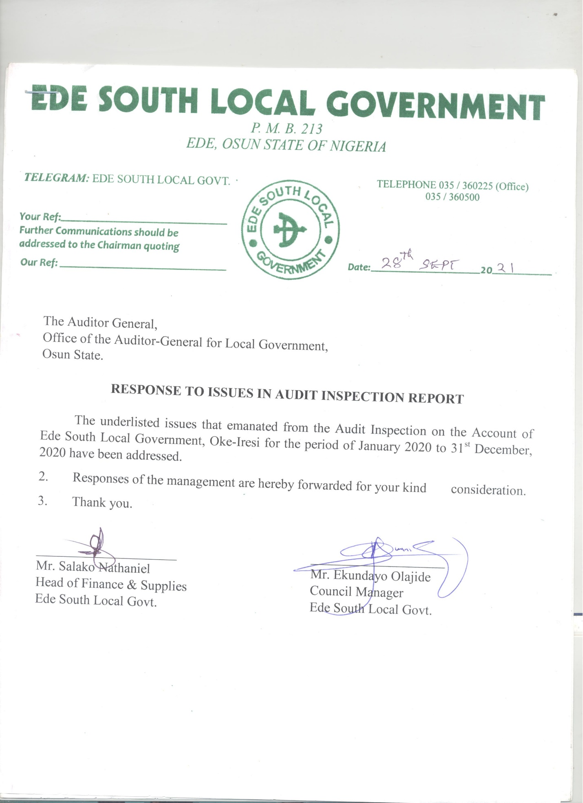

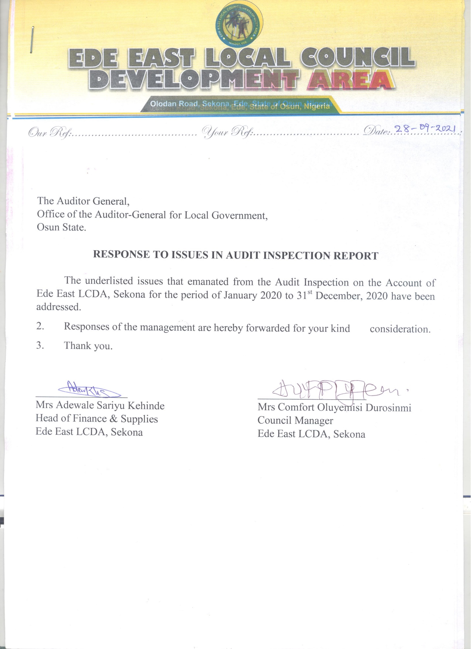

**MANAGEMENT LETTER**

**EDE SOUTH LOCAL GOVERNMENT, OKE-IRESI**

**OBSERVATIONS AND INTERNAL CONTROL REVIEW FOR THE FINANCIAL YEAR ENDED 31ST DECEMBER, 2020**

**1**. **UNRETIRED IMPREST AMOUNTING TO (~~N~~870,000.00):-** It was observed that the sum of Eight Hundred and Seventy Thousand Naira (~~N~~870,000.00) as monthly running cost paid to sundry beneficiaries during November and December, 2020 were not retired with necessary receipt and documents which is contrary to Financial Memoranda 14:27 which states that, “Imprest shall be retired when the purpose for which the imprest was granted is completed or at such intervals as are prescribed when the imprest is approved. However, all imprests shall be automatically be retired at the end of each financial year”.

***RISK:***

*Government Fund might not have been used for official purpose.*

***MANAGEMENT RESPONSE:***

*It was an oversight, and the receipt would be produced.*

***RECOMMENDATION-***

*Proper recording of petty cash should be done and all payments must be retired immediately and presented for audit verification.*

**2.** **EXPENDITURE NOT CHECKED AND PASSED AMOUNTING TO (~~N~~3,680,000.00):-** It was observed that the payment vouchers totalling Three Million, Six Hundred and Eighty Thousand Naira raised for the purchase of bags of rice for political ward Exco, food items for the youth, Kabiyesi and Chiefs were not checked and passed by the Internal Auditor before effecting the payment contrary to the provision of Financial Memoranda 40:10 which states that, “Before any payment is made, a pre-payment audit of vouchers and supporting documents shall be made by the Internal Auditor on all payment vouchers to verify that the provisions of these Financial Memoranda has been followed in all respects, the payment is one properly authorized and correctly charged to the stated Sub-Head or account and that sufficient funds are available to meet it”. This development showed that the Internal Control System in the Local Government was defective. The Head of Finance should put in place a proper Internal Control Mechanism to ensure accountability and probity.

***RISK:***

*Not subjecting payment vouchers to Internal Audit check before payment was an indication of weak Internal Control System which could result to misappropriation of public fund.*

***MANAGEMENT RESPONSE:*** *The payments were not subjected to prepayment audit before payment was made.*

***RECOMMENDATION:***

*The Internal Auditor should ensure that prepayment and post payment audit were carried out on all transactions of the Local Government.*

**3.** **POOR QUALITY WORK ON EVENTS CENTRE BUILDING AMOUNTING TO #29,531,052.00:-**Audit investigation revealed that part of the events centre building constructed by Ede South Local Government in the Secretariat Complex had started collapsing ostensibly due to poor quality of materials used for construction.

It was further observed that the sum of Twenty nine million, five hundred and thirty one thousand and fifty two naira (#29,531,052.00) spent on the building was in excess of the approved amount of Twenty nine million, two hundred and sixty two thousand twenty five naira (#29,262,025.00) earmarked for the job.

**4.** **BANK RECONCILIATION STATEMENT:** Bank Reconciliation Statement was prepared up to December, 2020. The following are the observations arising from the audit scrutiny of the Bank Reconciliation Statements of the Council prepared for the period under review.

**Bank Charges:** It was observed that a total sum of ~~N~~985, 419.64 was floating as Bank Charges from previous months to date which was yet to be brought into Accounts contrary to Financial Memoranda 19:27 which states that, “The Receipt and Payment vouchers shall be made out where any credits or charges shown in the Bank Statement have not been brought to account in the Cash Book and are positively identified as being items due from or to the Local Government”.

**EDE EAST LOCAL COUNCIL DEVELOPMENT AREA,SEKONA.**

**OBSERVATIONS AND INTERNAL CONTROL REVIEW FOR THE FINANCIAL YEAR ENDED 31ST DECEMBER, 2020**

**1.** **EXPENDITURE NOT SUPPORTED BY PROPER RECORDS OR ACCOUNTS AMOUNTING TO (~~N~~162,500.00):-**It was observed that the payment vouchers raised worth total sum of One hundred and sixty two thousand, five hundred naira (~~N~~162,500.00) paid to the members of staff of Ede East Local Council Development Area, Sekona for the printing of notice and other working tools for the use of town planning, production of personnel data for the year 2020 staff audit and verification exercise were neither receipted nor supported with necessary document such as sub-receipt contrary to Financial Memoranda 14:17 which states that, “An official printed receipt must be obtained and attached to the payment voucher in respect of a payment to Government of another Local Government or a commercial firm, if the printed receipt covers more than one payment vouchers, reference to the number”. This had been made the subject of Audit Query No. LQ/AUD/EDEE/LCDA/03/2020.

***RISK:***

*Payments made without supporting documents could imply non-execution of all or part of the services/purchases, or conceal inflation of prices.*

***MANAGEMENT RESPONSE:***

*It was an oversight and the receipt would be produced.*

***RECOMMENDATION:***

*The recipient/authorizing officer should ensure that all supporting documents were collected while incurring the expenditure.*

**2.** **EXPENDITURE NOT CHECKED AND PASSED AMOUNTING TO (~~N~~40,000.00):-**It was observed that the sum of Forty thousand naira was paid to staffer of the Local Council Authority as the monthly imprest for the month of October, 2020.The payment voucher was not checked and passed by the Internal Auditor before payment was effected which was contrary to Financial Memoranda 40:10 which states that, “Before any payment is made, a prepayment Audit of vouchers and supporting documents shall be made by the Internal Auditor on all payment vouchers to verify that the provisions of the Financial Memoranda have been followed in all respects, the payment is properly authorized and correctly charged to the stated sub-head or account and that sufficient funds are available to meet it”. This had been made a subject of Audit Query No. LQ/AUD/EDEE/LCDA/04/2020

***RISK:***

*Not subjecting payment vouchers to Internal Audit check before payment was an indication of weak Internal Control System which could result to misappropriation of public fund.*

***MANAGEMENT RESPONSE:*** *The payments were not subjected to prepayment audit before payment was made.*

***RECOMMENDATION:***

*The Internal Auditor should ensure that prepayment and post payment audit were carried out on all transactions of the Local Government.*

**3.** **BANK RECONCILIATION STATEMENT:** Bank Reconciliation Statement was prepared up to December, 2020. The following are the observations arising from the audit scrutiny of the Bank Reconciliation Statements of the Council prepared up to date.

**Bank Charges:** It was observed that a total sum of ~~N~~413, 048.33 was floating as Bank Charges from previous months to date which was yet to be brought into Accounts contrary to Financial Memoranda 19:27 which states that, “The Receipt and Payment vouchers shall be made out where any credits or charges shown in the bank statement have not been brought to account in the cashbook and are positively identified as being items due from or to the Local Government”.

However, the concerned Head of Department of Finance & Supplies should provide details of the aforementioned accumulated anomaly, effect necessary correction and inform this Office within 21 days of receipt of this report.

***RISK:***

*Non-preparation of Bank Reconciliation Statement by the Head of Finance could conceal fraud, errors perpetrated in the Bank transactions through extraneous debits in the Bank Statements, and Cashbook collusion between the signatories.*

***MANAGEMENT RESPONSE:*** *Payment vouchers in respect of the transactions were not ready as at the time of Audit exercise.*

***RECOMMENDATION:***

*The Head of Finance should ensure that payments are not effected until payment vouchers are completely processed.*

**INTERNAL AUDITOR’S REPORT**

1. The Internal control unit is not functioning well. The activities of the unit on the Revenue of the Local Government is not felt at all and other programmes executed inclusive.

2. The Internal control unit is still functioning very effectively, but the impacts are not effected on the Revenue generation likewise the programmes and projects of the Council.

**EDE SOUTH LOCAL GOVERNMENT, OKE-IRESI**

|  |  |  |  |  |  |
| --- | --- | --- | --- | --- | --- |
| **S/N** | **SUBJECTS** | **QUERIES NOS.** | **NOS. OF OFFICERS QUERIED** | **AMOUNT (#)** | **REMARKS** |
| 1 | Expenditure Not Supported by Proper Records or Accounts | LQ/AUD/EDS/01/2020 | 7 | 1,039,000.00 |  |
| 2 | Wasteful Expenditure | LQ/AUD/EDS/02/2020 | 5 | 600,000.00 |  |
| 3 | Expenditure Not checked & passed | LQ/AUD/EDS/03/2020 | 3 | 278,000.00 |  |
| 4 | Unrevalidated Voucher | LQ/AUD/EDS/04/2020 | 3 | 95,000.00 |  |
| 5 | Unretired Imprest | LQ/AUD/EDS/05/2020 | 10 | 480,000.00 |  |
| 6 | DOUBTFUL Expenditure | LQ/AUD/EDS/06/2020 | 05 | 3,594,500.00 |  |
| 7 | Unretired Imprest | LQ/AUD/EDS/08/2020 | 08 | 555,000.00 |  |
| 8 | Expenditure Not Checked and passed | LQ/AUD/EDS/09/2020 | 04 | 2,680,000.00 |  |
| 9 | Doubtful Expenditure | LQ/AUD/EDS/09/2020 | 2 | 1,000,000.00 |  |
| 10 | Poor Quality Work on Event Centre Civil Hall constructed | LQ/AUD/EDS/10/2020 | 1 | 29,531,052.00 |  |
|  |  |  | **48** | **39,850,552.00** |  |

**EDE EAST LOCAL COUNCIL DEVELOPMENT AREA, SEKONA EDE**

|  |  |  |  |  |  |
| --- | --- | --- | --- | --- | --- |
| **S/N** | **SUBJECTS** | **QUERIES NOS.** | **NOS. OF OFFICERS QUERIED** | **AMOUNT (#)** | **REMARKS** |
| 1 | Expenditure Not Checked and Passed | LQ/AUD/EDEE/LCDA/01/2020 | 1 | 50,000.00 |  |
| 2 | Unreceipted Expenditure | LQ/AUD/EDEE/LCDA/02/2020 | 2 | 330,000.00 |  |
| 3 | Expenditure Not Supported by Proper Records or Accounts | LQ/AUD/EDEE/LCDA/03/2020 | 4 | 162,000.00 |  |
| 4 | Expenditure Not Checked and Passed | LQ/AUD/EDEE/LCDA/04/2020 | 2 | 40,000.00 |  |
|  |  |  | **9** | **582,500.00** |  |