STATE GOVERNMENT OF OSUN, NIGERIA.

REPORT OF

THE

AUDITOR-GENERAL

FOR

LOCAL GOVERNMENTS

ON THE ACCOUNTS OF

EGBEDORE LOCAL GOVERNMENT

AWO

FOR THE YEAR ENDED

31ST DECEMBER, 2020.

**TABLE OF CONTENTS**

|  |  |  |
| --- | --- | --- |
|  | **DETAILS** | **PAGE** |
| 1 | TITLE PAGE | **1** |
| 2 | TABLE OF CONTENTS | **2** |
| 3 | LIST OF ABBREVIATIONS | **3** |
| 4 | STATEMENT OF RESPONSIBILITY FOR THE PREPARATION OF FINANCIAL STATEMENTS | **4** |
| 5 | STATEMENT OF RESPONSIBILITY OF THE AUDITOR-GENERAL | **5** |
| 6 | AUDIT CERTIFICATE | **6** |
| 7 | BASIS OF AUDIT OPINION | **7** |
| 8 | STATEMENT OF COMPLIANCE | **8** |
| 9 | STATEMENT OF ACCOUNTING POLICIES | **9-11** |
| 10 | GENERAL COMMENTS | **12-13** |
| 11 | **COMMENTS ON FINANCIAL STATEMENTS**   1. STATEMENT OF FINANCIAL PERFORMANCE 2. STATEMENT OF FINANCIAL POSITION | **14-18** |
| 12 | **AGGREGATE GENERAL PURPOSE FINANCIAL STATEMENTS**   1. CONSOLIDATED STATEMENT OF FINANCIAL POSITION. 2. CONSOLIDATED STATEMENT OF FINANCIAL PERFORMANCE. 3. CONSOLIDATED STATEMENT OF CASH FLOW. 4. CONSOLIDATED STATEMENT OF COMPARISON OF FINANCIAL OPERATIONS. 5. CONSOLIDATED STATEMENT OF NET ASSETS AND EQUITY 6. NOTES TO THE ACCOUNT | **19-33** |
| 13 | **FISCAL OPERATION REPORT**  i STATISTICAL AND ACCOUNTING RATIOS  ii NON-FINANCIAL DISCLOSURE | **34-35** |
| 14 | MANAGEMENT LETTER | **36-46** |
| 15 | LIST OF PROJECTS EXECUTED IN THE LOCAL GOVERNMENT | **47** |

**LIST OF ABBREVIATIONS**

1. AGLG - AUDITOR-GENERAL FOR LOCAL GOVERNMENTS
2. AO - AREA OFFICE/ADMINISTRATIVE OFFICE
3. FAAC - FEDERATION ACCOUNTS ALLOCATION COMMITTEE
4. F.M - FINANCIAL MEMORANDUM
5. FOR - FISCAL OPERATION REPORT
6. GPFS - GENERAL PURPOSE FINANCIAL STATEMENTS
7. IGR - INTERNALLY GENERATED REVENUE
8. ISSAI - INTERNATIONAL STANDARDS OF SUPREME AUDIT INSTITUTIONS
9. IPSAS - INTERNATIONAL PUBLIC SECTOR ACCOUNTING STANDARD
10. JAAC - JOINT ACCOUNTS ALLOCATION COMMITTEE
11. LGA - LOCAL GOVERNMENT AREA
12. LCDA -LOCAL COUNCIL DEVELOPMENT AREA
13. LGSC - LOCAL GOVERNMENT SERVICE COMMISSION
14. LGSPB - LOCAL GOVERNMENTS STAFF PENSION BOARD
15. LGLB - LOCAL GOVERNMENT LOANS BOARD
16. NCOA - NATIONAL CHART OF ACCOUNTS
17. NBV - NET BOOK VALUE
18. MLGCA- MINISTRY OF LOCAL GOVERNMENT AND CHIEFTAINCY AFFAIRS
19. PPE - PROPERTY, PLANTS AND EQUIPMENT
20. PSE - PUBLIC SECTOR ENTITIES
21. PHCB - PRIMARY HEALTH CARE BOARD
22. VAT - VALUE ADDED TAX

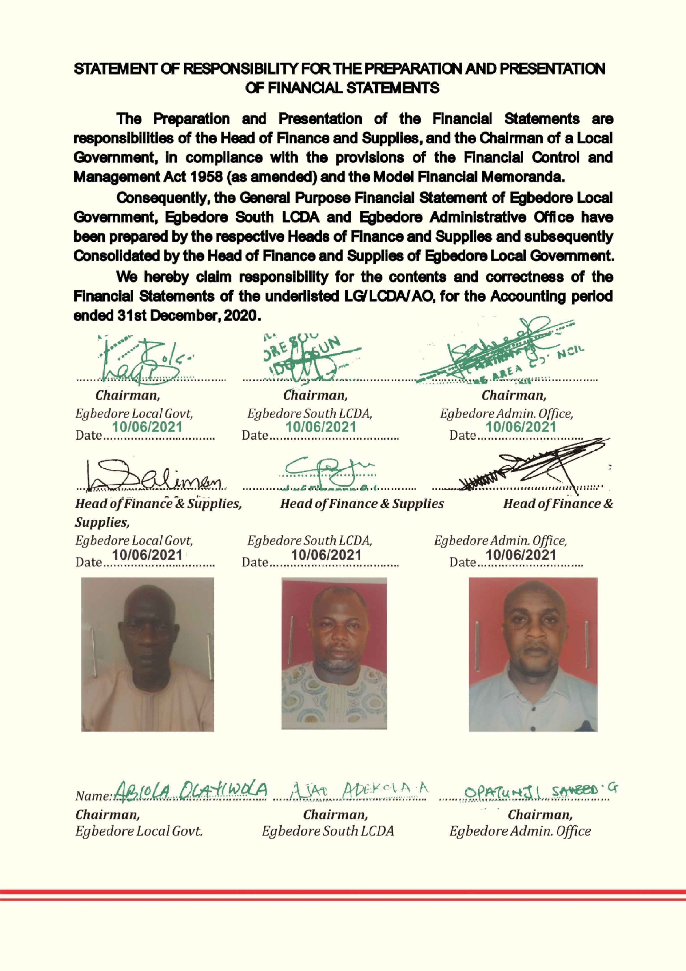

**STATEMENT OF FINANCIAL RESPONSIBILITY**

The preparation and fair presentation of Financial Statements of Local Governments, the State Joint Local Government Accounts, and offices administering elements of Local Governments Fund is the direct responsibility of the Heads of Finance and Supply in the Local Governments, the Accountant of the Ministry of Local Governments, and Directors of Finance in the Offices of the Local Governments, respectively, in compliance with the provisions of Finance Control and Management Act 1958 (as amended), the Model Financial Memoranda (1991 as amended), the Laws of Osun State 2002 (as amended) and with the provisions of the Constitution of the Federal Republic of Nigeria, 1999.

In the State of Osun, the Heads of Finance of main Local Governments are responsible for the consolidation of the respective Financial Statements with the subsidiary LCDAs, Area/Administrative offices, as may be applicable.

However, both the Head of Finance and Chairman of a Local Government, (the Accounting Officer) are responsible for establishing and maintaining a system of internal control designed to provide reasonable assurance that the transactions and Financial Statements give a fair presentation of the financial operations of the Local Government.

The acknowledgment of responsibility for the preparation of Financial Statement signed by Heads of Finance and Chairmen of the respective Local Governments are attached to individual report.

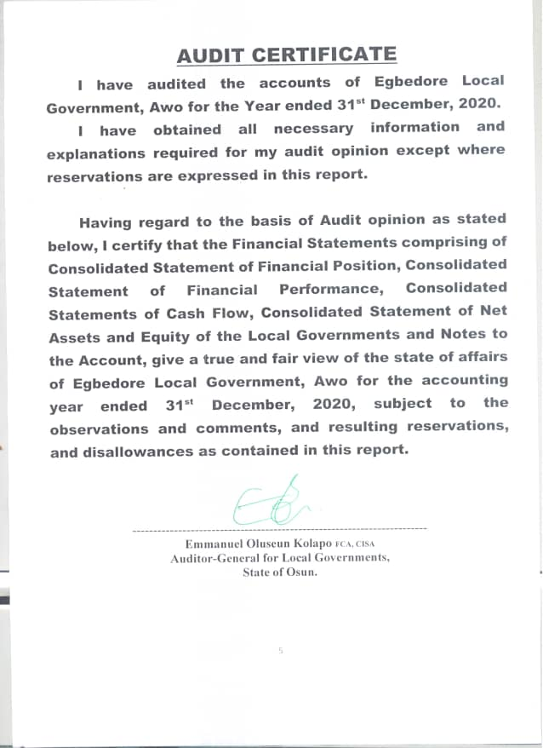

**STATEMENT OF RESPONSIBILITY OF THE AUDITOR-GENERAL.**

It is my responsibility to Audit the accounts of the Local Governments, the State Joint Local Government Account, and all offices of the Local Government as stipulated by the Laws of Osun State and the Financial Memoranda; and to form an independent opinion based on the Audit of the Financial Statements and accompany notes submitted by the Head of Finance and Supply of Local Governments, the Head of Accounts in the Ministry of Local Governments and various Institutions and all agencies, handling projects and programmes funded by Local Governments in the state.

**BASIS OF AUDIT OPINION**

In the course of auditing the accounts of Local Governments in the State of Osun, I have complied with the requirement and stipulations of the International Standards on Auditing, the Generally Acceptable Auditing Standards, International Standards of Supreme Audit Institutions (ISSAI,) Laws of Osun State, International Public Sector Accounting Standards and Audit Guide of the Office of the Auditor-General for Local Governments, Osun State.

I have conducted Financial and Compliance audit on the Finances of Local Governments and JAAC. Projects and Programmes were reasonably evaluated and verified on the principle of Performance Auditing. All items of Revenue and Expenditure were captured in the course of the Audit and Audit Tests were conducted on procedures, transactions and balances. Consequently 100% Substantive Test was done on all items of Revenue and Expenditure; and Assets and Liabilities, and appropriate Audit Tests of Control were conducted on procedures and transactions.

Where paucity of available Audit resources warranted sampling, objective statistical sampling techniques were applied to ensure representativeness, completeness, relevance, and timeliness in the determination of sampling elements. This ensured reliability of Audit Opinion, giving due recognition to principle of materiality. For example, multi-layered and structural sampling method was applied for verification of numbers and Emoluments of Teaching and Non-Teaching staff of the State Universal Basic Education Board (SUBEB), Staffers of Local Governments and the State Primary Health Care Board.

**STATEMENT OF COMPLIANCE**

The Accounting Policies have been consistently applied on preparation of the Financial Statements of Egbedore Local Government in the year under review. These have been prepared on the basis of Historical Cost and in accordance with IPSAS Accruals and other applicable standards. The Cash Flow Statement was prepared using the Direct Method. The basis of measurement is Naira and kobo which is the functional and reporting currency of the Federal Republic of Nigeria of which Osun State and Egbedore Local Governments are constituents.

The accounts of Egbedore Local Government have been audited and reported upon.

Audit noted some instances of non-compliance in the Local Governments, with the due process in revenue collection and payment procedure contrary to the provision of Financial Memoranda and relevant Guidelines. The associated internal control weaknesses have been addressed. The inspection reports (letters of Internal Control weaknesses) for the year 2020 have been issued and forwarded to the appropriate quarters for responses and compliance as required.

The queries were replied and appropriate recommendations were made as contained in the Management letter included.

**STATEMENT OF ACCOUNTING POLICIES**

1. **Basis of Preparation (IPSAS 1)**

The General Purposes Financial Statements were prepared under the historical cost convention and in accordance with IPSAS Accrual Basis and other applicable standards and conventions as may be defined by relevant Statutes.

1. **Accounting Period**

The accounting year (fiscal year) to which the report relates is 1st January to 31st December, 2020.

1. **Reporting Currency**

The General Purposes Financial Statements are prepared in the Nigerian Naira (NGN).

1. **Principal Statements in the General Purposes Financial Statements**
2. Statements of Financial Performance. (Aggregate and Consolidated)
3. Statements of Financial Position. (Aggregate and Consolidated)
4. Statements of Cash flow.(Aggregate and Consolidated)
5. Statementsof Comparison of Budgeted and Actual Amounts (Aggregate and Consolidated)
6. Statements of Changes in Net Asset/Equity. (Aggregate and Consolidated)
7. Notes to the GPFS.
8. Financial Statement of Joint Accounts Allocation Committee (JAAC)
9. **Consolidation Policy- IPSAS 6**

The Heads of Finance of the 69 Local Governments, LCDAs, and A/Cs and A/Os are required to prepare their individual GPFS at the end of the financial year on Accrual Basis of Accounting.

Each Local Government is a creation of the Constitution and none is subservient to the other. However in this situation, there are subsidiary entities such as LCDAs and Area offices, which are consolidated with the main Local Government. Consequentrly, the Heads of Finance of the 30 main Local Governments consolidate the GPFS of their respective main Local Government with the subsidiary LCDAs, AOs, and Ad. Os.

***The duty of the Auditor-General for Local Governments is not to prepare or consolidate Local Governments’ accounts, but to Audit and Aggregate the prepared Financial Statements in line with the Fiscal Operation Report Guideline.***

1. **Statement of Cash Flow** was prepared using the direct method (IPSAS 2) and it consists of Operating, Investing and Financing activities.
2. **Inventories (IPSAS 12) -** Inventories were measured initially at cost, and subsequently measured using the FIFO method.
3. **PROPERTY, PLANT & EQUIPMENT (PPE) – IPSAS 17**

All PPEs were stated at historical cost less accumulated depreciation and impairment losses.

1. **DEPRECIATION**

The cost of PPE shall be written off, from the time they are brought into use, on a straight line basis over their expected useful lives less any estimated residual value as follows:

1. Furniture & Fittings - 20%
2. Motor Vehicle - 20%
3. Plant & Equipment - 20%
4. Infrastructural Asset - 10%
5. Building - 2%
6. Office Equipment - 20%
7. **REVALUATION**
8. The Assets’ residual values and useful lives are reviewed at the end of the year.
9. **IMPAIRMENT**

Test for Impairment are done on Property, Plants and Equipments, where it is suspected that Impairment has occurred.

1. **INVESTMENT PROPERTIES – IPSAS 16**

The Investment properties are measured initially at cost, including transaction costs. Subsequent to initial recognition, investment properties are measured using the cost model and are depreciated the same way as PPE.

1. **INDEPENDENT REVENUE FROM NON-EXCHANGE TRANSACTION (IPSAS 23)**
2. Fees; taxes and fines: The Local Government recognised revenue from fees, taxes, and fines when the event occured, and the asset recognition criteria are met.
3. **OTHER REVENUE**

Other Revenues are proceeds that arise outside the Ordinary course of governmental busineess. These include:

1. Gain on disposal of Property, Plant and Equipment

2. Dsiposal of Investment such as Shares, bond etc

Gain on disposal is recognized at the date of control of the asset is passed to the buyer and is determined after deducting the carrying value of the Asset at that time.

1. **UNREMITTED DEDUCTION**

Unremitted deductions are monies owned to the third parties such as tax authorities, associations and other Government Agencies. These include tax deductions and other deductions at source

This amount shall be stated in GPFS at their repayment value, which shall be treated as current liabilities in the Statement of Financial Position.

**16. RESERVE**

Reserves shall be classified under Equity in the Statement of Financial Position which includes Accumulated Surplus/Deficit and the Additional Reserve.

**17. CONTIGENT LIABILITY IPSAS 19**

Contigent liabilities are only disclosed in the Notes to GPFS. Contingent liability is possible obligation arising from past events whose exigencies will be confirmed only by uncertain future event(s) or present obligation arising from the past events that are not recognized because of either an outflow of economic benefit is not probable or this amount of obligation.

**GENERAL COMMENTS**

I have audited the accounts of Egbedore Local Government, Awo for the financial year ended 31st December 2020, as required by Cap 72, Part 10 of the Laws of Osun State 2002, (as amended).

**AUTHORITY FOR DISBURSEMENTS FROM JAAC ACCOUNT:** Disbursements from JAAC accounts were made in consonance with the prescriptions of the House of Assembly while monthly distributions were collectively decided by the Chairmen of Egbedore Local Government and other Chairmen, all of whom were members of the Joint Account Allocation Committee.

**FULL ADOPTION OF IPSAS ACCRUALS:** 2020 GPFS reports were prepared in compliance with IPSAS Accrual which was fully adopted by Local Governments in the State of Osun in 2017.

The previous accounting training on conversion to IPSAS Accruals, severally sponsored by the EU/SLOGOR, LGSC, SUBEB in collaboration with Office of the Auditor-General for Local Governments, with the approval of Mr. Governor, for upgrades and re-training in 2020 have collectively enhanced the proficiency of operators of Local Government accounts in the State

**SCOPE OF AUDIT COVERAGE**: The Audit scope has 100% coverage on all aspects of Revenue and Expenditure, as well as verification of Assets and Liabilities including JAAC Accounts. Revenue covered included all Allocations and VAT from the Federation Accounts and other dependent and Independent Revenue sources of the Local Governments while Expenditure covered included all Capital and Recurrent Expenditure Items in all Local Governments, and LCDAs, all centrally executed Projects and programmes of Local Governments, and Statutory remittances to Traditional Councils.

**BUDGET PREPARATION / EXECUTION**

The Budget for 2020 for Egbedore Local Governments was prepared in compliance with new National Chart of Accounts. The 2020 Budget was an improvement on the previous Budget of 2019 as some of the obvious shortcomings observed by the Audit have been addressed.

**PROCUREMENT PRACTICES**

Osun State Public Procurement Law 2015 has been in force in line with global best practice. Procurement Officers was posted to the Local Governments and performed his duties. The Audit observed that the Offices need to be strengthened to further assist in promoting sound and transparent procurement practices in the Local Governments.

**VALUATION AND REVALUATION OF ASSETS**

The office of the Auditor-General for Local Governments was able to embark on verification exercise on valuation and Revaluation of Assets during the year. This involved Constitution of a standing multi-disciplinary team comprising seasoned and qualified professionals in the fields of valuation, engineering, town planning, medicine, etc. and others as were necessary. Consequently, the realism of the values of non-current asset is enhanced for the year under review. The verification exercise is continuous and value of the Local Governments non-current Assets is being updated monthly.

**INTERNALLY REVENUE GENERATION AND FINANCIAL VIABILITY**

Of concern to the Audit is the paltry amount of revenue that was generated in the Financial Year 2020. Audit examination showed that none of the Local Governments improved significantly on their revenue drive. The Total Internally Revenue generated by the Local Government for 2020 was N21,252,284.60 representing 1.55% the Total Revenue. More efforts at blocking leakages coupled with adequate research by the relevant unit of the Auditor-General for Local Government on comparative revenue advantages of individual Local Government’s office will assist in curbing this unwholesome situation.

**INTERNAL CONTROL WEAKNESS IN THE LOCAL GOVERNMENT AND RELATED AGENCIES**

At the conclusion of the Audit, 24 nos of Audit Queries were issued in respect of 2020 Accounts, involving a total sum of N1,589,000.00.

Queries were issued in respect of irregularities observed in fund management by beneficiary agencies of transfers from Local Governments fund and this had been forwarded to the respective Accounting Officers for response.

The identified internal control weaknesses, the inherent risks, the management Responses and Audit Recommendations are highlighted in Management Letter contained in this Report.

**COMMENTS ON FINANCIAL STATEMENTS**

1. **STATEMENT OF FINANCIAL PERFORMANCE**

**Share of FAAC and VAT:** To ensure completeness of Revenue, the total Allocation received from the Federation Account in respect of Egbedore Local Government as contained in JAAC Account was confirmed from the Accountant General of the State and further reference was made to data released by office of Accountant General of the Federation. The total sum of N959,538,531.85 was Share of FAAC and VAT amounted to N394,230,064.16.

THE CONCEPT OF **DEPENDENT REVENUE.** The term IndependentRevenue or synonymous with Internally Generated Revenue in the IPSAS. However, the term Dependent Revenue is used in proportion in the Report as it depicts the items of Revenue other than Internally Generated Revenue (IGR), i.e. the revenue over which the reporting entirely has no control on its generation or collection.

Essentially the proportion of Dependent Revenue is a measure of the extent of its vulnerability or dependently of the Local Government on finances from sources over which it has no control.

**EXPENDITURE:** As part of the disclosure requirements, expenditures that were Jointly incurred at JAAC level were separately disclosed from those expended at each Local Government Level.

**SUMMARY OF REVENUE FROM JAAC**

|  |  |  |  |  |  |  |  |  |  |  |
| --- | --- | --- | --- | --- | --- | --- | --- | --- | --- | --- |
| **LOCAL GOVERNMENT** | **STATUTORY ALLOCATION** | **VAT** | **EX RATE GAIN** | **FEDERAL GOVT INTERVENTION** | **EXCESS BANK** | **FOREX EQUALISATION** | **ECO** | **ADD FUND FRM SOLID MIN** | **NON-OIL EXCESS REVENUE** | **TOTAL** |
| Egbedore | 861,926,739.21 | 394,230,064.16 | 27,956,460.40 | 23,415,643.16 | 709,568.04 | 12,504,347.83 | 19,431,731.65 | 1,445,120.70 | 12,148,920.86 | 1,353,768,596.01 |

**INDEPENDENT REVENUE FROM NON-EXCHANGE TRANSACTION (IPSAS 23)**

Fees; taxes and fines: The Local Government recognised revenue from fees, taxes, and fines when the event occurs, and the asset recognition criteria are met. The Local Government earned and recognised. #21,252,284.60.

**SALARIES AND WAGES – N785,357,128.93**

Salaries and Wages which amounted to N785,357,128.93 comprised of salaries of Staff of the Local Governments, Teaching and Non-Teaching Staff of SUBEB, staff of Local Government Loans Board and the Primary Health Care Board. Salary Payment was centralised in the State of Osun for the year 2020.

**COMMENTS ON ITEMS OF FINANCIAL POSITION**

**CASH AND CASH EQUIVALENTS – #15,985,552.89**

The Aggregate closing cash and cash equivalents amounted to **₦15,985,552.89** for the Local Governments. The Bank Statements and Bank Reconciliation Statements of all Local Governments and Local Government Development Areas as at 31st December, 2020 were verified/examined to ascertain the bank balances. This balance does not include the balance in JAAC account which essentially should be a zero-balance account. Moreover any undistributed amount in the JAAC Account is treated as Receivable to the Local Governments.

**RECEIVABLES - ₦115,730,078.07**

A total sum of N115,730,078.07k was standing as Receivables as at 31st December, 2020. The Receivables include, Revenue Recognised in December 2020 but received in January, 2020 from Joint Allocation Account Committee (JAAC).

**INVENTORIES - ₦2,048,336.00**

The sum of ₦2,048,336.00represents inventories valued at historical cost in the Local Governments as at 31st December, 2020. These include unallocated stores both expendable and non-expendable; and consumable items.

**INVESTMENTS - ₦74,662,628.33**

All the Investments are classified as held-for-sale, while Equity Method is adopted in Recognition and Measurement. Most of the investments were in unquoted companies except for the Preference shares.

**PROPERTY, PLANT AND EQUIPMENT(PPE)**

Items of Property, Plant and Equipment or other Non -Current Assets are stated at Historical Cost Less accumulated Depreciation. Depreciation on Non - Current Assets are calculated to write off cost on valuation in a straight-line basis over the expected useful life on the assets, as follows:

**Particulars Rate%**

Fixture and fitting 20

Motor Vehicle 20

Plant and Equipment 20

Infrastructural Asset 10

Buildings 2

Office Equipment 20

There is need to make adequate provision for depreciation. Accounting for PPE is an area of Audit emphasis where there seems to be a gap in knowledge exhibited by the operators of the Account vis-à-vis expectation.

**PAYABLES - ₦648,862,613.42**

These comprised largely of commitments all over the Local Governments such as allowances, sundry overheads, and unpaid salary and wages, arrears of salaries, unremitted deductions etc. outstanding as at 31stDecember 2020.

**INVESTMENT PROPERTY - ₦161,998,058.35**

The carrying amount of Investment Properties of the Local Governments stood at N161,998,058.35 in the Statement of Financial Position. However, there is no restriction on title or property pledge as securities for liabilities. Straight Line Method of depreciation was applied.

**LONG – TERM BORROWINGS - ₦2,155,301,688.99**

These are the cumulative amount of various outstanding loans obtained from different sources to finance the under-listed projects:

* 1. Construction of over 10 kilometers of roads, (tagged 10KM roads/Local Government), across all the main Local Governments across the state.
  2. Environmental Projects – includes channelization, chlorinization, etc aimed at preserving lives and environments
  3. Intervention Projects including Grading, access to rural areas, etc..
  4. Repayment of Bail Out

**UNREMITTED DEDUCTIONS - ₦150,156,232.19**

These include deductions received from Joint Accounts Allocation Committee (JAAC) and deposits which ought to have been remitted to the appropriate quarters on or before 31st December, 2020. The management of the Local Councils are hereby advised to ensure that all deposits/deductions received are remitted promptly to avert the possibility of unnecessary accumulation of liabilities on Councils financial position

DISCLOSURES: In the statement of Financial Performance the amounts jointly expended by the Local Government is separated from the amount spent in individual Local Government.

**TRANSFER FROM MAIN COUNCILS TO LOCAL COUNCIL DEVELOPMENT AREAS:**

Transfer from main councils to the tune of #60,000,000.00 was made to the Local Council Development Areas and Area Offices in the period under review and was set off in the Consolidated Account.

**IMPAIRMENT - #16,000,000.00**

The impairment for the year stood at #16,000,000.00 which was beyond budgetary provision but observed to have been largely incurred due to the End-SARS Protest.

**EGBEDORE LOCAL GOVERNMENT, AWO**

**CONSOLIDATED STATEMENT OF FINANCIAL POSITION AS AT 31ST DECEMBER 2020**

|  |  |  |  |  |  |
| --- | --- | --- | --- | --- | --- |
| **FINANCIAL POSITION** | | | | | |
| **PARTICULAR** |  | **EGBEDORE** | **EGBEDORE SOUTH LCDA** | **OKINNI ADMIN OFFICE** | **EGBEDORE CONSOLIDATED** |
| **ASSETS** | **NOTE** |  |  |  |  |
| **Current Assets** |  |  |  |  |  |
| **Cash & Cash Equivalents** | **1** | 10,884,047.59 | 3,207,204.79 | 1,894,300.51 | 15,985,552.89 |
| **Receivables** | **2** | 114,855,522.98 | 628,181.31 | 246,373.78 | 115,730,078.07 |
| **Prepayment/Advance** | **3** | 7,700,000.00 |  |  | 7,700,000.00 |
| **Inventories** | **4** | 17,100.00 | 451,236.00 | 1,580,000.00 | 2,048,336.00 |
| **Total Current Asset** |  | 133,456,670.57 | 4,286,622.10 | 3,720,674.29 | 141,463,966.96 |
| **Non Current Asset:** |  |  |  |  | - |
| **Long Term Loan Granted** |  |  |  |  | - |
| **Investments** | **5** | 60,495,961.67 | 11,333,333.33 | 2,833,333.33 | 74,662,628.33 |
| **Property,Plant & Equipment** | **6** | 2,200,808,510.45 | 988,368,313.92 | 121,406,448.55 | 3,310,583,272.92 |
| **Investment Property** | **7** | 47,645,398.35 | 108,208,660.00 | 6,144,000.00 | 161,998,058.35 |
| **Biological Asset** | **8** | 3,614,982.75 |  |  | 3,614,982.75 |
| **Assets Under Construction(WIP)** | **9** |  |  |  | - |
| **Total Non-Current Asset** |  | 2,312,564,853.22 | 1,107,910,307.25 | 130,383,781.88 | 3,550,858,942.35 |
| **Total Asset** |  | 2,446,021,523.79 | 1,112,196,929.35 | 134,104,456.17 | 3,692,322,909.31 |
| **LIABILITIES** |  |  |  |  | - |
| **Current Liabilities:** |  |  |  |  | - |
| **Deposit** |  |  |  |  | - |
| **Unremitted Deductions** | **10** | 148,538,148.22 | 6,022,234.77 | (4,404,150.80) | 150,156,232.19 |
| **Short Term Loan & Debts** | **11** |  |  |  | - |
| **Payables** | **12** | 623,718,254.68 | 24,824,710.07 | 319,648.67 | 648,862,613.42 |
|  |  |  |  |  |  |
| **Short Term Provisions** |  |  |  |  | - |
| **Total Current Liability** |  | 772,256,402.90 | 30,846,944.84 | (4,084,502.13) | 799,018,845.61 |
| **Non Current Liabilities:** |  |  |  |  | - |
| **Long Term Borrowing** | **13** | 2,067,264,303.70 | 71,582,679.65 | 16,454,705.64 | 2,155,301,688.99 |
| **Total Liabilities** |  | **2,839,520,706.60** | **102,429,624.49** | **12,370,203.51** | **2,954,320,534.60** |
| **Net Assets** |  | (393,499,182.81) | 1,009,767,304.86 | 121,734,252.66 | 738,002,374.71 |
| **Financed by** |  |  |  |  | - |
| **Reserve** | **14** | 147,424,646.23 | 767,927,979.54 | 61,673,983.36 | 977,026,609.13 |
| **Net Surplus/Deficit** | **15** | (540,923,829.04) | 241,839,325.34 | 60,060,269.30 | (239,024,234.42) |
| **Total** |  | **(393,499,182.81)** | **1,009,767,304.86** | **121,734,252.66** | **738,002,374.71** |

**EGBEDORE LOCAL GOVERNMENT, AWO**

**CONSOLIDATED STATEMENT OF FINANCIAL PERFORMANCE AS AT 31ST DECEMBER 2020**

|  |  |  |  |  |  |
| --- | --- | --- | --- | --- | --- |
| **PERFORMANCE** | | | | | |
| **PARTICULAR** | **NOTE** | EGBEDORE | EGBEDORE SOUTH LCDA | OKINNI ADMIN OFFICE | EGBEDORE CONSOLIDATED |
| **Government Share of FAAC(Statutory Revenue)** | **16** | 861,926,739.21 |  |  | 861,926,739.21 |
| **Government Share of VAT** | **17** | 394,230,064.16 |  |  | 394,230,064.16 |
| **Additional Fund** | **18** | 1,445,120.70 |  |  | 1,445,120.70 |
| **Revenue Furniture Allowance** | **19** |  |  |  | - |
| **Ex Rate Gain** | **20** | 27,956,460.40 |  |  | 27,956,460.40 |
| **Augmentation** | **21** |  |  |  | - |
| **Federal Govt Intervention Fund** | **22** | 23,415,643.16 |  |  | 23,415,643.16 |
| **ECO** | **23** | 19,431,731.65 |  |  | 19,431,731.65 |
| **Solid Minerals** | **24** |  |  |  | - |
| **Non-Oil Revenue** | **25** | 12,148,920.86 |  |  | 12,148,920.86 |
| **Distributable from Goods & Valuables** | 26 |  |  |  | - |
| **Forex Equalisation** | **27** | 12,504,347.83 |  |  | 12,504,347.83 |
| **10% IGR** | **28** |  |  |  | - |
| **Excess Bank Charges** | **29** | 709,568.04 |  |  | 709,568.04 |
| **Aids & Grants** | 30 |  |  |  | - |
| **Overpayment Recovery** | 31 |  |  |  | - |
| **Sub-Total Dependent Revenue** |  | 1,353,768,596.01 | - |  | 1,353,768,596.01 |
| **Transfer from Main Council** | **32** |  | 45,758,480.19 | 14,241,519.81 | 60,000,000.00 |
| **Tax Revenue** | **33** | 83,000.00 | 144,050.00 |  | 227,050.00 |
| **Non-Tax Revenue** | **34** | 11,754,532.60 | 6,562,812.00 | 2,707,890.00 | 21,025,234.60 |
| **Other Income** | **35** |  |  |  |  |
| **Sub-Total Independent Revenue** |  | 11,837,532.60 | 6,706,862.00 | 2,707,890.00 | 21,252,284.60 |
| **Total Revenue** |  | 1,365,606,128.61 | 52,465,342.19 | 16,949,409.81 | 1,375,020,880.61 |
| **EXPENDITURE** |  |  |  |  | - |
| **JOINTLY EXPENDED** |  |  |  |  | - |
| **Salaries & Wages** | **36** | 785,357,128.93 |  |  | 785,357,128.93 |
| **Social Benefits** | **37** | 300,000.00 |  |  | 300,000.00 |
| **Overhead Cost** | **38** | 18,949,956.72 |  |  | 18,949,956.72 |
| **Grants & Social Contribution** | **39** | 29,641,494.02 |  |  | 29,641,494.02 |
| **Transfer to Other Agencies** | **40** | 472,957,802.03 |  |  | 472,957,802.03 |
| **Allowances** | **41** | 271,388.28 |  |  | 271,388.28 |
| **Stationaries** |  |  |  |  | - |
| **Public Debt Charge** |  |  |  |  | - |
| **L/GOVERNMENT EXPENDITURE** |  |  |  |  | - |
| **Social Benefits** | **42** | 670,000.00 | 1,822,000.00 | 614,000.00 | 3,106,000.00 |
| **Overhead Cost** | **43** | 5,592,655.76 | 14,519,849.34 | 2,616,650.75 | 22,729,155.85 |
| **Grants & Social Contribution** | **44** | 14,992,528.41 | 8,365,000.00 | 6,986,173.58 | 30,343,701.99 |
| **Depreciation** | **45** | 229,222,370.12 | 79,788,637.31 | 14,272,404.50 | 323,283,411.93 |
| **Transfer to LCDA** | **46** | 60,000,000.00 |  |  | - |
| **Allowances** | **47** | 2,395,000.00 | 28,030,535.95 | 8,840,540.00 | 39,266,075.95 |
| **Impairment** | **48** | 16,000,000.00 |  |  | 16,000,000.00 |
| **Tax Expenses** |  |  |  |  |  |
| **Bail-Out Repayment** |  |  |  |  | - |
| **Audit Fees** | **49** |  |  |  | - |
| **Stabilization Fund** | **50** |  |  |  | - |
| **Revenue Refunded** |  |  |  |  |  |
| **Total Expenditures** |  | 1,636,350,324.27 | 132,526,022.60 | 33,329,768.83 | 1,742,206,115.70 |
| **Net Surplus/Deficit** | **51** | (270,744,195.66) | (80,060,680.41) | (16,380,359.02) | (367,185,235.09) |
| **Net Surplus/Deficit 31/12/2019** |  | (270,179,633.38) | 321,900,005.73 | 76,440,628.32 | 128,161,000.67 |
| **Net Surplus/Deficit 31/12/2020** | **52** | (540,923,829.04) | 241,839,325.32 | 60,060,269.30 | (239,024,234.42) |

**EGBEDORE LOCAL GOVERNMENT, AWO**

**CONSOLIDATED STATEMENT OF CASHFLOW AS AT 31ST DECEMBER 2020**

|  |  |  |  |  |  |
| --- | --- | --- | --- | --- | --- |
| **CASHFLOW STATEMENT** | | | | | |
| **OPERATING ACTIVITIES** | **NOTE** | **EGBEDORE** | **EGBEDORE SOUTH LCDA** | **OKINNI ADMIN** | **EGBEDORE CONSOLIDATED** |
| **INFLOW** |  |  |  |  |  |
| **Statutory Revenue(JAAC)** | **53** | 918,696,284.98 |  |  | 918,696,284.98 |
| **Value Added Tax** | **54** | 348,344,268.80 |  |  | 348,344,268.80 |
| **Additional Fund** | **55** | 1,445,120.70 |  |  | 1,445,120.70 |
| **Furniture Allowance** |  |  |  |  | - |
| **Exchange Rate Gain** | **56** | 27,324,881.81 |  |  | 27,324,881.81 |
| **Others(Augmentation** |  |  |  |  | - |
| **Federal Govt Intervention Fund** | **57** | 23,415,643.16 |  |  | 23,415,643.16 |
| **Excess Crude Oil** | **58** | 19,431,731.65 |  |  | 19,431,731.65 |
| **Solid Minerals** | **59** |  |  |  | - |
| **Non-Oil Revenue** | **60** | 12,148,920.86 |  |  | 12,148,920.86 |
| **Distributable Good & Valuable** | **61** |  |  |  | - |
| **Forex Equalisation** | **62** | 11,382,796.14 |  |  | 11,382,796.14 |
| **10% IGR** |  |  |  |  | - |
| **Excess Bank Charges** | **63** | 709,568.04 |  |  | 709,568.04 |
| **Sub Total Dependent Revenue** |  | 1,362,899,216.14 |  |  | 1,362,899,216.14 |
| **Transfer from Main Council** | **64** |  | 45,758,480.19 | 14,241,519.81 | - |
| **Tax Revenue** | **65** | 83,000.00 | 144,050.00 |  | 227,050.00 |
| **Non-Tax Revenue** | **66** | 11,754,532.60 | 6,562,812.00 | 2,707,890.00 | 21,025,234.60 |
| **Aids and Grants** | **67** |  |  |  | - |
| **Overpayment Recovery** |  |  |  |  | - |
| **Other Income** | **68** |  |  |  |  |
| **Sub Total Independent Revenue** |  | 11,837,532.60 | 6,706,862.00 | 2,707,890 | 21,252,284.50 |
| **Total Inflow Operating Activities** |  | **1,374,736,748.74** | **52,465,342.19** | **16,949,409.81** | **1,384,151,500.74** |
| **OUTFLOW** |  |  |  |  | - |
| **Salaries & Wages** | **69** | 710,202,381.85 |  |  | 710,202,381.85 |
| **Overheads Cost** | **70** | 20,811,552.19 | 13,391,668.03 | 2,616,650.75 | 36,819,870.97 |
| **Allowances** | **71** | 2,643,772.59 | 28,030,535.95 | 8,840,540.00 | 39,514,848.54 |
| **Social Benefits** | **72** | 970,000.00 | 1,612,000.00 | 614,000.00 | 3,196,000.00 |
| **Social Contributions** | **73** | 42,278,353.77 | 4,450,000.00 | 6,986,173.58 | 53,714,527.35 |
| **Inventories** | **74** | 2,355,668.66 | 4,523,000.00 | 535,000.00 | 7,413,668.66 |
| **Transfer to LCDA** | **75** | 60,000,000.00 |  |  | - |
| **Audit Fee** | **76** |  |  |  | - |
| **Transfer to Other Govt Agencies** | **77** | 439,412,342.88 |  |  | 439,412,342.88 |
| **Revenue Refunded** |  |  |  |  |  |
| **Total Outflow from Operating Activities** |  | **1,278,674,071.94** | **52,007,203.98** | **19,592,364.33** | **1,290,273,640.25** |
| **Net Cashflow from Operating Activities** |  | **96,062,676.80** | **458,138.21** | **(2,642,954.52)** | **93,877,860.49** |
| **INVESTING ACTIVITIES** |  |  |  |  | - |
| **Total Inflow from Investing Activities** |  |  |  |  | - |
| **CashFlow from Investing Activities:** |  |  |  |  | - |
| **Administrative Sector** | **78** | 3,700,000.00 | 200,000.00 | 578,000.00 | 4,478,000.00 |
| **Economic Sector** | **79** | 8,330,320.00 | 1,707,500.00 |  | 10,037,820.00 |
| **Total Outflow from Investing Activites** |  | 12,030,320.00 | 1,907,500.00 | 578,000.00 | 14,515,820.00 |
| **Net Cashflow from Investing Activities** |  | (12,030,320.00) | (1,907,500.00) | (578,000.00) | (14,515,820.00) |
| **Inflow from Financing Activities** |  |  |  |  | - |
| **Bank Overdraft** | **80** |  |  |  | - |
| **Total Inflow from Financing Activities** |  |  |  |  |  |
| **OUTFLOW(REPAYMENT)** |  |  |  |  | - |
| **Bail-Out Repayment** | **81** | 13,671,440.90 |  |  | 13,671,440.90 |
| **10km Road** | **82** | 32,297,928.00 |  |  | 32,297,928.00 |
| **Water Project** | **83** |  |  |  | - |
| **Enviromental Sanitation Loan** | **84** | 3,886,086.72 |  |  | 3,886,086.72 |
| **Loan Repayment (Inherited)** | **85** |  |  |  | - |
| **Bank Loan** | **86** |  |  |  | - |
| **Intervention Loan** | **87** | 28,816,246.72 |  |  | 28,816,246.72 |
| **Total Outflow from Financing Activities** |  | **78,671,702.34** | **-** | **-** | **78,671,702.34** |
| **Net Cashflow from Financing Activities** | **88** | **(78,671,702.34)** | **-** | **-** | **(78,671,702.34)** |
| **Cash and Cash Equivalent for the year** |  | **5,360,654.46** | **(1,449,361.79)** | **(3,220,954.52)** | **690,338.15** |
| **Cash and Cash Equivalent 01/01/2020** |  | **5,523,393.13** | **4,656,566.58** | **5,115,255.03** | **15,295,214.74** |
| **Cash and Cash Equivalent 31/12/2020** | **89** | **10,884,047.59** | **3,207,204.79** | **1,894,300.51** | **15,985,552.89** |

**EGBEDORE LOCAL GOVERNMENT, AWO**

**CONSOLIDATED STATEMENT OF COMPARISON OF BUDGET AND ACTUAL AS AT 31ST DECEMBER 2020**

|  |  |  |  |  |  |  |  |  |  |  |  |  |  |
| --- | --- | --- | --- | --- | --- | --- | --- | --- | --- | --- | --- | --- | --- |
|  |  | **EGBEDORE** |  |  | **EGBEDORE SOUTH LCDA** |  |  | **EGBEDORE ADMIN OFFICE** |  |  | **EGBEDORE CONSLIDATED** |  |  |
| **PARTICULAR** | **NOTE** | **ACTUAL** | **FINAL BUDGET** | **VARIANCE** | **ACTUAL** | **FINAL BUDGET** | **VARIANCE** | **ACTUAL** | **FINAL BUDGET** | **VARIANCE %** | **ACTUAL** | **FINAL BUDGET** | **VARIANCE %** |
| **Government Share of FAAC(Statutory Revenue)** | **17** | 861,926,739.21 | 784,332,092.10 | 77,594,647.12 |  | 549,032,464.47 | (549,032,464.47) |  | 235,299,627.63 | (235,299,627.63) | **861,926,739.21** | **1,568,664,184.19** | **(706,737,444.98)** |
| **Government Share of VAT** | **18** | 394,230,064.16 | 273,350,000.00 | 120,880,064.16 |  | 191,345,000.00 | (191,345,000.00) |  | 82,005,000.00 | (82,005,000.00) | **394,230,064.16** | **546,700,000.00** | **(152,469,935.84)** |
| **Additional Fund** | **19** | 1,445,120.70 |  | 1,445,120.70 |  |  | - |  |  | - | **1,445,120.70** | **-** | **1,445,120.70** |
| **Revenue Furniture Allowance** | **20** | - |  | - | - |  | - | - |  | - | **-** | **-** | **-** |
| **Ex Rate Gain** | **21** | 27,956,460.40 |  | 27,956,460.40 |  |  | - |  |  | - | **27,956,460.40** | **-** | **27,956,460.40** |
| **Augmentation** | **22** | - |  | - | - |  | - | - |  | - | **-** | **-** | **-** |
| **Federal Govt Intervention Fund** | **23** | 23,415,643.16 | 154,500,000.00 | (131,084,356.84) |  |  | 108,150,000.00 | (108,150,000.00) |  | - | **23,415,643.16** | **262,650,000.00** | **(239,234,356.84)** |
| **ECO** | **24** | 19,431,731.65 |  | 19,431,731.65 |  | - | - |  | 46,350,000.00 | (46,350,000.00) | **19,431,731.65** | **46,350,000.00** | **(26,918,268.35)** |
| **Solid Minerals** | **25** | - |  | - | - |  | - | - |  | - | **-** | **-** | **-** |
| **Non-Oil Revenue** | **26** | 12,148,920.86 |  | 12,148,920.86 |  |  | - |  |  | - | **12,148,920.86** | **-** | **12,148,920.86** |
| **Distributable from Goods & Valuables** | 27 | - |  | - | - |  | - | - |  | - | **-** | **-** | **-** |
| **Forex Equalisation** | **28** | 12,504,347.83 |  | 12,504,347.83 |  |  | - |  |  | - | **12,504,347.83** | **-** | **12,504,347.83** |
| **10% IGR** | **29** | - |  | - | - |  | - | - |  | - | **-** | **-** | **-** |
| **Excess Bank Charges** | **30** | 709,568.04 |  | 709,568.04 |  |  | - |  |  | - | **709,568.04** | **-** | **709,568.04** |
| **Aids & Grants** | 31 | - |  | - | - |  | - | - |  | - | **-** | **-** | **-** |
| **Overpayment Recovery** | 32 | - |  | - | - |  | - | - |  | - | **-** | **-** | **-** |
| **Sub-Total Dependent Revenue** |  | **1,353,768,596.01** | **1,212,182,092.10** | **141,586,503.92** | **-** | **848,527,464.47** | **(848,527,464.47)** | **-** | **363,654,627.63** | **(363,654,627.63)** | **1,353,768,596.01** | **2,424,364,184.19** | **(1,070,595,588.18)** |
| **Transfer from Main Council** | **35** |  |  | **-** | **45,758,480.19** |  | **45,758,480.19** | **14,241,519.81** |  | **14,241,519.81** | **-** | **-** | **-** |
| **Tax Revenue** | **33** | 83,000.00 |  | 83,000.00 | 144,050.00 |  | 144,050.00 |  |  | - | **227,050.00** | **-** | **227,050.00** |
| **Non-Tax Revenue** | **34** | 11,754,532.60 | 8,158,656.00 | 3,595,876.60 | 6,562,812.00 | 5,711,059.20 | 851,752.80 | 2,707,890.00 | 2,447,596.80 | 260,293.20 | **21,025,234.60** | **16,317,312.00** | **4,707,922.60** |
| **Other Income** |  |  |  | - |  |  | - |  |  | - | **-** | **-** | **-** |
| **Sub-Total Independent Revenue** |  | **11,837,532.60** | **8,158,656.00** | **3,678,876.60** | **6,706,862.00** | **5,711,059.20** | **995,802.80** | **16,949,409.81** | **2,447,596.80** | **260,293.20** | **81,252,284.60** | **16,317,312.00** | **4,934,972.60** |
| **Total Revenue** |  | **1,365,606,128.61** | **1,220,340,748.10** | **145,265,380.52** | **52,465,342.19** | **854,238,523.67** | **(801,773,181.48)** | **16,949,409.81** | **366,102,224.43** | **(349,152,814.62)** | **1,435,020,880.61** | **2,440,681,496.19** | **(1,005,660,615.58)** |
| **EXPENDITURE** |  | - |  |  | - |  |  | - |  |  | **-** | **-** | **-** |
| **JOINTLY EXPENDED** |  | - |  |  | - |  |  | - |  |  | **-** | **-** | **-** |
| **Salaries & Wages** | **36** | 785,357,128.93 | 506,342,373.04 | (279,014,755.89) |  | 354,439,661.13 | 354,439,661.13 |  | 151,902,711.91 | 151,902,711.91 | **785,357,128.93** | **1,012,684,746.08** | **227,327,617.15** |
| **Social Benefits** | **37** | 300,000.00 | 5,000,000.00 | 4,700,000.00 |  | 3,500,000.00 | 3,500,000.00 |  | 1,500,000.00 | 1,500,000.00 | **300,000.00** | **10,000,000.00** | **9,700,000.00** |
| **Overhead Cost** | **38** | 18,949,956.72 | 61,300,000.00 | 42,350,043.28 |  | 42,910,000.00 | 42,910,000.00 |  | 18,390,000.00 | 18,390,000.00 | **18,949,956.72** | **122,600,000.00** | **103,650,043.28** |
| **Grants & Social Contribution** | **39** | 29,641,494.02 | 66,149,506.75 | 36,508,012.73 |  | 46,304,654.72 | 46,304,654.72) |  | 19,844,852.02 | 19,844,852.02 | **29,641,494.02** | **132,299,013.49** | **102,657,519.47** |
| **Transfer to Other Agencies** | **40** | 472,957,802.03 |  | (472,957,802.03) |  |  | - |  |  | - | **472,957,802.03** | **-** | **(472,957,802.03)** |
| **Allowances** | **41** | 271,388.28 | 11,987,675.00 | 11,716,286.72 |  | 8,391,372.50 | 8,391,372.50 |  | 3,596,302.50 | 3,596,302.50 | **271,388.28** | **23,975,350.00** | **23,703,961.72** |
| **Public Debt Charge** |  |  |  | - | - |  | - | - |  | - | **-** | **-** | **-** |
| **L/GOVERNMENT EXPENDITURE** |  |  |  | - | - |  | - | - |  | - | **-** | **-** | **-** |
| **Social Benefits** | **42** | 670,000.00 |  | (670,000.00) | 1,822,000.00 |  | (1,822,000.00) | 614,000.00 |  | (614,000.00) | **3,106,000.00** | **-** | **(3,106,000.00)** |
| **Overhead Cost** | **43** | 5,592,655.76 | 89,550,000.00 | 83,957,344.24 | 14,519,849.34 | 62,685,000.00 | 48,165,150.66 | 2,616,650.75 | 26,865,000.00 | 24,248,349.25 | **22,729,155.85** | **179,100,000.00** | **156,370,844.15** |
| **Grants & Social Contribution** | **44** | 14,992,528.41 | 16,000,000.00 | 1,007,471.59 | 8,365,000.00 | 11,200,000.00 | 2,835,000.00 | 6,986,173.58 | 4,800,000.00 | (2,186,173.58) | **30,343,701.99** | **32,000,000.00** | **1,656,298.01** |
| **Depreciation** | **45** | 229,222,370.12 | 4,422,285.00 | (224,800,085.12) | 79,788,637.31 | 3,095,599.50 | (76,693,037.81) | 14,272,404.50 | 1,326,685.50 | (12,945,719.00) | **323,283,411.93** | **8,844,570.00** | **(314,438,841.93)** |
| **Transfer to LCDA** | **46** | 60,000,000.00 |  | (60,000,000.00) |  |  | - |  |  | - | **-** | **-** | **-** |
| **Unpaid Contract** | **47** | - |  | - | - |  | - | - |  | - | **-** | **-** | **-** |
| **Legal Fees** | **48** | - |  | - | - |  | - | - |  | - | **-** | **-** | **-** |
| **Allowances** | **49** | 2,395,000.00 |  | (2,395,000.00) | 28,030,535.95 |  | (28,030,535.95) | 8,840,540.00 |  | (8,840,540.00) | **39,266,075.95** | **-** | **(39,266,075.95)** |
| **Stationaries** | **50** | - |  | - | - |  | - | - |  | - | **-** | **-** | **-** |
| **Assets Devaluation** | **51** | - |  | - | - |  | - | - |  | - | **-** | **-** | **-** |
| **Impairment** | **52** | 16,000,000.00 |  | (16,000,000.00) | - |  | - | - |  | - | **16,000,000.00** | **-** | **(16,000,000.00)** |
| **Tax Expenses** | **53** |  |  | - |  |  | - |  |  | - | **-** | **-** | **-** |
| **Bail-Out Repayment** |  | - |  | - | - |  | - | - |  | - | **-** | **-** | **-** |
| **Audit Fees** |  | - |  | - | - |  | - | - |  | - | **-** | **-** | **-** |
| **Stabilization Fund** |  |  |  | - |  |  | - | - |  | - | **-** | **-** | **-** |
| **Disposal of Assets** |  |  |  | - |  |  | - |  |  | - | **-** | **-** | **-** |
| **Revenue Refunded** |  |  |  | - |  |  | - |  |  | - | **-** | **-** | **-** |
| **Total Expenditures** |  | **1,636,350,324.27** | **760,751,839.79** | **(875,598,484.49)** | **132,526,022.60** | **532,526,287.85** | **400,000,265.25** | **33,329,768.83** | **228,225,551.94** | **194,895,783.11** | **1,802,206,115.70** | **1,521,503,679.57** | **(280,702,436.13)** |
| **Net Surplus/Deficit** | **54** | **(270,744,195.66)** | **459,588,908.31** | **730,333,103.97** | **(80,060,680.41)** | **321,712,235.82** | **401,772,916.23** | **(16,380,359.02)** | **137,876,672.49** | **154,257,031.51** | **(367,185,235.09)** | **919,177,816.62** | **(1,286,363,051.71)** |
| **Net Surplus/Deficit 31/12/2019** |  | 270,179,633.38 | 287,486,982.70 | 557,666,616.08 | (321,900,005.73) | 229,989,585.76 | (91,910,419.97) | 76,440,628.32 | 57,653,046.44 | (18,787,581.88) | 128,161,000.67 | 575,129,614.90 | (446,968,614.23) |
| **Net Surplus/Deficit 31/12/2020** | **55** | **(540,923,829.04)** | **747,075,891.01** | **1,287,999,720.05** | **241,839,325.32** | **551,701,821.58** | **309,862,496.26** | **60,060,269.30** | **195,529,718.93** | **135,469,449.63** | **(239,024,234.42)** | **1,494,307,431.52** | **1,733,331,665.94** |

**EGBEDORE LOCAL GOVERNMENT, AWO**

**CONSOLIDATED STATEMENT OF NET ASSET/EQUITY AS AT 31ST DECEMBER 2020**

|  |  |  |  |  |  |  |  |  |  |  |  |  |  |
| --- | --- | --- | --- | --- | --- | --- | --- | --- | --- | --- | --- | --- | --- |
| **PARTICULAR** | **EGBEDORE** | | | | **EGBEDORE SOUTH** | | | **OKINNIN ADMIN OFFICE** | | | **EGBEDORE CONSOLIDATED** | | |
|  | **RESERVE** | **ACCUMULATED SURPLUS** | **TOTAL** | **RESERVE** | | **ACCUMULATED SURPLUS** | **TOTAL** | **RESERVE** | **ACCUMULATED SURPLUS** | **TOTAL** | **RESERVE** | **ACCUMULATED SURPLUS** | **TOTAL** |
| **OPENING BALANCE AS AT 1/1/2020** | **147,424,646.23** | **(270,179,633.38)** | **(122,754,987.15)** | **767,927,979.54** | | **321,900,005.73** | **1,089,827,985.27** | **61,673,983.36** | **76,440,628.32** | **138,114,611.68** | **977,026,609.13** | **128,161,000.67** | **1,105,187,609.80** |
| **Adjusted Reserve** |  |  |  |  | | **-** |  |  |  |  |  |  |  |
| **Adjusted Balance** | **147,424,646.23** | **(270,179,633.38)** | **(122,754,987.15)** | **767,927,979.54** | | **321,900,005.73** | **1,089,827,985.27** | **61,673,983.36** | **76,440,628.32** | **138,114,611.68** | **977,026,609.13** | **128,161,000.67** | **1,105,187,609.80** |
| **NET SURPLUS FOR THE YEAR** |  | **(270,744,195.66)** | **(270,744,195.66)** | **-** | | **(80,060,680.41)** | **(80,060,680.41)** |  | **(16,380,359.02)** | **(16,380,359.02)** | **-** | **(367,185,235.09)** | **367,185,235.09** |
| **CLOSING BALANCE AS AT 31/12/2020** | **147,424,646.23** | **(540,923,829.04)** | **(393,499,182.81)** | **767,927,979.54** | | **241,839,325.32** | **1,009,767,304.86** | **61,673,983.36** | **60,060,269.30** | **121,734,252.66** | **977,026,609.13** | **239,024,234.42** | **738,002,374.71** |

**EGBEDORE LOCAL GOVERNMENT, EJIGBO**

**[NOTES TO THE ACCOUNT]**

NOTE 1

CASH AND CASH EQUIVALENT #

FCMB Bank 1,841,607.13

Zenith Bank 6,795,833.14

First Bank 236,092.85

Polaris Bank 6,633,519.27

Wema Bank 478,500.50

15,985,552.89

NOTE 2 -- RECEIVABLES

#

JAAC 68,091,152.43

VAT 45,885,795.36

FOREX EQUILIZATION 1,121,551.69

EXCHANGE RATE GAIN 631,578.59

**115,730,078.07**

NOTE 3

PREPAYMENT/ADVANCES #

Housing Loan 5,700,000.00

Vehicle Loan 2,000,000.00

7,700,000.00

NOTE 4

INVENTORIES #

Finance Materials 2,048,336.00

NOTE 5

INVESTMENT #

Omoluabi 13,132,942.00

Kajola integrated 9,523,810.00

Osicol 267,000.00

Preference shares 32,499,999.99

Others 19,238,876.34

74,662,628.33

NOTE 6

PROPERTY, PLANTS AND EQUIPMENT #

Building 660,449,530.23

Infrastructural facilities 2,390,230,390.62

Plant & machinery 114,886,993.60

Motor vehicles 27,889,168.00

Equipment 11,205,210.21

Furniture & fittings 5,921,980.26

Land -

3,310,583,272.92

NOTE 7

INVESTMENT PROPERTY #

Open Market 32,140,000.00

Lock Up Stall -

Shopping Complex 129,858,058.35

161,998,058.35

NOTE 8

BIOLOGICAL ASSETS #

Teak Plantation 1,614,982.75

Cashew Plantation 2,000,000.00

3,614,982.75

NOTE 10

UNREMITTED DEDUCTION #

B/F 142,335,658.27

Unpaid Deductions 7,820,573.92

150,156,232.19

NOTE 11

SHORT TERM BORROWING NIL

NOTE 12

#

Payables 648,862,613.42

NOTE 13

LONG-TERM LOAN #

Balance as at 1st January, 2020 2,236,707,679.51

10km (32,297,928.00)

Intervention (28,816,246.72)

Environment (3,886,086.72)

Bailout (13,671,440.90)

December Payables (Bailout) (2,734,288.18)

2,155,301,688.99

NOTE 14

RESERVES #

B/F 977,026,609.13

NOTE 15

ACCUMULATED SURPLUS/DEFICIT #

Net Surplus/Deficit for the year (367,185,235.09)

Net Surplus (1st January 2020) 128,161,000.67

Net Surplus/Deficit 31/12/2020 (239,024,234.42)

NOTE 16

STATUTORY ALLOCATION #

JAAC 861,926,739.21

NOTE 17

#

Value Added Tax (VAT) 394,230,064.16

NOTE 18

#

Additional Fund 1,445,120.70

NOTE 19

#

Revenue Furniture Allowance NIL

NOTE 20

#

Ex-Rate Gain 27,956,460.40

NOTE 21

#

Federal Government Intervention Fund 23,415,643.16

NOTE 22

#

ECO 19,431,731.65

NOTE 24

#

Non-Oil Revenue 12,148,920.86

NOTE 26

#

Forex-Equalisation 12,504,347.83

NOTE 28

#

Excess Bank Charges 709,568.04

NOTE 29

DEPENDENT REVENUE #

JAAC 861,926,739.21

VAT 394,230,064.16

Additional Fund 1,445,120.70

Ex Rate Gain 27,956,460.40

Federal Government Intervention Fund 23,415,643.16

ECO 19,431,731.65

Non-Oil Revenue 12,148,920.86

Forex Equalisation 12,504,347.83

Excess Bank Charges 709,568.04

1,353,768,596.01

NOTE 30 -TAX REVENUE

#

Community Tax 227,050.00

NOTE 31 --- NON TAX REVENUE

#

License Fees 21,025,234.60

NOTE 32

#

Other Income NIL

NOTE 34

TOTAL REVENUE #

Dependent Revenue 1,353,768,596.01

Independent Revenue 21,252,284.60

1,375,020,880.61

NOTE 35

SALARY AND WAGES #

Local Government Staff 324,066,047.15

Teaching & Non-Teaching Staff Elementary 212,798,674.83

Teaching & Non-Teaching Staff Middle 75,769,321.32

Local Government Staff Loans Board 803,604.83

Local Government Pension Board 1,094,377.13

PHC Staff 170,825,163.67

785,357,128.83

NOTE 36

SOCIAL BENEFIT #

Human Resources 100,000.00

Training Workshop 200,000.00

300,000.00

NOTE 37

OVERHEAD #

General Expenses 18,949,956.72

NOTE 38

GRANTS & SOCIAL CONTRIBUTION #

Grading (Joint Project) 29,641,494.02

NOTE 39

TRANSFER TO OTHER AGENCIES #

Traditional Council 45,167,087.81

Training Fund (LGSC) 9,033,417.66

SUBEB 45,273,865.21

O’Meal 21,481,092.00

O’YES 40,000,000.00

O’HIS 11,426,164.09

O’RAMP 11,079,423.09

SUBEB (ADM) 407,600.04

Pension 234,649,613.76

SUBEB Contract 271,388.28

Local Statutory Deduction 33,135,417.05

Audit Fees 21,032,733.04

472,957,802.03

NOTE 40 - ALLOWANCES

O’ CLEAN ALLOWANCE 271,388.28

NOTE 41

PUBLIC DEBT CHARGES -

NOTE 42

SOCIAL BENEFIT #

Training & Workshop 3,000,000.00

Financial Workshop 106,000.00

*3,106,000.00*

NOTE 43

OVERHEAD COST #

Repair & Maintenance 17,087,321.75

Utility 1,500,000.00

Entertainment 3,500,000.00

General Expenses 641,834.10

22,729,155.85

NOTE 44

Ileya Gift & Others 12,000,000.00

Christmas Celebration 11,000,000.00

Gradings 2,343,701.99

Palliative Materials (COVID-19) 5,000,000.00

30,343,701.99

NOTE 45

DEPRECIATION #

Buildings 13,387,174.09

Infrastructural Facilities 266,820,043.41

Biological Asset 190,262.25

Plant & Machinery 28,721,748.40

Motor Vehicles 6,753,292.00

Office Equipment 2,693,177.56

Furniture & Fittings 1,605,495.07

Investment Properties 3,112,219.15

323,283,411.93

NOTE 46

ALLOWANCES #

Committee Allowances 39,266,075.95

NOTE 47

Impairment 16,000,000.00

NOTE 48

Stabilization Fund NIL

NOTE 49

Revenue Refunded NIL

NOTE 50-51

NET SURPLUS/DEFICIT #

Total Revenue 1,375,020,880.61

Total Expenditure 1,742,206,115.70

Net Surplus/Deficit (367,125,235.09)

Net Surplus/Deficit 1/1/2020 128,161,000.67

Net Surplus/Deficit [ 239,0234,234.42]

**EGBEDORE LOCAL GOVERNMENT, AWO**

**STATUTORY FISCAL OPERATIONS REPORT FOR THE YEAR ENDED 31ST DECEMBER, 2020**

**STATEMENT OF CASHFLOW RATIO**

1. FEDERAL STATUTORY ALLOCATION + STATE STATUTORY ALLOCATION: TOTAL REVENUE

1,362,899,216.14 X 100

1,384,151,500.74 1 = **98.46%**

2. TOTAL INDEPENDENT REVENUE = TOTAL REVENUE

21,252,284.60 * 100

1,384,151,500.74 1 = **1.54%**

3. PERSONNEL: TOTAL RECURRENT EXPENDITURE

710,202,381.85 * 100

1,290,273,640.25 1 = **55.5%**

**STATEMENT OF FINANCIAL POSITION RATIO**

4. CURRENT RATIO = CURRENT ASSETS = 141,463,966.96

CURRENT LIABILITIES 799,018,845.61 = **0.18:1**

5. TOTAL ASSET: TOTAL LIABILITIES = 3,692,322,909.31

2,954,320,534.60 = **1.25:1**

6. EQUITY : TOTAL ASSET = 738,002,374.71

3,692,322,909.31 = **0.20:1**

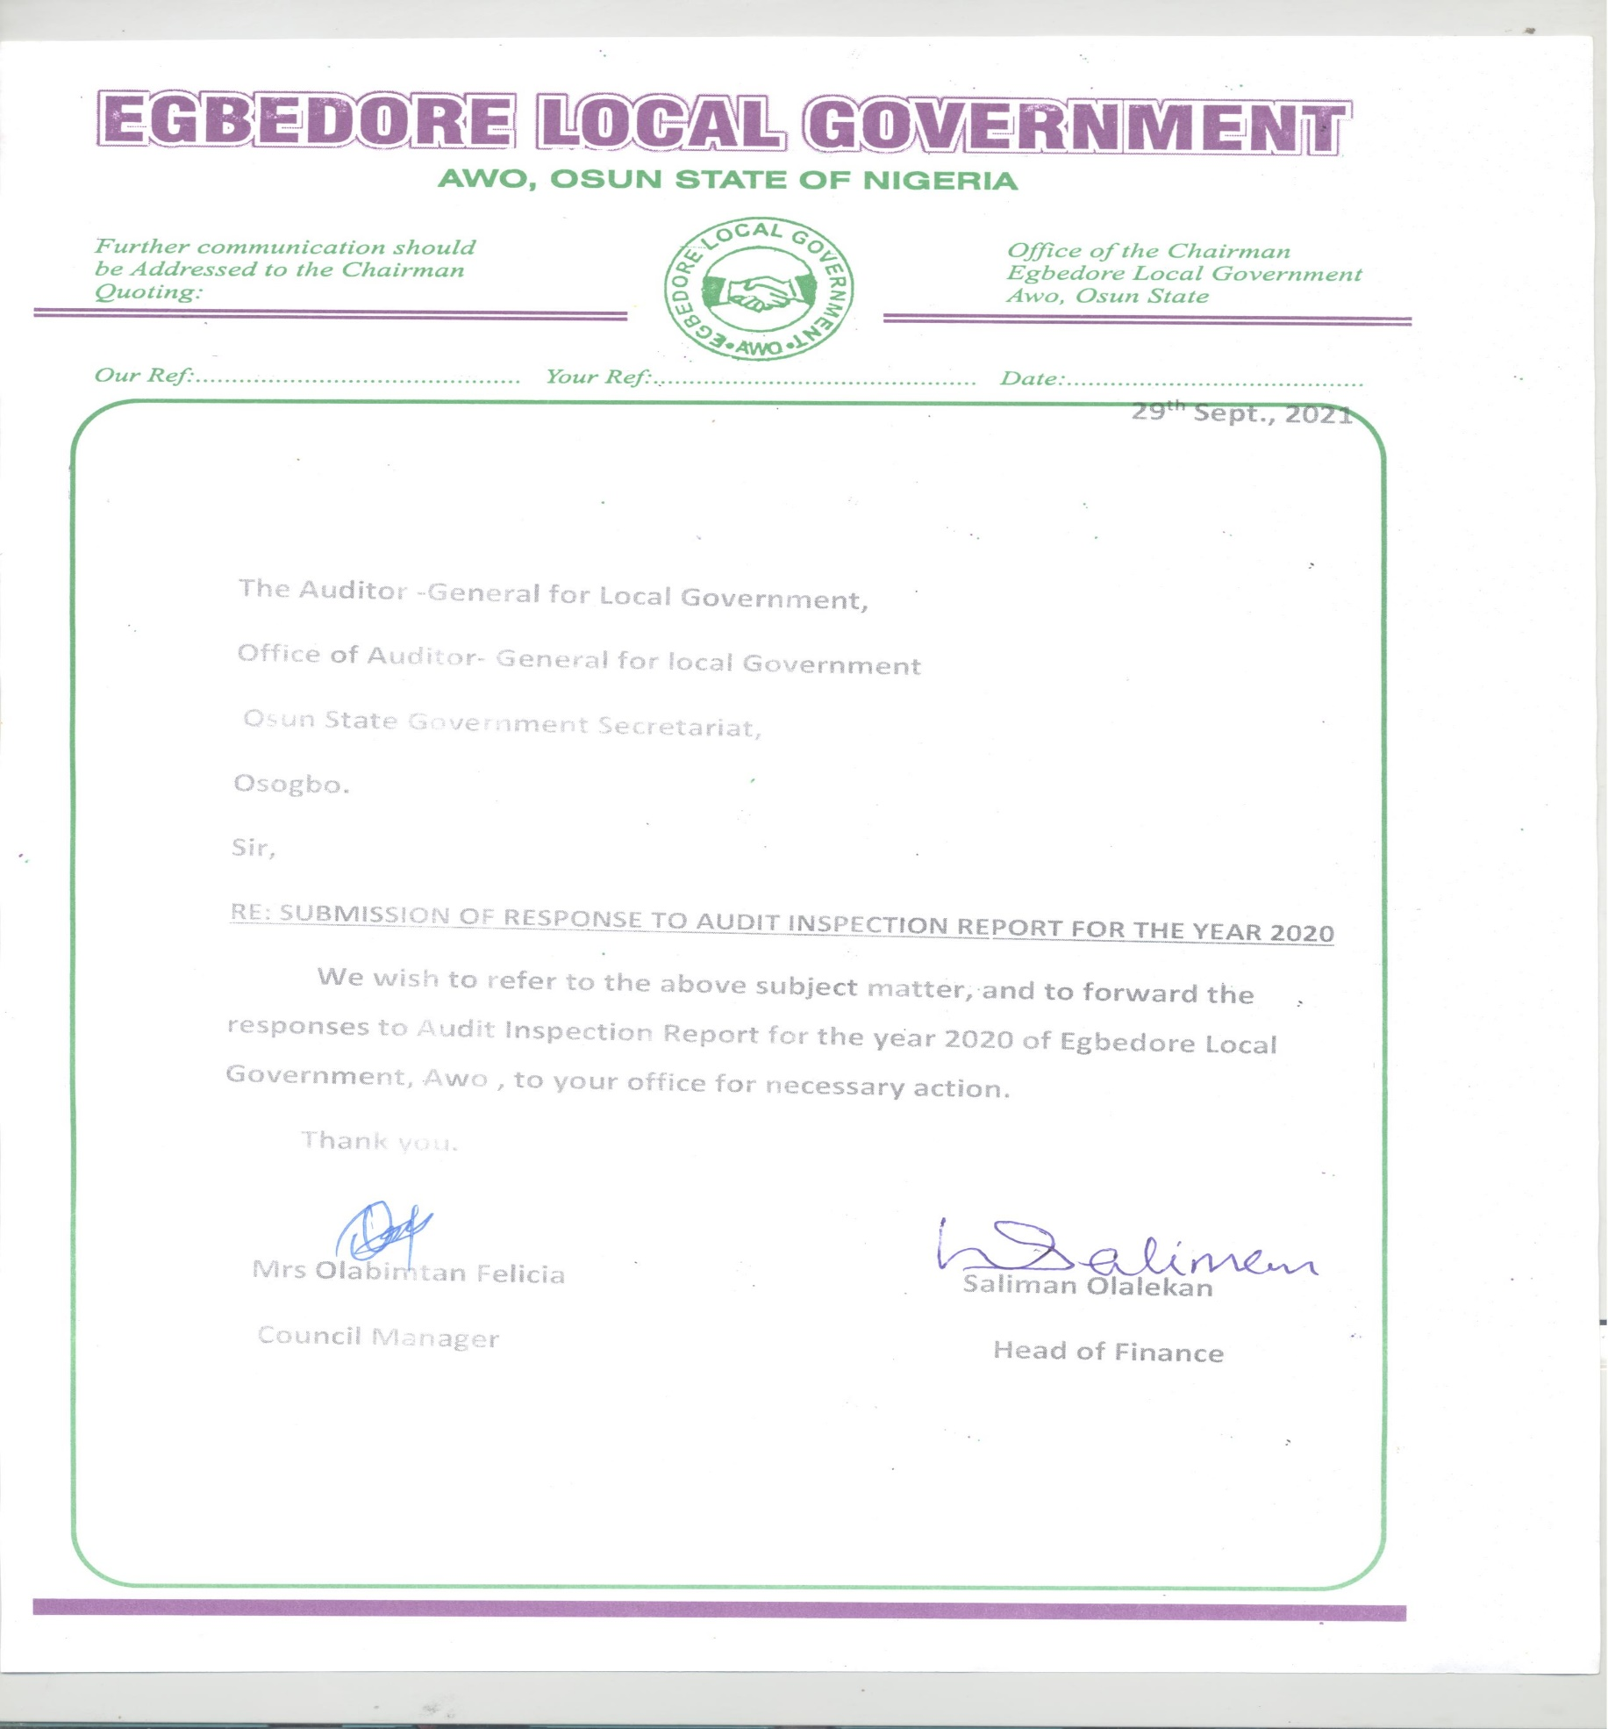

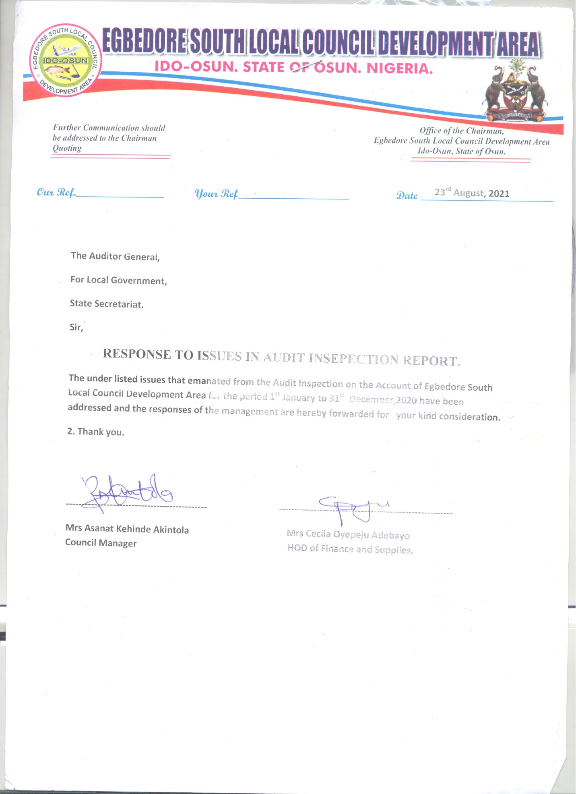

**MANAGEMENT LETTER**

**EGBEDORE LOCAL GOVERNMENT, AWO**

**OBSERVATIONS AND INTERNAL CONTROL REVIEW FOR THE FINANCIAL YEAR ENDED 31ST DECEMBER, 2020**

**1. UNRETIRED IMPREST AMOUNTING TO (~~N~~53,500.00):-** It was observed that the sum of Fifty Three Thousand Five Hundred Naira received by certain members of staff of Egbedore Local Government, Awo as monthly running imprest were not retired contrary to Financial Memoranda 14:27 which states that, “Imprest shall be retired when the purpose for which the imprest was granted is completed or at such intervals as are prescribed when the imprest is approved. However, all imprests shall automatically be retired at the end of each financial year ’’. This had been made the subject of Audit Query No. LG/AUD/EGB/LCDA/05/2020.

***RISK:***

*Government Fund might not have been used for official purpose.*

***MANAGEMENT RESPONSE:*** *It was an oversight and the receipts were eventually presented.*

***RECOMMENDATION-***

*Proper recording of petty cash should be done and all payments must be retired immediately and presented for audit verification*

**2. EXPENDITURE NOT SUPPORTED BY PROPER RECORDS/ACCOUNT AMOUNTING TO (~~N~~700,000.00):-** It was observed that the amount of Seven Hundred Thousand Naira made to some members of staff of the Local Government for public talk, inauguration of newly elected executives and the purchase of office materials were not acknowledged with official receipts to authenticate that the expenditure was actually incurred contrary to the provision of Financial Memoranda 14:17 which states that, “An official printed receipt must be obtained and attached to the payment voucher in respect of a payment to Government, another Local Government or a Commercial firm. If the printed receipt covers more than one payment voucher, reference to the number of the payment voucher to which the receipt is attached, shall be entered on the other vouchers”.

***RISK:***

*Payments made without supporting documents could imply non-execution of all or part of the services/purchases, or conceal inflation of prices.*

***MANAGEMENT RESPONSE:***

*It was an oversight and the receipt would be produced.*

***RECOMMENDATION:***

*The recipient/authorizing officer should ensure that all supporting documents were collected while incurring the expenditure.*

**3.** **BANK RECONCILIATION STATEMENT:** Bank Reconciliation Statement was prepared up to December, 2020. The following are the observations arising from the audit scrutiny of the Bank Reconciliation Statements of the Council prepared up to date.

i **Bank Charges:** It was observed that a total sum of ~~N~~12, 270.65 was floating as Bank Charges from previous months to date which was yet to be brought into Accounts contrary to Financial Memoranda 19:27 which states that, “The Receipt and Payment vouchers shall be made out where any credits or charges shown in the bank statement have not been brought to account in the cashbook and are positively identified as being items due from or to the Local Government”.

**EGBEDORE ADMINISTRATIVE OFFICE, OKINNI**

**OBSERVATIONS AND INTERNAL CONTROL REVIEW FOR THE FINANCIAL YEAR ENDED 31ST DECEMBER, 2020**

**1.** **UNCLAIMED EXPENDITURE AMOUNTING TO (~~N~~58,000.00):-**It was observed that the payment voucher raised for the donation, entertainment and transportation of the invited guest to Egbedore Administrative Office towards the launching of 100 million for the roofing and completion of Da’awatul Islamiyyah Central Mosque, Okinni was neither acknowledged nor claimed by the recipient to authenticate the payment. This is contrary to Financial Memoranda 14:13 which states that, “Payment shall as far as possible, be made to the person to whom it is due, payment for a third party shall only be made on production of a written authority from the person to whom payment is due, such authority being attached to the payment voucher after payment”

***RISK:***

*This was an indication that purported items might not have been purchased thereby resulting to loss of Local Government fund.*

***MANAGEMENT RESPONSE:*** *The sub-receipt and receipt column had been duly signed as evidence of the claimed expenditure and reattached to payment voucher.*

***RECOMMENDATION:***

*An official printed receipt must be obtained and attached to the payment voucher as this proved the authenticity that the expenditure was carried out.*

**2.** **DOUBTFUL EXPENDITURE AMOUNTING TO (~~N~~165,000.00):-**It was observed that the payment vouchers raised on behalf of members of staff of Egbedore Administrative Area Office, Okinni for the visit of elders, entertainment of youth across the town, general staff meeting and enrolment of vulnerable appeared doubtful because tangible evidence that would justify the payment such as the evidence of documentation could not be produced for audit scrutiny.

***RISK:***

*The implication of this expenditure was that the services might not have been performed, thus the public fund might have been diverted for personal purposes.*

***MANAGEMENT RESPONSE:*** *The effect of the work done had been eroded with the passage of time before inspection was done supporting evidences would be presented.*

***RECOMMENDATION:***

*The recipients must attach all necessary supporting evidence such as sub-receipts, evidence of participation, or video coverage to prove genuineness of the expenditure.*

**3.** **BANK RECONCILIATION STATEMENT:** Bank Reconciliation Statement was prepared up to December, 2020. The following are the observations arising from the audit scrutiny of the Bank Reconciliation Statements of the Council prepared up to date.

**Bank Charges:** It was observed that a total sum of ~~N~~6, 975.83 was floating as Bank Charges from previous months to date which was yet to be brought into Accounts contrary to Financial Memoranda 19:27 which states that, “The Receipt and Payment vouchers shall be made out where any credits or charges shown in the bank statement have not been brought to account in the cashbook and are positively identified as being items due from or to the Local Government”.

However, the concerned Head of Department of Finance & Supplies should provide details of the aforementioned accumulated anomaly, effect necessary correction and inform this Office within 21 days of receipt of this report.

***RISK:***

*Non-preparation of Bank Reconciliation Statement by the Head of Finance could conceal fraud, errors perpetrated in the Bank transactions through extraneous debits in the Bank Statements, and Cashbook collusion between the signatories.*

***MANAGEMENT RESPONSE:*** *Payment vouchers in respect of the transactions were not ready as at the time of Audit exercise.*

***RECOMMENDATION:***

*The Head of Finance should raise and process payment voucher to wipe off the accumulated bank charges. The Head of Finance should ensure that payments are not made until payment vouchers are completely processed.*

**EGBEDORE SOUTH LOCAL COUNCIL DEVELOPMENT AREA, IDO-OSUN**

**OBSERVATIONS AND INTERNAL CONTROL REVIEW FOR THE FINANCIAL YEAR ENDED 31ST DECEMBER, 2020**

**1.** **EXPENDITURE NOT SUPPORTED BY PROPER RECORDS OR ACCOUNTS AMOUNTING TO (~~N~~180,000.00):-** It was observed that the payment voucher of One Hundred and Eighty thousand naira for the purchase of bags of rice distributed to selected Christian leaders was not supported with official receipts such as Stores Receipt Voucher (SRV), distribution list to authenticate that the expenditure was actually incurred contrary to the provision of Financial Memoranda 14:17 which states that, “An official printed receipt must be obtained and attached to the payment voucher in respect of a payment to Government, another Local Government or a Commercial firm. If the printed receipt covers more than one payment voucher, reference to the number of the payment voucher to which the receipt is attached, shall be entered on the other vouchers”.

***RISK:***

*Payments made without supporting documents could imply non-execution of all or part of the services/purchases, or conceal inflation of prices.*

***MANAGEMENT RESPONSE:***

*It was an oversight and the receipt would be produced.*

***RECOMMENDATION:***

*The recipient/authorizing officer should ensure that all supporting documents were collected while incurring the expenditure.*

**2.** **BANK RECONCILIATION STATEMENT:** Bank Reconciliation Statement was prepared up to December, 2020. The following are the observations arising from the audit scrutiny of the Bank Reconciliation Statements of the Council prepared up to date.

**Bank Charges:** It was observed that a total sum of ~~N~~8, 810.46 was floating as Bank Charges from previous months to date which was yet to be brought into Accounts contrary to Financial Memoranda 19:27 which states that, “The Receipt and Payment vouchers shall be made out where any credits or charges shown in the bank statement have not been brought to account in the cashbook and are positively identified as being items due from or to the Local Government”.

However, the concerned Head of Department of Finance & Supplies should provide details of the aforementioned accumulated anomaly, effect necessary correction and inform this Office within 21 days of receipt of this report.

***RISK:***

*Non-preparation of Bank Reconciliation Statement by the Head of Finance could conceal fraud, errors perpetrated in the Bank transactions through extraneous debits in the Bank Statements, and Cashbook collusion between the signatories.*

***MANAGEMENT RESPONSE:*** *Payment vouchers in respect of the transactions were not ready as at the time of Audit exercise.*

***RECOMMENDATION:***

*The Head of Finance should raise and process payment voucher to wipe off the accumulated bank charges. The Head of Finance should ensure that payments are not made until payment vouchers are completely processed.*

**INTERNAL AUDITOR’S REPORT**

1. There are other sources of the Revenue for the Local Government as identified by the Internal Control Unit but not properly tapped and monitored by the Management. Such Revenue items are the Local Government Teak and Cashew farms of the Local Government.

2. The impacts of the Internal Audit Control Unit are not much felt on the Revenue items of the Local Government. The Rate Section’s activities are viewed to be going down gradually and the IGR is observed to be reducing monthly, making the Council to rely heavily on the State monthly allocation.

3. The Internal Control Unit is viewed to be weak and the impacts of the Unit are not felt on the administration of the Council particularly, the Revenue Unit making the IGR to be at reducing rate monthly.

**LIST OF PROJECTS EXECUTED BY EGBEDORE LOCAL GOVERNMENT, AWO [JANUARY – DECEMBER 2020]**

|  |  |  |  |  |  |  |  |
| --- | --- | --- | --- | --- | --- | --- | --- |
| **S/N** | **DESCRIPTION** | **LOCATION** | **MODE OF EXECUTION** | **PROJECT COST** | **AMOUNT RELEASED** | **BALANCE** | **REMARKS** |
| 1. | Construction of stairs to NULGE Hall | Local Government Secretariat, Awo | Direct | 10,000.00 | 10,000.00 | NIL | Completed |
| 2. | Production of road network map of Egbedore Local Government, Awo. | Works of grannies of Local Government Area. | Direct | 15,000.00 | 15,000.00 | NIL | Completed |
| 3. | Construction of a 5 unit lock-up store with toilet facilities. | Egbedore Local Government Frontage, Awo | Direct | 3,355,320.00 | 3,355,320.00 | NIL | Completed |
| 4. | Construction of a 5 unit lock-up store with toilet facilities. | Egbedore Local Government Frontage, Awo. | Direct | 3,785,210.00 | 1,000,000.00 | 2,785,210.00 | On-going |
|  | **TOTAL** |  |  | **7,165,530.00** | **4,380,320.00** | **2,785,210.00** |  |

**LIST OF PROJECTS EXECUTED BY EGBEDORE ADMINISTRATIVE OFFICE, OKINNI [JANUARY – DECEMBER 2020]**

|  |  |  |  |  |  |  |  |
| --- | --- | --- | --- | --- | --- | --- | --- |
| **S/N** | **DESCRIPTION** | **LOCATION** | **MODE OF EXECUTION** | **PROJECT COST** | **AMOUNT RELEASED** | **BALANCE** | **REMARKS** |
| 1. | Tilling of Okinni Central Mosque (2019). | Okinni Central Mosque | Direct | 1,572,900.00 | 600,000.00 | 972,900.00 | On-going |
| 2. | Completion of Administrative office building Okinni 2020. | Administrative building, Okinni | Direct | 4,871,475.00 | 1,360,000.00 | 3,511,475.00 | On-going |
| 3. | Purchase of Toyota Camry Muscle Engine. (Tokunbo). | Administrative Okinni | Direct | 400,000.00 | 400,000.00 | NIL | Completed |
| 4. | Partitioning of executive secretary’s office 2020 | Administrative Office | Direct | 105,000.00 | 105,000.00 | NIL | Completed |
| 5. | Construction of block wall fence in front of secretariat office, Okinni 2020 | Okinni | Direct | 280,000.00 | 280,000.00 | NIL | Completed |
|  | **TOTAL** |  |  | **7,229,375.00** | **2,745,000.00** | **4,484,375.00** |  |

**LIST OF PROJECTS EXECUTED BY EGBEDORE SOUTH LOCAL GOVERNMENT, AWO [JANUARY – DECEMBER 2020]**

|  |  |  |  |  |  |  |  |
| --- | --- | --- | --- | --- | --- | --- | --- |
| **S/N** | **DESCRIPTION** | **LOCATION** | **MODE OF EXECUTION** | **PROJECT COST** | **AMOUNT RELEASED** | **BALANCE** | **REMARKS** |
| 1. | Land scaping of Egbedore South LCDA permanent secretariat, Ido-Osun. | LCDA Permanent Secretariat, Ido-Osun | Direct | 400,000.00 | 150,000.00 | 250,000.00 | On-going |
| 2. | Post construction works and cleaning of Egbedore South LCDA permanent secretariat. | LCDA Permanent Secretariat, Ido-Osun | Direct | 100,000.00 | 100,000.00 | NIL | Completed |
| 3. | Partitioning of offices in Egbedore South LCDA permanent secretariat. | LCDA Permanent Secretariat, Ido-Osun | Direct | 326,000.00 | 200,000.00 | 126,000.00 | On-going |
| 4. | Connection of electricity to the permanent secretariat. | LCDA Permanent Secretariat, Ido-Osun | Direct | 160,000.00 | 30,000.00 | 130,000.00 | On-going |
| 5. | Provision of marble plague for commissioning of Egbedore South LCDA permanent secretariat. | LCDA Permanent Secretariat, Ido-Osun | Direct | 72,500.00 | 72,500.00 | NIL | Completed |
|  | **TOTAL** |  |  | **1,058,500.00** | **552,500.00** | **506,000.00** |  |