STATE GOVERNMENT OF OSUN, NIGERIA.

REPORT OF

THE

AUDITOR-GENERAL

FOR

LOCAL GOVERNMENTS

ON THE ACCOUNTS OF

IFE EAST LOCAL GOVERNMENT,

OKE OGBO

FOR THE YEAR ENDED

31ST DECEMBER, 2020.

**TABLE OF CONTENTS**

|  |  |  |
| --- | --- | --- |
|  | **DETAILS** | **PAGE** |
| 1 | TITLE PAGE | **1** |
| 2 | TABLE OF CONTENTS | **2** |
| 3 | LIST OF ABBREVIATIONS | **3** |
| 4 | STATEMENT OF RESPONSIBILITY FOR THE PREPARATION OF FINANCIAL STATEMENTS | **4** |
| 5 | STATEMENT OF RESPONSIBILITY OF THE AUDITOR-GENERAL | **5** |
| 6 | AUDIT CERTIFICATE | **6** |
| 7 | BASIS OF AUDIT OPINION | **7** |
| 8 | STATEMENT OF COMPLIANCE | **8** |
| 9 | STATEMENT OF ACCOUNTING POLICIES | **9-11** |
| 10 | GENERAL COMMENTS | **12-13** |
| 11 | **COMMENTS ON FINANCIAL STATEMENTS**   1. STATEMENT OF FINANCIAL PERFORMANCE 2. STATEMENT OF FINANCIAL POSITION | **14-18** |
| 12 | **AGGREGATE GENERAL PURPOSE FINANCIAL STATEMENTS**   1. CONSOLIDATED STATEMENT OF FINANCIAL POSITION. 2. CONSOLIDATED STATEMENT OF FINANCIAL PERFORMANCE. 3. CONSOLIDATED STATEMENT OF CASH FLOW. 4. CONSOLIDATED STATEMENT OF COMPARISON OF FINANCIAL OPERATIONS. 5. CONSOLIDATED STATEMENT OF NET ASSETS AND EQUITY 6. NOTES TO THE ACCOUNT | **19-33** |
| 13 | **FISCAL OPERATION REPORT**  i STATISTICAL AND ACCOUNTING RATIOS  ii NON-FINANCIAL DISCLOSURE | **34-35** |
| 14 | MANAGEMENT LETTER | **36-41** |
| 15 | LIST OF PROJECTS EXECUTED IN THE LOCAL GOVERNMENT | **42** |

**LIST OF ABBREVIATIONS**

1. AGLG - AUDITOR-GENERAL FOR LOCAL GOVERNMENTS
2. AO - AREA OFFICE/ADMINISTRATIVE OFFICE
3. FAAC - FEDERATION ACCOUNTS ALLOCATION COMMITTEE
4. F.M - FINANCIAL MEMORANDUM
5. FOR - FISCAL OPERATION REPORT
6. GPFS - GENERAL PURPOSE FINANCIAL STATEMENTS
7. IGR - INTERNALLY GENERATED REVENUE
8. ISSAI - INTERNATIONAL STANDARDS OF SUPREME AUDIT INSTITUTIONS
9. IPSAS - INTERNATIONAL PUBLIC SECTOR ACCOUNTING STANDARD
10. JAAC - JOINT ACCOUNTS ALLOCATION COMMITTEE
11. LGA - LOCAL GOVERNMENT AREA
12. LCDA -LOCAL COUNCIL DEVELOPMENT AREA
13. LGSC - LOCAL GOVERNMENT SERVICE COMMISSION
14. LGSPB - LOCAL GOVERNMENTS STAFF PENSION BOARD
15. LGLB - LOCAL GOVERNMENT LOANS BOARD
16. NCOA - NATIONAL CHART OF ACCOUNTS
17. NBV - NET BOOK VALUE
18. MLGCA- MINISTRY OF LOCAL GOVERNMENT AND CHIEFTAINCY AFFAIRS
19. PPE - PROPERTY, PLANTS AND EQUIPMENT
20. PSE - PUBLIC SECTOR ENTITIES
21. PHCB - PRIMARY HEALTH CARE BOARD
22. VAT - VALUE ADDED TAX

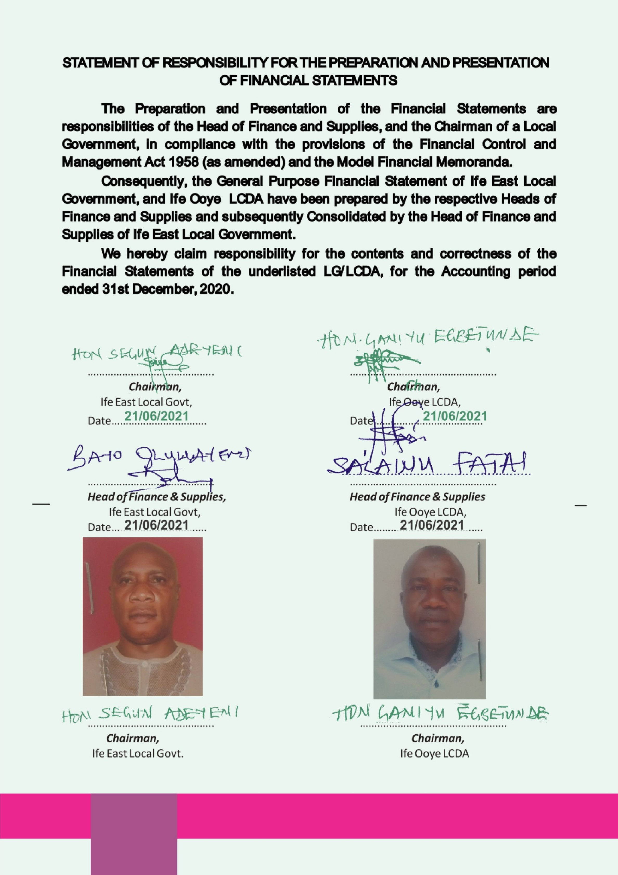

**STATEMENT OF FINANCIAL RESPONSIBILITY**

In compliance with the provisions of Finance Control and Management Act 1958 (as amended), the Model Financial Memoranda (1991 as amended), the Laws of Osun State 2002 (as amended) and with the provisions of the Constitution of the Federal Republic of Nigeria, 1999.

Consequently, the Heads of Finance of main Local Governments in the State of Osun are responsible for the preparation of the respective Local Government GPFS as well as Financial Statements with the Financial Statement of the subsidiary LCDAs, Area/Administrative offices, as may be applicable.

However, both the Head of Finance and Chairman of a Local Government, (the Accounting Officer) are responsible for establishing and maintaining a system of internal control designed to provide reasonable assurance that the transactions and Financial Statements give a fair presentation of the financial operations of the Local Government.

The acknowledgment of responsibility for the preparation of Financial Statements signed by Heads of Finance and Chairmen of the Ife East Local Governments and subsidiary LCDAs is attached to this report.

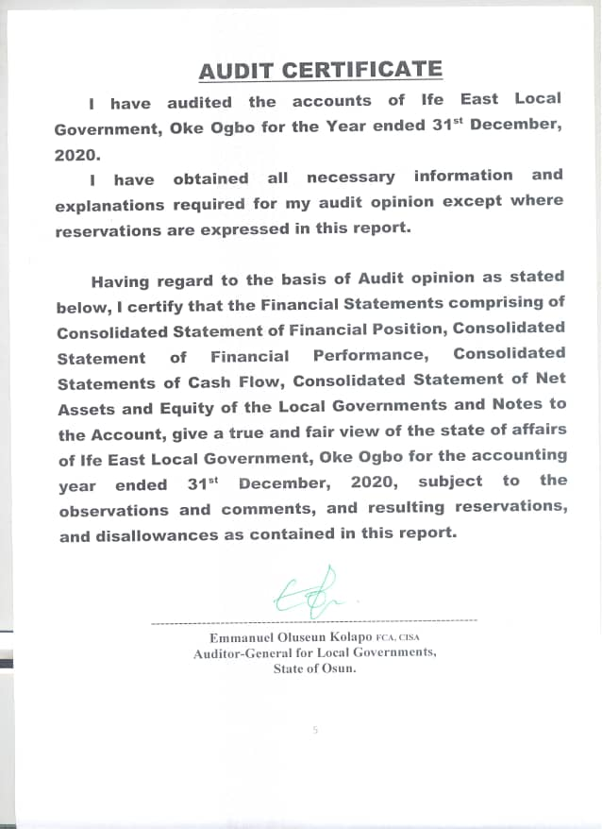

**STATEMENT OF RESPONSIBILITY OF THE AUDITOR-GENERAL.**

It is my responsibility to Audit the accounts of the Local Governments, the State Joint Local Government Account, and all offices of the Local Government(inclusive of Ife East Local Govt) as stipulated by the Laws of Osun State and the Financial Memoranda; and to form an independent opinion based on the Audit of the Financial Statements and accompany notes submitted by the Head of Finance and Supply of Ede South Local Government in the state.

**BASIS OF AUDIT OPINION**

In the course of auditing the accounts of Ife East Local Government Oke-Ogbo in the State of Osun, I have complied with the requirement and stipulations of the International Standards on Auditing, the Generally Acceptable Auditing Standards, International Standards of Supreme Audit Institutions (ISSAI,) Laws of Osun State, International Public Sector Accounting Standards and Audit Guide of the Office of the Auditor-General for Local Governments, Osun State.

I have conducted Financial and Compliance audit on the Finances of the Local Governments and Projects and Programmes were reasonably evaluated and verified on the principle of Performance Auditing. All items of Revenue and Expenditure were captured in the course of the Audit and Audit Tests were conducted on procedures, transactions and balances. Consequently 100% Substantive Test was done on all items of Revenue and Expenditure; and Assets and Liabilities, and appropriate Audit Tests of Control were conducted on procedures and transactions.

Where paucity of available Audit resources warranted sampling, objective statistical sampling techniques were applied to ensure representativeness, completeness, relevance, and timeliness in the determination of sampling elements. This ensured reliability of Audit Opinion, giving due recognition to principle of materiality. For example, multi-layered and structural sampling method was applied for verification of numbers and Emoluments of Teaching and Non-Teaching staff of Ife East Local Govt Education Authority.

**STATEMENT OF COMPLIANCE**

The Accounting Policies have been consistently applied on preparation of the Financial Statements of Ede South Local Government in the year under review. These have been prepared on the basis of Historical Cost and in accordance with IPSAS Accruals and other applicable standards. The Cash Flow Statement was prepared using the Direct Method. The basis of measurement is Naira and kobo which is the functional and reporting currency of the Federal Republic of Nigeria of which Osun State and Ife East Local Governments are constituents.

The accounts of Ife East Local Governments have been audited and reported upon.

Audit noted some instances of non-compliance in the Local Governments, with the due process in revenue collection and payment procedure contrary to the provision of Financial Memoranda and relevant Guidelines. The associated internal control weaknesses have been addressed. The inspection reports (letters of Internal Control weaknesses) for the year 2020 have been issued and forwarded to the appropriate quarters for responses and compliance as required.

The queries were replied and appropriate recommendations were made as contained in the Management letter included.

**STATEMENT OF ACCOUNTING POLICIES**

1. **Basis of Preparation (IPSAS 1)**

The General Purposes Financial Statements were prepared under the historical cost convention and in accordance with IPSAS Accrual Basis and other applicable standards and conventions as may be defined by relevant Statutes.

1. **Accounting Period**

The accounting year (fiscal year) to which the report relates is 1st January to 31st December, 2020.

1. **Reporting Currency**

The General Purposes Financial Statements are prepared in the Nigerian Naira (NGN).

1. **Principal Statements in the General Purposes Financial Statements**
2. Statements of Financial Performance.
3. Statements of Financial Position.
4. Statements of Cash flow.
5. Statements of Comparison of Budgeted and Actual Amounts
6. Statements of Changes in Net Asset/Equity.
7. Notes to the GPFS.
8. **Consolidation Policy- IPSAS 6**

The Heads of Finance of the each Local Governments, LCDA, and A/C and A/O are required to prepare their individual GPFS at the end of the financial year on Accrual Basis of Accounting.

Each Local Government is a creation of the Constitution and none is subservient to the other. However in this situation, there are subsidiary entities such as LCDAs and Area offices, which are consolidated with the main Local Government. Consequently, the Heads of Finance of the 30 main Local Governments consolidate the GPFS of their respective main Local Government with the subsidiary LCDAs, AOs, and Ad. Os.

***The duty of the Auditor-General for Local Governments is not to prepare or consolidate Local Governments’ accounts, but to Audit and Aggregate the prepared Financial Statements in line with the Fiscal Operation Report Guideline.***

1. **Statement of Cash Flow** was prepared using the direct method (IPSAS 2) and it consists of Operating, Investing and Financing activities.
2. **Inventories (IPSAS 12) -** Inventories were measured initially at cost, and subsequently measured using the FIFO method.
3. **PROPERTY, PLANT & EQUIPMENT (PPE) – IPSAS 17**

All PPEs were stated at historical cost less accumulated depreciation and impairment losses.

1. **DEPRECIATION**

The cost of PPE shall be written off, from the time they are brought into use, on a straight line basis over their expected useful lives less any estimated residual value as follows:

1. Furniture & Fittings - 20%
2. Motor Vehicle - 20%
3. Plant & Equipment - 20%
4. Infrastructural Asset - 10%
5. Building - 2%
6. Office Equipment - 20%
7. **REVALUATION**
8. The Assets’ residual values and useful lives are reviewed at the end of the year.
9. **IMPAIRMENT**

Test for Impairment are done on Property, Plants and Equipments, where it is suspected that Impairment has occurred.

1. **INVESTMENT PROPERTIES – IPSAS 16**

The Investment properties are measured initially at cost, including transaction costs. Subsequent to initial recognition, investment properties are measured using the cost model and are depreciated the same way as PPE.

1. **INDEPENDENT REVENUE FROM NON-EXCHANGE TRANSACTION (IPSAS 23)**
2. Fees; taxes and fines: The Local Government recognised revenue from fees, taxes, and fines when the event occured, and the asset recognition criteria are met.
3. **OTHER REVENUE**

Other Revenues are proceeds that arise outside the Ordinary course of governmental busineess. These include:

1. Gain on disposal of Property, Plant and Equipment

2. Dsiposal of Investment such as Shares, bond etc

Gain on disposal is recognized at the date of control of the asset is passed to the buyer and is determined after deducting the carrying value of the Asset at that time.

1. **UNREMITTED DEDUCTION**

Unremitted deductions are monies owned to the third parties such as tax authorities, associations and other Government Agencies. These include tax deductions and other deductions at source

This amount shall be stated in GPFS at their repayment value, which shall be treated as current liabilities in the Statement of Financial Position.

**16. RESERVE**

Reserves shall be classified under Equity in the Statement of Financial Position which includes Accumulated Surplus/Deficit and the Additional Reserve.

**17. CONTIGENT LIABILITY IPSAS 19**

Contigent liabilities are only disclosed in the Notes to GPFS. Contingent liability is possible obligation arising from past events whose exigencies will be confirmed only by uncertain future event(s) or present obligation arising from the past events that are not recognized because of either an outflow of economic benefit is not probable or this amount of obligation.

**GENERAL COMMENT**

I have audited the accounts of Ife East Local Government, Oke-Ogbo (including elements of Local Government fund in various Agencies and Institutions of Government, comprising Traditional Councils, LGSPB, LGSC, SUBEB, O’Meals and other Jointly executed programmes and projects of Local Governments) for the financial year ended 31st December 2020, as required by Cap 72, Part 10 of the Laws of Osun State 2002, (as amended).

**AUTHORITY FOR DISBURSEMENTS FROM JAAC ACCOUNT:** Disbursements from JAAC accounts were made in consonance with the prescriptions of the House of Assembly while monthly distributions were collectively decided by the Chairmen of Ife East Local Government and other Chairmen, all of whom were members of the Joint Account Allocation Committee.

**FULL ADOPTION OF IPSAS ACCRUALS:** 2020 GPFS reports were prepared in compliance with IPSAS Accrual which was fully adopted by Local Governments in the State of Osun in 2017.

The previous accounting training on conversion to IPSAS Accruals, severally sponsored by the EU/SLOGOR, LGSC, SUBEB in collaboration with Office of the Auditor-General for Local Governments, with the approval of Mr. Governor, for upgrades and re-training in 2020 have collectively enhanced the proficiency of operators of Local Government accounts in the State

**SCOPE OF AUDIT COVERAGE**: The Audit scope has 100% coverage on all aspects of Revenue and Expenditure, as well as verification of Assets and Liabilities including JAAC Accounts. Revenue covered included all Allocations and VAT from the Federation Accounts and other dependent and Independent Revenue sources of the Local Governments while Expenditure covered included all Capital and Recurrent Expenditure Items in all Local Governments, and LCDAs, all centrally executed Projects and programmes of Local Governments, and Statutory remittances to Traditional Councils.

**BUDGET PREPARATION / EXECUTION**

The Budget for 2020 for Ife East Local Governments was prepared in compliance with new National Chart of Accounts. The 2020 Budget was an improvement on the previous Budget of 2019 as some of the obvious shortcomings observed by the Audit have been addressed.

**PROCUREMENT PRACTICES**

Osun State Public Procurement Law 2015 has been in force in line with global best practice. Procurement Officers was posted to the Local Governments and performed his duties. The Audit observed that the Offices need to be strengthened to further assist in promoting sound and transparent procurement practices in the Local Governments.

**VALUATION AND REVALUATION OF ASSETS**

The office of the Auditor-General for Local Governments embarked on verification exercise on valuation and Revaluation of Assets during the year. This involved Constitution of a standing multi-disciplinary team comprising seasoned and qualified professionals in the fields of valuation, engineering, town planning, medicine, etc. and others as were necessary. Consequently, the realism of the values of non-current asset is enhanced for the year under review. The verification exercise is continuous and value of the Local Governments non-current Assets is being updated monthly.

**INTERNALLY REVENUE GENERATION AND FINANCIAL VIABILITY**

The Total Internally Revenue generated by the Local Government for 2020 was N33,281,509.97 representing 1.74% the Total Revenue. More efforts at blocking leakages coupled with adequate research by the relevant unit of the Auditor-General for Local Government on comparative revenue advantages of individual Local Government’s office will assist in curbing this unwholesome situation.

**INTERNAL CONTROL WEAKNESS IN THE LOCAL GOVERNMENT AND RELATED AGENCIES**

At the conclusion of the Audit, 9 nos of Audit Queries were issued in respect of 2020 Accounts, involving a total sum of N300,000.00.

Queries were issued in respect of irregularities observed in fund management by beneficiary agencies of transfers from Local Governments fund and this had been forwarded to the respective Accounting Officers for response.

The identified internal control weaknesses, the inherent risks, the management Responses and Audit Recommendations are highlighted in Management Letter contained in this Report.

**COMMENTS ON FINANCIAL STATEMENTS**

1. **STATEMENT OF FINANCIAL PERFORMANCE**

**Share of FAAC and VAT:** The total sum of N1,335,494,553.31 was Share of FAAC and VAT amounted to N545,384,413.45.

THE CONCEPT OF **DEPENDENT REVENUE.** The term IndependentRevenue or synonymous with Internally Generated Revenue in the IPSAS. However, the term Dependent Revenue is used in proportion in the Report as it depicts the items of Revenue other than Internally Generated Revenue (IGR), i.e. the revenue over which the reporting entirely has no control on its generation or collection.

Essentially the proportion of Dependent Revenue is a measure of the extent of its vulnerability or dependently of the Local Government on finances from sources over which it has no control.

**EXPENDITURE:** As part of the disclosure requirements, expenditures that were Jointly incurred at JAAC level were separately disclosed from those expended at each Local Government Level.

**SUMMARY OF REVENUE FROM JAAC**

|  |  |  |  |  |  |  |  |  |  |  |
| --- | --- | --- | --- | --- | --- | --- | --- | --- | --- | --- |
| **LOCAL GOVERNMENT** | **STATUTORY ALLOCATION** | **VAT** | **EX RATE GAIN** | **FEDERAL GOVT INTERVENTION** | **EXCESS BANK** | **FOREX EQUALISATION** | **ECO** | **ADD FUND FRM SOLID MIN** | **NON-OIL EXCESS REVENUE** | **TOTAL** |
| Ife East | 1,199,890,867.08 | 545,384,413.45 | 38,837,511.13 | 32,529,343.46 | 985,741.97 | 17,371,217.29 | 26,994,837.10 | 2,007,582.17 | 16,877,453.11 | 1,880,878,966.76 |

**INDEPENDENT REVENUE FROM NON-EXCHANGE TRANSACTION (IPSAS 23)**

Fees; taxes and fines: The Local Government recognised revenue from fees, taxes, and fines when the event occurs, and the asset recognition criteria are met. The Local Government earned and recognised. #33,281,509.97.

**SALARIES AND WAGES – N891,459,234.55**

Salaries and Wages which amounted to N891,459,234.55 comprised of salaries of Staff of the Local Governments, Teaching and Non-Teaching Staff of SUBEB, staff of Local Government Loans Board and the Primary Health Care Board. Salary Payment was centralised in the State of Osun for the year 2020.

**COMMENTS ON ITEMS OF FINANCIAL POSITION**

**CASH AND CASH EQUIVALENTS – #11,530,208.82**

The Aggregate closing cash and cash equivalents amounted to **₦11,530,208.82** for the Local Governments. The Bank Statements and Bank Reconciliation Statements of all Local Governments and Local Government Development Areas as at 31st December, 2020 were verified/examined to ascertain the bank balances. This balance does not include the balance in JAAC account which essentially should be a zero-balance account. Moreover any undistributed amount in the JAAC Account is treated as Receivable to the Local Governments.

**RECEIVABLES - ₦155,286,015.43**

A total sum of N155,286,015.43k was standing as Receivables as at 31st December, 2020. The Receivables include, Revenue Recognised in December 2020 but received in January, 2020 from Joint Allocation Account Committee (JAAC).

**INVENTORIES - ₦1,942,390.00**

The sum of ₦1,942,390.00represents inventories valued at historical cost in the Local Governments as at 31st December, 2020. These include unallocated stores both expendable and non-expendable; and consumable items.

**INVESTMENTS - ₦68,689,584.43**

All the Investments are classified as held-for-sale, while Equity Method is adopted in Recognition and Measurement. Most of the investments were in unquoted companies except for the Preference shares.

**PROPERTY, PLANT AND EQUIPMENT(PPE)**

Items of Property, Plant and Equipment or other Non -Current Assets are stated at Historical Cost Less accumulated Depreciation. Depreciation on Non - Current Assets are calculated to write off cost on valuation in a straight-line basis over the expected useful life on the assets, as follows:

**Particulars Rate%**

Fixture and fitting 20

Motor Vehicle 20

Plant and Equipment 20

Infrastructural Asset 10

Buildings 2

Office Equipment 20

There is need to make adequate provision for depreciation. Accounting for PPE is an area of Audit emphasis where there seems to be a gap in knowledge exhibited by the operators of the Account vis-à-vis expectation.

**PAYABLES - ₦1,909,764,770.75**

These comprised largely of commitments all over the Local Governments such as allowances, sundry overheads, and unpaid salary and wages, arrears of salaries, unremitted deductions etc. outstanding as at 31stDecember 2020.

**INVESTMENT PROPERTY - ₦65,650,148.00**

The carrying amount of Investment Properties of the Local Governments stood at N65,650,148.00 in the Statement of Financial Position. However, there is no restriction on title or property pledge as securities for liabilities. Straight Line Method of depreciation was applied.

**LONG – TERM BORROWINGS - ₦1,580,230,153.04**

These are the cumulative amount of various outstanding loans obtained from different sources to finance the under-listed projects:

* 1. Construction of over 10 kilometers of roads, (tagged 10KM roads/Local Government), across all the main Local Governments across the state.
  2. Environmental Projects – includes channelization, chlorination, etc aimed at preserving lives and environments
  3. Intervention Projects including Grading, access to rural areas, etc..
  4. Repayment of Bail Out

**UNREMITTED DEDUCTIONS - ₦112,876,491.77**

These include deductions received from Joint Accounts Allocation Committee (JAAC) and deposits which ought to have been remitted to the appropriate quarters on or before 31st December, 2020. The management of the Local Councils are hereby advised to ensure that all deposits/deductions received are remitted promptly to avert the possibility of unnecessary accumulation of liabilities on Councils financial position

DISCLOSURES: In the statement of Financial Performance the amounts jointly expended by the Local Government is separated from the amount spent in individual Local Government.

**TRANSFER FROM MAIN COUNCILS TO LOCAL COUNCIL DEVELOPMENT AREAS:**

Transfer from main councils to the tune of #47,558,572.02 was made to the Local Council Development Areas and Area Offices in the period under review and was set off in the Consolidated Account.

**IFE EAST LOCAL GOVERNMENT, OKE-OGBO**

**CONSOLIDATED STATEMENT OF FINANCIAL POSITION AS AT 31ST DECEMBER 2020**

|  |  |  |  |  |  |
| --- | --- | --- | --- | --- | --- |
| **PARTICULAR** |  | **IFE EAST** | **IFE OOYE** | **IFE NORTH EAST** | **IFE EAST CONSOLIDATED** |
| **ASSETS** | **NOTE** |  |  |  |  |
| **Current Assets** |  |  |  |  |  |
| **Cash & Cash Equivalents** | **1** | 3,716,357.54 | 3,207,932.69 | 4,605,918.59 | 11,530,208.82 |
| **Receivables** | **2** | 136,718,685.83 |  | 18,567,329.60 | 155,286,015.43 |
| **Prepayment/Advance** | **3** | 1,800,000.00 |  |  | 1,800,000.00 |
| **Inventories** | **4** | 1,007,500.00 | 283,000.00 | 651,890.00 | 1,942,390.00 |
| **Total Current Asset** |  | 143,242,543.37 | 3,490,932.69 | 23,825,138.19 | 170,558,614.25 |
| **Non Current Asset:** |  |  |  |  | - |
| **Long Term Loan Granted** |  |  |  |  | - |
| **Investments** | **5** | 34,765,832.43 | 8,500,000.00 | 25,423,752.00 | 68,689,584.43 |
| **Property, Plant & Equipment** | **6** | 1,786,818,988.35 | 929,892,937.12 | 1,865,104,641.71 | 4,581,816,567.18 |
| **Investment Property** | **7** | 52,593,500.00 |  |  | 52,593,500.00 |
| **Biological Asset** | **8** |  |  | 13,056,648.00 | 65,650,148.00 |
| **Assets Under Construction(WIP)** | **9** |  |  |  | - |
| **Total Non-Current Asset** |  | 1,874,178,320.78 | 938,392,937.12 | 1,903,585,041.71 | 4,716,156,299.61 |
| **Total Asset** |  | 2,017,420,864.15 | 941,883,869.81 | 1,927,410,179.90 | 4,886,714,913.86 |
| **LIABILITIES** |  |  |  |  | - |
| **Current Liabilities:** |  |  |  |  | - |
| **Deposit** |  |  |  |  | - |
| **Unremitted Deductions** | **10** | 45,045,069.06 | 15,524,692.42 | 52,306,730.29 | 112,876,491.77 |
| **Short Term Loan & Debts** | **11** |  |  |  | - |
| **Payables** | **12** | 861,385,517.15 | 180,172,440.62 | 868,206,812.98 | 1,909,764,770.75 |
|  |  |  |  |  | - |
| **Short Term Provisions** |  |  |  |  | - |
| **Total Current Liability** |  | 906,430,586.21 | 195,697,133.04 | 920,513,543.27 | 2,022,641,262.52 |
| **Non Current Liabilities:** |  |  |  |  | - |
| **Long Term Borrowing** | **13** | 906,271,817.83 | 232,472,815.86 | 441,485,519.35 | 1,580,230,153.04 |
| **Total Liabilities** |  | 1,812,702,404.04 | 428,169,948.90 | 1,361,999,062.62 | 3,602,871,415.56 |
| **Net Assets** |  | 204,718,460.11 | 513,713,920.91 | 565,411,117.28 | 1,283,843,498.30 |
| **Financed by** |  |  |  |  | - |
| **Reserve** | **14** | 848,710,641.36 | 549,421,536.44 | 877,376,672.63 | 1,398,132,177.80 |
| **Net Surplus/Deficit** | **15** | (643,992,181.25) | (35,707,615.53) | (311,965,555.35) | (991,665,352.13) |
| **Total** |  | 204,718,460.11 | 513,713,920.91 | 565,411,117.28 | 1,283,843,498.30 |

**IFE EAST LOCAL GOVERNMENT, OKE-OGBO**

**CONSOLIDATED STATEMENT OF FINANCIAL PERFORMANCE AS AT 31ST DECEMBER 2020**

|  |  |  |  |  |  |
| --- | --- | --- | --- | --- | --- |
| **PARTICULAR** | **NOTE** | **IFE EAST** | **IFE OOYE** | **IFE NORTH EAST** | **IFE EAST CONSOLIDATED** |
| **Government Share of FAAC(Statutory Revenue)** | **16** | 1,078,736,284.36 | - | 121,154,582.72 | 1,199,890,867.08 |
| **Government Share of VAT** | **17** | 381,769,087.03 | - | 163,615,253.31 | 545,384,413.45 |
| **Additional Fund** | **18** | 1,405,307.52 | - | 602,274.65 | 2,007,582.17 |
| **Revenue Furniture Allowance** | **19** |  |  |  | - |
| **Ex Rate Gain** | **20** | 27,186,257.82 | - | 11,651,253.31 | 38,837,511.13 |
| **Augmentation** | **21** |  |  |  | - |
| **Federal Govt Intervention Fund** | **22** | 22,770,540.44 | - | 9,758,803.02 | 32,529,343.46 |
| **ECO** | **23** | 18,896,385.98 | - | 8,098,451.12 | 26,994,837.10 |
| **Solid Minerals** | **24** |  |  |  | - |
| **Non-Oil Revenue** | **25** | 11,814,217.18 | - | 5,063,235.93 | 16,877,453.11 |
| **Distributable from Goods & Valuables** | 26 |  |  |  | - |
| **Forex Equalisation** | **27** | 12,164,852.11 | - | 5,206,365.18 | 17,371,217.29 |
| **10% IGR** | **28** |  |  |  | - |
| **Excess Bank Charges** | **29** | 690,019.39 | - | 295,722.58 | 985,741.97 |
| **Aids & Grants** | 30 |  |  |  | - |
| **Overpayment Recovery** | 31 |  |  |  | - |
| **Sub-Total Dependent Revenue** |  | 1,555,432,951.83 | - | 325,446,014.93 | 1,880,878,966.76 |
| **Transfer from Main Council** | **32** |  | 47,558,572.02 |  | - |
| **Tax Revenue** | **33** | 547,889.40 | 45,800.00 | 129,500.00 | 723,189.40 |
| **Non-Tax Revenue** | **34** | 24,102,170.07 | 2,796,893.50 | 5,659,257.00 | 32,558,320.57 |
| **Other Income** | **35** |  |  |  |  |
| **Sub-Total Independent Revenue** |  | 24,650,059.47 | 2,842,693.50 | 5,788,757.00 | 33,281,509.97 |
| **Total Revenue** |  | 1,580,083,011.30 | 2,842,693.50 | 331,234,771.93 | 1,914,160,476.73 |
| **EXPENDITURE** |  |  |  |  | - |
| **JOINTLY EXPENDED** |  |  |  |  | - |
| **Salaries & Wages** | **36** | 587,703,006.63 |  | 303,756,227.92 | 891,459,234.55 |
| **Social Benefits** | **37** | 4,970,000.00 |  | 1,300,000.00 | 6,270,000.00 |
| **Overhead Cost** | **38** | 21,888,153.02 |  | 6,176,228.09 | 28,064,381.11 |
| **Grants & Social Contribution** | **39** | 1,750,000.00 |  | 12,185,057.42 | 13,935,057.42 |
| **Transfer to Other Agencies** | **40** | 362,225,776.70 |  | 142,280,537.96 | 504,506,314.66 |
| **Allowances** | **41** | 237,464.10 |  |  | 237,464.10 |
| **Stationaries** |  |  |  |  | - |
| **Public Debt Charge** |  |  |  |  | - |
| **L/GOVERNMENT EXPENDITURE** |  |  |  |  | - |
| **Social Benefits** | **42** | 2,983,730.00 | 2,002,000.00 |  | 4,985,730.00 |
| **Overhead Cost** | **43** | 41,884,023.72 | 11,979,650.00 | 513,467.28 | 54,377,141.00 |
| **Grants & Social Contribution** | **44** | 784,277,676.70 | 25,639,481.38 |  | 809,917,158.08 |
| **Depreciation** | **45** | 4,917,600.00 | 18,323,000.00 | 143,655,594.65 | 166,896,194.65 |
| **Transfer to LCDA** | **46** | 47,558,572.02 |  |  | 47,558,572.02 |
| **Allowances** | **47** | 112,096,500.00 | 5,021,700.00 | 6,805,856.16 | 123,924,056.16 |
| **Impairment** | **48** |  |  |  | - |
| **Tax Expenses** |  |  |  |  | - |
| **Bail-Out Repayment** |  |  |  |  | - |
| **Audit Fees** | **49** |  |  |  | - |
| **Stabilization Fund** | **50** |  |  |  | - |
| **Disposal of Assets** |  |  |  |  |  |
| **Revenue Refunded** |  |  |  |  |  |
| **Total Expenditures** |  | 1,972,492,509.89 | 62,965,831.38 | 616,672,969.48 | 2,652,131,303.75 |
| **Net Surplus/Deficit** | **51** | (392,409,491.59) | (60,123,137.88) | (285,438,197.55) | (737,970,827.02) |
| **Net Surplus/Deficit 31/12/2019** |  | (251,582,689.66) | (23,143,049.68) | (26,527,357.80) | (301,253,097.13) |
| **Net Surplus/Deficit 31/12/2020** | **52** | (643,992,181.25) | (83,266,187.55) | (311,965,555.35) | (1,039,223,924.15) |

**IFE EAST LOCAL GOVERNMENT, OKE-OGBO**

**CONSOLIDATED STATEMENT OF CASHFLOW AS AT 31ST DECEMBER 2020**

|  |  |  |  |  |  |
| --- | --- | --- | --- | --- | --- |
| **OPERATING ACTIVITIES** | **NOTE** | **IFE EAST** | **IFE OOYE** | **IFE NORTH EAST** | **IFE EAST CONSOLIDATED** |
| **INFLOW** |  |  |  |  |  |
| **Statutory Revenue(JAAC)** | **53** | 1,693,915,247.38 |  | 269,855,939.94 | 1,963,771,187.32 |
| **Value Added Tax** | **54** | 340,138,482.69 |  | 145,773,638.85 | 485,912,121.54 |
| **Additional Fund** | **55** | 1,405,307.52 |  | 602,274.65 | 2,007,582.17 |
| **Furniture Allowance** |  |  |  |  | - |
| **Exchange Rate Gain** | **56** | 26,572,079.26 |  | 11,388,033.93 | 37,960,113.19 |
| **Others(Augmentation** |  |  |  |  | - |
| **Federal Govt Intervention Fund** | **57** | 22,770,540.44 |  | 9,758,803.02 | 32,529,343.46 |
| **Excess Crude Oil** | **58** | 18,896,385.98 |  | 8,098,451.12 | 26,994,837.10 |
| **Solid Minerals** | **59** |  |  |  | - |
| **Non-Oil Revenue** | **60** | 11,814,217.18 |  | 5,063,235.93 | 16,877,453.11 |
| **Distributable Good & Valuable** |  |  |  |  | - |
| **Forex Equalisation** | **61** | 11,069,199.24 |  | 4,743,942.53 | 15,813,141.77 |
| **10% IGR** |  |  |  |  | - |
| **Excess Bank Charges** | **62** | 690,019.39 |  | 295,722.58 | 985,741.97 |
| **Sub Total Dependent Revenue** |  | 2,127,271,479.08 |  | 455,580,042.53 | 2,582,851,521.63 |
| **Transfer from Main Council** | **63** |  | 47,558,572.02 |  | - |
| **Tax Revenue** | **64** | 547,889.40 | 45,800.00 | 129,500.00 | 723,189.40 |
| **Non-Tax Revenue** | **65** | 24,102,170.07 | 2,796,893.50 | 5,659,257.00 | 32,558,320.57 |
| **Aids and Grants** | **66** |  |  |  | - |
| **Overpayment Recovery** |  |  |  |  | - |
| **Sub Total Independent Revenue** |  | 24,650,059.47 | 2,842,693.50 | 5,788,757.00 | 33,281,509.97 |
| **Total Inflow Operating Activities** |  | **2,151,921,538.55** | **50,401,265.52** | **461,368,799.55** | **2,616,133,031.60** |
| **OUTFLOW** |  |  |  |  | - |
| **Salaries & Wages** | **67** | 535,094,683.65 | - | 281,209,803.82 | 816,304,487.47 |
| **Overheads Cost** | **68** | 62,560,434.63 | 11,979,650.00 | 4,970,377.88 | 79,510,462.51 |
| **Allowances** | **69** | 112,318,133.16 | 5,021,700.00 | 6,799,071.48 | 124,138,904.64 |
| **Social Benefits** | **70** | 7,953,730.00 | 2,002,000.00 | 1,300,000.00 | 11,255,730.00 |
| **Social Contributions** | **71** | 784,277,676.70 | 25,639,481.38 | 9,578,200.14 | 819,495,358.22 |
| **Inventories** | **72** | 117,000.00 | 258,000.00 | 593,390.00 | 968,390.00 |
| **Transfer to other Agencies:** | **73** | 501,152,977.51 |  | 133,720,881.37 | 634,873,858.88 |
| **Transfer to LCDA** | **74** | 47,558,572.02 |  |  | - |
| **Audit Fee** | **76** |  |  |  | - |
| **Total Outflow from Operating Activities** |  | **2,051,033,207.67** | **44,900,831.38** | **438,171,724.69** | **2,486,547,191.72** |
| **Net Cashflow from Operating Activities** |  | **100,888,330.88** | **5,500,434.14** | **23,197,074.86** | **129,585,839.88** |
| **INVESTING ACTIVITIES** |  |  |  |  | - |
| **Total Inflow from Investing Activities** |  |  |  |  | - |
| **CashFlow from Investing Activities:** |  |  |  |  | - |
| **Administrative Sector** | **77** |  |  |  | - |
| **Economic Sector** | **78** | 18,323,000.00 | 4,917,600.00 | 1,210,500.00 | 24,451,100.00 |
| **Total Outflow from Investing Activities** |  | 18,323,000.00 | 4,917,600.00 | 1,210,500.00 | 24,451,100.00 |
| **Net Cashflow from Investing Activities** |  | (18,323,000.00) | (4,917,600.00) | (1,210,500.00) | (24,451,100.00) |
| **Inflow from Financing Activities** |  |  |  |  | - |
| **Bank Overdraft** | **79** |  |  |  | - |
| **Total Inflow from Financing Activities** |  |  |  |  |  |
| **OUTFLOW(REPAYMENT)** |  |  |  |  | - |
| **Bail-Out Repayment** | **80** |  |  | 4,101,432.25 | 4,101,432.25 |
| **10km Road** | **81** |  |  | 7,403,042.48 | 7,403,042.48 |
| **Water Project** | **82** |  |  |  | - |
| **Environmental Sanitation Loan** | **83** |  |  | 1,165,826.88 | 1,165,826.88 |
| **Loan Repayment (Inherited)** | **84** | 82,875,582.86 |  |  | 82,875,582.86 |
| **Bank Loan** | **85** |  |  |  | - |
| **Intervention Loan** | **86** |  |  |  | - |
| **Total Outflow from Financing Activities** |  | **82,875,582.86** | **-** | **21,839,500.01** | **104,715,082.87** |
| **Net Cashflow from Financing Activities** | **87** | **(82,875,582.86)** | **-** | **(21,839,500.01)** | **(104,715,082.87)** |
| **Cash and Cash Equivalent for the year** |  | **(310,251.98)** | **582,834.14** | **147,074.85** | **419,657.01** |
| **Cash and Cash Equivalent 01/01/2020** |  | **4,026,609.52** | **2,625,098.55** | **4,458,843.74** | **11,110,551.81** |
| **Cash and Cash Equivalent 31/12/2020** | **88** | **3,716,357.54** | **3,207,932.69** | **4,605,918.59** | **11,530,208.82** |

**IFE EAST LOCAL GOVERNMENT, OKE-OGBO**

**CONSOLIDATED STATEMENT OF COMPARISON OF BUDGET AND ACTUAL AS AT 31ST DECEMBER 2020**

|  |  |  |  |  |  |  |  |  |  |  |  |  |  |
| --- | --- | --- | --- | --- | --- | --- | --- | --- | --- | --- | --- | --- | --- |
| **PARTICULAR** |  | IFE EAST | | | IFE OOYE | | | IFE NORTH EAST | | | CONSOLIDATED | | |
| **Dependent Revenue** |  | ACTUAL | FINAL BUDGET | VARIANCE | ACTUAL | FINAL BUDGET | VARIANCE | ACTUAL | FINAL BUDGET | VARIANCE % | ACTUAL | FINAL BUDGET | VARIANCE % |
| **Government Share of FAAC(Statutory Revenue)** |  | 1,078,736,284.36 | 909,052,213.27 | 169,684,071.09 | - | 269,684,071.09 | (269,684,071.09) | 121,154,582.72 | 354,024,541.00 | (232,869,958.28) | 1,199,890,867.08 | 1,532,760,825.36 | (332,869,958.28) |
| **Government Share of VAT** |  | 381,769,087.03 | 386,326,815.27 | (4,557,728.24) | - | 95,442,271.75 | (95,442,271.75) | 163,615,326.42 | 220,452,000.00 | (56,836,673.58) | 545,384,413.45 | 702,221,087.02 | (156,836,673.57) |
| **Additional Fund** |  | 1,405,307.52 | 2,053,980.64 | (648,673.12) | - | 351,326.88 | (351,326.88) | 602,274.65 | 750,000.00 | (147,725.35) | 2,007,582.17 | 3,155,307.52 | (1,147,725.35) |
| **Exchange Rate Gain** |  | 27,186,257.82 | 30,389,693.37 | (3,203,435.55) | - | 6,796,564.45 | (6,796,564.45) | 11,651,253.31 | 145,000,000.00 | (133,348,746.69) | 38,837,511.13 | 182,186,257.82 | (143,348,746.69) |
| **Forex Equalisation** |  | 12,164,852.11 | 10,123,639.83 | 2,041,212.28 | - | 3,041,213.02 | (3,041,213.02) | 5,206,365.18 | 42,570,000.00 | (37,363,634.82) | 17,371,217.29 | 55,734,852.85 | (38,363,635.56) |
| **ECO** |  | 18,896,385.98 | 24,172,289.47 | (5,275,903.49) |  | 4,724,096.49 | (4,724,096.49) | 8,098,451.12 |  | 8,098,451.12 | 26,994,837.10 | 28,896,385.96 | (1,901,548.86) |
| **Federal Govt Intervention Fund** |  | 22,770,540.44 | 27,077,905.33 | (4,307,364.89) |  | 5,692,635.11 | (5,692,635.11) | 9,758,803.02 | 12,425,000.00 | (2,666,196.98) | 32,529,343.46 | 45,195,540.44 | (12,666,196.98) |
| **Non-Oil Revenue** |  | 11,814,217.18 | 9,860,662.89 | 1,953,554.29 |  | 2,953,554.29 | (2,953,554.29) | 5,063,235.93 | 10,470,000.00 | (5,406,764.07) | 16,877,453.11 | 23,284,217.18 | (6,406,764.07) |
| **Excess Bank Charges** |  | 690,019.39 | 1,517,514.54 | (827,495.15) |  | 172,504.84 | (172,504.84) | 295,722.58 | 430,000.00 | (134,277.42) | 985,741.97 | 2,120,019.38 | (1,134,277.41) |
| **Sub-Total Dependent Revenue** |  | 1,555,432,951.83 | 1,400,574,714.61 | 154,858,237.22 | - | 388,858,237.92 | (388,858,237.92) | 325,446,014.93 | 786,121,541.00 | (460,675,526.07) | 1,880,878,966.76 | 2,575,554,493.53 | (694,675,526.77) |
| **Transfer from Main Council** |  |  |  |  |  |  |  |  |  |  |  |  |  |
| **Independent Revenue** |  |  |  |  |  |  |  |  |  |  |  |  |  |
| **Tax Revenue** |  | 547,889.40 | 410,917.05 | 136,972.35 | 45,800.00 | 136,972.35 | (91,172.35) | 129,500.00 | 30,500.00 | 99,000.00 | 723,189.40 | 578,389.40 | 144,800.00 |
| **Non-Tax Revenue** |  | 24,102,170.07 | 18,076,627.55 | 6,025,542.52 | 2,796,893.50 | 6,025,542.51 | (3,228,649.01) | 5,659,257.00 | 54,201,454.00 | (48,542,197.00) | 32,558,320.57 | 78,303,624.06 | (45,745,303.49) |
| **Other Income** |  |  |  | - | - | - | - |  |  | - | - | - | - |
| **Sub-Total Independent Revenue** |  | 24,650,059.47 | 18,487,544.60 | 6,162,514.87 | 2,842,693.50 | 6,162,514.86 | (3,319,821.36) | 5,788,757.00 | 54,231,954.00 | (48,443,197.00) | 33,281,509.97 | 78,882,013.46 | (45,600,503.49) |
| **Total Revenue** |  | 1,580,083,011.30 | 1,419,062,259.21 | 161,020,752.09 | 2,842,693.50 | 395,020,752.78 | (392,178,059.28) | 331,234,771.93 | 840,353,495.00 | (509,118,723.07) | 1,914,160,476.73 | 2,654,436,506.99 | (740,276,030.26) |
| **EXPENDITURE** |  |  |  |  |  |  |  |  |  |  |  |  |  |
| **JOINTLY EXPENDED** |  |  |  |  |  |  |  |  |  |  |  |  |  |
| **Salaries & Wages** |  | 587,703,006.63 | 440,777,254.97 | (146,925,751.66) |  | 14,625,751.66 | 14,625,751.66 | 303,756,227.92 | 485,005,000.00 | 181,248,772.08 | 891,459,234.55 | 940,408,006.63 | 48,948,772.08 |
| **Social Benefits** |  | 4,970,000.00 | 4,727,500.00 | (242,500.00) |  | 1,242,508.00 | 1,242,508.00 | 1,300,000.00 | 4,562,146.00 | 3,262,146.00 | 6,270,000.00 | 10,532,154.00 | 4,262,154.00 |
| **Overhead Cost** |  | 21,888,153.02 | 26,416,114.77 | 4,527,961.75 |  | 5,531,404.25 | 5,531,404.25 | 6,176,228.09 |  | (6,176,228.09) | 28,064,381.11 | 31,947,519.02 | 3,883,137.91 |
| **Grants & Social Contribution** |  | 1,750,000.00 | 1,312,500.00 | (437,500.00) |  | 437,038.25 | 437,038.25 | 12,185,057.42 | 34,250,444.00 | 22,065,386.58 | 13,935,057.42 | 35,999,982.25 | 22,064,924.83 |
| **Transfer to Other Agencies** |  | 362,225,776.70 | 515,151,711.96 | 152,925,935.26 |  | 243,919,879.44 | 243,919,879.44 | 142,280,537.96 | 398,222,601.44 | 255,942,063.48 | 504,506,314.66 | 1,157,294,192.84 | 652,787,878.18 |
| **Allowances** |  | 237,464.10 | 178,098.00 | (59,366.10) |  | 905,566,444.17 | 905,566,444.17 |  |  | - | 237,464.10 | 905,744,542.17 | 905,507,078.07 |
| **Stationaries** |  |  |  | - |  |  | - |  |  | - | - | - | - |
| **Public Debt Charge** |  |  |  | - |  |  | - |  |  | - | - | - | - |
| **L/GOVERNMENT EXPENDITURE** |  |  |  | - |  |  | - |  |  | - | - | - | - |
| **Social Benefits** |  | 2,983,730.00 | 5,739,297.50 | 2,755,567.50 | 2,002,000.00 | 1,246,432.50 | (755,567.50) |  |  | - | 4,985,730.00 | 6,985,730.00 | 2,000,000.00 |
| **Overhead Cost** |  | 41,884,023.72 | 41,397,755.29 | (486,268.43) | 11,979,650.00 | 13,465,918.43 | 1,486,268.43 | 513,467.28 | 52,750,000.00 | 52,236,532.72 | 54,377,141.00 | 107,613,673.72 | 53,236,532.72 |
| **Grants & Social Contribution** |  | 784,277,676.70 | 707,437,868.56 | (76,839,808.14) | 25,639,481.38 | 202,479,289.52 | 176,839,808.14 |  |  | - | 809,917,158.08 | 909,917,158.08 | 100,000,000.00 |
| **Depreciation** |  | 4,917,600.00 | 1,318,315.50 | (3,599,284.50) | 18,323,000.00 | 439,438.50 | (17,883,561.50) | 143,655,594.65 | 252,000,000.00 | 108,344,405.35 | 166,896,194.65 | 253,757,754.00 | 86,861,559.35 |
| **Transfer to LCDA** |  | 47,558,572.02 | 46,668,929.02 | (889,643.00) | - | 11,889,643.00 | 11,889,643.00 |  |  | - | 47,558,572.02 | 58,558,572.02 | 11,000,000.00 |
| **Allowances** |  | 112,096,500.00 | 77,838,650.00 | (34,257,850.00) | 5,021,700.00 | 29,279,550.00 | 24,257,850.00 | 6,805,856.16 | 14,200,000.00 | 7,394,143.84 | 123,924,056.16 | 121,318,200.00 | (2,605,856.16) |
| **Assets Devaluation** |  |  |  | - |  |  | - |  |  | - | - | - | - |
| **Impairment** |  |  |  | - |  |  | - |  |  | - | - | - | - |
| **Tax Expenses** |  |  |  | - |  |  | - |  |  | - | - | - | - |
| **Stabilization Fund** |  |  |  | - |  |  | - |  |  | - | - | - | - |
| **Disposal of Assets** |  |  |  | - |  |  | - |  |  | - | - | - | - |
| **Revenue Refunded** |  |  |  | - |  |  | - |  |  | - | - | - | - |
| **Total Expenditures** |  | 1,972,492,502.89 | 1,868,963,995.57 | (103,528,507.32) | 62,965,831.38 | 1,430,123,297.72 | 1,367,157,466.34 | 616,672,969.48 | 1,240,990,191.44 | 624,317,221.96 | 2,652,131,303.75 | 4,540,077,484.73 | 1,887,946,180.98 |
| **Net Surplus/Deficit** |  | (392,409,491.59) | (449,901,736.36) | 264,549,259.41 | (60,123,137.88) | (1,035,102,544.94) | (1,759,335,525.62) | (285,438,197.55) | (400,636,696.44) | (1,133,435,945.03) | (737,970,827.02) | (1,885,640,977.74) | (2,628,222,211.24) |
| **Net Surplus/Deficit 31/12/2019** |  | (251,582,689.66) | 148,022,770.00 | (399,605,459.66) | (23,143,049.67) | 453,098,077.81 | (476,241,127.48) | (26,527,357.80) | 198,689,349.00 | 225,216,706.80 | (301,253,097.13) | 799,810,196.81 | (650,629,880.34) |
| **Net Surplus/Deficit 31/12/2020** |  | (643,992,181.25) | (301,878,966.36) | (135,056,200.25) | (83,266,187.55) | (582,004,467.13) | (2,235,576,653.10) | (311,965,555.35) | (201,947,347.44) | (908,219,238.23) | (1,039,223,924.15) | (1,085,830,780.93) | (3,278,852,091.58) |

**IFE EAST LOCAL GOVERNMENT, OKE-OGBO**

**CONSOLIDATED STATEMENT OF NET ASSET/EQUITY AS AT 31ST DECEMBER 2020**

|  |  |  |  |  |  |  |  |  |  |  |  |  |
| --- | --- | --- | --- | --- | --- | --- | --- | --- | --- | --- | --- | --- |
| **PARTICULAR** | **IFE EAST** | | | **IFE OOYE** | | | **IFE NORTH EAST** | | | **IFE EAST CONSOLIDATED** | | |
|  | **RESERVE** | **ACCUMULATED SURPLUS** | **TOTAL** | **RESERVE** | **ACCUMULATED SURPLUS** | **TOTAL** | **RESERVE** | **ACCUMULATED SURPLUS** | **TOTAL** | **RESERVE** | **ACCUMULATED SURPLUS** | **TOTAL** |
| **OPENING BALANCE AS AT 1/1/2020** | **848,710,641.36** | **(251,582,689.66)** | **597,127,951.70** | **549,421,536.44** | **(23,143,049.67)** | **526,278,486.77** | **877,376,672.63** | **(26,527,357.81)** | **850,849,314.82** | **2,275,508,850.43** | **301,253,097.14** | **1,974,255,753.29** |
| **Adjusted Reserve** |  |  |  |  |  |  |  |  |  |  |  |  |
| **Adjusted Balance** | **848,710,641.36** | **(251,582,689.66)** | **597,127,951.70** | **549,421,536.44** | **(23,143,049.67)** | **526,278,486.77** | **877,376,672.63** | **(26,527,357.81)** | **850,849,314.82** | **2,275,508,850.43** | **301,253,097.14** | **1,974,255,753.29** |
| **NET SURPLUS FOR THE YEAR** | **-** | **(392,409,491.59)** | **(392,409,491.59)** | **-** | **(12,564,565.86)** | **(12,564,565.86)** |  | **(285,438,197.54)** | **(285,438,197.54)** | **-** | **(690,412,254.99** | **(690,412,254.99)** |
| **CLOSING BALANCE AS AT 31/12/2020** | **848,710,641.36** | **(643,992,181.25)** | **204,718,460.11** | **549,421,536.44** | **(35,707,615.53)** | **513,713,920.91** | **877,376,672.63** | **(311,965,555.35)** | **565,411,117.28** | **2,275,508,850.43** | **(991,665,,352.13)** | **1,283,843,498.30** |

**NOTES TO THE ACCOUNT**

**IFE EAST AND IFE NORTH EAST**

**[NOTE 1 - CASH AND CASH EQUIVALENT]**

**IFE EAST**

Zenith Bank 6,474,719.48

Polaris Bank 18,111.66

Eco Bank 191,565.66

Wema Bank 239,893.43

6,924,290.23

**IFE NORTH EAST**

Wema Bank 4,605,918.59

**11,530,208.82**

**[NOTE 2 - RECEIVABLE]**

Value Added Tax 154,560,373.40

Forex Equalization 462,422.65

Exchange Rate Gain 263,219.38

**155,286,329.60**

**[NOTE 3 - PREPAYMENT]**

Ife East - Housing Loan 1,300,000.00

Ife North-East - Vehicle Loan 500,000.00

**1,800,000.00**

**[NOTE 4 - INVENTORIES]**

Ife East - Works Material 1,290,500.00

Ife North-East - Official Materials 651,890.00

**1,942,390.00**

**[NOTE 5 - INVESTMENT]**

|  |  |  |  |
| --- | --- | --- | --- |
|  | **IFE EAST** | **IFE NORTH EAST** | **TOTAL (#)** |
| Omoluabi | 13,132,942.00 | 13,132,942.42 | **26,265,884.00** |
| Kajola Integrated | 9,523,810.00 | 9,523,810.00 | **19,047,620.00** |
| Osicol | 267,000.00 | 267,000.00 | **534,000.00** |
| Preference Shares | 20,333,333.54 | 1,883,333.33 | **22,216,666.87** |
| Others | 8,746.89 | 616,666.67 | **625,413.56** |
| **Total** | **43,265,832.43** | **25,423,752.00** | **68,689,584.43** |

**[NOTE 6 - PPE]**

|  |  |  |  |
| --- | --- | --- | --- |
|  | **IFE EAST** | **IFE NORTH EAST** | **TOTAL (#)** |
| Building | 970,893,465.02 | 1,051,624,340.94 | **2,022,517,805.96** |
| Infrastructural Facilities | 589,817,323.59 | 587,206,747.55 | **1,177,024,071.14** |
| Plants & Machinery | 413,997,756.19 | 66,052,800.00 | **480,050,556.19** |
| Motor Vehicle | 249,868,260.18 | 3,210,253.22 | **253,078,513.40** |
| Equipment | 162,704,708.39 | 157,010,500.00 | **319,715,208.39** |
| F & F | 329,430,412.10 | - | **329,430,412.10** |
| Land | - | - | **-** |
| **Total** | **2,716,711,925.47** | **1,865,104,641.71** | **4,581,816,567.18** |

**[NOTE 7 – INVESTMENT PROPERTY]**

|  |  |  |  |
| --- | --- | --- | --- |
|  | **IFE EAST** | **IFE NORTH EAST** | **TOTAL (#)** |
| Open Market (NBV) | 4,338,750.00 | 2,056,648.00 | **6,395,398.00** |
| Lock up Stall (NBV) | 8,254,750.00 | 4,000,000.00 | **12,254,750.00** |
| Shopping Complex (NBV) | 40,000,000.00 | 7,000,000.00 | **47,000,000.00** |
| **Total** | **52,593,500.00** | **13,056,648.00** | **65,650,148.00** |

**[NOTE 8 – BIOLOGICAL] - NIL**

**[NOTE 9 – ASSETS UNDER CONSTRUCTION] - NIL**

**[NOTE 10 – UNREMITTED DEDUCTION]**

|  |  |  |  |
| --- | --- | --- | --- |
|  | **IFE EAST** | **IFE NORTH EAST** | **TOTAL (#)** |
| As @ 1st Jan, 2020 | 34,732,154.86 | 51,518,037.22 | **86,250,192.08** |
| Unpaid Deductions | 25,837,606.62 | 788,693.07 | **26,626,299.69** |
| **Total** | **60,569,761.48** | **52,306,703.29** | **112,876,491.77** |

**[NOTE 11 – SHORT TERM BORROWING] – Nil**

**[NOTE 12 - PAYABLES]**

Ife East 1,041,557,957.77

Ife North-East 868,206,812.98

**1,909,764,770.75**

**[NOTE 13 – LONGTERM LOAN]**

|  |  |  |  |
| --- | --- | --- | --- |
|  | **IFE EAST** | **IFE NORTH EAST** | **TOTAL (#)** |
| Bal B/F | 1,749,199,945.63 | 464,145,305.81 | **2,213,345,251.44** |
| Intervention | (26,407,797.36) | (7,403,042.48) | **(33,810,839.84)** |
| Environmental | (20,745,998.16) | (9,169,198.40) | **(29,915,196.56)** |
| Bailout | (13,671,440.90) | (4,101,432.25) | **(17,772,873.15)** |
| Dec (Payable) | (545,743,988.80) | (820,286.53) | **(546,564,275.33)** |
| **Total** | **1,138,744,633.69** | **441,485,519.35** | **1,580,230,153.04** |

**[NOTE 14 - RESERVE]**

Ife East 1,398,132,177.80

Ife North-East 877,376,672.63

**2,275,508,850.43**

**[NOTE 15 – ACCUMULATED SURPLUS/DEFICIT]**

|  |  |  |  |
| --- | --- | --- | --- |
|  | **IFE EAST** | **IFE NORTH EAST** | **TOTAL (#)** |
| Net Surplus/Deficit 1/1/2020 | (404,974,057.45) | (285,438,197.55) | **(690,412,255.00)** |
| Additional Net Surplus/Deficit | (274,725,739.33) | (26,527,357.80) | **(301,253,097.13)** |
| **Total** | **(679,699,796.78)** | **(311,969,555.35)** | **(991,665,352.13)** |

**[NOTE 16 – STATUTORY ALLOCATION]**

|  |  |  |  |
| --- | --- | --- | --- |
|  | **IFE EAST** | **IFE NORTH EAST** | **TOTAL (#)** |
| JAAC | 1,078,736,284.36 | 121,154,582.72 | **1,199,890,867.08** |

**[NOTE 17 – VALUE ADDED TAX]**

|  |  |  |  |
| --- | --- | --- | --- |
|  | **IFE EAST** | **IFE NORTH EAST** | **TOTAL (#)** |
| VAT | 381,769,087.03 | 163,615,326.42 | **545,384,413.45** |

**[NOTE 18 – ADDITIONAL FUND]**

|  |  |  |  |
| --- | --- | --- | --- |
|  | **IFE EAST** | **IFE NORTH EAST** | **TOTAL (#)** |
| Add. Fund | 1,405,307.52 | 602,274.65 | **2,007,582.17** |

**[NOTE 19 – REVENUE FURNITURE ALLOWANCE] – NIL**

**[NOTE 20 – EX-RATE GAIN]**

|  |  |  |  |
| --- | --- | --- | --- |
|  | **IFE EAST** | **IFE NORTH EAST** | **TOTAL (#)** |
| Ex. Rate Gain | 27,186,257.82 | 11,651,253.31 | **38,837,511.13** |

**[NOTE 21 – FED. GOVERNMENT INTERV. FUND]**

|  |  |  |  |
| --- | --- | --- | --- |
|  | **IFE EAST** | **IFE NORTH EAST** | **TOTAL (#)** |
| Fed. Govt. Interv. Fund | 22,770,540.44 | 9,758,803.02 | **32,529,343.46** |

**[NOTE 22 – ECO]**

|  |  |  |  |
| --- | --- | --- | --- |
|  | **IFE EAST** | **IFE NORTH EAST** | **TOTAL (#)** |
| ECO | 18,896,385.98 | 8,098,451.12 | **26,994,837.10** |

**[NOTE 23 – SOLID MINERALS] - NIL**

**[NOTE 24 – NON-OIL REVENUE]**

|  |  |  |  |
| --- | --- | --- | --- |
|  | **IFE EAST** | **IFE NORTH EAST** | **TOTAL (#)** |
| Non-Oil Rev. | 11,814,217.18 | 5,063,235.93 | **16,877,453.11** |

**[NOTE 25 - DISTRIBUTABLE FROM GOODS & VALUABLE] - NIL**

**[NOTE 26 – FOREX EQUALIZATION]**

|  |  |  |  |
| --- | --- | --- | --- |
|  | **IFE EAST** | **IFE NORTH EAST** | **TOTAL (#)** |
| Forex Equalization | 12,164,852.11 | 5,206,365.18 | **17,371,217.29** |

**[NOTE 27 – 10% IGR] - NIL**

**[NOTE 28 – EXCESS BANK CHARGES]**

|  |  |  |  |
| --- | --- | --- | --- |
|  | **IFE EAST** | **IFE NORTH EAST** | **TOTAL (#)** |
| Excess Bank Charges | 690,019.39 | 295,722.58 | **985,741.97** |

**[NOTE 29 – DEPENDENT REVENUE]**

|  |  |  |  |
| --- | --- | --- | --- |
|  | **IFE EAST** | **IFE NORTH EAST** | **TOTAL (#)** |
| JAAC | 1,078,736,284.36 | 121,154,583.72 | **1,199,890,868.08** |
| VAT | 381,769,087.03 | 163,615,326.42 | **545,384,413.45** |
| Additional Fund | 1,405,307.52 | 602,274.65 | **2,007,582.17** |
| Ex Rate Gain | 27,186,257.82 | 11,651,253.31 | **38,837,511.13** |
| Fed. Govt. Intervention Fund | 22,770,540.44 | 9,758,803.02 | **32,529,343.46** |
| Eco | 18,896,385.98 | 8,098,451.12 | **26,994,837.10** |
| Non-Oil Revenue | 11,814,217.18 | 5,063,235.93 | **16,877,453.11** |
| Forex Equalization | 12,164,852.11 | 5,206,365.18 | **17,371,217.28** |
| Excess Bank Charges | 690,019.89 | 295,722.58 | **985,742.47** |
| **Total** | **1,555,432,951.83** | **325,446,014.93** | **1,880,878,966.76** |

**[NOTE 30 – TAX REVENUE]**

|  |  |  |  |
| --- | --- | --- | --- |
|  | **IFE EAST** | **IFE NORTH EAST** | **TOTAL (#)** |
| Community Tax | 593,689.40 | 129,500.00 | **723,189.40** |

**[NOTE 31 – NON-TAX REVENUE]**

|  |  |  |  |
| --- | --- | --- | --- |
|  | **IFE EAST** | **IFE NORTH EAST** | **TOTAL (#)** |
| Licenses | 26,899,063.57 | 5,659,257..00 | **32,558,320.57** |

**[NOTE 32 – OTHER INCOME] - NIL**

**[NOTE 33 – INDEPENDENT REVENUE]**

|  |  |  |  |
| --- | --- | --- | --- |
|  | **IFE EAST** | **IFE NORTH EAST** | **TOTAL (#)** |
| Tax Revenue | 593,689.00 | 129,500.00 | **723,189.00** |
| Non Tax Revenue | 26,899,063.57 | 5,659,257.00 | **32,558,320.57** |
| **Total** | **27,492,752.97** | **5,788,757.00** | **33,281,509.97** |

**[NOTE 34 – TOTAL REVENUE]**

|  |  |  |  |
| --- | --- | --- | --- |
|  | **IFE EAST** | **IFE NORTH EAST** | **TOTAL (#)** |
| Dependent Revenue | 1,555,432,951.83 | 325,446,014.93 | **1,880,878,966.76** |
| Independent Revenue | 27,492,752.97 | 5,788,757.00 | **33,281,509.97** |
| **Total** | **1,582,925,704.80** | **331,234,771.93** | **1,914,160,476.73** |

**[NOTE 35 – SALARIES AND WAGES]**

|  |  |  |  |
| --- | --- | --- | --- |
|  | **IFE EAST** | **IFE NORTH EAST** | **TOTAL (#)** |
| Local Govt. Staff | 222,108,322.48 | 101,158,766.24 | **323,267,088.72** |
| TNT Elementary | 184,035,719.37 | 104,221,130.48 | **288,256,849.85** |
| TNT Middle | 79,667,577.53 | 38,341,275.64 | 118,008,853.17 |
| Local Govt. Staff Loans Board | 562,523.39 | 241,081.56 | 803,604.95 |
| Local Govt. Staff Pension Board | 766,064.01 | 3,281,313.37 | 1,094,377.38 |
| PHC Staff | 100,562,799.85 | 59,465,660.63 | 160,028,460.48 |
|  | **587,703,006.63** | **303,756,227.92** | **891,459,234.55** |

**[NOTE 36 – SOCIAL BENEFIT]**

|  |  |  |  |
| --- | --- | --- | --- |
|  | **IFE EAST** | **IFE NORTH EAST** | **TOTAL (#)** |
| Human Resources | 970,000.00 | 300,000.00 | **1,270,000.00** |
| Training & Workshops | 4,000,000.00 | 1,000,000.00 | **5,000,000.00** |
| **Total** | **4,970,000.00** | **1,3700,000.00** | **6,270,000.00** |

**[NOTE 37 – OVERHEAD]**

|  |  |  |  |
| --- | --- | --- | --- |
|  | **IFE EAST** | **IFE NORTH EAST** | **TOTAL (#)** |
| Running Cost (ALGON) | 21,88,153.02 | 6,176,228.09 | **28,064,381.11** |

**[NOTE 38 – GRANTS & SOCIAL CONTRIBUTION]**

|  |  |  |  |
| --- | --- | --- | --- |
|  | **IFE EAST** | **IFE NORTH EAST** | **TOTAL (#)** |
| FAAC Distributors | 1,750,000.00 | 12,185,957.42 | **13,935,057.42** |

**[NOTE 39 – TRANSFER TO OTHER AGENCIES]**

|  |  |  |  |
| --- | --- | --- | --- |
|  | **IFE EAST** | **IFE NORTH EAST** | **TOTAL (#)** |
| Traditional Council | 32,010,814.68 | 13,718,920.51 | **45,729,735.19** |
| Training Fund (LGSC) | 6,402,162.64 | 2,743,783.96 | **9,145,946.60** |
| SUBEB | 31,691,719.64 | 13,582,159.57 | **45,273,879.21** |
| O’Meal | 15,036,751.80 | 6,444,322.20 | **21,481,074.00** |
| O’YES | 28,000,000.00 | 12,000,000.00 | **40,000,000.00** |
| O’HIS | 9,584,919.55 | 6,310,036.83 | **15,894,956.38** |
| O’RAMP | 7,755,596.19 | 3,323,826.90 | **11,079,423.09** |
| SUBEB (ADM) | 285,318.84 | 122,280.00 | **407,598.84** |
| Pension | 181,828,111.20 | 76,904,618.88 | **258,732,730.08** |
| SUBEB Contract | 189,971.28 | 81,416.16 | **271,387.44** |
| Local Statutory Deduction | 33,135,417.05 | - | **33,135,417.05** |
| Audit Fees | 16,304,993.83 | 7,049,172.95 | **23,354,166.78** |
| **Total** | **362,225,776.70** | **142,280,537.96** | **504,506,314.66** |

**[NOTE 40 – ALLOWANCES]**

|  |  |  |  |
| --- | --- | --- | --- |
|  | **IFE EAST** | **IFE NORTH EAST** | **TOTAL (#)** |
| O’ Clean Allowance | 237,464.10 | - | **237,464.10** |

**[NOTE 41 – PUBLIC DEBT CHARGES] - NIL**

**[NOTE 42 – SOCIAL BENEFIT]**

|  |  |  |  |
| --- | --- | --- | --- |
|  | **IFE EAST** | **IFE NORTH EAST** | **TOTAL (#)** |
| Training & Workshop | 1,661,910.00 | - | **1,661,910.00** |
| Gift to Staff | 3,323,820.00 | - | **3,323,820.00** |
| **Total** | **4,985,730.00** | - | **4,985,730.00** |

**[NOTE 43 – OVERHEAD]**

|  |  |  |  |
| --- | --- | --- | --- |
|  | **IFE EAST** | **IFE NORTH EAST** | **TOTAL (#)** |
| Repair & Maintenance | 17,954,557.91 | 513,457.28 | **18,468,015.19** |
| Entertainment | 11,969,705.27 | - | **11,969,705.27** |
| Imprest | 23,939,420.54 | - | **23,939,420.54** |
| **Total** | **53,863,673.72** | **513,457.28** | **54,377,141.00** |

**[NOTE 44 – GRANTS & SOCIAL CONTRIBUTIONS]**

|  |  |  |  |
| --- | --- | --- | --- |
|  | **IFE EAST** | **IFE NORTH EAST** | **TOTAL (#)** |
| Ileya Celebration | 29,188,114.16 | - | **29,188,114.16** |
| Empowerment Programme | 370,200,000.00 | - | **370,200,000.00** |
| Ramadan | 13,197,500.00 | - | **13,197,500.00** |
| Christmas | 12,540,608.18 | - | **12,540,608.18** |
| Cleaning of Debris | 19,500,000.00 | - | **19,500,000.00** |
| Boreholes | 15,000,000.00 | - | **15,000,000.00** |
| Electrification | 62,691,494.02 | - | **62,691,494.02** |
| Grading | 122,570,000.00 | - | **122,570,000.00** |
| Sensitizing & Training | 133,590,092.87 | - | **133,590,092.87** |
| Palliative Materials | 31,449,348.85 | - | **31,449,348.85** |
| **Total** | **809,917,158.08** | - | **809,917,158.08** |

**[NOTE 45 – DEPRECIATION]**

|  |  |  |  |
| --- | --- | --- | --- |
|  | **IFE EAST** | **IFE NORTH EAST** | **TOTAL (#)** |
| Buildings | 14,160,200.00 | 21,461,721.32 | **35,621,921.32** |
| Infrastructural | 2,800,000.00 | 65,134,082.43 | **67,934,082.43** |
| Biological Asset | - | - | **-** |
| Plant & Machinery | 253,000.00 | 16,513,200.00 | **16,766,200.00** |
| Motor Vehicle | 4,243,000.00 | 802,563.90 | **5,045,563.90** |
| Office Equipment | 658,500.00 | 39,200,000.00 | **39,858,500.00** |
| Furniture & Fittings | 1,125,900.00 | - | **1,125,900.00** |
| Investment Property | - | 544,027.00 | **544,027.00** |
| **Total** | **23,240,600.00** | **143,655,594.65** | **166,896,194.65** |

**[NOTE 46 – ALLOWANCE]**

|  |  |  |  |
| --- | --- | --- | --- |
|  | **IFE EAST** | **IFE NORTH EAST** | **TOTAL (#)** |
| Committee Allowance | 117,000,000.00 | 6,000,000.00 | **123,000,000.00** |
| Furniture Alowance | 118,200.00 | 805,856.16 | **924,056.16** |
| **Total** | **117,118,200.00** | **6,805,856.16** | **123,924,056.16** |

**[NOTE 47 – IMPAIRMENT] - NIL**

**[NOTE 48 – STABILIZATION FUND] - NIL**

**[NOTE 49 – REVENUE REFUNDED] - NIL**

**[NOTE 50-51 – NET SURPLUS/DEFICIT]**

|  |  |  |  |
| --- | --- | --- | --- |
|  | **IFE EAST** | **IFE NORTH EAST** | **TOTAL (#)** |
| Net Surplus/Deficit | (452,532,629.47) | (285,438,197.55) | **(737,970,827.02)** |
| Net Surplus/Deficit 31/12/2019 | (274,725,739.33) | (26,527,357.80) | **(301,253,097.13)** |
| **Total** | **(727,258,368.80)** | **(311,965,555.35)** | **(1,039,223,924.15)** |

**IFE EAST LOCAL GOVERNMENT**

**STATUTORY FISCAL OPERATIONS REPORT FOR THE YEAR ENDED 31ST DECEMBER, 2020**

**STATEMENT OF CASHFLOW RATIO**

1. INDEPENDENT REVENUE: TOTAL REVENUE

2,582,851,521.63 X 100

2,616,133,031.60 1 = **98.73%**

2. INDEPENDENT REVENUE / TOTAL REVENUE * 100

33,281,509.97 * 100

2,616,133,031.60 1 = **1.27%**

3. PERSONNEL: TOTAL RECURRENT EXPENDITURE * 100

816,304,487.47 * 100

2,486,547,191.72 1 = **32.83%**

**STATEMENT OF FINANCIAL POSITION RATIO**

4. CURRENT RATIO = CURRENT ASSETS = 170,558,614.25

CURRENT LIABILITIES 2,022,641,262.52 = **0.08:1**

5. TOTAL ASSET: TOTAL LIABILITIES = 4,886,714,913.86

3,602,871,415.56 = **1.36:1**

6. EQUITY : TOTAL ASSET = 1,283,843,498.30

4,886,714,913.86 = **0.26:1**

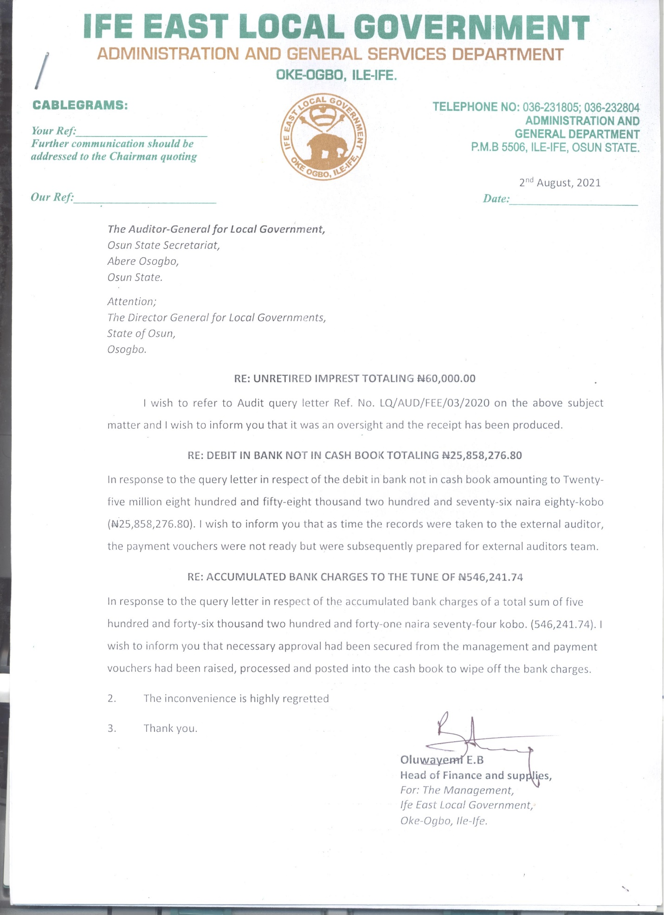

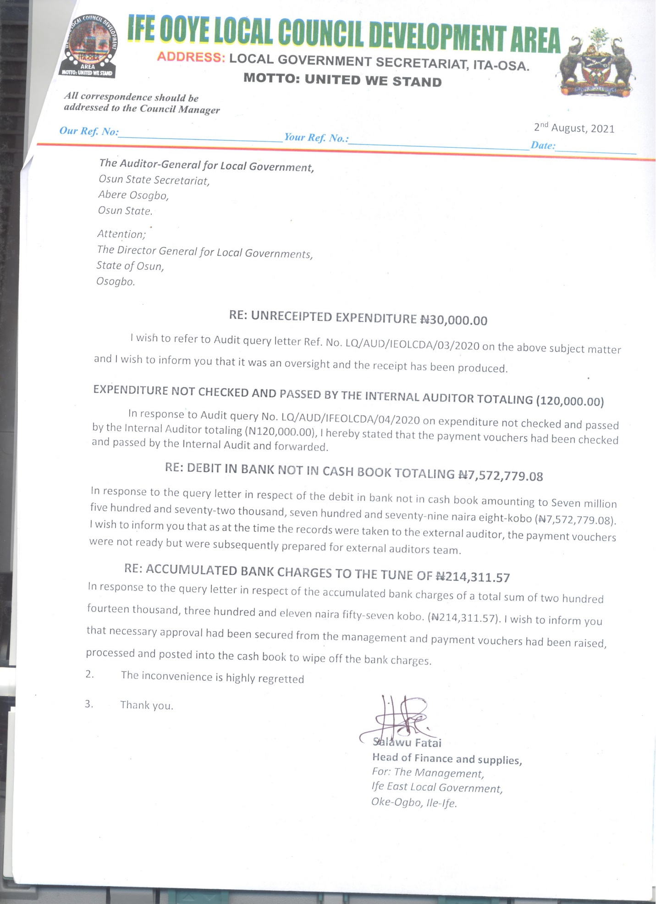

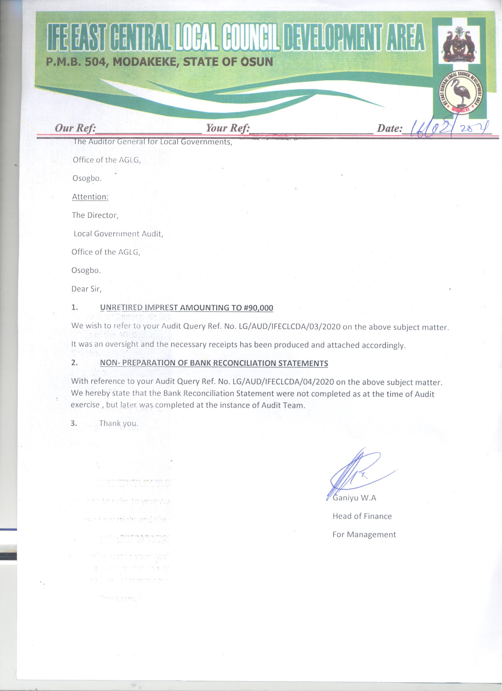

**MANAGEMENT LETTER**

**IFE EAST LOCAL GOVERNMENT, OKE OGBO**

**OBSERVATIONS AND INTERNAL CONTROL REVIEW FOR THE FINANCIAL YEAR ENDED 31ST DECEMBER, 2020**

**1. UNRETIRED IMPREST TOTALLING (#60,000.00):** It was observed that the monthly imprest of Sixty Thousand Naira was not supported with relevant documents to support the genuineness of the expenditure contrary to Financial Memoranda No. 14:16-18 which states that, contrary to Financial Memoranda No.14:27 which states that, “Imprest shall be retired when the purpose for which the imprest was granted is completed or at such intervals as are prescribed when the imprest is approved. However, all imprests shall automatically be retired at the end of each financial year’’.

***RISK:***

*Government Fund might not have been used for official purpose.*

***MANAGEMENT RESPONSE:***

*It was an oversight, and the receipt would be produced.*

***RECOMMENDATION-***

*Proper recording of petty cash should be done and all payments must be retired immediately and presented for audit verification*

**IFE OOYE LOCAL COUNCIL DEVELOPMENT AREA, ITA-OSA**

**OBSERVATIONS AND INTERNAL CONTROL REVIEW FOR THE FINANCIAL YEAR ENDED 31ST DECEMBER, 2020**

**1. UNRECEIPTED EXPENDITURE TOTALLING (#30,000.00):** It was observed during the Audit Inspection that the sum of Thirty thousand naira (#30,000.00) was released for the Monthly meeting of Community Development Council in Ife-Ooye Local Council Development Area, Ita-Oosa contrary to Financial Memoranda 14:17 which states that, “An official printed receipt must be obtained and attached to the payment voucher in respect of a payment to Government, another Local Government or a Commercial firm. If the printed receipt covers more than one payment voucher, reference to the number of the payment voucher to which the receipt is attached, shall be entered on the other vouchers”.

***RISK:***

*This was an indication that the purported items might not have been purchased thereby resulting to loss of Local Government fund.*

***MANAGEMENT RESPONSE:***

*It was an oversight, and the receipt would be produced.*

***RECOMMENDATION-***

*All necessary supporting documents such as store receipt voucher and store issued vouchers should be attached to the payment vouchers before put into use.*

**2. EXPENDITURE NOT CHECKED AND PASSED BY THE INTERNAL AUDITOR TOTALLING (#120,000.00):** It was observed during the Audit Inspection that the payment vouchers totaling One hundred and Twenty thousand naira (#120,000.00) were not checked and passed by the Internal Auditor. Also, the payment was not supported with proper records or accounts like bills or receipts to justify the authenticity of the payment contrary to the provision of Financial Memoranda No. 40:10 which states that, “Before any payment is made, a prepayment audit of vouchers and supporting documents shall be made by the Internal Auditor on all payment vouchers to verify that the provision of these Financial Memoranda have been followed in all respects, the payment is one properly authorized and correctly charged to the stated sub-head or account, and that sufficient funds are available to meet it”.

***RISK:***

*Not subjecting payment vouchers to Internal Audit check before payment was an indication of weak Internal Control System which could result to misappropriation of public fund.*

***MANAGEMENT RESPONSE:*** *The payments were not subjected to prepayment audit before payment was made.*

***RECOMMENDATION:***

*The Internal Auditor should ensure that prepayment and post payment audit were carried out on all transactions of the Local Government.*

**IFE EAST-CENTRAL LOCAL COUNCIL DEVELOPMENT AREA, MODAKEKE**

**OBSERVATIONS AND INTERNAL CONTROL REVIEW FOR THE FINANCIAL YEAR ENDED 31ST DECEMBER, 2020**

**1.** **UNRETIRED IMPREST TOTALLING (#90,000.00):** It was observed that the monthly imprest of Ninety thousand naira was not supported with relevant documentary evidence to ascertain the genuineness of the expenditure contrary to Financial Memoranda 14:27 which states that, “Imprest shall be retired when the purpose for which the imprest was granted is completed or at such intervals as are prescribed when the imprest is approved. However, all imprests shall automatically be retired at the end of each financial year ’’. This had been made a subject of Audit Query No. LQ/AUD/IFECLCDA/03/2020.

***RISK:***

*Government Fund might not have been used for official purpose.*

***MANAGEMENT RESPONSE:*** *It was an oversight and the receipts were eventually produced.*

***RECOMMENDATION-***

*Proper recording of petty cash should be done and all payments must be retired immediately and presented for audit verification.*

**2.** **NON-PREPARATION OF BANK RECONCILIATION STATEMENTS:**  It was revealed during the Audit Inspection that the Local Government did not submit the Bank Reconciliation Statement as at 31st December, 2020 for Audit Scrutiny contrary to the provision of Financial Memoranda 19:23 which stipulates that “At the end of the month’s detailed statement must be obtained from the bank of the month’s transactions on the Local Government’s account, and where this can be obtained, a certification of the balance on the Local Government’s account. The transactions according to the bank statement must be checked against the entries in the Local Government’s Cash Book and the two records reconciled”.

The Head of Finance must be alive to his responsibility in this regard.

***RISK:***

*Non-preparation of Bank Reconciliation Statement by the Head of Finance could conceal fraud, errors perpetrated in the Bank transactions through extraneous debits in the Bank Statements, and Cashbook collusion between the signatories.*

***MANAGEMENT RESPONSE:*** *Payment vouchers in respect of the transactions were under processing as at the time of Audit exercise.*

***RECOMMENDATION:***

*The head of Finance had been instructed to prepare the Bank Reconciliation Statements and forward same with all details to the Auditor-General without further delay.*

**IFE EAST-CENTRAL LOCAL COUNCIL DEVELOPMENT AREA, MODAKEKE**

**OBSERVATIONS AND INTERNAL CONTROL REVIEW FOR THE FINANCIAL YEAR ENDED 31ST DECEMBER, 2020**

**1.** **UNRETIRED IMPREST TOTALLING (#90,000.00):** It was observed that the monthly imprest of Ninety thousand naira was not supported with relevant documentary evidence to ascertain the genuineness of the expenditure contrary to Financial Memoranda 14:27 which states that, “Imprest shall be retired when the purpose for which the imprest was granted is completed or at such intervals as are prescribed when the imprest is approved. However, all imprests shall automatically be retired at the end of each financial year ’’. This had been made a subject of Audit Query No. LQ/AUD/IFECLCDA/03/2020.

***RISK:***

*Government Fund might not have been used for official purpose.*

***MANAGEMENT RESPONSE:*** *It was an oversight and the receipts were eventually produced.*

***RECOMMENDATION-***

*Proper recording of petty cash should be done and all payments must be retired immediately and presented for audit verification.*

**2.** **NON-PREPARATION OF BANK RECONCILIATION STATEMENTS:**  It was revealed during the Audit Inspection that the Local Government did not submit the Bank Reconciliation Statement as at 31st December, 2020 for Audit Scrutiny contrary to the provision of Financial Memoranda 19:23 which stipulates that “At the end of the month’s detailed statement must be obtained from the bank of the month’s transactions on the Local Government’s account, and where this can be obtained, a certification of the balance on the Local Government’s account. The transactions according to the bank statement must be checked against the entries in the Local Government’s Cash Book and the two records reconciled”.

The Head of Finance must be alive to his responsibility in this regard.

***RISK:***

*Non-preparation of Bank Reconciliation Statement by the Head of Finance could conceal fraud, errors perpetrated in the Bank transactions through extraneous debits in the Bank Statements, and Cashbook collusion between the signatories.*

***MANAGEMENT RESPONSE:*** *Payment vouchers in respect of the transactions were under processing as at the time of Audit exercise.*

***RECOMMENDATION:***

*The head of Finance had been instructed to prepare the Bank Reconciliation Statements and forward same with all details to the Auditor-General without further delay.*

**INTERNAL AUDITOR’S REPORT**

**1.** The activities of the Internal control units are not effected on the activities of the Council particularly, on the Revenue generation and monitoring. The IGR is reducing monthly.

**2.** The Internal Auditor is always fond of late submission of his quarterly reports. The activities of the Internal Control Units are not felt on the Rate Section and the IGR is at reducing rate monthly.

**LIST OF PROJECTS EXECUTED BY IFE EAST LOCAL GOVERNMENT, OKE-OGBO [JANUARY – DECEMBER 2020]**

|  |  |  |  |  |  |  |
| --- | --- | --- | --- | --- | --- | --- |
| **S/N** | **NAME OF PROJECT** | **LOCATION** | **PROJECT COST** | **AMOUNT RELEASED** | **BALANCE** | **REMARK** |
| 1 | Bill of Engineering Measurement and Evaluation | Village | 2,600,000.00 | 2,600,000.00 | Nill | Completed |
| 2 | Grading | Adeyemo,Iloro,Oke Ayo Zone | 950,000.00 | 950,000.00 | Nill | Completed |
| 3 | Grading | Orilonise, Moore Falolu,Ayelabowo,Kanmi Area Kosere and Oke ayo | 950,000.00 | 950,000.00 | Nill | Completed |
| 4 | Grading | Mokuro Road Idita Zone 1-3 | 954,000.00 | 954,000.00 | Nill | Completed |
| 5 | Grading Filling of Potholes and repairsof damaged | NTA Road | 950,000.00 | 950,000.00 | Nill | Completed |
| 6 | Grading | Ile Funfun Ilesa Road | 930,000.00 | 930,000.00 | Nill | Completed |
| 7 | Grading | Saga, Obalayan road | 950,000.00 | 950,000.00 | Nill | Completed |
| 8 | Block Line Drainage | Oke-Ogbo junction to lokore Junction | 345,000.00 | 345,000.00 | Nill | Completed |
| 9 | Construction Of Forty-five lock up shop(Two blocks) | Ejigbomekun market | 16,873,000.00 | 13,158,000.00 | 3,715,000.00 | On-Going |
|  | **TOTAL** |  | **25,502,000.00** | **21,787,000.00** | **3,715,000.00** |  |

**LIST OF PROJECT EXECUTED BY IFE OOYE LOCAL COUNCIL DEVELOPMENT AREA, ITA-OOSA [JANUARY – DECEMBER 2020]**

|  |  |  |  |  |  |  |
| --- | --- | --- | --- | --- | --- | --- |
| **S/N** | **NAME OF PROJECT** | **LOCATION** | **PROJECT COST** | **AMOUNT RELEASED** | **BALANCE** | **REMARK** |
| 1 | Grading of deplorable earth Roads | Yekemi Ward | 1,933,300.00 | 1,800,000.00 | 133,300 | On-Going |
| 2 | Grading of deplorable earth Roads | Okerewe Ward 3A&B | 1,841,200.00 | 625,000.00 | 1,216,200.00 | On-Going |
| 3 | Grading of deplorable earth Roads | Okerewe Ward 1 | 1,725,500.00 | 1,200,000.00 | 525,500.00 | -Do- |
| 4 | Repair of Damage roof and Floor | At block A open Court yard block A extension | 75,000.00 | 75,000.00 | Nill | Completed |
| 5 | Dregging of run-off way | Gbodo | 80,000.00 | 80,000.00 | Nill | Completed |
| 6 | Temporary connected of council Secretariat to IBDECGRID | Ife OOye | 250,000.00 | 172,000.00 | 78,000.00 | On-Going |
| 7 | Desilting,Burglary proof,cart-away of debris & filling of earth roads | Obalejugbe junction & Olubodo | 155,700.00 | 155,700.00 | Nill | Completed |
| 8 | Purchase of Official car to the office of Council manager | Ife Ooye | 2,500,000.00 | 2,350,000.00 | 150,000.00 | On-Going |
|  | **TOTAL** |  | **8,560,700.00** | **6,457,700.00** | **2,103,000.00** |  |