STATE GOVERNMENT OF OSUN, NIGERIA.

REPORT OF

THE

AUDITOR-GENERAL

FOR

LOCAL GOVERNMENTS

ON THE ACCOUNTS OF

OROLU LOCAL GOVERNMENT

IFON-OSUN

FOR THE YEAR ENDED

31ST DECEMBER, 2020.

**TABLE OF CONTENTS**

|  |  |  |
| --- | --- | --- |
|  | **DETAILS** | **PAGE** |
| 1 | TITLE PAGE | **1** |
| 2 | TABLE OF CONTENTS | **2** |
| 3 | LIST OF ABBREVIATIONS | **3** |
| 4 | STATEMENT OF RESPONSIBILITY FOR THE PREPARATION OF FINANCIAL STATEMENTS | **4** |
| 5 | STATEMENT OF RESPONSIBILITY OF THE AUDITOR-GENERAL | **5** |
| 6 | AUDIT CERTIFICATE | **6** |
| 7 | BASIS OF AUDIT OPINION | **7** |
| 8 | STATEMENT OF COMPLIANCE | **8** |
| 9 | STATEMENT OF ACCOUNTING POLICIES | **9-11** |
| 10 | GENERAL COMMENTS | **12-13** |
| 11 | **COMMENTS ON FINANCIAL STATEMENTS**   1. STATEMENT OF FINANCIAL PERFORMANCE 2. STATEMENT OF FINANCIAL POSITION | **14-18** |
| 12 | **AGGREGATE GENERAL PURPOSE FINANCIAL STATEMENTS**   1. CONSOLIDATED STATEMENT OF FINANCIAL POSITION. 2. CONSOLIDATED STATEMENT OF FINANCIAL PERFORMANCE. 3. CONSOLIDATED STATEMENT OF CASH FLOW. 4. CONSOLIDATED STATEMENT OF COMPARISON OF FINANCIAL OPERATIONS. 5. CONSOLIDATED STATEMENT OF NET ASSETS AND EQUITY 6. NOTES TO THE ACCOUNT | **19-32** |
| 13 | **FISCAL OPERATION REPORT**  i STATISTICAL AND ACCOUNTING RATIOS  ii NON-FINANCIAL DISCLOSURE | **33-35** |
| 14 | MANAGEMENT LETTER | **35-40** |
| 15 | LIST OF PROJECTS EXECUTED IN THE LOCAL GOVERNMENT | **41** |

**LIST OF ABBREVIATIONS**

1. AGLG - AUDITOR-GENERAL FOR LOCAL GOVERNMENTS
2. AO - AREA OFFICE/ADMINISTRATIVE OFFICE
3. FAAC - FEDERATION ACCOUNTS ALLOCATION COMMITTEE
4. F.M - FINANCIAL MEMORANDUM
5. FOR - FISCAL OPERATION REPORT
6. GPFS - GENERAL PURPOSE FINANCIAL STATEMENTS
7. IGR - INTERNALLY GENERATED REVENUE
8. ISSAI - INTERNATIONAL STANDARDS OF SUPREME AUDIT INSTITUTIONS
9. IPSAS - INTERNATIONAL PUBLIC SECTOR ACCOUNTING STANDARD
10. JAAC - JOINT ACCOUNTS ALLOCATION COMMITTEE
11. LGA - LOCAL GOVERNMENT AREA
12. LCDA -LOCAL COUNCIL DEVELOPMENT AREA
13. LGSC - LOCAL GOVERNMENT SERVICE COMMISSION
14. LGSPB - LOCAL GOVERNMENTS STAFF PENSION BOARD
15. LGLB - LOCAL GOVERNMENT LOANS BOARD
16. NCOA - NATIONAL CHART OF ACCOUNTS
17. NBV - NET BOOK VALUE
18. MLGCA- MINISTRY OF LOCAL GOVERNMENT AND CHIEFTAINCY AFFAIRS
19. PPE - PROPERTY, PLANTS AND EQUIPMENT
20. PSE - PUBLIC SECTOR ENTITIES
21. PHCB - PRIMARY HEALTH CARE BOARD
22. VAT - VALUE ADDED TAX

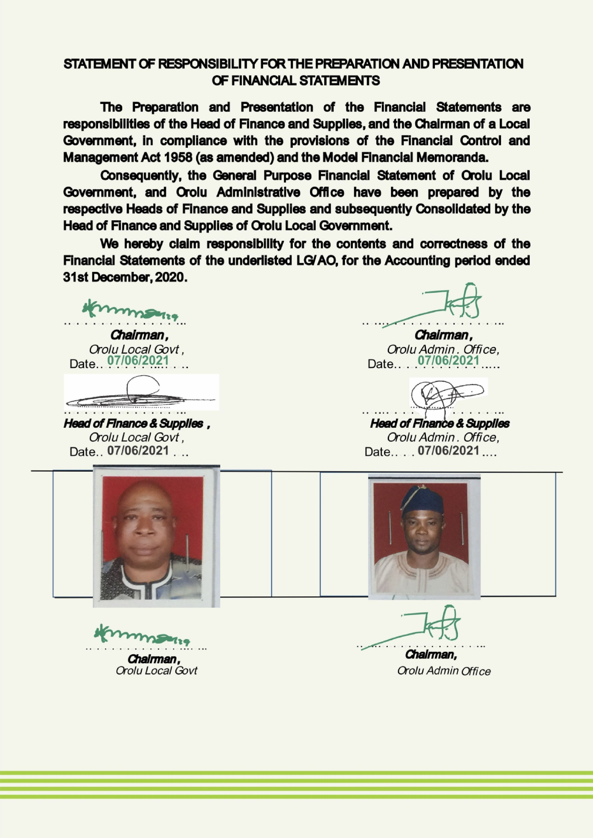

**STATEMENT OF FINANCIAL RESPONSIBILITY**

In compliance with the provisions of Finance Control and Management Act 1958 (as amended), the Model Financial Memoranda (1991 as amended), the Laws of Osun State 2002 (as amended) and with the provisions of the Constitution of the Federal Republic of Nigeria, 1999.

Consequently, the Heads of Finance of main Local Governments in the State of Osun are responsible for the preparation of the respective Local Government GPFS as well as with the Financial Statement of the subsidiary LCDAs, Area/Administrative offices, as may be applicable.

However, both the Head of Finance and Chairman of a Local Government, (the Accounting Officer) are responsible for establishing and maintaining a system of internal control designed to provide reasonable assurance that the transactions and Financial Statements give a fair presentation of the financial operations of the Local Government.

The acknowledgment of responsibility for the preparation of Financial Statement signed by Heads of Finance and Chairmen of the Orolu Local Government and subsidiary LCDAs is attached to this report.

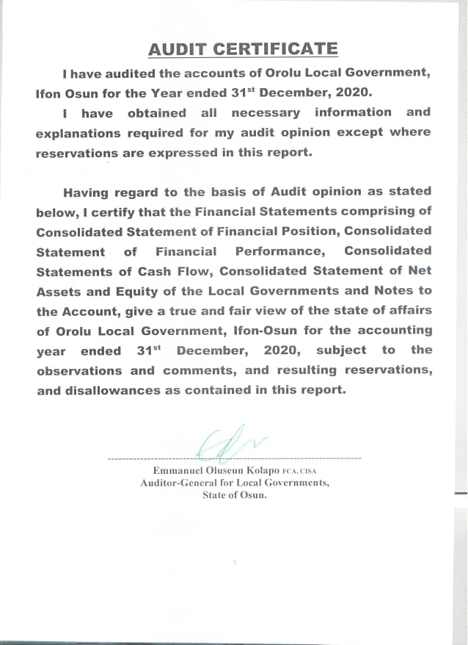

**STATEMENT OF RESPONSIBILITY OF THE AUDITOR-GENERAL.**

It is my responsibility to Audit the accounts of the Local Governments, the State Joint Local Government Account, and all offices of the Local Government (inclusive of Orolu Local Government) as stipulated by the Laws of Osun State and the Financial Memoranda; and to form an independent opinion based on the Audit of the Financial Statements and accompany notes submitted by the Head of Finance and Supply of Orolu Local Governments, in the state.

**BASIS OF AUDIT OPINION**

In the course of auditing the accounts of Orolu Local Governments Ifon-Osun in the State of Osun, I have complied with the requirement and stipulations of the International Standards on Auditing, the Generally Acceptable Auditing Standards, International Standards of Supreme Audit Institutions (ISSAI,) Laws of Osun State, International Public Sector Accounting Standards and Audit Guide of the Office of the Auditor-General for Local Governments, Osun State.

I have conducted Financial and Compliance audit on the Finances of the Local Governments and. Projects and Programmes were reasonably evaluated and verified on the principle of Performance Auditing. All items of Revenue and Expenditure were captured in the course of the Audit and Audit Tests were conducted on procedures, transactions and balances. Consequently 100% Substantive Test was done on all items of Revenue and Expenditure; and Assets and Liabilities, and appropriate Audit Tests of Control were conducted on procedures and transactions.

Where paucity of available Audit resources warranted sampling, objective statistical sampling techniques were applied to ensure representativeness, completeness, relevance, and timeliness in the determination of sampling elements. This ensured reliability of Audit Opinion, giving due recognition to principle of materiality. For example, multi-layered and structural sampling method was applied for verification of numbers and Emoluments of Teaching and Non-Teaching staff of the Orolu Local Government Education Authority.

**STATEMENT OF COMPLIANCE**

The Accounting Policies have been consistently applied on preparation of the Financial Statements of Orolu Local Government in the year under review. These have been prepared on the basis of Historical Cost and in accordance with IPSAS Accruals and other applicable standards. The Cash Flow Statement was prepared using the Direct Method. The basis of measurement is Naira and kobo which is the functional and reporting currency of the Federal Republic of Nigeria of which Osun State and Orolu Local Governments are constituents.

The accounts of Orolu Local Governments, Ifon-Osun have been audited and reported upon.

Audit noted some instances of non-compliance in the Local Governments, and appendages, with the due process in revenue collection and payment procedure contrary to the provision of Financial Memoranda and relevant Guidelines. The associated internal control weaknesses have been addressed. The inspection reports (letters of Internal Control weaknesses) for the year 2020 have been issued and forwarded to the appropriate quarters for responses and compliance as required.

The queries were replied and appropriate recommendations were made as contained in the Management letter included.

**STATEMENT OF ACCOUNTING POLICIES**

1. **Basis of Preparation (IPSAS 1)**

The General Purposes Financial Statements were prepared under the historical cost convention and in accordance with IPSAS Accrual Basis and other applicable standards and conventions as may be defined by relevant Statutes.

1. **Accounting Period**

The accounting year (fiscal year) to which the report relates is 1st January to 31st December, 2020.

1. **Reporting Currency**

The General Purposes Financial Statements are prepared in the Nigerian Naira (NGN).

1. **Principal Statements in the General Purposes Financial Statements**
2. Statements of Financial Performance.
3. Statements of Financial Position
4. Statements of Cash flow.
5. Statements of Comparison of Budgeted and Actual Amounts
6. Statements of Changes in Net Asset/Equity
7. Notes to the GPFS.
8. **Consolidation Policy- IPSAS 6**

The Heads of Finance of the each Local Governments, LCDAs, and A/Cs and A/Os are required to prepare their individual GPFS at the end of the financial year on Accrual Basis of Accounting.

Each Local Government is a creation of the Constitution and none is subservient to the other. However in this situation, there are subsidiary entities such as LCDAs and Area offices, which are consolidated with the main Local Government. Consequently, the Heads of Finance of the 30 main Local Governments consolidate the GPFS of their respective main Local Government with the subsidiary LCDAs, AOs, and Ad. Os.

***The duty of the Auditor-General for Local Governments is not to prepare or consolidate Local Governments’ accounts, but to Audit and Aggregate the prepared Financial Statements in line with the Fiscal Operation Report Guideline.***

1. **Statement of Cash Flow** was prepared using the direct method (IPSAS 2) and it consists of Operating, Investing and Financing activities.
2. **Inventories (IPSAS 12) -** Inventories were measured initially at cost, and subsequently measured using the FIFO method.
3. **PROPERTY, PLANT & EQUIPMENT (PPE) – IPSAS 17**

All PPEs were stated at historical cost less accumulated depreciation and impairment losses.

1. **DEPRECIATION**

The cost of PPE shall be written off, from the time they are brought into use, on a straight line basis over their expected useful lives less any estimated residual value as follows:

1. Furniture & Fittings - 20%
2. Motor Vehicle - 20%
3. Plant & Equipment - 20%
4. Infrastructural Asset - 10%
5. Building - 2%
6. Office Equipment - 20%
7. **REVALUATION**
8. The Assets’ residual values and useful lives are reviewed at the end of the year.
9. **IMPAIRMENT**

Test for Impairment are done on Property, Plants and Equipments, where it is suspected that Impairment has occurred.

1. **INVESTMENT PROPERTIES – IPSAS 16**

The Investment properties are measured initially at cost, including transaction costs. Subsequent to initial recognition, investment properties are measured using the cost model and are depreciated the same way as PPE.

1. **INDEPENDENT REVENUE FROM NON-EXCHANGE TRANSACTION (IPSAS 23)**
2. Fees; taxes and fines: The Local Government recognised revenue from fees, taxes, and fines when the event occured, and the asset recognition criteria are met.
3. **OTHER REVENUE**

Other Revenues are proceeds that arise outside the Ordinary course of governmental busineess. These include:

1. Gain on disposal of Property, Plant and Equipment

2. Dsiposal of Investment such as Shares, bond etc

Gain on disposal is recognized at the date of control of the asset is passed to the buyer and is determined after deducting the carrying value of the Asset at that time.

1. **UNREMITTED DEDUCTION**

Unremitted deductions are monies owned to the third parties such as tax authorities, associations and other Government Agencies. These include tax deductions and other deductions at source

This amount shall be stated in GPFS at their repayment value, which shall be treated as current liabilities in the Statement of Financial Position.

**16. RESERVE**

Reserves shall be classified under Equity in the Statement of Financial Position which includes Accumulated Surplus/Deficit and the Additional Reserve.

**17. CONTIGENT LIABILITY IPSAS 19**

Contigent liabilities are only disclosed in the Notes to GPFS. Contingent liability is possible obligation arising from past events whose exigencies will be confirmed only by uncertain future event(s) or present obligation arising from the past events that are not recognized because of either an outflow of economic benefit is not probable or this amount of obligation.

**GENERAL CCOMMENTS**

I have audited the accounts of Orolu Local Government, Ifon Osun (including elements of Local Government fund in various Agencies and Institutions of Government, comprising Traditional Councils, LGSPB, LGSC, SUBEB, O’Meals and other Jointly executed programmes and projects of Local Governments) for the financial year ended 31st December 2020, as required by Cap 72, Part 10 of the Laws of Osun State 2002, (as amended).

**AUTHORITY FOR DISBURSEMENTS FROM JAAC ACCOUNT:** Disbursements from JAAC accounts were made in consonance with the prescriptions of the House of Assembly while monthly distributions were collectively decided by the Chairmen of Orolu Local Government and other Chairmen, all of whom were members of the Joint Account Allocation Committee.

**FULL ADOPTION OF IPSAS ACCRUALS:** 2020 GPFS reports were prepared in compliance with IPSAS Accrual which was fully adopted by Local Governments in the State of Osun in 2017.

The previous accounting training on conversion to IPSAS Accruals, severally sponsored by the EU/SLOGOR, LGSC, SUBEB in collaboration with Office of the Auditor-General for Local Governments, with the approval of Mr. Governor, for upgrades and re-training in 2020 have collectively enhanced the proficiency of operators of Local Government accounts in the State

**SCOPE OF AUDIT COVERAGE**: The Audit scope has 100% coverage on all aspects of Revenue and Expenditure, as well as verification of Assets and Liabilities including JAAC Accounts. Revenue covered included all Allocations and VAT from the Federation Accounts and other dependent and Independent Revenue sources of the Local Governments while Expenditure covered included all Capital and Recurrent Expenditure Items in all Local Governments, and LCDAs, all centrally executed Projects and programmes of Local Governments, and Statutory remittances to Traditional Councils.

**BUDGET PREPARATION / EXECUTION**

The Budget for 2020 for Orolu Local Governments was prepared in compliance with new National Chart of Accounts. The 2020 Budget was an improvement on the previous Budget of 2019 as some of the obvious shortcomings observed by the Audit have been addressed.

**PROCUREMENT PRACTICES**

Osun State Public Procurement Law 2015 has been in force in line with global best practice. Procurement Officers was posted to the Local Governments and performed his duties. The Audit observed that the Offices need to be strengthened to further assist in promoting sound and transparent procurement practices in the Local Governments.

**VALUATION AND REVALUATION OF ASSETS**

The office of the Auditor-General for Local Governments embarked on verification exercise on valuation and Revaluation of Assets during the year. This involved Constitution of a standing multi-disciplinary team comprising seasoned and qualified professionals in the fields of valuation, engineering, town planning, medicine, etc. and others as were necessary. Consequently, the realism of the values of non-current asset is enhanced for the year under review. The verification exercise is continuous and value of the Local Governments non-current Assets is being updated monthly.

**INTERNALLY REVENUE GENERATION AND FINANCIAL VIABILITY**

Of concern to the Audit is the paltry amount of revenue that was generated in the Financial Year 2020. Audit examination showed that none of the Local Governments improved significantly on their revenue drive. The Total Internally Revenue generated by the Local Government for 2020 was N1,297,745.00 representing 0.088% the Total Revenue. More efforts at blocking leakages coupled with adequate research by the relevant unit of the Auditor-General for Local Government on comparative revenue advantages of individual Local Government’s office will assist in curbing this unwholesome situation.

**INTERNAL CONTROL WEAKNESS IN THE LOCAL GOVERNMENT AND RELATED AGENCIES**

At the conclusion of the Audit, 79 nos of Audit Queries were issued in respect of 2020 Accounts, involving a total sum of N42,072,746.13.

Queries were issued in respect of irregularities observed in fund management by beneficiary agencies of transfers from Local Governments fund and this had been forwarded to the respective Accounting Officers for response.

The identified internal control weaknesses, the inherent risks, the management Responses and Audit Recommendations are highlighted in Management Letter contained in this Report.

**COMMENTS ON FINANCIAL STATEMENTS**

1. **STATEMENT OF FINANCIAL PERFORMANCE**

**Share of FAAC and VAT:** To ensure completeness of Revenue, the total Allocation received from the Federation Account in respect of Orolu Local Government as contained in JAAC Account was confirmed from the Accountant General of the State and further reference was made to data released by office of Accountant General of the Federation. The total sum of N1,021,635,764.26 was share of FAAC and VAT amounted to #432,323,218.10.

THE CONCEPT OF **DEPENDENT REVENUE.** The term IndependentRevenue or synonymous with Internally Generated Revenue in the IPSAS. However, the term Dependent Revenue is used in proportion in the Report as it depicts the items of Revenue other than Internally Generated Revenue (IGR), i.e. the revenue over which the reporting entirely has no control on its generation or collection.

Essentially the proportion of Dependent Revenue is a measure of the extent of its vulnerability or dependently of the Local Government on finances from sources over which it has no control.

**EXPENDITURE:** As part of the disclosure requirements, expenditures that were Jointly incurred at JAAC level were separately disclosed from those expended at each Local Government Level.

**SUMMARY OF REVENUE FROM JAAC**

|  |  |  |  |  |  |  |  |  |  |  |
| --- | --- | --- | --- | --- | --- | --- | --- | --- | --- | --- |
| **LOCAL GOVERNMENT** | **STATUTORY ALLOCATION** | **VAT** | **EX RATE GAIN** | **FEDERAL GOVT INTERVENTION** | **EXCESS BANK** | **FOREX EQUALISATION** | **ECO** | **ADD FUND FRM SOLID MIN** | **NON-OIL EXCESS REVENUE** | **TOTAL** |
| Orolu | 917,786,652.72 | 432,323,215.08 | 29,742,856.78 | 24,911,884.80 | 754,908.90 | 13,303,366.08 | 20,673,404.39 | 1,537,462.81 | 12,925,227.58 | 1,453,958,979.14 |

**INDEPENDENT REVENUE FROM NON-EXCHANGE TRANSACTION (IPSAS 23)**

Fees; taxes and fines: The Local Government recognised revenue from fees, taxes, and fines when the event occurs, and the asset recognition criteria are met. The Local Government earned and recognised. #1,297,745.00.

**SALARIES AND WAGES – N753,879,974.43**

Salaries and Wages which amounted to N753,879,974.43 comprised of salaries of Staff of the Local Governments, Teaching and Non-Teaching Staff of SUBEB, staff of Local Government Loans Board and the Primary Health Care Board. Salary Payment was centralised in the State of Osun for the year 2020.

**COMMENTS ON ITEMS OF FINANCIAL POSITION**

**CASH AND CASH EQUIVALENTS – #17,793,691.55**

The Aggregate closing cash and cash equivalents amounted to **₦17,793,691.55** for the Local Governments. The Bank Statements and Bank Reconciliation Statements of all Local Governments and Local Government Development Areas as at 31st December, 2020 were verified/examined to ascertain the bank balances. This balance does not include the balance in JAAC account which essentially should be a zero-balance account. Moreover any undistributed amount in the JAAC Account is treated as Receivable to the Local Governments.

**RECEIVABLES - ₦130,407,199.67**

A total sum of N130,407,199.67k was standing as Receivables as at 31st December, 2020. The Receivables include, Revenue Recognised in December 2020 but received in January, 2020 from Joint Allocation Account Committee (JAAC).

**INVENTORIES - ₦48,572,740.00**

The sum of ₦48,572,740.00represents inventories valued at historical cost in the Local Governments as at 31st December, 2020. These include unallocated stores both expendable and non-expendable; and consumable items.

**INVESTMENTS - ₦55,833,085.83**

All the Investments are classified as held-for-sale, while Equity Method is adopted in Recognition and Measurement. Most of the investments were in unquoted companies except for the Preference shares.

**PROPERTY, PLANT AND EQUIPMENT(PPE)**

Items of Property, Plant and Equipment or other Non -Current Assets are stated at Historical Cost Less accumulated Depreciation. Depreciation on Non - Current Assets are calculated to write off cost on valuation in a straight-line basis over the expected useful life on the assets, as follows:

**Particulars Rate%**

Fixture and fitting 20

Motor Vehicle 20

Plant and Equipment 20

Infrastructural Asset 10

Buildings 2

Office Equipment 20

There is need to make adequate provision for depreciation. Accounting for PPE is an area of Audit emphasis where there seems to be a gap in knowledge exhibited by the operators of the Account vis-à-vis expectation.

**PAYABLES - ₦673,115,704.96**

These comprised largely of commitments all over the Local Governments such as allowances, sundry overheads, and unpaid salary and wages, arrears of salaries, unremitted deductions etc. outstanding as at 31stDecember 2020.

**INVESTMENT PROPERTY - ₦79,595,644.84**

The carrying amount of Investment Properties of the Local Governments stood at N79,595,644.84 in the Statement of Financial Position. However, there is no restriction on title or property pledge as securities for liabilities. Straight Line Method of depreciation was applied.

**LONG – TERM BORROWINGS - ₦922,464,480.90**

These are the cumulative amount of various outstanding loans obtained from different sources to finance the under-listed projects:

* 1. Construction of over 10 kilometers of roads, (tagged 10KM roads/Local Government), across all the main Local Governments across the state.
  2. Environmental Projects – includes channelization, chlorination, etc aimed at preserving lives and environments
  3. Intervention Projects including Grading, access to rural areas, etc..
  4. Repayment of Bail Out

**UNREMITTED DEDUCTIONS - ₦103,425,826.14**

These include deductions received from Joint Accounts Allocation Committee (JAAC) and deposits which ought to have been remitted to the appropriate quarters on or before 31st December, 2020. The management of the Local Councils are hereby advised to ensure that all deposits/deductions received are remitted promptly to avert the possibility of unnecessary accumulation of liabilities on Councils financial position

DISCLOSURES: In the statement of Financial Performance the amounts jointly expended by the Local Government is separated from the amount spent in individual Local Government.

**TRANSFER FROM MAIN COUNCILS TO LOCAL COUNCIL DEVELOPMENT AREAS:**

Transfer from main councils to the tune of #32,900,638.95 was made to the Local Council Development Areas and Area Offices in the period under review and was set off in the Consolidated Account.

**OROLU LOCAL GOVERNMENT, IFON-0SUN**

**CONSOLIDATED STATEMENT OF FINANCIAL POSITION AS AT 31ST DECEMBER 2020**

|  |  |  |  |  |
| --- | --- | --- | --- | --- |
| **FINANCIAL POSITION** | | | | |
| **PARTICULAR** |  | **OROLU** | **OROLU ADMIN** | **OROLU CONSOLIDATED** |
| **ASSETS** | **NOTE** |  |  |  |
| **Current Assets** |  |  |  |  |
| **Cash & Cash Equivalents** | **1** | 15,349,803.44 | 2,443,888.11 | 17,793,691.55 |
| **Receivables** | **2** | 122,686,615.48 | 7,720,584.19 | 130,407,199.67 |
| **Prepayment/Advance** | **3** | 3,300,000.00 |  | 3,300,000.00 |
| **Inventories** | **4** | 45,484,140.00 | 3,088,600.00 | 48,572,740.00 |
| **Total Current Asset** |  | 186,820,558.92 | 13,253,072.30 | 200,073,5631.22 |
| **Non Current Asset:** |  |  |  | - |
| **Long Term Loan Granted** |  |  |  | - |
| **Investments** | **5** | 50,166,419.16 | 5,666,666.67 | 55,833,085.83 |
| **Property,Plant & Equipment** | **6** | 1,314,620,666.37 | 510,556,894.24 | 1,825,177,560.61 |
| **Investment Property** | **7** | 79,595,644.84 |  | 79,595,644.84 |
| **Biological Asset** | **8** | 7,917,400.00 | 260,000.00 | 8,177,400.00 |
| **Assets Under Construction(WIP)** | **9** | 24,500,000.00 |  | 24,500,000.00 |
| **Total Non-Current Asset** |  | 1,476,800,130.37 | 516,483,560.91 | 1,993,283,691.28 |
| **Total Asset** |  | 1,663,620,689.29 | 529,736,633.21 | 2,193,357,322.50 |
| **LIABILITIES** |  |  |  | - |
| **Current Liabilities:** |  |  |  | - |
| **Deposit** |  |  |  | - |
| **Unremitted Deductions** | **10** | 92,734,217.01 | 10,691,609.13 | 103,425,826.14 |
| **Short Term Loan & Debts** | **11** |  |  | - |
| **Payables** | **12** | 517,960,934.62 | 155,154,770.34 | 673,115,704.96 |
|  |  |  |  | - |
| **Short Term Provisions** |  |  |  | - |
| **Total Current Liability** |  | 610,695,151.63 | 165,846,379.47 | 776,541,531.10 |
| **Non Current Liabilities:** |  |  |  | - |
| **Long Term Borrowing** | **13** | 538,717,835.56 | 383,746,645.34 | 922,464,480.90 |
| **Total Liabilities** |  | 1,149,412,987.19 | 549,593,024.81 | 1,699,006,012.00 |
| **Net Assets** |  | 514,207,702.10 | (19,856,391.60) | 494,351,310.50 |
| **Financed by** |  |  |  | - |
| **Reserve** | **14** | 152,595,024.08 | 46,595,959.10 | 199,190,983.18 |
| **Net Surplus/Deficit** | **15** | 361,612,678.02 | (66,452,350.70) | 295,160,327.32 |
| **Total** |  | 514,207,702.10 | (19,856,391.60) | 494,351,310.50 |

**OROLU LOCAL GOVERNMENT, IFON-0SUN**

**CONSOLIDATED STATEMENT OF FINANCIAL PERFORMANCE AS AT 31ST DECEMBER 2020**

|  |  |  |  |  |
| --- | --- | --- | --- | --- |
| **PERFORMANCE** | | | | |
| **PARTICULAR** | **NOTE** | **OROLU** | **OROLU ADMIN** | **OROLU CONSOLIDATED** |
| **Government Share of FAAC(Statutory Revenue)** | **16** | 917,786,652.70 |  | 917,786,652.70 |
| **Government Share of VAT** | **17** | 432,323,215.10 |  | 432,323,215.10 |
| **Additional Fund** | **18** | 1,537,462.81 |  | 1,537,462.81 |
| **Revenue Furniture Allowance** | **19** |  |  | - |
| **Ex Rate Gain** | **20** | 29,742,856.78 |  | 29,742,856.78 |
| **Augmentation** | **21** |  |  | - |
| **Federal Govt Intervention Fund** | **22** | 24,911,884.80 |  | 24,911,884.80 |
| **ECO** | **23** | 20,673,404.39 |  | 20,673,404.39 |
| **Solid Minerals** | **24** |  |  | - |
| **Non-Oil Revenue** | **25** | 12,925,227.88 |  | 12,925,227.88 |
| **Distributable from Goods & Valuables** | 26 |  |  | - |
| **Forex Equalisation** | **27** | 13,303,366.08 |  | 13,303,366.08 |
| **10% IGR** | **28** |  |  | - |
| **Excess Bank Charges** | **29** | 754,908.80 |  | 754,908.80 |
| **Aids & Grants** | 30 |  |  | - |
| **Overpayment Recovery** | 31 |  |  | - |
| **Sub-Total Dependent Revenue** |  | 1,453,958,979.36 | - | 1,453,958,979.36 |
| **Transfer from Main Council** | **32** |  | 32,900,638.95 | 32,900,638.95 |
| **Tax Revenue** | **33** | 54,600.00 | 37,900.00 | 92,500.00 |
| **Non-Tax Revenue** | **34** | 495,065.00 | 710,180.00 | 1,205,245.00 |
| **Other Income** | **35** |  |  | 1,297,745.00 |
| **Sub-Total Independent Revenue** |  | 549,665.00 | 33,648,718.95 | 34,198,383.95 |
| **Total Revenue** |  | 1,454,508,644.36 | 33,648,718.95 | 1,455,256,724.36 |
| **EXPENDITURE** |  |  |  | - |
| **JOINTLY EXPENDED** |  |  |  | - |
| **Salaries & Wages** | **36** | 753,879,974.43 |  | 753,879,974.43 |
| **Social Benefits** | **37** | 300,000.00 |  | 300,000.00 |
| **Overhead Cost** | **38** | 22,418,956.72 |  | 22,418,956.72 |
| **Grants & Social Contribution** | **39** | 4,445,000.00 |  | 4,445,000.00 |
| **Transfer to Other Agencies** | **40** | 473,190,690.00 |  | 473,190,690.00 |
| **Allowances** | **41** | 271,388.28 |  | 271,388.28 |
| **Public Debt Charge** |  |  |  | - |
| **L/GOVERNMENT EXPENDITURE** |  |  |  | - |
| **Social Benefits** | **42** | 3,797,000.00 | 3,090,000.00 | 6,887,000.00 |
| **Overhead Cost** | **43** | 63,525,729.50 | 5,801,979.20 | 69,327,708.70 |
| **Grants & Social Contribution** | **44** | 49,549,411.73 | 11,029,556.76 | 60,578,968.49 |
| **Depreciation** | **45** | 124,227,471.74 | 46,219,409.33 | 170,446,881.07 |
| **Transfer to LCDA** | **46** | 32,900,638.95 |  | - |
| **Allowances** | **47** | 290,000.00 | 14,217,250.00 | 14,507,250.00 |
| **Stationaries** |  | 200,000.00 |  | 200,000.00 |
|  |  |  |  |  |
| **Impairment** | **48** |  |  | - |
| **Tax Expenses** |  |  |  |  |
| **Bail-Out Repayment** |  |  |  | - |
| **Audit Fees** | **49** |  |  | - |
| **Stabilization Fund** | **50** |  |  | - |
| **Disposal of Assets** |  |  |  |  |
| **Revenue Refunded** |  |  |  |  |
| **Total Expenditures** |  | 1,508,108,364.92 | 80,141,459.77 | 1,555,349,185.74 |
| **Net Surplus/Deficit** | **51** | (53,599,720.56) | (46,492,740.82) | (100,092,461.38) |
| **Net Surplus/Deficit 31/12/2019** |  | 415,212,398.58 | (19,959,609.88) | 395,252,788.70 |
| **Net Surplus/Deficit 31/12/2020** | **52** | 361,612,678.02 | (66,452,350.70) | 295,160,327.32 |

**OROLU LOCAL GOVERNMENT, IFON-0SUN**

**CONSOLIDATED STATEMENT OF CASHFLOW AS AT 31ST DECEMBER 2020**

|  |  |  |  |  |
| --- | --- | --- | --- | --- |
| CASHFLOW STATEMENT | | | | |
| **Operating Activities** | **NOTE** | OROLU | OROLU ADMIN | OROLU CONSOLIDATED |
| **INFLOW** |  |  |  |  |
| **Statutory Revenue(JAAC)** | **53** | 946,719,366.67 |  | 946,719,366.67 |
| **Value Added Tax** | **54** | 383,013,419.82 |  | 383,013,419.82 |
| **Additional Fund** | **55** | 1,537,462.81 |  | 1,537,462.81 |
| **Furniture Allowance** |  |  |  | - |
| **Exchange Rate Gain** | **56** | 29,070,920.80 |  | 29,070,920.80 |
| **Others(Augmentation** |  |  |  | - |
| **Federal Govt Intervention Fund** | **57** | 24,911,884.80 |  | 24,911,884.80 |
| **Excess Crude Oil** | **58** | 20,673,404.39 |  | 20,673,404.39 |
| **Solid Minerals** | **59** |  |  | - |
| **Non-Oil Revenue** | **60** | 12,925,227.88 |  | 12,925,227.88 |
| **Distributable Good & Valuable** | **61** |  |  | - |
| **Forex Equalisation** | **62** | 12,110,148.09 |  | 12,110,148.09 |
| **10% IGR** | **63** |  |  | - |
| **Excess Bank Charges** | **64** | 754,908.80 |  | 754,908.80 |
| **Sub Total Dependent Revenue** |  | 1,431,716,744.06 |  | 1,431,716,744.06 |
| **Transfer from Main Council** | **65** |  | 32,900,638.95 | 32,900,638.95 |
| **Tax Revenue** | **66** | 54,600.00 | 37,900.00 | 92,500.00 |
| **Non-Tax Revenue** | **67** | 495,065.00 | 710,180.00 | 1,205,245.00 |
| **Aids and Grants** | **68** |  |  | - |
| **Overpayment Recovery** |  |  |  | - |
| **Sub Total Independent Revenue** |  | 549,665.00 | 748,080.00 | 1,297,745.00 |
| **Total Inflow Operating Activities** |  | **1,432,266,409.06** | **33,648,718.95** | **1,465,915,128.01** |
| **OUTFLOW** |  |  |  | - |
| **Salaries & Wages** | **69** | 753,012,013.49 |  | 753,012,013.49 |
| **Overheads Cost** | **70** | 63,325,729.50 | 5,801,979.20 | 69,327,708.70 |
| **Allowances** | **71** | 538,772.59 | 14,217,250.00 | 14,756,022.59 |
| **Social Benefits** | **72** | 4,097,000.00 | 3,090,000.00 | 7,187,000.00 |
| **Social Contributions** | **73** | 56,829,411.65 | 11,029,556.76 | 67,858,968.41 |
| **Stabilisation Fund** | **74** | - |  | - |
| **Transfer to LCDA** | **75** | 32,900,638.95 |  | - |
| **Subeb-Grant** |  |  |  | - |
| **Audit Fee** | **76** |  |  | - |
| **Transfer to Other Govt Agencies** | **77** | 368,482,233.89 |  | 368,482,233.89 |
| **OHIS** |  |  |  | - |
| **Contingent Liabilities Paid** |  |  |  |  |
| **Revenue Refunded** |  |  |  |  |
| **Total Outflow from Operating Activities** |  | **1,279,385,800.07** | **34,138,785.96** | **1,280,623,947.08** |
| **Net Cashflow from Operating Activities** |  | **152,880,608.99** | **(490,067.01)** | **152,390,541.98** |
| **INVESTING ACTIVITIES** |  |  |  | - |
| **Total Inflow from Investing Activities** |  |  |  | - |
| **CashFlow from Investing Activities:** |  |  |  | - |
| **Adminstrative Sector** | **78** | - | - | - |
| **Economic Sector** | **79** | 115,579,192.47 | 2,783,200.80 | 118,362,392.47 |
| **Total Outflow from Investing Activites** |  | 115,579,192.47 | 2,783,200.00 | 118,362,392.47 |
| **Net Cashflow from Investing Activities** |  | (115,579,192.47) | (2,783,200.00) | (118,362,392.47) |
| **Inflow from Financing Activities** |  |  |  | - |
| **Bank Overdraft** | **80** |  |  | - |
| **Total Inflow from Financing Activities** |  |  |  |  |
| **OUTFLOW(REPAYMENT)** |  |  |  | - |
| **Bail-Out Repayment** | **81** |  |  | - |
| **10km Road** | **82** | 24,544,812.32 |  | 24,544,812.32 |
| **Water Project** | **83** |  |  | - |
| **Environmental Sanitation Loan** | **84** | 3,886,086.72 |  | 3,886,086.72 |
| **Loan Repayment (Inherited)** | **85** |  |  | - |
| **Bank Loan** | **86** |  |  | - |
| **Intervention Loan** | **87** | 5,736,945.12 |  | 5,736,945.12 |
| **Total Outflow from Financing Activities** |  | **34,167,844.16** | **-** | **34,167,844.16** |
| **Net Cashflow from Financing Activities** | **88** | **(34,167,844.16)** | **-** | **(34,167,844.16)** |
| **Cash and Cash Equivalent for the year** |  | **3,133,572.36** | **(3,273,267.01)** | **(139,694.65)** |
| **Cash and Cash Equivalent 01/01/2020** |  | **12,216,231.08** | **5,717,155.12** | **17,933,386.20** |
| **Cash and Cash Equivalent 31/12/2020** | **89** | **15,349,803.44** | **2,443,888.11** | **17,793,691.55** |

**OROLU LOCAL GOVERNMENT, IFON-0SUN**

**CONSOLIDATED STATEMENT OF COMPARISON OF BUDGET AND ACTUAL AS AT 31ST DECEMBER 2020**

|  |  |  |  |  |  |  |  |  |  |  |
| --- | --- | --- | --- | --- | --- | --- | --- | --- | --- | --- |
|  |  | **OROLU** | | | **OROLU ADMINISTRATIVE** | | | **OROLU CONSOLIDATED** | | |
| **PARTICULAR** | **NOTE** | **ACTUAL** | **FINAL BUDGET** | **VARIANCE** | **ACTUAL** | **FINAL BUDGET** | **VARIANCE** | **ACTUAL** | **FINAL BUDGET** | **VARIANCE** |
| **Government Share of FAAC(Statutory Revenue)** |  | 917,786,652.70 | 726,721,201.46 | 191,065,451.24 |  | 242,240,400.49 | (242,240,400.49) | **917,785,652.72** | **968,961,601.95** | **(151,174,949.23)** |
| **Government Share of VAT** |  | 432,323,215.10 | 287,260,064.86 | 145,063,150.24 |  | 95,753,354.96 | (95,753,354.96) | **432,323,215.10** | **383,013,419.82** | **49,309,795.28** |
| **Additional Fund** |  | 1,537,462.81 | 1,153,097.10 | 384,365.71 |  | 384,365.71 | (384,365.71) | **1,537,462.81** | **1,537,462.81** | **-** |
| **Exchange Rate Gain** |  | 29,742,856.78 | 21,803,190.60 | 7,939,666.18 |  | 7,267,730.20 | (7,267,730.20) | **29,742,856.78** | **29,070,920.80** | **671,935.98** |
| **Forex Equalisation** |  | 13,303,366.08 | 9,082,611.08 | 4,220,755.00 |  |  | - | **13,303,366.08** | **9,082,611.08** | **4,220,755.00** |
| **10%** |  |  |  | - |  | 3,027,537.03 | (3,027,537.03) | **-** | **3,027,537.03** | **(3,027,537.03)** |
| **ECO** |  | 20,673,404.39 | 15,505,053.29 | 5,168,351.10 |  | 5,168,351.10 | (5,168,351.10) | **20,673,404.39** | **20,673,404.39** | **-** |
| **Federal Govt Intervention Fund** |  | 24,911,884.80 | 18,683,913.60 | 6,227,971.20 |  | 6,227,971.20 | (6,227,971.20) | **24,911,884.80** | **24,911,884.80** | **-** |
| **Non-Oil Revenue** |  | 12,925,227.88 | 9,693,920.91 | 3,231,306.97 |  | 3,231,306.97 | (3,231,306.97) | **12,925,227.88** | **12,925,227.88** | **-** |
| **Excess Bank Charges** |  | 754,908.80 | 566,181.60 | 188,727.20 |  | 188,727.20 | (188,727.20) | **754,908.80** | **754,908.80** | **-** |
| **Sub-Total Dependent Revenue** |  | **1,453,958,979.34** | **1,090,469,234.50** | **363,489,744.84** | **-** | **363,489,744.86** | **(363,489,744.86)** | **1,453,958,979.34** | **1,453,958,979.36** | **(0.02)** |
| **Transfer from Main Council** |  | **-** | **-** | **-** | **32,900,638.95** | **8,225,159.74** | **24,675,479.21** | **32,900,638.95** | **8,225,159.74** | **24,675,479.21** |
| **Tax Revenue** |  | 54,600.00 | 69,375.00 | (14,775.00) | 37,900.00 | 23,125.00 | 14,775.00 | **92,500.00** | **92,500.00** | **-** |
| **Non-Tax Revenue** |  | 495,065.00 | 903,933.75 | (408,868.75) | 710,180.00 | 301,311.25 | 408,868.75 | **1,205,245.00** | **1,205,245.00** | **-** |
| **Other Income** |  |  |  | - |  |  | - | **-** | **-** | **-** |
| **Sub-Total Independent Revenue** |  | **549,665.00** | **973,308.75** | **(422,643.75)** | **748,080.00** | **324,436.25** | **423,643.75** | **1,297,745.00** | **1,297,745.00** | **-** |
| **Total Revenue** |  | **1,454,508,644.34** | **1,091,442,543.25** | **363,066,101.09** | **33,648,718.95** | **372,039,340.85** | **(338,390,621.90)** | **1,488,157,363.29** | **1,463,481,884.10** | **24,675,479.21** |
| **EXPENDITURE** |  |  |  |  |  |  |  | **-** | **-** | **-** |
| **JOINTLY EXPENDED** |  |  |  |  |  |  |  | **-** | **-** | **-** |
| **Salaries & Wages** |  | 753,879,974.43 | 598,893,949.91 | (154,986,024.52) | - | 199,631,316.64 | 199,631,316.64 | **753,879,974.43** | **798,525,266.55** | **44,645,292.12** |
| **Social Benefits** |  | 300,000.00 | 225,000.00 | (75,000.00) | - | 75,000.00 | 75,000.00 | **300,000.00** | **300,000.00** | **-** |
| **Overhead Cost** |  | 22,418,956.72 | 16,814,217.54 | (5,604,739.18) | - | 5,604,739.18 | 5,604,739.18 | **22,418,956.72** | **22,418,956.72** | **-** |
| **Grants & Social Contribution** |  | 4,445,000.00 | 3,333,750.00 | (1,111,250.00) | - | 1,111,250.00 | 1,111,250.00 | **4,445,000.00** | **4,445,000.00** | **-** |
| **Transfer to Other Agencies** |  | 473,190,690.00 | 325,730,667.08 | (147,460,022.92) | - | 108,576,889.03 | 108,576,889.03 | **473,190,690.00** | **434,307,556.11** | **(38,883,133.89)** |
| **Allowances** |  | 271,388.28 | 203,541.21 | (67,847.07) | - | 67,847.07 | 67,847.07 | **271,388.28** | **271,388.28** | **-** |
| **Stationaries** |  |  |  | - |  |  | - | **-** | **-** | **-** |
| **Public Debt Charge** |  |  |  | - |  |  | - | **-** | **-** | **-** |
| **L/GOVERNMENT EXPENDITURE** |  |  |  | - |  |  | - | **-** | **-** | **-** |
| **Social Benefits** |  | 3,797,000.00 | 5,165,250.00 | 1,368,250.00 | 3,090,000.00 | 1,721,750.00 | (1,368,250.00) | **6,887,000.00** | **6,887,000.00** | **-** |
| **Overhead Cost** |  | 42,837,833.07 | 31,658,725.13 | (11,179,107.94) | 5,585,243.68 | 10,552,908.38 | 4,967,664.70 | **48,423,076.75** | **42,211,633.51** | **(6,211,443.24)** |
| **Grants & Social Contribution** |  | 49,549,411.73 | 45,434,226.36 | (4,115,185.37) | 11,029,556.76 | 15,144,742.13 | 4,115,185.37 | **60,578,968.49** | **60,578,968.49** | **0.00** |
| **Depreciation** |  | 124,227,471.74 | 127,835,160.80 | 3,607,689.06 | 46,219,409.33 | 42,611,720.27 | (3,607,689.06) | **170,446,881.07** | **170,446,881.07** | **0.00** |
| **Transfer to LCDA** |  | 32,900,638.95 | 32,818,229.21 | (82,409.74) | - | 82,409.74 | 82,409.74 | **32,900,638.95** | **32,900,638.95** | **0.00** |
| **Unpaid Contract** |  |  |  | - |  |  | - | **-** | **-** | **-** |
| **Legal Fees** |  |  |  | - |  |  | - | **-** | **-** | **-** |
| **Allowances** |  | 290,000.00 | 10,880,437.50 | 10,590,437.50 | 14,217,250.00 | 3,626,812.50 | (10,590,437.50) | **14,507,250.00** | **14,507,250.00** | **-** |
| **Stationaries** |  |  | 150,000.00 | 150,000.00 |  | 50,000.00 | 50,000.00 | **-** | **200,000.00** | **200,000.00** |
| **Assets Devaluation** |  |  |  | - |  |  | - | **-** | **-** | **-** |
| **Impairment** |  |  |  | - |  |  | - | **-** | **-** | **-** |
| **Tax Expenses** |  |  | 8,582.43 | 8,582.43 |  | 2,860.81 | 2,860.81 | **-** | **11,443.24** | **11,443.24** |
| **Bail-Out Repayment** |  |  |  | - |  |  | - | **-** | **-** | **-** |
| **Audit Fees** |  |  |  | - |  |  | - | **-** | **-** | **-** |
| **Stabilization Fund** |  |  |  | - |  |  | - | **-** | **-** | **-** |
| **Disposal of Assets** |  |  |  | - |  |  | - | **-** | **-** | **-** |
| **Revenue Refunded** |  |  |  | - |  |  | - | **-** | **-** | **-** |
| **Total Expenditures** |  | **1,508,108,364.92** | **1,199,151,737.17** | **(308,956,627.75)** | **80,141,459.77** | **388,860,245.75** | **308,718,785.98** | **1,588,249,824.69** | **1,588,011,982.92** | **(237,841.77)** |
| **Net Surplus/Deficit** |  | **(53,599,720.58)** | **(107,709,193.92)** | **54,109,473.34** | **(46,492,740.82)** | **(16,820,904.90)** | **(29,671,835.92)** | **(100,092,461.38)** | **(124,530,098.82)** | **24,437,637.42** |
| **Net Surplus/Deficit 31/12/2019** |  | 415,212,398.58 | 762,214,823.19 | (347,002,424.61) | (19,959,609.88) | 346,149,069.61 | (366,108,679.49) | 395,252,788.70 | 1,108,363,892.80 | (713,111,104.10) |
| **Net Surplus/Deficit 31/12/2020** |  | **361,612,678.00** | **654,505,629.27** | **(292,892,951.27)** | **(66,452,350.70)** | **329,328,164.71** | **(395,780,515.41)** | **295,160,327.32** | **983,833,793.98** | **(688,673,466.68)** |

**OROLU LOCAL GOVERNMENT, IFON-0SUN**

**CONSOLIDATED STATEMENT OF NET ASSET/EQUITY AS AT 31ST DECEMBER 2020**

|  |  |  |  |  |  |  |  |  |  |
| --- | --- | --- | --- | --- | --- | --- | --- | --- | --- |
| **PARTICULAR** | **OROLU** | | | **OROLU AREA OFFICE** | | | **OROLU CONSOLIDATED** | | |
|  | **RESERVE** | **ACCUMULATED SURPLUS** | **TOTAL** | **RESERVE** | **ACCUMULATED SURPLUS** | **TOTAL** | **RESERVE** | **ACCUMULATED SURPLUS** | **TOTAL** |
| **OPENING BALANCE AS AT 1/1/2020** | **152,595,024.08** | **415,212,398.58** | **567,807,422.66** | **46,595,959.10** | **(19,959,609.88)** | **26,636,349.22** | **199,190,983.18** | **395,252,788.70** | **594,443,771.88** |
| **Adjusted Reserve** |  |  |  |  |  |  |  |  |  |
| **Adjusted Balance** | **152,595,024.08** | **415,212,398.58** | **567,807,422.66** | **46,595,959.10** | **(19,959,609.88)** | **26,636,349.22** | **199,190,983.18** | **395,252,788.70** | **594,443,771.88** |
| **NET SURPLUS FOR THE YEAR** | **-** | **(53,599,720.56)** | **(53,599,720.56)** | **-** | **(46,492,740.82)** | **(46,492,740.82)** | **-** | **(100,092,461.38)** | **(100,092,461.38)** |
| **CLOSING BALANCE AS AT 31/12/2020** | **152,595,024.08** | **361,612,678.00** | **514,207,702.08** | **46,595,959.10** | **(66,452,350.70)** | **` (19,856,391.60)** | **199,190,983.18** | **295,160,327.320** | **494,351,310.50** |

**NOTES TO THE ACCOUNTS**

NOTE 1 CASH & CASH EQUIVALENTS

ZENITH BANK 8,091,611.41

FIRST BANK 2,443,888.11

POLARIS BANK 7,258,192.03

**17,793,691.55**

NOTE 2 RECEIVABLES

JAAC 79,232,250.44

VAT 49,309,795.26

FOREX EQUALIZATION 1,193,217.99

EXCHANGE RATE GAIN 671,935.98

**130,407,199.67**

NOTE 3 PREPAYMENT/ADVANCES

HOUSING LOAN 2,500,000.00

VEHICLE LOAN 800,000.00

3,300,000.00

NOTE 4 INVENTORIES

WORK MATERIALS 25,247,780.39

FINANCE MATERIALS 10,754,000.00

OFFICE MATERIALS 12,770,959.61

NOTE 5 INVESTMENTS

OMOLUABI 13,132,942.00

KAJOLA INTEGRATED 9,523,810.00

OSICOL 267,000.00

PREFERENCE SHARES 28,333,333.33

OTHERS 4,576,000.49

55,833,085.34

NOTE 6 PROPERTY, PLANT & EQUIPMENT

BUILDING 596,598,386.24

INFRASTRUCTURAL FACILITIES 907,977,479.92

PLANTS & MACHINERY 92,828,631.00

MOTOR VEHICLE 47,204,963.00

EQUIPMENTS 63,711,028.45

FURNITURE & FITTINGS 45,147,072.00

LAND 71,710,000.00

1,825,177,560.51

NOTE 7 INVESTMENT PROPERTY

OTHERS(NBV) 25,000,000.00

OPEN MARKET(NBV) 40,595,644.84

LOCK UP STALL 14,000,000.00

79,595,644.84

NOTE 8 BIOLOGICAL ASSETS

POULTRY 8,177,400.00

NOTE 9 ASSETS UNDER CONSTRUCTION

CONSTITUENCY PROJECT 24,500,000.00

NOTE 10 UNREMITTED DEDUCTION

AS AT 1ST JAN 2020 85,306,674.92

UNPAID DEDUCTIONS 18,119,151.22

103,425,826.14

NOTE 11 SHORT TERM BORROWING

NIL

NOTE 12 PAYABLE

PAYABLE 673,115,704.96

NOTE 13 LONG TERM LOAN

BAL B/F 959,366,613.24

10 KM (24,544,812.32)

INTERVENTION (5,736,945.12)

ENVIRONMENTAL (3,886,086.72)

BAIL-OUT (36,902,132.34)

DECEMBER PAYABLES (34,167,844.16)

922,464,480.90

NOTE 14 RESERVES

BAL B/F 199,190,983.18

NOTE 15 ACCUMULATED SURPLUS/(DEFICIT)

NET DEFICIT(1ST JAN 2020) (100,092,461.38)

ADDITIONAL NET SURPLUS FOR THE YEAR 395,252,788.90

295,160,327.32

NOTE 16 STATUTORY ALLOCATION

JAAC 917,786,652.72

NOTE 17 VAT

VAT 432,323,215.10

NOTE 18 ADDITIONAL FUND

ADDITIONAL FUND 1,537,462.81

NOTE 19 REVENUE FURNITURE ALLOWANCE

NIL

NOTE 20 EXCHANGE RATE GAIN

EXCHANGE RATE GAIN 29,742,856.78

NOTE 21 FEDERAL GOVT INTERVENTION FUND

FEDERAL GOVT INTERVENTION FUND 24,911,884.80

NOTE 22 ECO

ECO 20,673,404.39

NOTE 23 SOLID MINERALS

NIL

NOTE 24 NON-OIL REVENUE

NON-OIL REVENUE 12,925,227.88

NOTE 25 DISTRIBUTABLE FROM GOODS & VALUABLES

NIL

NOTE 26 FOREX EQUALISATION

FOREX EQUALISATION 13,303,366.08

NOTE 27 10% IGR

NIL

NOTE 28 EXCESS BANK CHARGES

EXCESS BANK CHARGES 754,908.80

NOTE 29 DEPENDENT REVENUE

JAAC 917,786,652.72

VAT 432,323,215.10

ADDITIONAL FUND 1,537,462.81

EXCHANGE RATE GAIN 29,742,856.78

FEDERAL GOVT INTERVENTION FUND 24,911,884.80

ECO 20,673,404,39

NON-OIL REVENUE 12,925,227.88

FOREX EQUALISATION 13,303,366.08

EXCESS BANK CHARGES 754,908.80

1,453,958,979.36

NOTE 30 TAX REVENUE

COMMUNITY TAX 92,500.00

NOTE 31 NON-TAX REVENUE

LICENSE FEE 1,205,245.00

NOTE 32 OTHER INCOME

NIL

NOTE 33 INDEPENDENT REVENUE

TAX REVENUE 92,500.00

NON-TAX REVENUE 1,205,245.00

TOTAL 1,297,745.00

NOTE 34 TOTAL REVENUE

DEPENDENT REVENUE 1,453,958,979.36

INDEPENDENT REVENUE 1,297,745.00

1,455,256,724.36

NOTE 35 SALARY & WAGES

LOCAL GOVT STAFF 306,545,046.10

TEACHING & NON-TEACHING STAFF:ELEMENTARY 211,304,585.43

MIDDLE 77,489,711.53

LOCAL GOVT STAFF LOANS BOARD 803,604.83

LOCAL GOVERNMENT PENSION BOARD 1,094,377.13

PHC STAFF 156,642,649.41

753,879,974.43

NOTE 36 SOCIAL BENEFITS

HUMAN RESOURCES

TRAINING & WORKSHOP

300,000.00

NOTE 37 OVERHEAD

RUNNING COST(ALGON SECRETARIAT) 22,418,956.72

NOTE 38 GRANTS & CONTRIBUTION

GRADING JOINT PROJECT 4,445,000.00

NOTE 39 TRANSFER TO OTHER AGENCIES

TRADITIONAL COUNCIL 46,205,977.27

TRAINING FUND 9,241,217.21

SUBEB 45,273,865.21

OMEAL 21,481,092.00

OYES 40,000,000.00

OHIS 9,414,787.68

ORAMP 11,079,423.09

SUBEB(ADMIN) 407,600.04

PENSION 235,266,080.16

SUBEB(CONTRACT) 271,388.28

LOCAL STATUTORY DEDUCTIONS 33,135,417.05

AUDIT FEES 21,413,842.01

473,190,690.00

NOTE 40 ALLOWANCE

ALLOWANCE 271,388.28

NOTE 41 PUBLIC DEBT CHARGES

FINANCE COST NIL

LOCAL GOVERNMENT EXPENDITURE

NOTE 42 SOCIAL BENEFITS

TRAINING & WORKSHOP 3,797,000.00

GIFT TO STAFF DURING CELEBRATION 3,090,000.00

6,887,000.00

NOTE 43 OVERHEAD COST

GENERA;L EXPENSES 211,443.24

IMPREST 48,211,633.51

48,423,076.75

NOTE 44 GRANT & SOCIAL CONTRIBUTION

ILEYA GIFT & OTHERS 25,000,000.00

EASTER CELEBRATION 10,000,000.00

CHRISTMAS CELEBRATION 12,000,000.00

GRADING 5,578,968.49

PALLIATIVE MATERIAL(COVID 19) 18,000,000.00

60,578,968.49

NOTE 45 DEPRECIATION

BUILDING 12,118,672.27

INFRASTRUCTURAL FACILITIES 100,886,386.65

PLANT & MACHINERY 16,511,839.00

MOTOR VEHICLE 10,179,915.48

EQUIPMENT 16,146,814.46

FURNITURE & FITTINGS 11,286,768.00

INVESTMENT PROPERTY 3,316,485.20

170,446,881.07

NOTE 46 ALLOWANCE

COMMITTEE ALLOWANCE 14,507,250.00

NOTE 47 IMPAIRMENT COST

NIL

NOTE 48 STABILISATION FUND

NIL

NOTE 49 REVENUE REFUNDED

NIL

NOTE 50-51 NET SURPLUS/DEFICIT

TOTAL REVENUE 1,455,256,724.36

TOTAL EXPENDITURE 1,555,349,185.74

NET SURPLUS/DEFICIT (100,092,461.70)

NET SURPLUS/DEFICIT 1/1/2020 395,252,788.70

NET SURPLUS/DEFICIT 295,160,327.32

**OROLU LOCAL GOVERNMENT, IFON-OSUN**

**STATUTORY FISCAL OPERATIONS REPORT FOR THE YEAR ENDED 31ST DECEMBER, 2020**

**STATEMENT OF CASHFLOW RATIO**

1. FEDERAL STATUTORY ALLOCATION + STATE STATUTORY ALLOCATION: TOTAL REVENUE

1,431,716,744.06 X 100

1,433,014,489.06 1 = **99.91%**

2. TOTAL INDEPENDENT REVENUE = TOTAL REVENUE

1,297,745.00 * 100

1,433,014,489.06 1 = **0.09%**

3. PERSONNEL: TOTAL RECURRENT EXPENDITURE

753,012,013.49 * 100

1,280,623,947.08 1 = **58.80%**

**STATEMENT OF FINANCIAL POSITION RATIO**

4. CURRENT RATIO = CURRENT ASSETS = 200,073,631.22

CURRENT LIABILITIES 776,541,531.10 = **0.25:1**

5. TOTAL ASSET: TOTAL LIABILITIES = 2,193,357,322.50

1,699,006,012.00 = **1.29:1**

6. EQUITY : TOTAL ASSET = 494,351,310.50

2,193,357,322.50 = 0.22:1

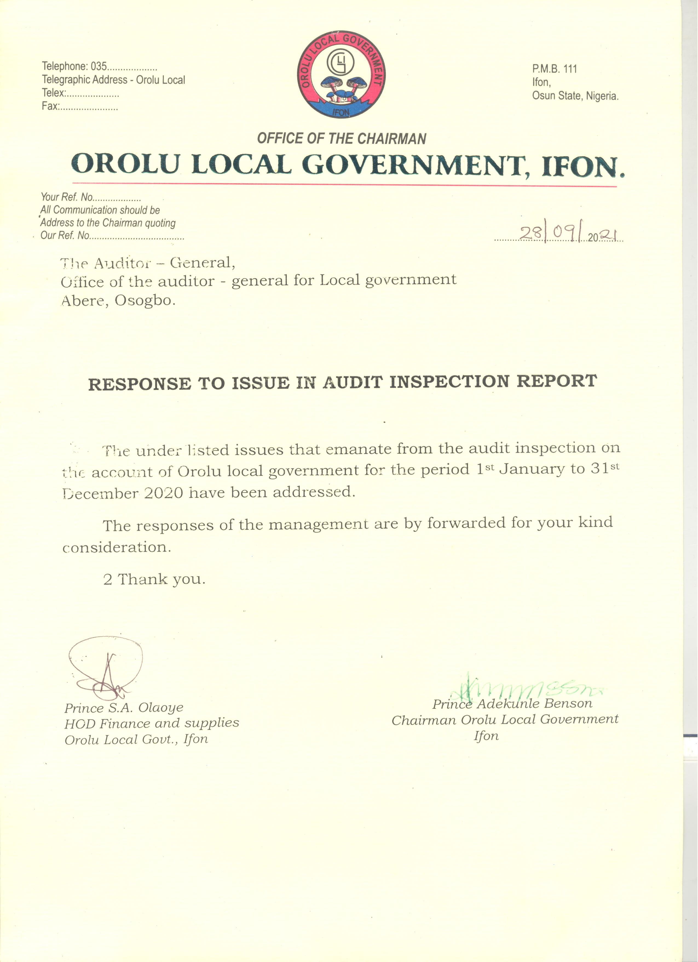

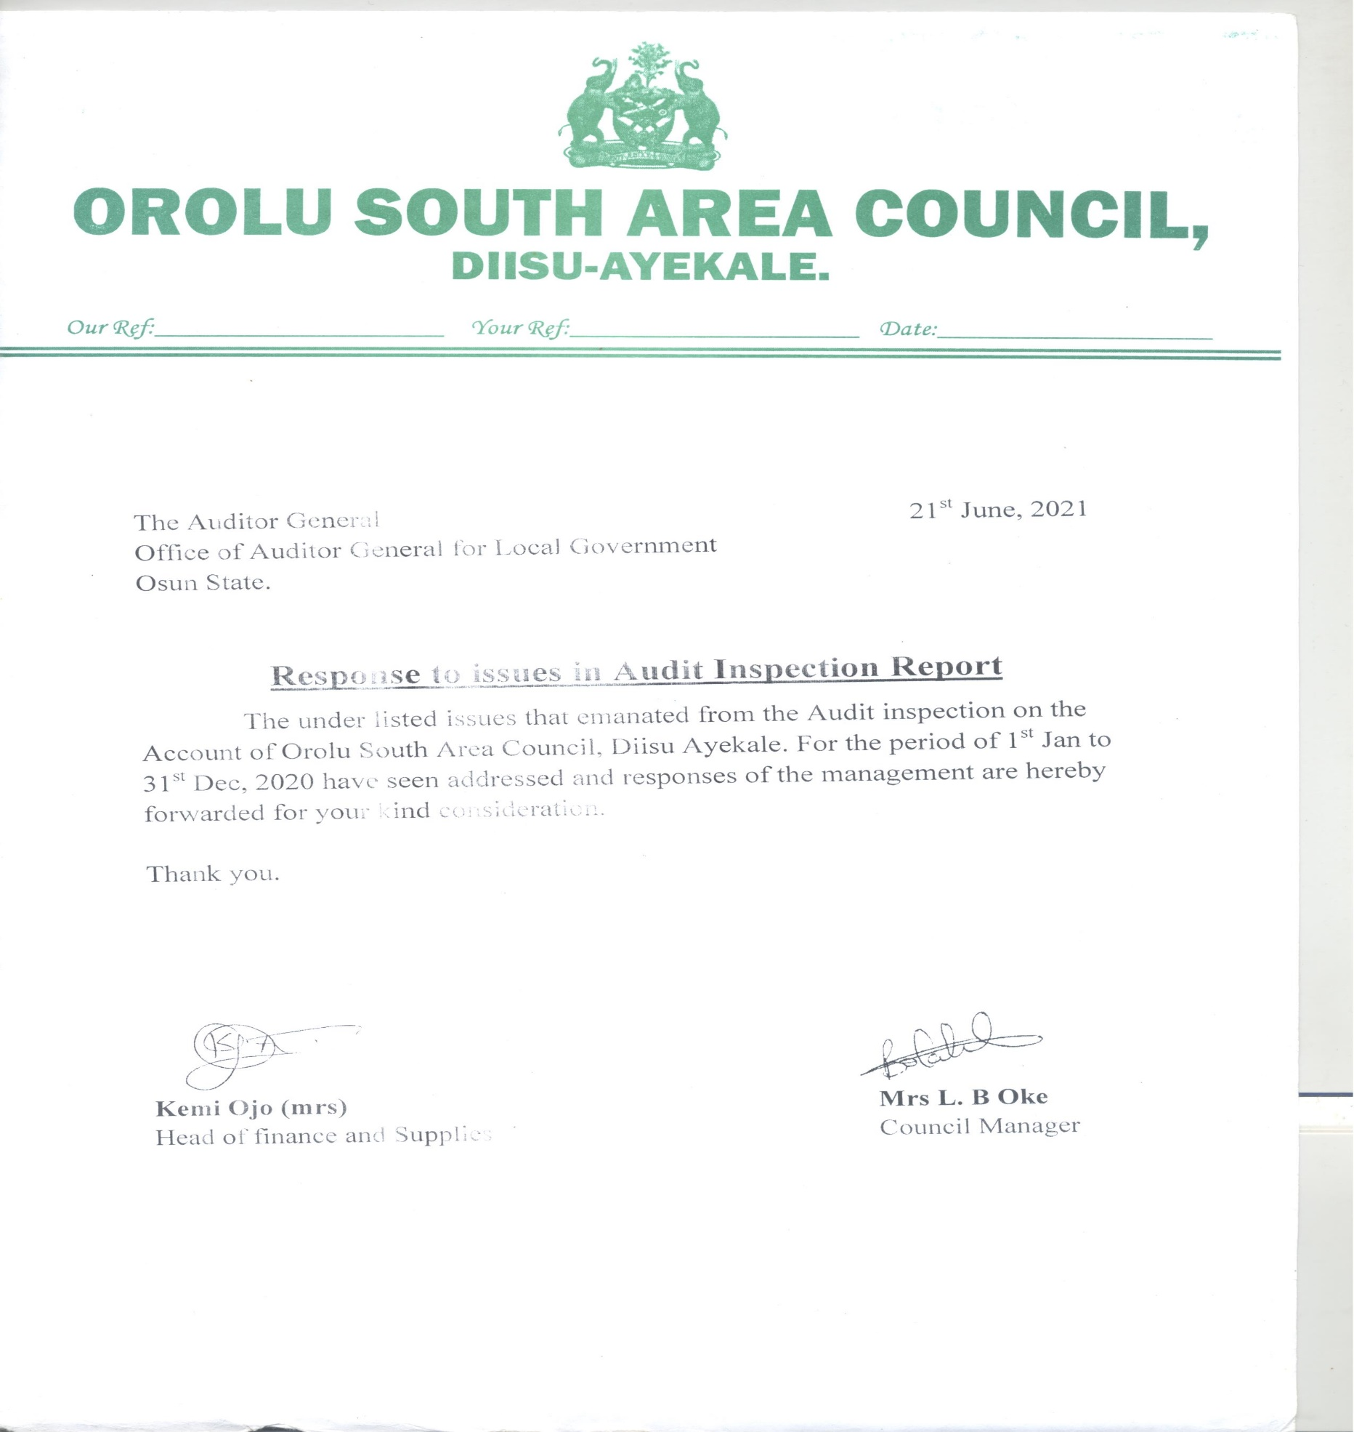

**MANAGEMENT LETTER**

**OROLU LOCAL GOVERNMENT, IFON – OSUN**

**OBSERVATIONS AND INTERNAL CONTROL REVIEW FOR THE FINANCIAL YEAR ENDED 31ST DECEMBER, 2020**

**1.** **BOOK OF ACCOUNTS:** The Book of Account were posted in arrears at the instance of the Audit Team despite my comments in the previous report, the action which had not only made the auditing exercise to be unduly prolonged but had affected the timely presentation of Financial Statement in the period under review.

***MANAGEMENT RESPONSE:*** *General Purpose Financial Statement (GPFS) was submitted within the stipulated time.*

**2.** **PAYMENT VOUCHERS:** The payment vouchers for the month of June, 2020 to August 2020 could not be examined, scrutinized and verified in the period under review. Therefore, opinion could not be formed on the vouchers, this was as a result of the October 20 End SARS Protest which was hijacked by the hoodlum in the Local Government where properties and documents were vandalized, multilated and destroyed.

**3.** **UNRECEIPTED EXPENDITURE TOTALLY N3,000,000.00:** Payment vouchers amounting to N3,000,000.00 were not supported with required official receipts and document which is contrary to the provision of Financial Memoranda 14:17 which states that, “An official printed receipt must be obtained and attached to the payment voucher in respect of a payment to Government, another Local Government or a Commercial firm. If the printed receipt covers more than one payment voucher, reference to the number of the payment voucher to which the receipt is attached, shall be entered on the other vouchers”. This has been made a subject of Audit Query No LQ/AUD/ORL/07/2020 attached.

***RISK:***

*This was an indication that the purported items might not have been purchased thereby resulting to loss of Local Government fund.*

***MANAGEMENT RESPONSE:***

*It was an oversight, and the receipt would be produced.*

***RECOMMENDATION-***

*All necessary supporting documents such as store receipt voucher and store issued vouchers should be attached to the payment vouchers before put into use.*

**4.** **EXPENDITURE NOT TAKEN ON CHARGE N1,490,000.00:** It was observed with dismay that the Local Government did not have a good store to safeguard materials purchased or donated. Audit investigation revealed that printed and stationaries purchased totaling N1,490,000.00 were not charged to the store before usage which is contrary to the Financial Memoranda 34:17 (1-2) which states that “All stores should be examined immediately they are received by the store keeper or other official responsible for the stores. The stores must be checked for quantities, weights, e.t.c. against the Local Purchase order, invoice of Government store issue voucher; if the stores delivered are found to be correct and in good condition, they will be taken on charge and entered as a receipt in the appropriate stores ledger”.. This has been made a subject of Audit Query Nos. LQ/AUD/ORL/08/2020 attached.

***RISK:***

*This was an indication that the purported items might not have been purchased thereby resulting to loss of Local Government fund.*

***MANAGEMENT RESPONSE:*** *Supporting documents to the expenditure were not ready at the time of Audit inspection which were eventually produced.*

***RECOMMENDATION-***

*All necessary supporting documents such as store receipt voucher and store issued vouchers should be attached to the payment vouchers before put into use.*

**5.** **DOUBTFUL EXPENDITURE AMOUNTING N9,310,000.00:** It was observed that the total sum of N9,310,000.00 was expended on purchase of Bike and Sanitary materials, Sensitization and Youth empowerments. The expenditure appeared doubtful and could not be proved with tangible evidence of performance such as list of participant/beneficiaries, letter of invitation and evidence of payment of honorarium to the resource person to justify the payment made. This has been made a subject of audit queries No. LQ/AUD/ORL/09/2020 attached.

***RISK:***

*The implication of this expenditure was that the services might not have been performed, thus the public fund might have been diverted for personal purposes.*

***MANAGEMENT RESPONSE:*** *The effect of the work done had been eroded with the passage of time before inspection was done supporting evidences would be presented.*

***RECOMMENDATION:***

*The recipients must attach all necessary supporting evidence such as sub-receipts, evidence of participation, or video coverage to prove genuineness of the expenditure.*

**OROLU ADMINISTRATIVE OFFICE, DISU – AYEKALE**

**OBSERVATIONS AND INTERNAL CONTROL REVIEW FOR THE FINANCIAL YEAR ENDED 31ST DECEMBER, 2020**

**1.** **BOOKS OF ACCOUNT:** The Books of Account were not properly kept. The Cash Book was mutilated, tipexing and cancellations were noticed in it almost in all the months of the accounting period. The Cashier had been seriously warned to desist from this habit henceforth.

**2.** **UNRETIRED IMPREST TOTALLING (N395,000.00):** The recent Audit inspection revealed that imprest made to some officers were not retired before subsequent ones were paid to them contrary to the provision of Financial Memoranda 14:27 which states that, “Imprest shall be retired when the purpose for which the imprest was granted is completed or at such intervals as are prescribed when the imprest is approved. However, all impests shall be automatically be retired at the end of each financial year”.

***RISK:***

*Government Fund might not have been used for official purpose.*

***MANAGEMENT RESPONSE:***

*It was an oversight, and the receipt would be produced.*

***RECOMMENDATION-***

*Proper recording of petty cash should be done and all payments must be retired immediately and presented for audit verification*

**4.** **IRREGULAR PAYMENT AMOUNTING TO (N23,146.13):** The examination of the payment vouchers showed that payments made to some people for various jobs done totaling (N23,146.13) were irregular, not checked and passed by the Internal Auditor before payment were made contrary to Financial Memoranda 14:10 which states that, “Before any payment is made, a prepayments audit of vouchers and supporting documents shall be made by the Internal Auditor on all payment vouchers to verify that the provision of these financial memoranda have been followed in all respects, the payment is one properly authorized and correctly charged to the stated sub-head or account, and that sufficient funds are available to meet it”.

***RISK:***

*Not subjecting payment vouchers to Internal Audit check before payment was an indication of weak Internal Control System which could result to misappropriation of public fund.*

***MANAGEMENT RESPONSE:*** *No response.*

***RECOMMENDATION:***

*The signatories to the cheque should explain the rationale behind making payment without Internal Auditor’s involvement.*

**5.** **DOUBTFUL EXPENDITURE TOTALLING (N360,000.00):** The expenditure incurred by the Local Council Administrative Office on Sensitization Programme for Community Leaders, Security Guards, Drivers on Increasing Rate of Burglary and Entertainment on Erinle/Owala River Festival appeared doubtful because tangible evidence that would justify the payments such as list of participants and video clip could not be produced for Audit scrutiny. Worst still, the names and sub-receipts of resource person could not be produced on the sensitization which makes the genuineness of the programme/expenditure doubtful.

***RISK:***

*The implication of this expenditure was that the services might not have been performed, thus the public fund might have been diverted for personal purposes.*

***MANAGEMENT RESPONSE:*** *The effect of the work done had been eroded with the passage of time before inspection was done supporting evidences would be presented.*

***RECOMMENDATION:***

*The recipients must attach all necessary supporting evidence such as sub-receipts, evidence of participation, or video coverage to prove genuineness of the expenditure.*

**6**. **STORE ITEMS NOT TAKEN ON CHARGE AMOUNTING (N940,000.00):** Audit verification revealed that payments were made to various Officers of the Local Government for the repair and replacement of some parts and purchase of needed accessories and the printing of proposed year 2021 draft estimate. It was observed that the materials could not be traced to the store nor there was evidence such as receipt to show that the items were actually produced or purchased which is contrary to the Financial Memoranda 34:17 (1-2) which states that, “All stores should be examined immediately they are received by the store keeper or other official responsible for the stores. The stores must be checked for quantities, weights, e.t.c. against the Local Purchase order, invoice of Government store issue voucher; if the stores delivered are found to be correct and in good condition, they will be taken on charge and entered as a receipt in the appropriate stores ledger”. This had been made a subject of Audit Query No. LQ/AUD/ORLA/12/2020.

***RISK:***

*This was an indication that the purported items might not have been purchased thereby resulting to loss of Local Government fund.*

***MANAGEMENT RESPONSE:*** *Store ledgers were not updated as at the time of audit inspection.*

***RECOMMENDATION-***

*The Internal Auditor should be alive to his responsibilities and audit attachments to payment vouchers and reflect in the internal Auditor’s Report. The Internal Auditor should audit Stores to ascertain receipt and distribution of items.*

**INTERNAL AUDITOR’S REPORT**

1. The Internal Control unit is very effective only the management should try to tap other Revenue items yet untapped. Embark on Agriculture with the supports of other Revenue generating Departments, like WES, Town Planning and the Marriage Unit be thoroughly monitored to boost the IGR of the Council.

2. Despite the fact that the Internal Control is functioning well, the Local Government should prioritize and divert attention fully on Agriculture with the cooperation of other Revenue generating Departments to boost the monthly IGR of the Local Government. The existing Local Markets be revived timely to assist in Revenue generation, specifically on the farms outputs.