**MINISTRY OF LOCAL GOVERNMENT AND CHIEFTAINCY AFFAIRS, STATE SECRETARIAT, OSOGBO, OSUN STATE**

**PROFILE**

The Ministry is one of the MDAs, (Ministries, Departments and Agencies) that came along with the creation of Osun State on August, 31st 1991 under the Military Regime of General Ibrahim Babangida. Initially, the Ministry was known as Ministry of Local Government, Chieftaincy Affairs and Community Development, but eventually, Community Development was moved to another agency and the name of this Ministry now remains Ministry of Local Government and Chieftaincy Affairs.

The Ministry is structured to exercise as a full-fledged Ministry and is being headed by both political and administrative office holders. The Commissioner for Local Government and the Special Adviser on Chieftaincy Matters are the two leading political office holders in the Ministry. The Accounting officer who doubles as the Administrative Head of the Ministry is the Permanent Secretary. The Ministry is sub-divided into departments and each department is headed by a Director. The following departments exist in the Ministry.

(i) Local Government and Inspectorate Services;

(ii) Chieftaincy Affairs;

(iii) Finance and Accounts;

(iv) Administration and Supplies;

(v) Project Monitoring and Evaluation;

(vi) Planning, Research and Statistics;

(vii) Information.

**OBJECTIVES OF THE MINISTRY**

- set agenda and monitor activities of governance and administration of all local governments in order to remove impediments to efficiency and effective implementation of programmes and projects.

- provide guidelines and exercise control on annual budgeting process for all local governments.

- supervise all activities relating to the selection and installation of new Obas to ensure that they are in line with the State’s Chieftaincy Laws.

- treat all chieftaincy disputes and ensure that they are settled and resolved amicably.

- attend to all requests on promotion or elevation of our royal fathers within the State’s Council of Obas.

- give approval for local government capital projects and programmes and monitor their implementation to ensure that they are on the same page with the State Government’s policy on development.

- support local governments and provide guidelines on how to attract local and international development partners for sustainable human and infrastructural development at the local government level.

- ensure that due process is followed for costing of projects and programmes and public procurements at the local governments.

- provide secretarial services and assistance for the meetings of council of Obas in the State.

- maintain and improve transparency and accountability in local government accounts.

- give approval on issue of loans and monitor the projects or programmes for which they are meant for.

- generate revenue for the State through the sales of forms for promotion and elevation of our royal fathers.

**VISION**

The vision of the Ministry of Local Government and Chieftaincy Affairs is to see that the people at the grassroot feel the positive impact of our local governments through improved service delivery and ensure that all issues of chieftaincy are peacefully resolved without bitterness and rancour.

**MISSION**

- provide an administrative framework and strategic guidelines for sustainable human and infrastructural development in all our local governments in Osun State.

- ensure peaceful atmosphere on issues of chieftaincy affairs and promote harmonious relationship among our royal fathers in the State.

**FUNCTIONS AND RESPONSIBILITIES**

a. The policy thrust of the Ministry of Local Government and Chieftaincy Affairs is to maintain the activities of all the Local Governments in Osun State. The Ministry is to guide Local Governments on issue of general administration, governance and chieftaincy affairs to ensure that there is policy coherence between the State and Local Governments.

b. The Ministry is to ensure that the Local Governments do not misallocate and mismanage their resources.

c. The Ministry is to settle amicably and manage all crisis arising from our Local Governments such crisis may include issues of administration and chieftaincy matters.

d. The Ministry also provides administrative framework and supervise the process of allocation of fund among local government through the Joint Account Committee JAC.

**LIST OF LOCAL GOVERNMENTS AND THEIR HEADQUARTERS IN OSUN STATE.**

|  |  |  |
| --- | --- | --- |
| **S/NO.** | **LOCAL GOVERNMENT** | **HEADQUATERS** |
| **1.** | **AYEDAADE** | **GBONGAN** |
| **2.** | **AYEDAADE SOUTH** | **ORILE-OWU** |
| **3.** | **AYEDIRE** | **ILE-OGBO** |
| **4.** | **AYEDIRE SOUTH** | **OLUPONNA** |
| **5.** | **ATAKUNMOSA EAST** | **IPERINDO** |
| **6.** | **ATAKUNMOSA EAST CENTRAL** | **IWARA** |
| **7.** | **ATAKUNMOSA WEST** | **OSU** |
| **8.** | **ATAKUNMOSA WEST CENTRAL** | **IFEWARA** |
| **9.** | **BORIPE** | **IRAGBIJI** |
| **10.** | **BORIPE NORTH** | **IREE** |
| **11.** | **BOLUWADURO** | **OTAN-AYEGBAJU** |
| **12.** | **BOLUWADURO EAST** | **AJODA** |
| **13.** | **EDE EAST** | **SEKONA** |
| **14.** | **EDE NORTH** | **OJA-TIMI, EDE** |
| **15.** | **EDE SOUTH** | **OKE-IRESI, EDE** |
| **16.** | **EGBEDORE** | **AWO** |
| **17.** | **EGBEDORE SOUTH** | **IDO-OSUN** |
| **18.** | **EJIGBO** | **EJIGBO** |
| **19.** | **EJIGBO SOUTH** | **ILAWO** |
| **20.** | **EJIGBO WEST** | **OGURO** |
| **21.** | **IFEDAYO** | **OKE-ILA** |
| **22.** | **IFELODUN** | **IKIRUN** |
| **23.** | **IFELODUN NORTH** | **EWETA** |
| **24.** | **IFE CENTRAL** | **ILE-IFE** |
| **25.** | **IFE CENTRAL WEST** | **ELEFON-OWAA** |
| **26.** | **IFE OOYE** | **ITA-OOSA** |
| **27.** | **IFE EAST** | **OKE-OGBO, ILE-IFE** |
| **28.** | **IFE NORTH** | **IPETUMODU** |
| **29.** | **IFE EAST CENTRAL** | **MODAKEKE** |
| **30.** | **IFE NORTH WEST** | **EDUNABON** |
| **31.** | **IFE SOUTH** | **IFETEDO** |
| **32.** | **IFE SOUTH WEST** | **AWOLOWO TOWN** |
| **33.** | **ILA** | **ILA-ORANGUN** |
| **34.** | **ILA CENTRAL** | **MAGBON** |
| **35.** | **ILESA EASST** | **IYEMOGUN ROAD, ILESA** |
| **36.** | **ILESA NORTH EAST** | **IMO** |
| **37.** | **ILESA WEST** | **OMI-ALADIYE ILESA** |
| **38.** | **ILESA WEST CENTRAL** | **EREJA SQUARE** |
| **39.** | **IREPODUN** | **ILOBU** |
| **40.** | **IREPODUN SOUTH** | **ERIN-OSUN** |
| **41.** | **IREWOLE** | **IKIRE** |
| **42.** | **OBOKUN EAST** | **ILARE** |
| **43.** | **ISOKAN** | **APOMU** |
| **44.** | **ISOKAN SOUTH** | **IKOYI** |
| **45.** | **IWO** | **IWO** |
| **46.** | **IWO EAST** | **OLOMOWEWE** |
| **47.** | **IWO WEST** | **AGBERIRE** |
| **48.** | **OBOKUN** | **IBOKUN** |
| **49.** | **IREWOLE NORTH EAST** | **WASINMI** |
| **50.** | **ODO-OTIN** | **OKUKU** |
| **51.** | **ODO-OTIN NORTH** | **OYAN** |
| **52.** | **ODO-TIN SOUTH** | **INISHA** |
| **53.** | **OLA-OLUWA** | **BODE-OSI** |
| **54.** | **OLA-OLUWA SOUTH EAST** | **ILEMOWU** |
| **55.** | **OLORUNDA** | **IGBONA OSOGBO** |
| **56.** | **OLORUNDA NORTH** | **OTA-EFUN** |
| **57.** | **ORIADE** | **IJEBU-IJESA** |
| **58.** | **ORIADE SOUTH** | **IPETU-IJESHA** |
| **59.** | **OROLU** | **IFON-OSUN** |
| **60.** | **OSOGBO** | **OSOGBO** |
| **61.** | **OSOGBO SOUTH** | **ISALE-OSUN** |
| **62.** | **OSOGBO WEST** | **OKE-ARUNGBO** |
| **63.** | **IFE NORTH AREA COUNCIL** | **OYERE-BORISADE** |
| **64.** | **EDE NORTH AREA COUNCIL** | **OWODE-EDE** |
| **65.** | **IFELODUN AREA COUNCIL** | **IBA** |
| **66.** | **OLORUNDA AREA COUNCIL** | **ILIE** |
| **67.** | **OROLU ADMINISTRATIVE OFFICE** | **DIISU AYEKALE** |
| **68.** | **OKINNI- ADMINISTRATIVE OFFICE** | **OKINNI** |
| **69.** | **IFEDAYO AREA COUNCIL** | **IDI-ODAN** |

**The above list is made up of the original 30 Local Governments and the Local Council Development areas (LCDA), Area Councils and Administrative office. The LCDAs, Area Councils and Administrative office were created by the regime of former Governor Rauf Aregbesola**

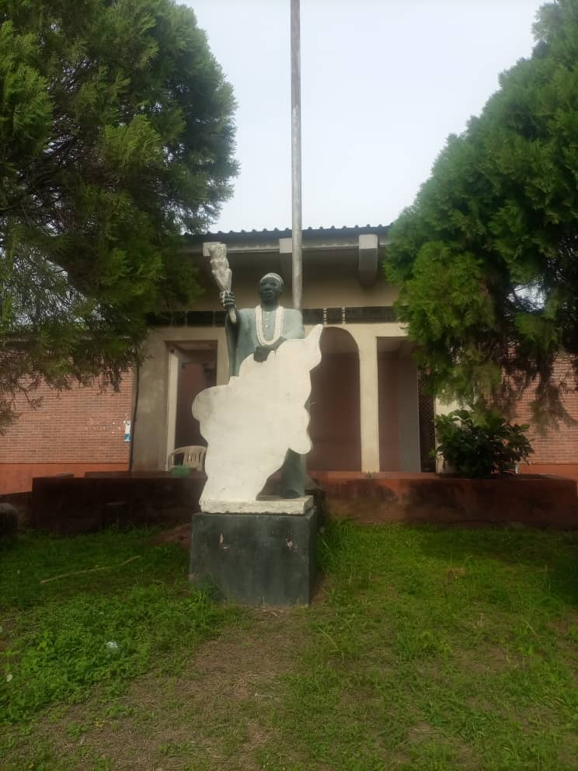

**Front View of the Ministry of Local Government and chieftaincy affairs**

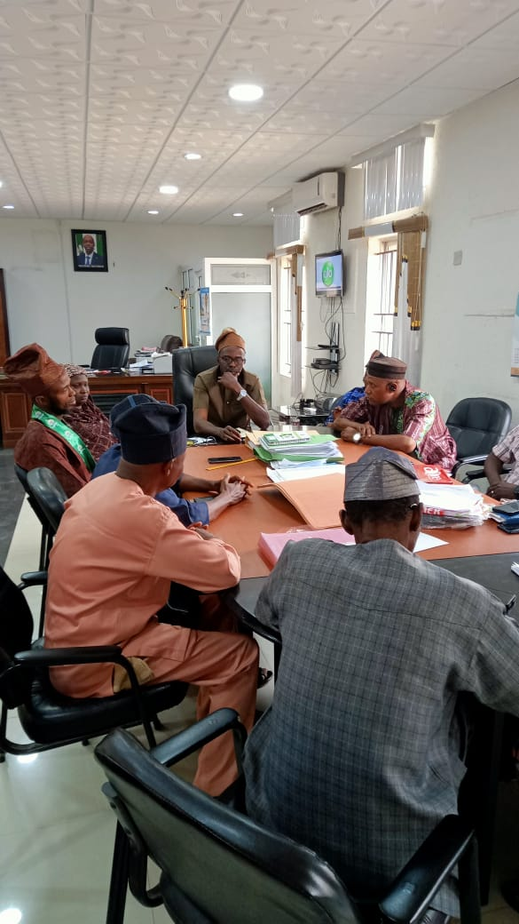

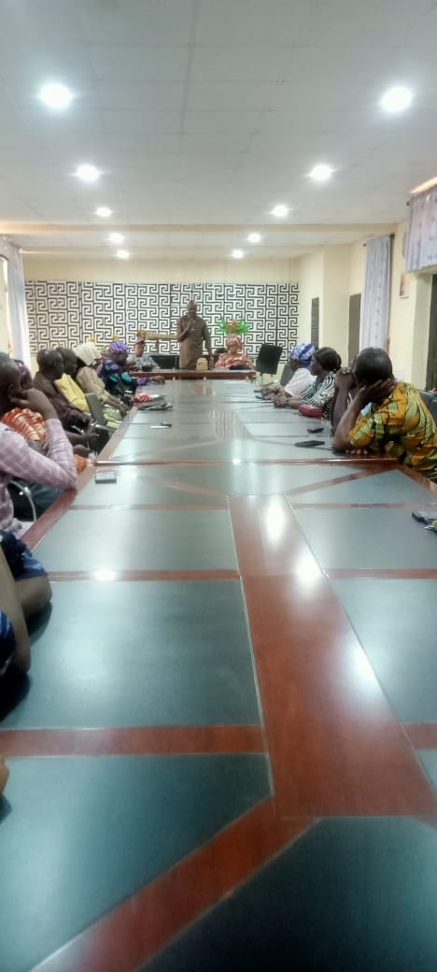

**Meetings with the Stake holders at the local governments to ensure that there is policy coherence between the state and local government**

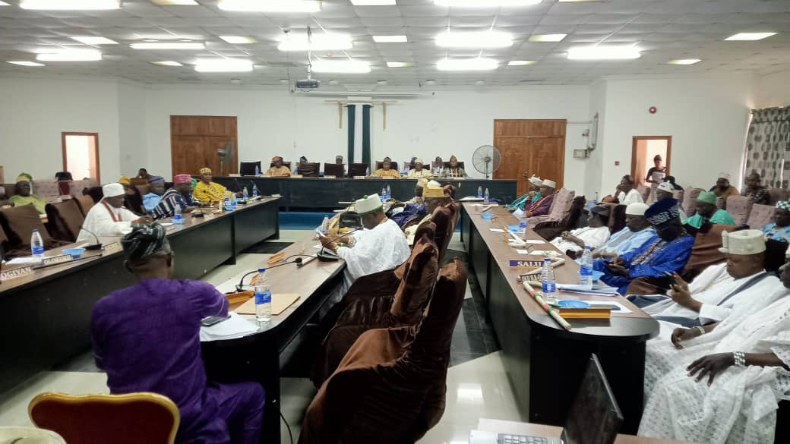

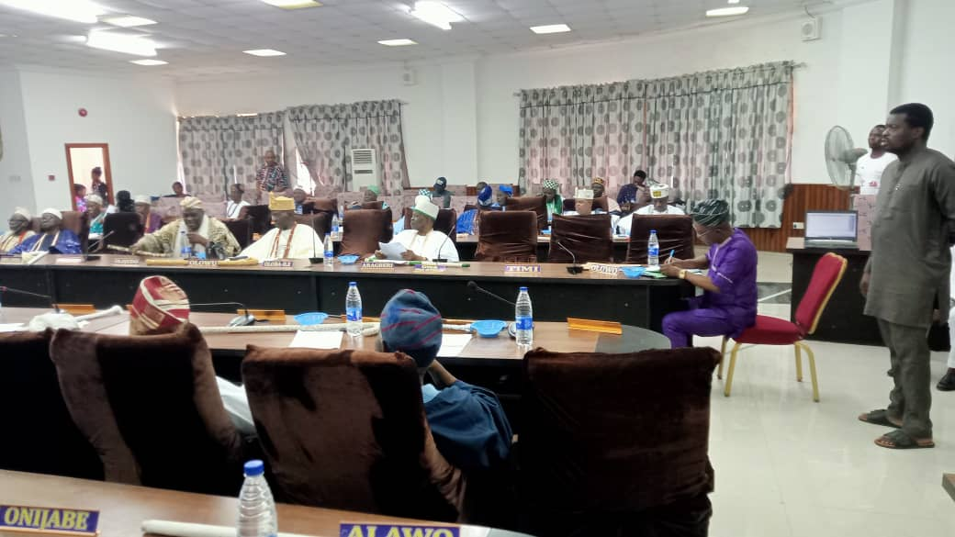

**Meeting of the Council of Obas in Osun State**

**KEY OFFICERS WITH THEIR PROFILE AND CONTACTS**

**HON COMMISSIONER**

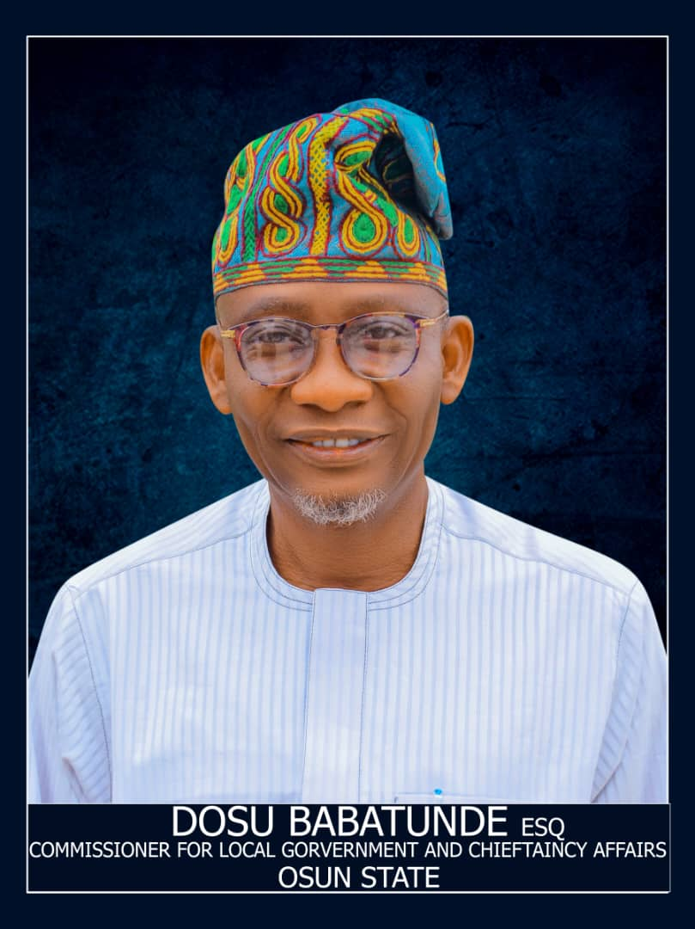

Dosu Babatunde was born on December 2nd, 1961, in Ilesa, to the family of late Chief Isaiah Oyeleye Babatunde and Mrs Caroline Sijuwola Babatunde of Oke-Bode in Atakunmosa West Local Government area of Osun state.

He attended Methodist Primary School Oke-Ese, Ilesa for his primary education and the prestigious Ilesa Grammar School, Ilesa for his secondary education.

He also had his higher school certificate, HSC at Ilesa Grammar School, Ilesa.

Dosu Babatunde was also at the premier University, the University of Ibadan where he bagged his Bachelor of laws degree (LLB Hons) in 1987.

He did not rest on his oars in his academic pursuit as he added another feather to his cap with a Master of Laws degree (LL.M), from the Obafemi Awolowo University Ile-Ife in 1998.

He was at the Nigerian Law School, Lagos and was called to the Nigerian bar as a Barrister and Solicitor of the Supreme Court of Nigeria on the 4th of November, 1988.

He had his mandatory National Youth Service Corp with the reputable law office of M.O.B OHUNTA & CO SOLICITORS, ABA in the then IMO state now ABIA state.

In his determination to be more grounded in the nitty gritty of the law profession , he had his tutelage with the law offices of M.O.B OHUNTA & CO, ABA and E.A. ADELEKUN & CO, ILESA.

Dosu Babatunde established his own law office- DOSU BABATUNDE & CO, Barristers and Solicitors (Adasonla Chambers) Ilesa, in 1992.

He was Secretary of the Nigerian Bar Association, Ilesa branch between 1991 and 1993 and became the Chairman of the bar between 2008 and 2010.

In recognition of his strict adherence to the rules and tenets of the legal profession, he was appointed as a member and secretary respectively of the Nigerian Bar Association, South West Disciplinary Panel B, from 2014- 2016 and from 2016-2018.

On the Political Science, Dosu Babatunde carved a niche for himself by being a thorough bred and reliable Politician.This had earned him various leadership political positions in his local Government, Atakunmosa West and in Osun State. He was the Secretary to the Local Government from 1999 --2002, he was the Chairman caretaker Committee of the local Government from 2003--2004 and the elected Executive Chairman to the local Government between 2004 and 2007.

Dosu Babatunde was appointed a member of the Governing Council of the Osun State College of Education,Ila Orangun between 2008 and 2010.He was until recently the Legal Adviser of the Peoples Democratic Party, PDP in the South West of Nigeria.

Owing to his grassroot political dexterity, he became the cynosure of simplicity, honesty and forthrightness that is most uncommon in political circles and this earned him the cognomen -"Eniari"(the preferred)

At the religious level, Dosu Babatunde, a year 2000 Jerusalem pilgrim, was confirmed as a communicant by the Bishop of Ilesa South West Diocese of the Anglican Communion, Rt. Rev Samuel Olukunle Egbebunmi in 2010.He has also been a bishop's nominee to the synod and for several years a member of the standing committee of the Cathedral Church of Holy Trinity Omofe, Ilesa.

He is married to Barrister Abimbola Babatunde and the marriage is blessed with three children, two of whom are already lawyers and the last also almost done with her law studies.

**PERMANENT SECRETARY**

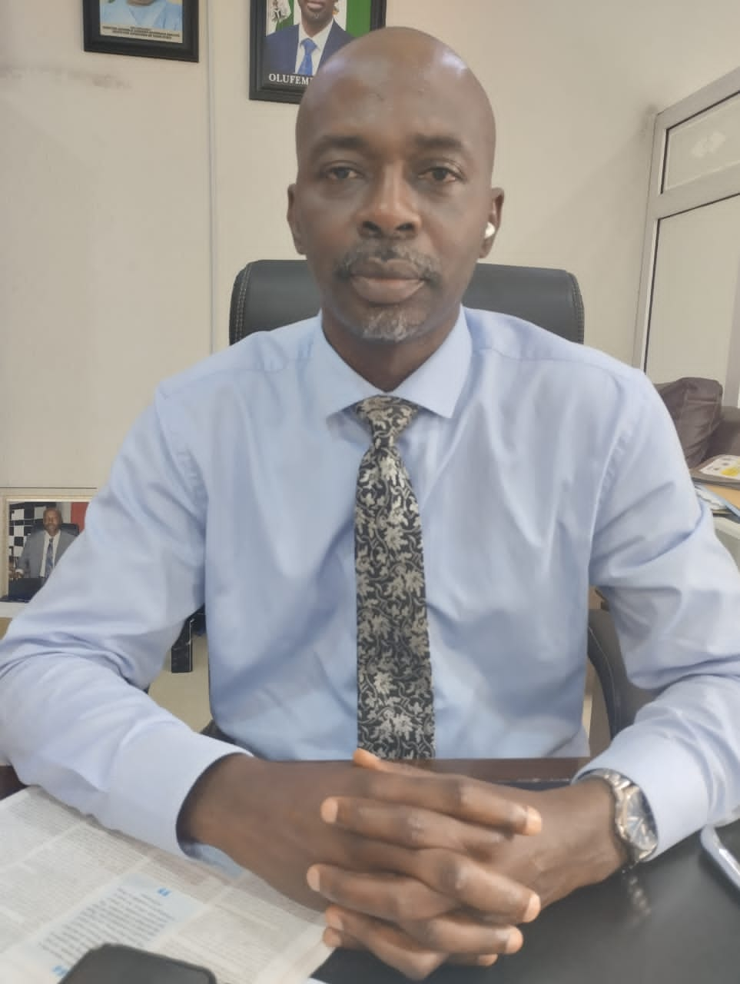

**MR. FEMI OGUNDUN**

Mr. Femi Ogundun, an indigene of Ila-Orangun is the Permanent Secretary and Accounting Officer in the Ministry. Prior to his appointment as the Permanent Secretary on 30th of May, 2023, Mr. Ogundun had been serving as Coordinating Director (Acting Permanent Secretary) since May, 2022 after the retirement of the former Coordinating Director, Mr. Kola Adedokun. He is a product of Obafemi Awolowo University, Ile-Ife where he studied English and also holds a Master of Public Administration (M.P.A.) Degree from the same Institution.

Phone/Whatshapp No. +2348062342580

Email: [femiogundun10@gmail.com](mailto:femiogundun10@gmail.com).

**SPECIAL ADVISER ON CHIEFTAINCY AFFAIRS**

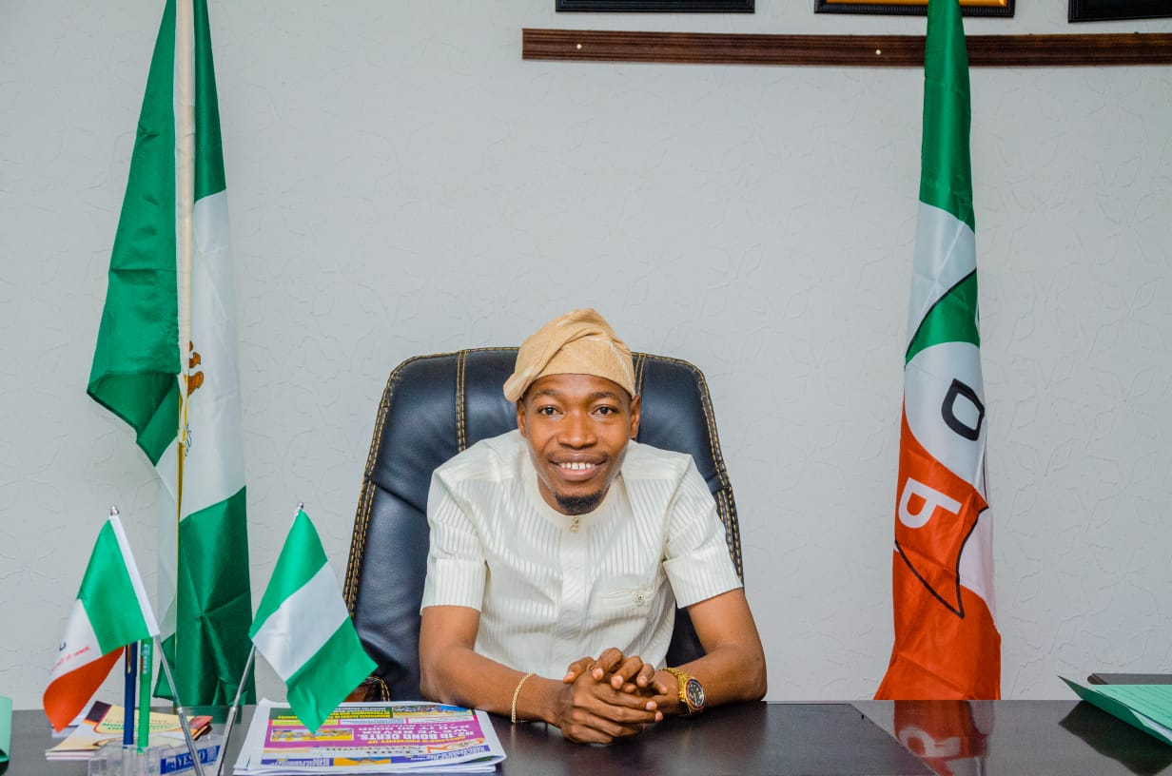

Hon. Adam Akintunde Akindeere was born to the family of Sheikh Isiaka Akintunde and Mrs Monsurat Akindeere from Mobi compound, Ede, Osun State over three decades ago and was fostered by His royal Highness, Oba Dr Munirudeen Adesola Lawal.

Little Adam attended Islamic Nursery and Primary School,Ede, Osun State in the early 1990s. He later got admission to Lilly field comprehensive High School, Asamu Lagos State where he obtained WASSCE

His desires to have University education took him to the famous Ladoke Akintola University of Technology, Ogbomoso, Oyo State where he read B. Tech in Crop Protection and graduated in the year 2018.

Adam Akintunde is a lover of education. No wonder, he still enrolled for Masters degree in Agricultural Sciences program from the same great institution, Ladoke Akintola University of Technology Ogbomoso.

Hon Alh. Adam Akintunde Akindeere is happily married to his pretty wife Mrs Aaliyah Omotayo Akindeere and blessed with two lovely sons.

**SPECIAL ADVISER ON LOCAL GOVERNMENT**

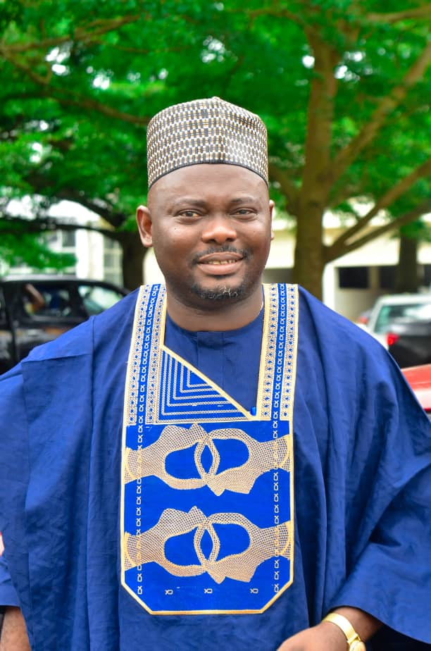

**Name**: Goddey Olije

**Designation**: Special Adviser

**Phone Number**: 08033428915

**Email**: goddeyolije@gmail.com

**Experience**: Councilor; 2008-2010

Businessman; 2010 - Till date

MD (Goddey Frozen Foods)

**EDUCATION**

**OND**: 1999; Federal Polytechnic Offa, Kwara State

**HND**: 2003; Federal Polytechnic Offa, Kwara State

**PGD: LAUTH**, Ogbomoso, Oyo State

**M.B.A.: LAUTH**, Ogbomoso, Oyo State

Goals; Working diligently to achieve success at every stage.

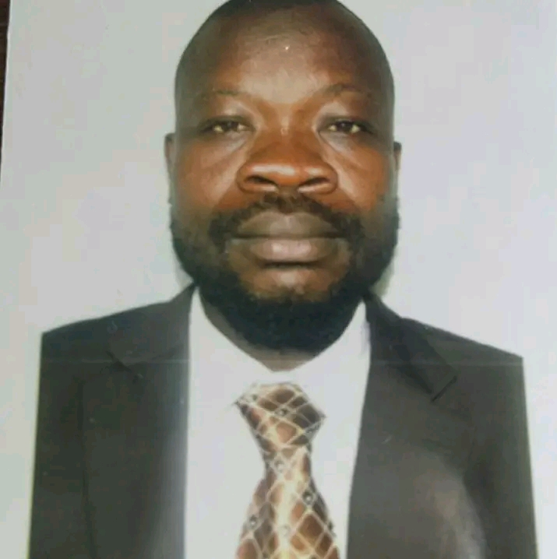**DIRECTOR, LOCAL GOVERNMENT AND INSPECTORATE SERVICES**

**MR. TAJUDEEN OLATUNDE ADELABU**

Mr.TajudeenOlatundeAdelabu is a native of Ilobu in Irepodun Local Government of

Osun State. He holds a Bachelor of Arts Degree from University of Ilorin and he is

the Director of Local Government and Inspectorate Services, Ministry of Local

Government and Chieftaincy Affairs.

Phone/Whatshapp Number: 08039619770

Email: [tunde4islam@gmail.com](mailto:tunde4islam@gmail.com).

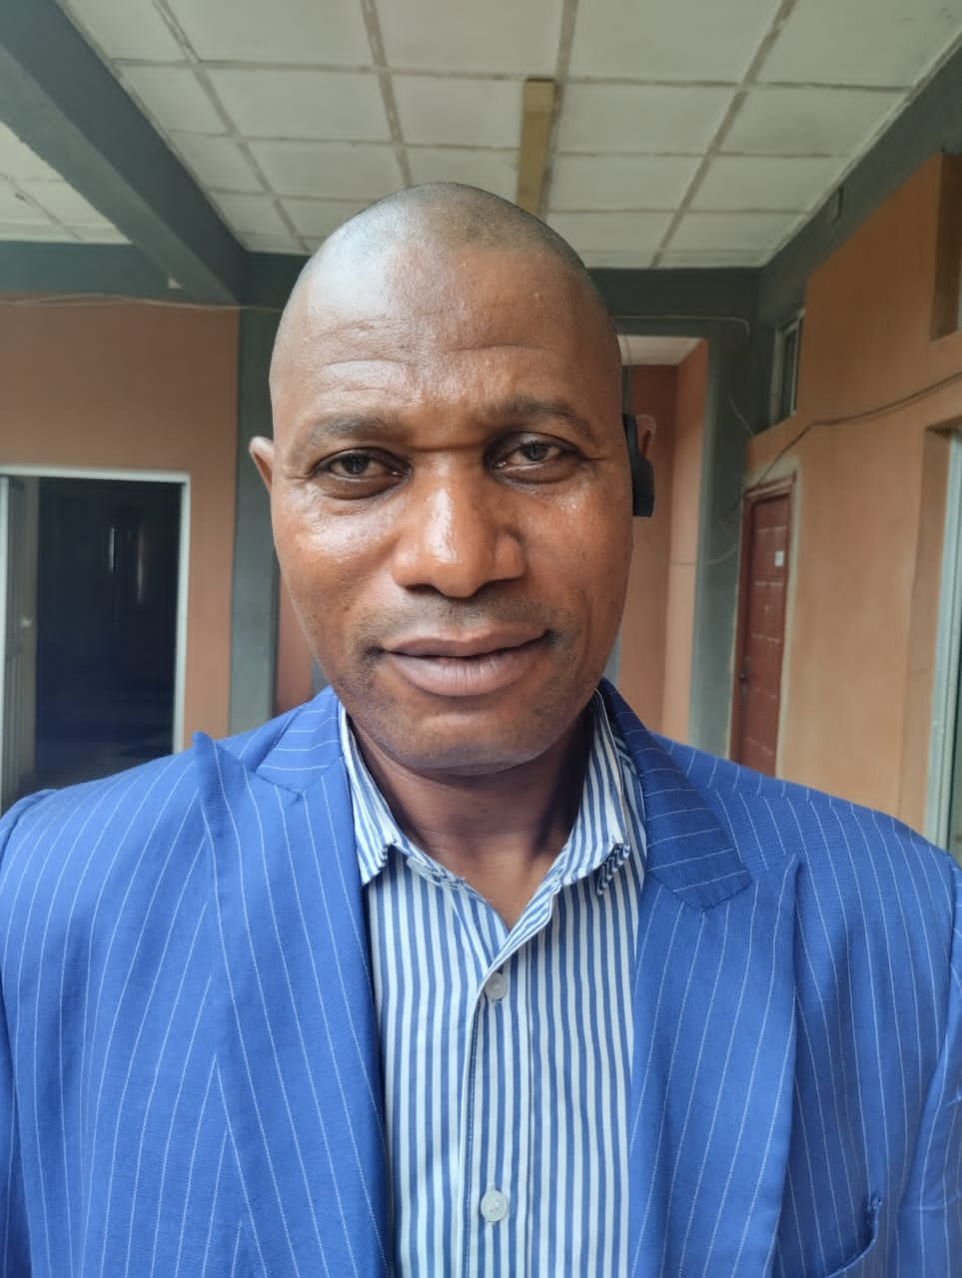**DIRECTOR, CHIEFTAINCY AFFAIRS**

**MR. BASHIR OLADIPUPO**

Mr. Bashir Oladipupo, an indigene of Osogbo is a product of University of Ibadan

where he obtained B. A. and M. A. in Islamic Studies. He is the current Director of

Chieftaincy Affairs at the Ministry of Local Government and Chieftaincy Affairs,

Osun State, Nigeria.

**DIRECTOR , FINANCE AND ACCOUNTS**

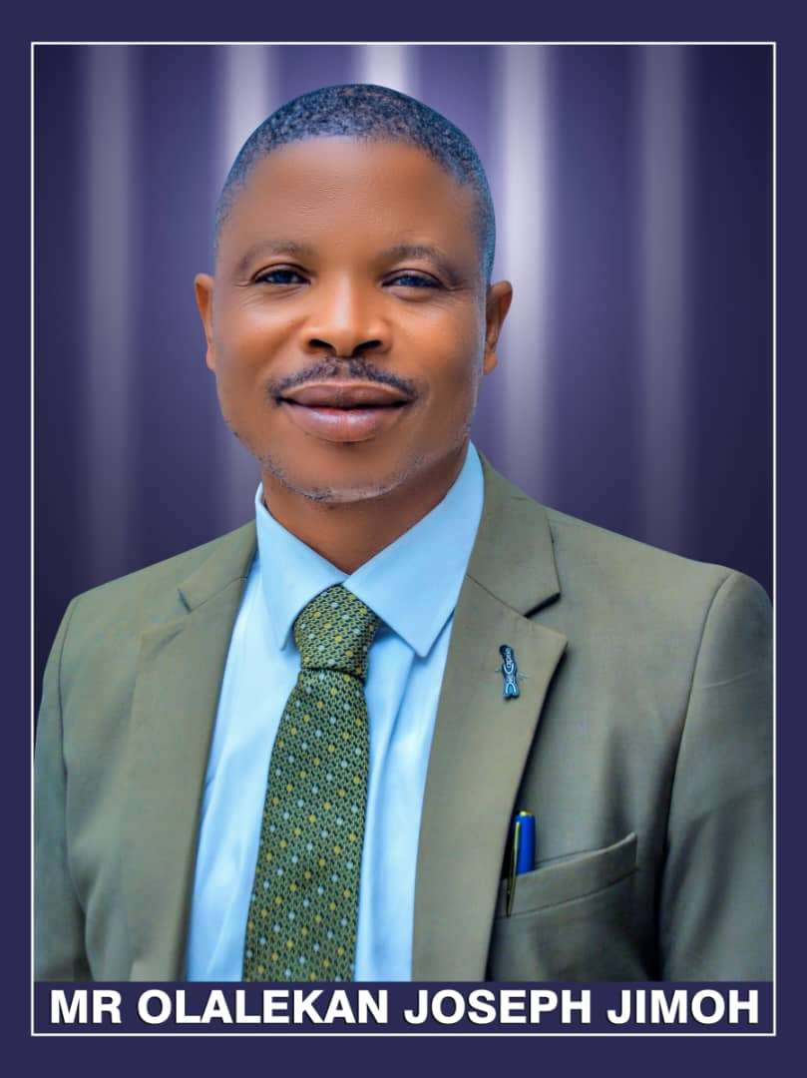

Mr. Jimoh Olalekan is a holder of B.Sc certificate in Accounting from Ladoke Akintola University, Ogbomosho, he is a Chartered Accountant and member of various Professional bodies.

He is a native of Osogbo and the Director of finance and Accounts at the Ministry of Local Government and Chieftaincy affairs.

**Phone/Whatapp No**: 07031039615

**Email**: jimoholalekan13@gmail.com

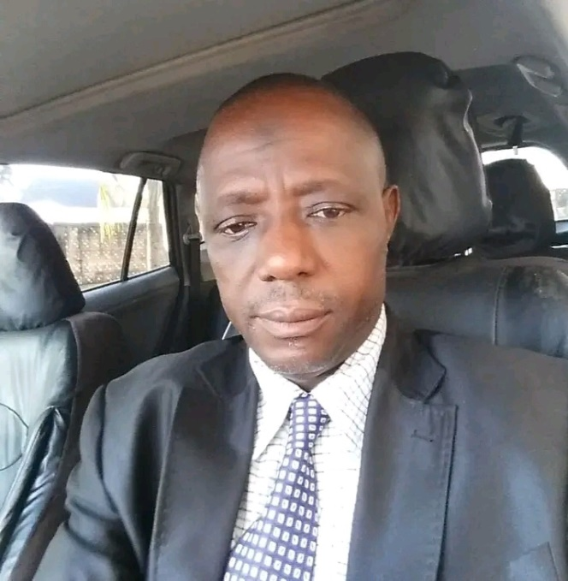**DIRECTOR, PROJECT MONITORING AND EVALUATION**

**ENGR. KUNLE TIJANI**

Engr. KunleTijani is a native of Ede, Osun State Nigeria. He attended University of

Ilorin, Nigeria where he graduated as an Engineer. He also acquired other Higher

Degrees which include M.B.A. (Ife) now Obafemi Awolowo University and M P A

from LAUTECH, Ogbomoso. He is the current Director of Project Monitoring and

Evaluation, Ministry of Local Government and Chieftaincy Affairs, Osun State,

Nigeria.

Phone/Whatshapp No: +2347088433902

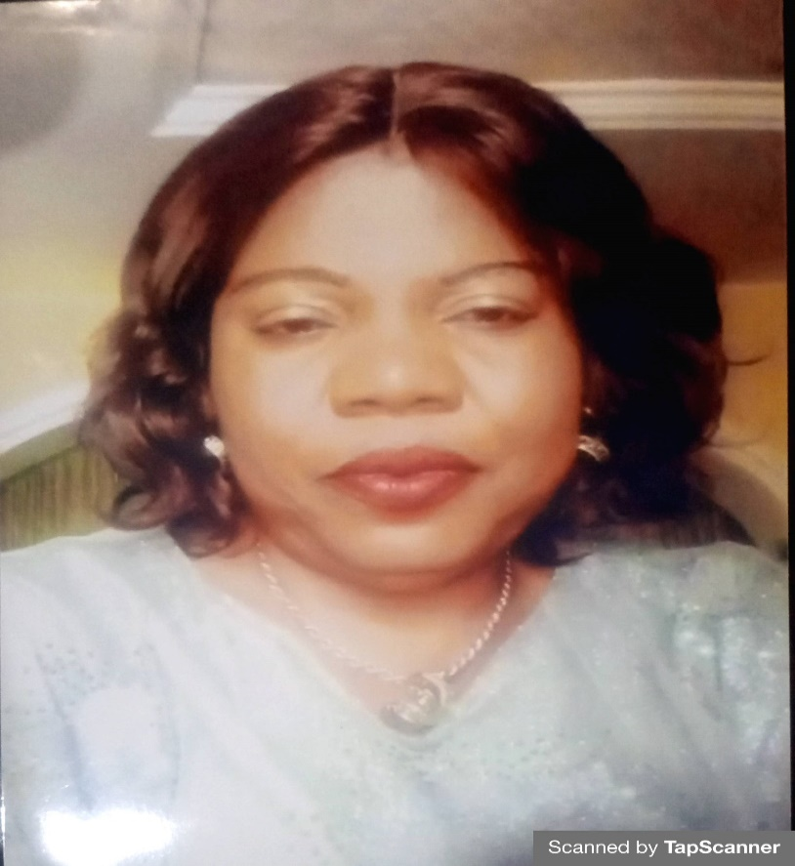**DIRECTOR ADMIN AND SUPPLIES**

**MRS SHOFARASIN HELEN IKEADE**

Mrs Helen Ikeade Shofarasin, a native of Ile-Ife and a product of Obafemi Awolowo University, Ile-ife where he studied History and also holds a master of Public Administration (MPA) Degree form the same Chartered institute of Public Administration (CIPAN)

**Phone/Whatsapp No**.: 080033773658

**Email Address**: shofarasinhelen@gmail.com

**DIRECTOR, PLANNING, RESEARCH AND STATISTICS**

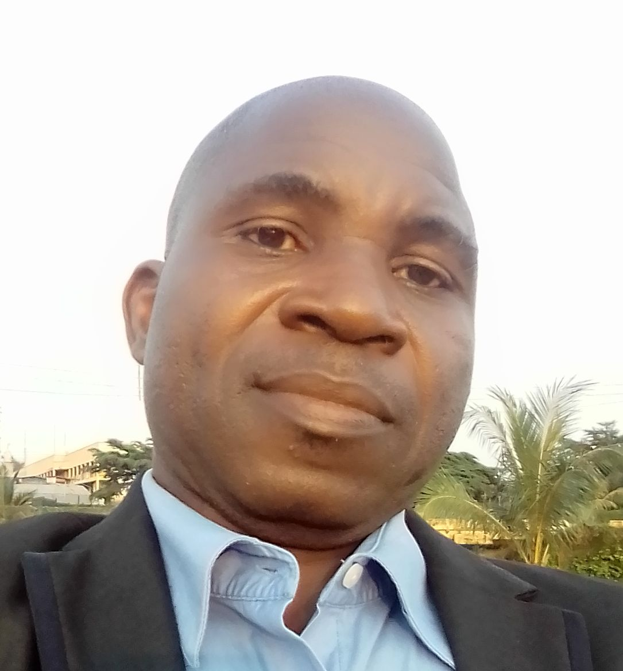

**MR. IYIOLA DADA**

Mr.Iyiola Dada is from Iperindo, Atakumosa East Local Government, Osun State.

He is a product of Lagos State University, Lagos, Nigeria where he studied Political

Science. He is the current Director of Planning, Research and Statistics, Ministry of

Local Government and Chieftaincy Affairs, Osun State, Nigeria.

Phone/Whatshapp No: +2347038761985

Email: [iyioladepo2016@gmail.com](mailto:iyioladepo2016@gmail.com).

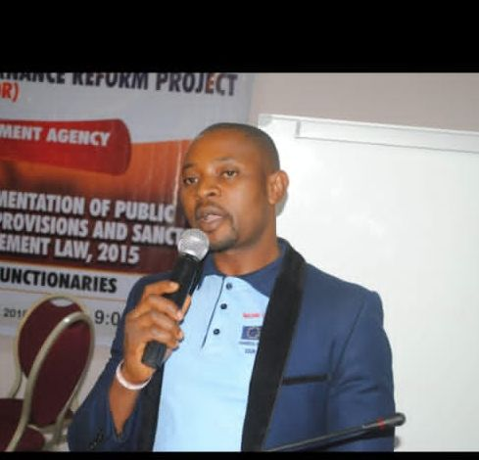**DIRECTOR OF INFORMATION**

**MR. OLUGBENGA OLUSUYI ONI**

Mr.Olugbenga Oni is from Atakumosa West Local Government of Osun State. He is

a product of the University of Ibadan where he obtained B. A. (Hons) in Yoruba from

Department of Linguistics and African Language. He also holds post graduate

diploma (PGD) in Journalism. He is the current Director of Information, Ministry of

Local Government and Chieftaincy Affairs.

Phone/Whatshapp No: +2348062342580