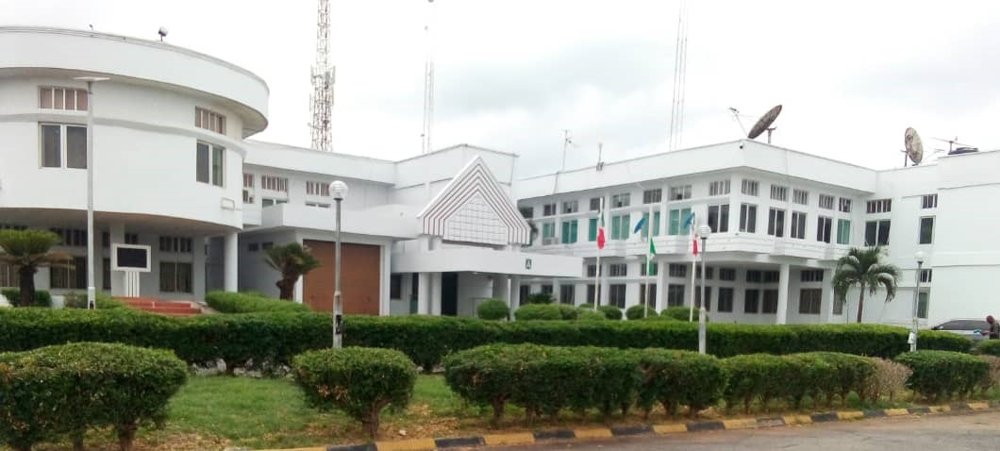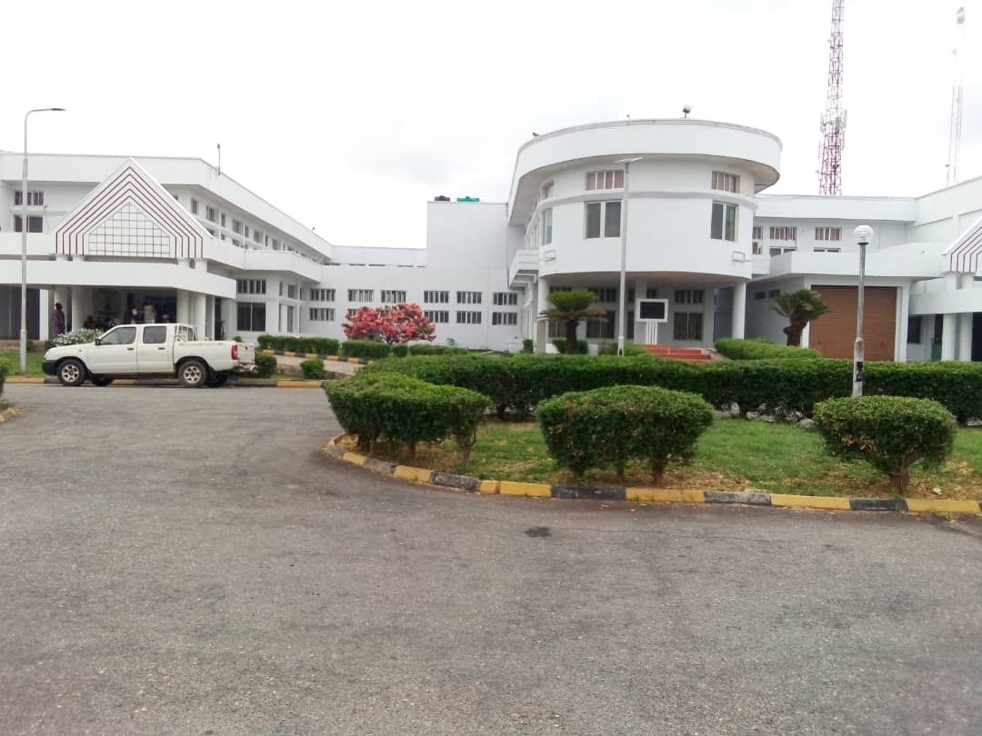

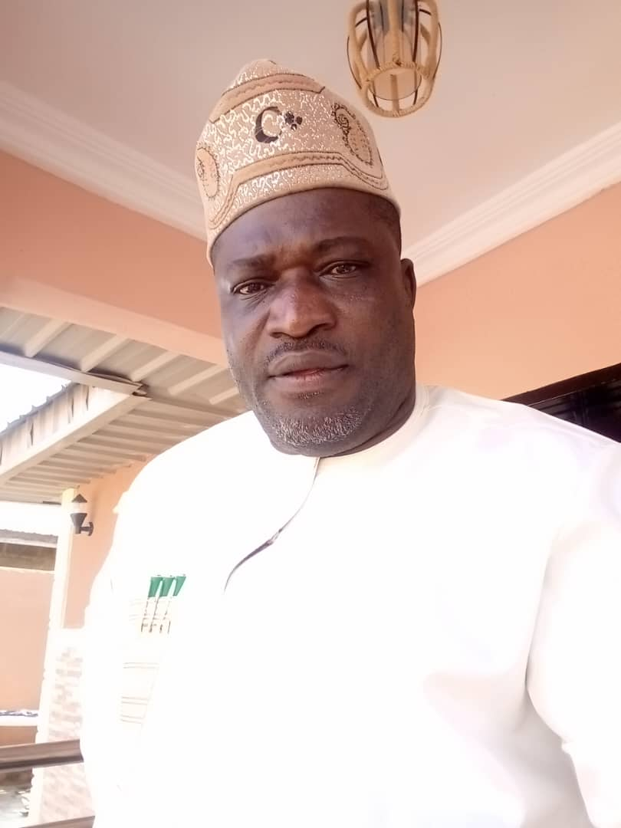Hon. Olusoji Korede Ajeigbe is the Honourable Commissioner, Government House and Protocol. An educationist who had experience spanning over a decade in education sector, is a holder of Bachelor of Education in Guidance and Counselling from University of Ado Ekiti. He is a chartered member of Nigerian Institute of Management. He is married with children.

Contact: [sojiajeigbedavid@gmail.com](mailto:sojiajeigbedavid@gmail.com)

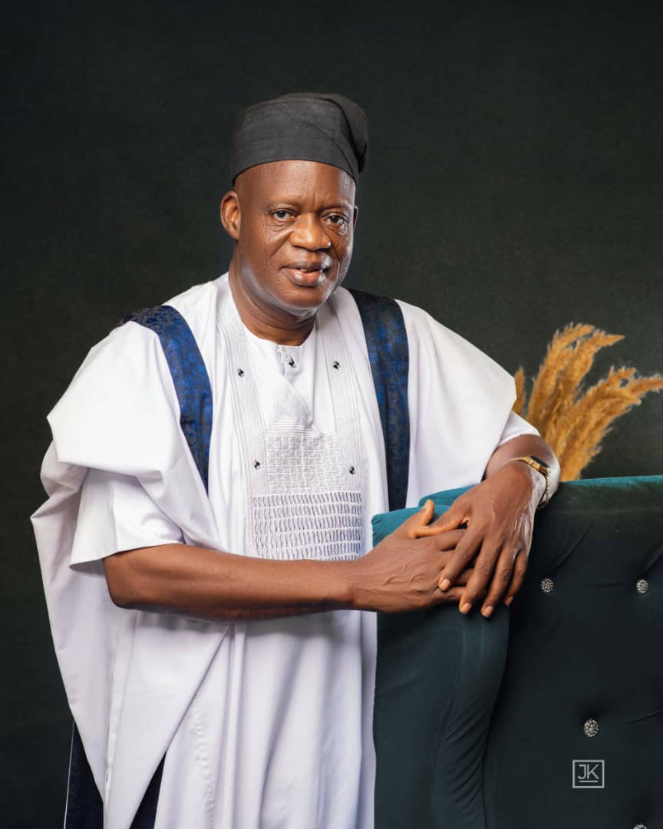Mr. Akinlabi Akanfe Olaniyi, the Special Adviser on Protocol to His Excellency, Senator (Dr.) Ademola Jackson Nurudeen Adeleke was born to the family of Pa and Madam Olaniyi of Elewiri Compound, Odeomu, Osun State, Nigeria.

He attended Oyo State College of Education Ilesa. In his quest for Western Education, he obtained National Certificates of Education (NCE). He further proceeded to the University of Nigeria, Nsukka where he bagged B.Sc in Education. He crowned his certificates with Master of Education in Adult Education from the University of Ibadan, Ibadan.

He joined the service of the then Oyo State as Class Teacher in 1978 and after the creation of Osun State, he transferred his service to the main stream of the Civil Service in 1993 as Senior Administrative Officer.

He steadily progressed the career to become Coordinating Director Teaching Services Commission (TESCOM) before his voluntary retirement from the active service of Osun State in the year 2012. He is happily married with lovely children.

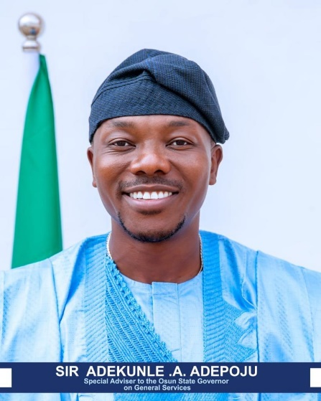Sir Adekunle A. Adepoju, Special Adviser to the Executive Governor of Osun State (General Services)

Sir Adekunle holds a B.Sc in Accounting, another B.Sc in Organizational Leadership with a Project Management Focus (Summa Cum Laude) honors from Arizona State University. He also holds an M.Sc in Public Administration and also an MBA from the prestigious W.P. Carey Business School, USA.

His professional journey is marked by significant achievements, including being decorated as a Sir Knight of the Order of Knights of Columbus USA, and later made Grand Knight of MSGR Thomas E O'Connell Council #6589. His exceptional service to humanity and community development activities has earned him numerous awards and recognitions.

Outside his professional responsibilities, Sir Adekunle enjoys playing golf reflecting his passion for both strategic and dynamic pursuits. Contact: [aadepoju@asu.edu](mailto:aadepoju@asu.edu)

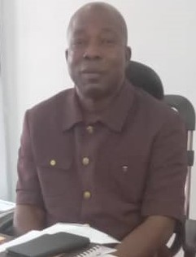

Mr. Adesina T. Okandeji, Permanent Secretary, Bureau of General Services, Protocol and Government House, was born on 6th day of January, 1970 into the family of Alhaji & Mrs. Okandeji, in Osogbo, Osogbo Local Government Area of Osun State.

He had his primary and secondary education in Osogbo, Osun State and a tertiary education at the prestigious University of Ilorin, Kwara State, Nigeria.

He began his career as Administrative Officer with the Osun State Government in 1998 and served in various capacities before he was appointed the Permanent Secretary, Bureau of General Services, Protocol and Government House on Tuesday, 30thMay,2023. He is happily married with children. Contact: [tjokandeji@gmail.com](mailto:tjokandeji@gmail.com)

The Permanent Secretary, Office of the Governor, supervises the Bureau of General Services as well as the Bureau of Government House and Protocol. The Permanent Secretary reports directly to the Chief of Staff via Head of Service. The Permanent Secretary equally relates with other top government functionaries in the Office of the Governor. These include:the Deputy Governor, Secretary to the State Government and other Governor-in-Council by virtue of the fact, that the Permanent Secretary is the Head of Bureaucracy in the Office of the Governor.

**SPECIFIC MANDATES OF DEPARTMENTS INTHE OFFICE OF THE GOVERNOR**

1. The Bureau of General Services, Office of the Governor is headed by the Permanent Secretary. It comprises of four (4) Departments and two (2) units which are; Administration and Supplies, Establishment Matters, Finance and Accounts, Planning, Research and Statistics and the Internal Audit Unit as well as Catering Unit. Three of these Departments (Administration and Supplies, Establishment Matters and Finance and Accounts) are headed by Directors, while the Planning, Research and Statistics has no substantive Director. All the Departments and the two (2) units (Internal Audit and Catering) relate directly with the Permanent Secretary.

1.1 Mandates of each department are as follows;

**DEPARTMENT OF ADMINISTRATION AND SUPPLIES**:-

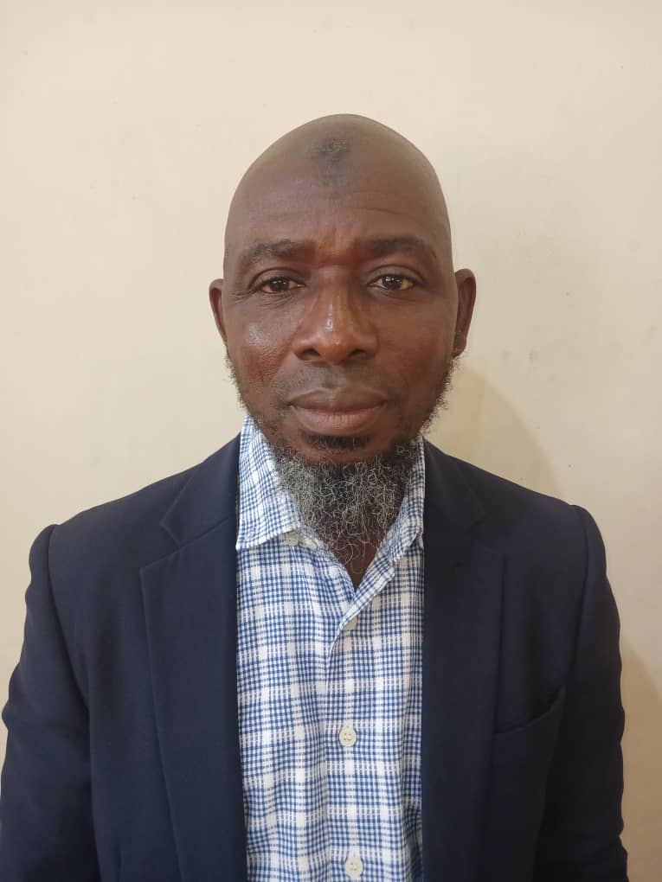Mr. Sikiru Adetona Alao, was born on the 11th of August, 1968 into the family of Mr. & Mrs. Uthman Alao.

He began his education at A.U.D Primary School, Osogbo and proceeded to the C.A.C. Commercial Modern School, Osogbo and C.A.C Secondary Commercial Grammar School, Osogbo for his secondary education, he later went to Osun State College of Education, Ilesa. He graduated with Honours in Economics Education from the prestigious Obafemi Awolowo University, Ile Ife.

Mr. Alao joined the Osun State Civil Service in 2003 as an Administrative Officer and steadily rose through the ranks to become Director. He has served in various capacities across the MDAs. He is happily married to Mrs. Alao and they are blessed with lovely children. Contact: [adetonasikiru@gmail.com](mailto:adetonasikiru@gmail.com)

The Department is responsible for the allocation and maintenance of Offices within the Bola-Ige Office Complex and Government Quarters, Supervises Administrative activities in the Office of the Governor, pooling and maintenance of all official vehicles in the Office of the Governor, processes financial requests to the Governor, maintains a functional store within the White House for safe-keeping of items of Stationery and other office equipment on purchase. Sections and Units under the Department includes; the Store Unit, Maintenance Unit and Transport Pool. The Chief Technical Officer (CTO) is the professional head of all Drivers and Mechanics in the Office of the Governor. The Department also allocates and maintains government quarters. These are:

(i) Garden Estate, Government Residential Area, (GRA), Osogbo;

(ii) Omiyale Estate, Oke-Onitea, Osogbo;

(iii) GRA I, Government Residential Area, Osogbo;

(iv) GRA II, Government Residential Area, Osogbo;

(v) Commissioners’ Quarters, Jaiye Area, Along Ikirun Road, Osogbo;

(vi) Amorit Estate, Abere;

(vii) Olufunmilayo Estate, Abere and

(viii) Government House Annex, Oke-fia, Osogbo.

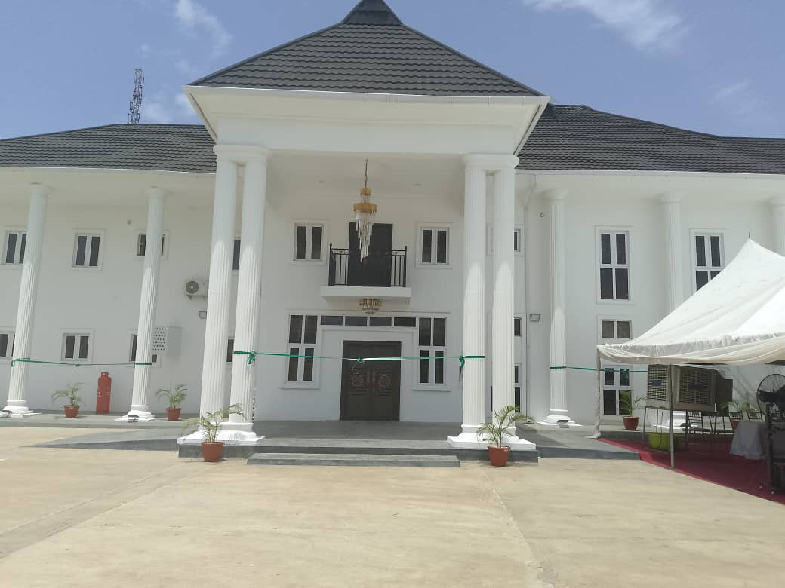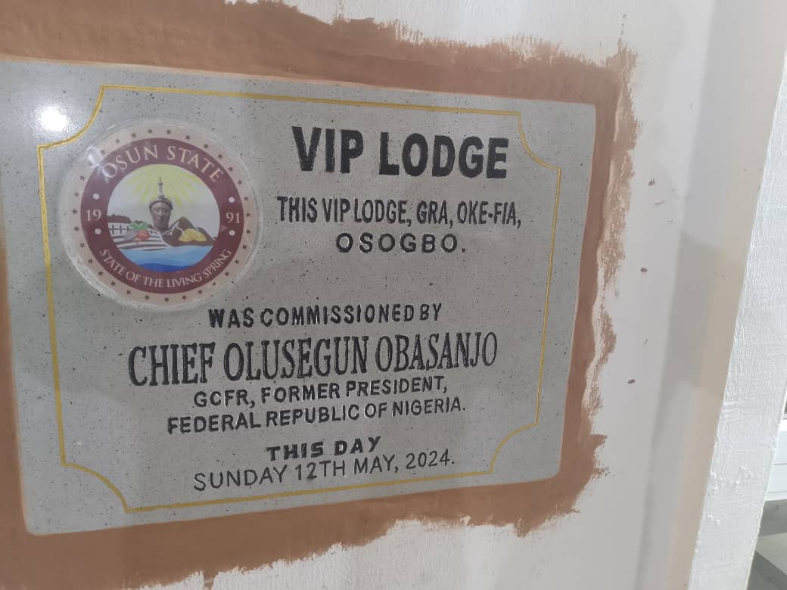

***It was abandoned by previous Administration but renovated and completed by Senator Ademola Jackson Nurudeen Adeleke and commissioned by Chief Olusegun Obasanjo on Sunday 12th May, 2024.***

**DETAILS OF GOVERNMENT QUARTERS**

|  |  |  |  |  |  |  |
| --- | --- | --- | --- | --- | --- | --- |
| **S/N** | **DESCRIPTION** | **VIP QUARTERS** | **THREE (3) BEDROOM FLATS** | **TWO (2) BEDROOM FLATS** | **BOYS QUARTERS** | **OTHERS** |
| **1** | **GARDEN ESTATE, GRA, OSOGBO** | **-** | **8** | **-** | **8** | **-** |
| **2** | **OMIYALE ESTATE, OKE-ONITEA, OSOGBO** | **-** | **9** | **9** | **9** | **-** |
| **3** | **GRA 1. GOVT. RESIDENTIAL AREA, OSOGBO** | **2(Speaker of the HOA & HOS)** | **6** | **-** | **6** | **-** |
| **4** | **GRA II, GOVT. RESIDENTIAL AREA, OSOGBO** | **-** | **7** | **-** | **7** | **-** |
| **5** | **COMMISSIONERS’ QUARTERS, JAIYE AREA, OSOGBO** | **-** | **14** | **-** | **14** | **-** |
| **6** | **AMORIT ESTATE, ABERE** | **-** | **3** | **-** | **-** | **-** |
| **7** | **OLUFUNMILAYO ESTATE, ABERE** | **-** | **10** | **-** | **-** | **-** |
| **8** | **GOVERNMENT HOUSE ANNEX, OKE-FIA, OSOGBO** |  |  |  |  | **Block A1 to Block N9** |

**1.1.3 DEPARTMENT OF ESTABLISHMENT MATTERS**:-

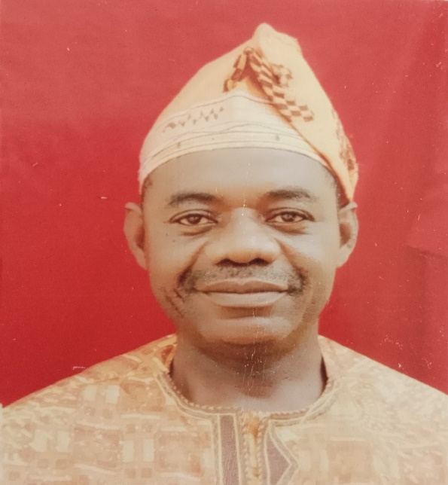Mr. E. O. Apelegan born to the family of Mr. & Mrs. Olu Joseph Apelegan of Osogbo on 9th July, 1970. He attended St. Benedict Catholic Primary School, Isale Aro Osogbo for his elementary education and later went to St. Joseph Catholic Secondary School, Ondo State. For his post secondary education, he attended the Premier University, University of Ibadan, Ibadan to obtain Honours in Philosophy. Mr. Apelegan joined the service of Osun State Civil Service in 2006 as an Administrative Officer and since rose to the position of a Director. He had worked in various capacities across the MDAs. He is happily married to Mrs. Rita Omonike Apelegan and are blessed with children. Contact: [apeleganemmanuel@gmail.com](mailto:apeleganemmanuel@gmail.com)

The Department is responsible for monitoring the activities of Agencies under the Office of the Governor with regards to appointment, confirmation, promotion and discipline of Staff, process the retirement benefits of staff, manages the career of senior and management staff, enhances the capacity of the Ministries, Departments and Agencies of Government to deliver public value. Other functions of the Department include the preparation of Annual Budgets, Processing of Certificate of State of Origin. The Department is in charge of the Registries (Open & Confidential) of the Bureau of General Services.

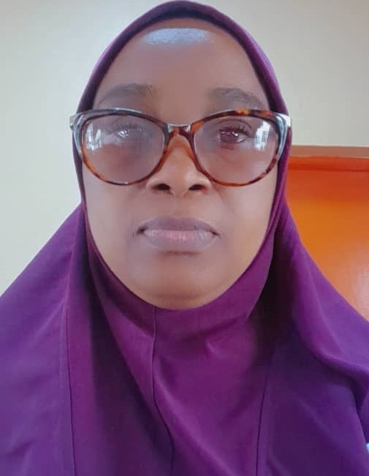1.1.3**DEPARTMENT OF FINANCE AND ACCOUNTS:-**

Mrs. Abolude Ganiyat Titilola, Director, Finance and Accounts, Bureau of General Services, Office of the Governor, was born August 22, 1969. She obtained Higher National Diploma at The Polytechnic, Ibadan, Bachelor of Science at Ambrose Alli University, Ekpoma in 1993 and 2004 respectively. She is a member of Association of National Accountants of Nigeria (ANAN). She also bagged Masters in Business Administration (MBA) from the prestigious Obafemi Awolowo University. She joined the service of Osun State Government on January, 1996 as Account Assistant and worked at various MDAs and rose to the post of a Director. Contact: [aboludepg69@gmail.com](mailto:aboludepg69@gmail.com)

Mandates of the Department are; to process Mr. Governor’s Approval to the Ministry of Economic Planning, Budget and Development, raising vouchers to the Office of the Accountant General for the release of Fund, Keeping records and rendering returns of revenue and expenditure of Government, Preparation of Annual Memorandum and Appropriation Accounts, Preparation of Bank reconciliation Statements, withdrawal of cash from Bank for disbursement to beneficiaries, preparation of salaries and allowances of career and Political office holders,Preparation of annual Budget Estimates of the Agency. Other duties as may be assigned by the Authority, from time to time.

1.1.4 **SALARY AND PAYROLL MANAGEMENT**

The monthly salary requests of the Office of the Governor are endorsed by the Permanent Secretary to the Ministry of Finance at the latest, 7th of every month for further processing. The payroll includes the request of the political appointees and career officers in the Office of the Governor. Apart from the staff of the Bureau of General Services, there are about 16 other agencies under the Office of the Governor, whose payroll are domiciled in the Office of the Governor.

1.1.5 **PLANNING, RESEARCH AND STATISTICS**:-

The Unit is responsible for the; Preparation of monthly, annual and situation reports, collection and management of data, Preparation of Annual Budget, Monitoring and Evaluation of Projects and any other duties as may be assigned.

**2.0** The Bureau of General Services coordinates the activities of 16other offices under the Office of the Governor and all these are under the supervision of the Chief of Staff to the Governor ably supported by the Commissioner for Government and Protocol, Special Adviserson General Services and Governor’s Officeand the Accounting Officer, the Permanent Secretary. The Offices are as follows:

i. Office of the Governor;

ii. Office of the Wife of the Governor;

iii. Office of the Deputy Governor;

iv. Office of the Chief of Staff;

v. Commissioner for Protocol & Government House;

vi. (a) Office of the Special Adviser (Protocol)

(b) Office of the Special Adviser (General Services);

(c) Office of the Special Adviser (Governor’s Office);

vii. Department of Security Matters;

viii. Bureau of Social Services (BOSS);

ix. Bureau of Government House and Protocol;

x. Sustainable Development Goals (SDGs);

xi. United Nation Development Programme (UNDP);

xii. Bureau of Communication and Strategy;

xiii. Osun Investment and Promotion Agency;

xiv. Osun Micro Credit Agency;

xv. Osun Signage, Hoarding and Advertisement

(O-SIGNAGE);

xvi. Political Functionaries.

**3.0 MAINTENANCE OF UTILITIES IN THE GOVERNOR’S OFFICE**

In order to ensure prompt maintenance of utilities such as water and electricity, foremen of diverse professions are deployed by the Ministry of Works and Infrastructure to the Office of the Governor(including Government House). For instance, there are Plumbers and Electricians who attend to issues of minor repair of utilities. If there are major issues on the functioning of utilities that are beyond the competence of the foremen, they are referred to the Ministry of Works and Infrastructure. The Ministry is also in charge of Electricity supply through generating sets to the Office of the Governor whenever public supply fails or becomes ineffective.

**4.0 ENVIRONMENTAL SANITATION OF BOLA-IGE HOUSE**

The Environmental Sanitation and Cleanliness of the Office of the Governor (Bola-Ige House) is being handled by Ajagbe Cleaners, a cleaning outfit that was given the retainership in the year 2023. The outfit maintains the external and interior of the White House. The contract is renewed annually while payment is made by the Office of the Accountant-General on monthly basis.

**5.0** **THE PRINCIPAL PRIVATE SECRETARY TO THE GOVERNOR**

The Principal Private Secretary is one of the career Aides of the Executive Governor. He saddled with the following responsibilities under the proper coordination and supervision of the Permanent Secretary, Office of the Governor for implementation;

* facilitate the seamless administration of the unit;
* draw and seek approval of weekly itinerary of the Governor;
* facilitate courtesy visit to Mr. Governor;
* link and work on correspondences with VIPs who have dealings with the State;
* finalize letters of invitation for State activities;
* write important letters on felicitations, empathy, condolences e.t.c for the signature of Mr. Governor;
* write letters of assistance for students seeking

admission in tertiary institutions;

* assist in linking with Federal GovernmentAgencies and International bodies;
* work with all MDAs in putting their letters in proper perspective for the signature ofMr. Governor;
* attend to any other assignments directed to his office.

**BUREAU OF GOVERNMENT HOUSE AND PROTOCOL**

**Temitope Ajibola Ajibade,** the Director of Protocolwas born and raised by **Mr. & Mrs. Ajibade,** Modakeke, Ife East Area Office, Osun State**,** on the 26thday of October1976. He attended University of Ibadan and Osun State University, Osogbo where he obtained Bachelor of Education in Political Science and Special Education and Master of Science in Intelligence and Strategies Studies respectively. He joined the service of Osun State in the year 2009. He has since served in various capacities. Contact:[temitopeajibadeola@gmail.com](mailto:temitopeajibadeola@gmail.com)

**1.0 INTRODUCTION**

The Bureau of Government House and Protocol is one of the Agencies under the Governor’s Office and the Permanent Secretary, Office of the Governor also supervises the activities of the Bureau which has the sole responsibilities amongst others for the welfare of the First Family, welfare and safety of all Government Guests. It handles seamlessly public and private outings of the Governor and his family, other top functionaries and officials of the Government.In a nutshell, the primary purpose of the Bureau of Government House and Protocol is to ensure that the Governor is not subjected to any form of embarrassment, distress or ridicule either in his private or official capacities. All programmes that the Governor will be involved must exhibit emporium of excellence which definitely, requires proper planning and execution.

The Permanent Secretary,who is the Accounting Officer also relates directly with the Honourable Commissioner, Bureau of Government House and Protocol and the Special Adviser on Protocol Matters.

**2.0 DEPARTMENT UNDER THE BUREAU**

**3.0 FINANCE AND ACCOUNTS UNIT**

The finance and accounts Unit is responsible for the processing of approval of funds and other financial transaction of the Bureau. The Unit relates with the Offices of the Accountant General, Auditor-General and the Internal Auditor. The Bureau operates Account for over-head and other charges expenditure which includes expendable imprest of Mr. Governor, funding of Government programme, fund trips and Financial Assistance in which approval shall be given by the Governor.

**4.0 FUNCTIONS OF THE BUREAU OF GOVERNMENT HOUSE AND PROTOCOL**

* 1. The following are the specific functions and responsibilities of the Bureau.

(i) welfare of the First Family within and outside the Country;

(ii) security of the First Family and other top Government functionaries;

(iii) upkeep of the Government House and associated quarters;

(iv) maintenance of Government House Clinic and the Animal Yard;

(v) maintenance of the Presidential Lodge, VIP Lodge and Chalets;

(vi) maintenance of the Government House Annex, Oke-fia, Osogbo;

(vii) supervision of the Chief Driver of the Government House Transport Pool;

(viii) maintenance of vehicles in the Governor’s Convoy;

(ix) ensuring prompt fuelling of vehicles in the convoy of the Governor, Wife of the Governor, Chief of Staff, etc.

(x) welfare of Government Guests, including accommodation, hospitality, etc.

(xi) organizing seamless programmes of the Governor within the State and outside to ensure best standards and practices;

(xii) processing overseas trips of the Governor and other top Government functionaries;

(xiii) procurement of gifts to be distributed by the Governor during festivals e.g. Easter/Ramadan Fasting period, Ileya, Xmas and new year’s festivals;

(xiv) dealing with Hotels in the State;

(xv) ensuring the welfare of Security Staff of the Governor;

(xvi) supervising of the Catering Unit of the Government House;

**A. T. Okandeji**

Permanent Secretary,

Office of the Governor,

July, 2024.