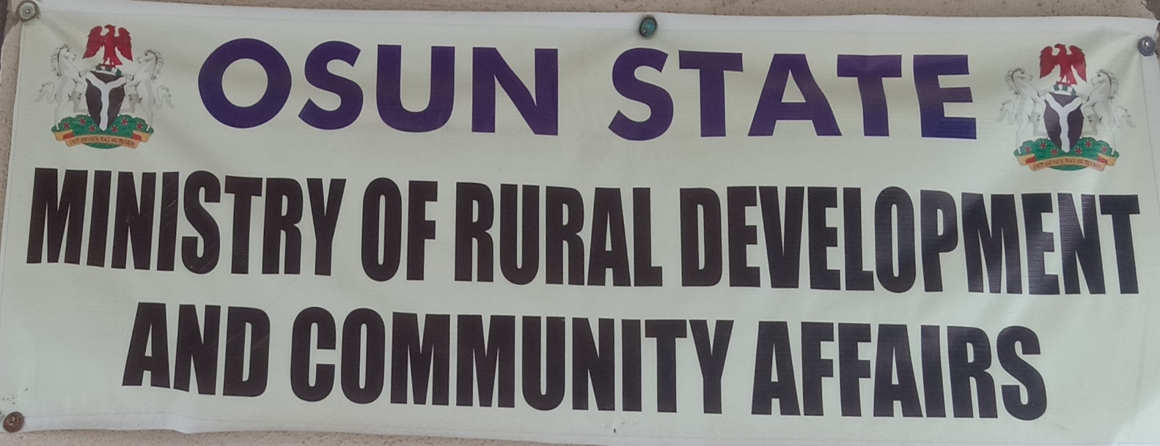

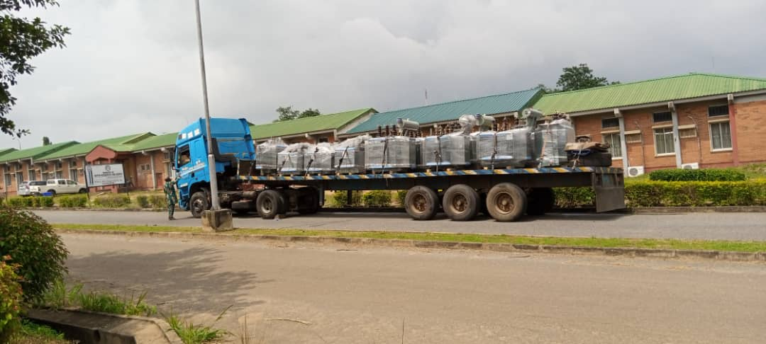

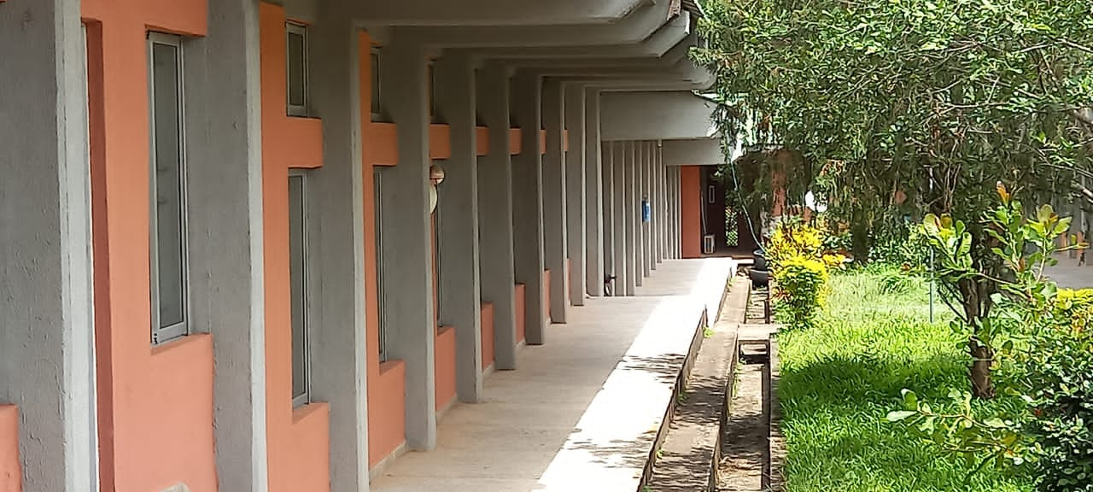

**PREAMBLE**

The Ministry of Rural Development and Community Affairs came into being in 2019 when there was a slight restructuring of the State Civil Service for easy and effective administration. The Ministry was carved out from the Office of Water Resources, Rural Development and Community Affairs.

**OBJECTIVES/MANDATES OF THE MINISTRY**

1. Formulate policies on Rural and Community Development for implementation by relevant Agencies of Government in the Osun State
2. Coordinate and liaise with other State MDAs and all Local Governments on Rural Development matters;
3. Liaise with the Federal Ministry of Agriculture and Rural Development and other Federal Government Agencies including Federal Institutions of learning and internal organization on matters affecting the development of Rural Areas of the Osun State
4. Gather, collate and analyze Community Development Affairs data with a view to developing and disseminating useful information relevant to improving rural development and community affairs in the State;
5. Coordinate the Community Development Departments and units of all Local Governments to ensure harmonious development and steady progress of all identified rural communities in the Osun State;
6. Mobilize the private sector for active participation in the rural development efforts of the State Government;
7. Coordinate Community Development Associations and Neighborhood Watch Matters as well as participate in National and International events that provide opportunities for learning developments in the sector;
8. Mobilize the rural communities to accept responsibility for maintenance of rural infrastructure (roads and sanitation)
9. Provide rural water supply, rural electrification, rural feeder roads and rural concrete foot bridges.
10. Provide amenities and related infrastructure in rural areas for improved quality of life.
11. Promote voluntary agencies, private sector and individuals’ involvement for rural development.

**LIST OF ELECTRIFICATION PROJECTS IN 2024 (DEPARTMENT OF RURAL DEVELOPMENT)**

|  |  |  |
| --- | --- | --- |
| **S/N** | **PROJECT** | **COMPLETION PERCENTAGE** |
| 1 | REPLACEMENT/INSTALLATION OF DAMAGED AGBALE TRANSFORMER, EDE | 100% |
| 2 | RURAL ELECTRIFICATION OF PREMIER ESTATE, AWO, EGBEDORE LG. | 97% |
| 3 | REPLACEMENT/INSTALLATION OF DAMAGED DAGBOLU-ATAOJA TRANSFORMER, OSOGBO | 100% |
| 4 | RURAL ELECTRIFICATION OF ADURAGBEMI COMMUNITY, OGBAAGBA ROAD, ORI-ERU, IWO | 97% |
| 5 | RE-ACTIVATION OF HIGH-TENSION LINE AND SUBSTATION OF IREPODUN VILLAGE, OSOGBO L G. | 97% |
| 6 | RURAL ELECTRIFICATION OF AANUOLUWAPO COMMUNITY, OWODE-EDE | 97% |
| 7 | REPLACEMENT/INSTALLATION OF DAMAGED SHITTU STREET TRANSFORMER, OBELAWO AREA, OSOGBO, OLORUNDA LG. | 100% |
| 8 | REPLACEMENT/INSTALLATION OF DAMAGED ODEYINKA VILLAGE TRANSFORMER, IREWOLE LG | 100% |
| 9 | RURAL ELECTRIFICATION OF EGBEJODA COMMUNITY, WORU ZONE C, EGBEDORE L. G. | 97% |
| 10 | RURAL ELECTRIFICATION OF OSAARA COMMUNITY, FOUNTAIN UNIVERSITY AREA, OSOGBO | 97% |
| 11 | REPLACEMENT/INSTALLATION OF DAMAGED TEMIDIRE COMMUNITY TRANSFORMER, ILOBU | 100% |
| 12 | RURAL ELECTRIFICATION OF DAGBOLU, OLD IKIRUN ROAD, IFELODUN LG. | 97% |
| 13 | RURAL ELECTRIFICATION OF AYEDAADE VILLAGE, ILOBU, IREPODUN L. G. | 97% |
| 14 | REPLACEMENT/INSTALLATION OF DAMAGED ITA-IMAM TRANSFORMER, TELEMU, OLA-OLUWA LG. | 100% |
| 15 | REPLACEMENT/INSTALLATION OF DAMAGED SHARP CORNER TRANSFORMER, ILA-ORANGUN, ILA LG.. | 100% |
| 16 | RURAL ELECTRIFICATION OF IFEDAPO QUARTERS, IFEWARA, ATAKUMOSA WEST LG | 97% |
| 17 | RURAL ELECTRIFICATION OF OLUWALANA COMMUNITY, OWODE-EDE | 97% |

18. A day training and workshop for Communities Vigilante Groups

**KEY OFFICERS WITH THEIR PROFILE AND CONTACTS:**

**Full Name: HON. GANIYU OLAOLUWA**

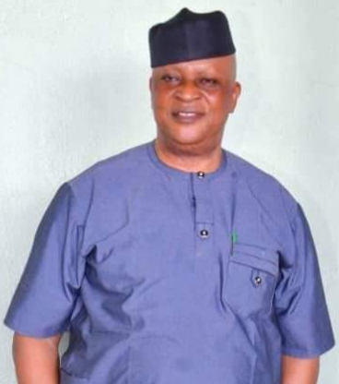

**Designation: HONOURABLE COMMISSIONER**

**Phone Number: 08037212025**

**Email Address: olaayobami223@gmail.com**

**Date of Birth 11 – 05 - 1962**

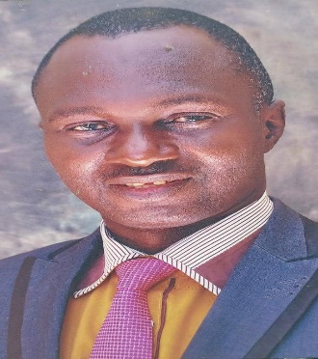

**Full Name: LATEEF ADESINA ADEDAPO**

**Designation: ACTING PERMANENT SECRETARY**

**Phone Number: 08035016120**

**Email Address: adedapo_adeshina@yahoo.com**

**Date of Birth 14 – 2 - 1965**

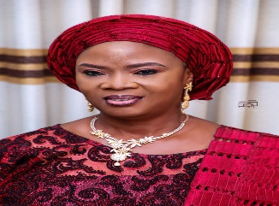**Full Name: AJIBOLA OLUBUNMI FALODE**

**Designation: DIRECTOR ADMINISTRATION & SUPPLIES**

**Phone Number: 08033731589**

**Email Address:** [**ajibolafalode@gmail.com**](mailto:ajibolafalode@gmail.com)

**Date of Birth 21 - 4 – 1966**



**Full Name : BASIRAT OLANIKE AGBOLADE**

**Designation: DIRECTOR FINANCE AND ACCOUNTS**

**Phone Number: 08038638621**

**Email Address:** [**agboladeolanike@gmail.com**](mailto:agboladeolanike@gmail.com)

**Date of Birth 17 - 7 – 1969**

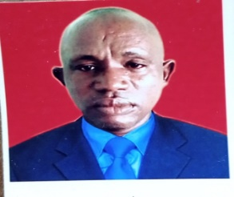**Full Name: KAYODE KAZEEM GBADAMOSI**

**Designation: DIRECTOR RURAL DEVELOPMENT**

**Phone Number: 08067099720**

**Email Address:** [**kayodegbadamosi@gmail.com**](mailto:kayodegbadamosi@gmail.com)

**Date of Birth 24 - 7 – 1973**

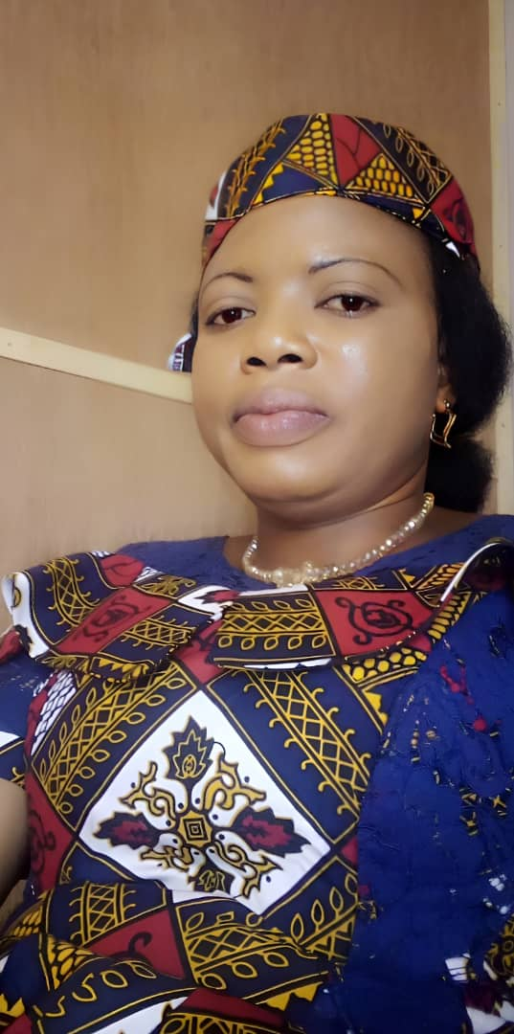

**Full Name: IYABO OLUWAFUNMILAYO ODUBIYI**

**Designation: PLANNING RESEARCH & STATISTICS OFFICER**

**Phone Number: 08062116557**

**Email Address:** [**adegbajuoluwafunmilayo@gmail.com**](mailto:adegbajuoluwafunmilayo@gmail.com)

**Date of Birth 7 - 4 – 1977**



**Full Name: JELILI AKINSOLA BABATUNDE**

**Designation: DEPUTY DIRECTOR RURAL DEVELOPMENT**

**Phone Number: 08030508071**

**Email Address:** [**akintope_4real@yahoo.com**](mailto:akintope_4real@yahoo.com)**, akintopereal@gmai**

**Date of Birth 12 - 2 – 1982**

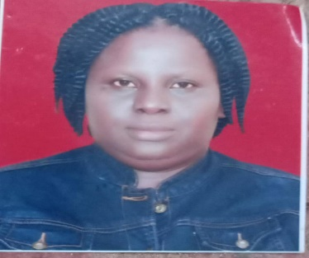

**Full Name: BAMIDELE ADEBIMPE AKINOLA**

**Designation: DEPUTY DIRECTOR COMMUNITY AFFAIRS**

**Phone Number: 08135621457**

**Email Address:** [**fayofunmi@gmail.com**](mailto:fayofunmi@gmail.com)

**Date of Birth 19 - 8 – 1974**

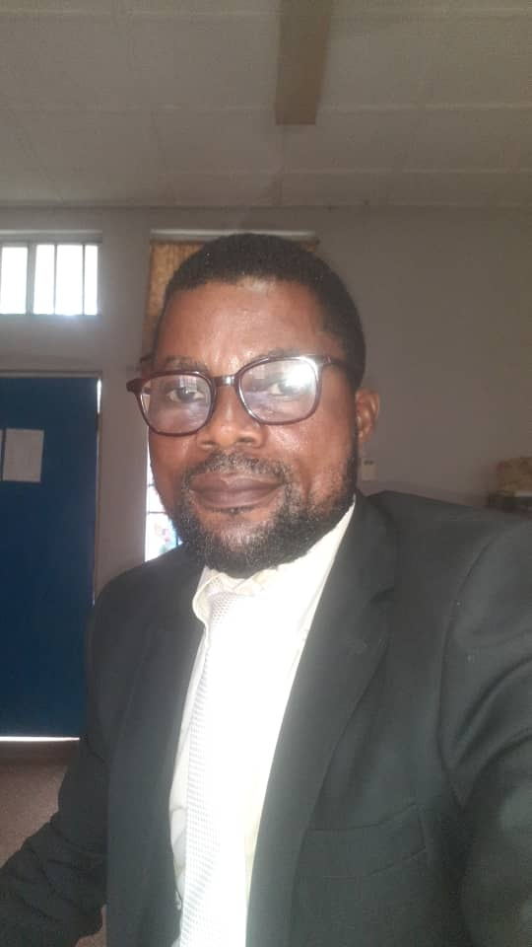

**Full Name: ABIODUN TEMITAYO OJO**

**Designation: ADMIN OFFICER**

**Phone Number: 08034908462**

**Email Address:** [**abiodunojo1312@gmail.com**](mailto:abiodunojo1312@gmail.com)

**Date of Birth 01 – 01 - 1984**

**Full Name: JOBA GIDEON OYEJIDE**



**Designation: INTERNAL AUDITOR**

**Phone Number: 08038124438**

**Email Address:** [**oyejidejoba@gmail.com**](mailto:oyejidejoba@gmail.com)

**Date of Birth 8 - 3 – 1966**