**REPORT OF PROFILE OF KEY OFFICERS AND OBJECTIVE EVENTS AND ACTIVITIES OF MINISTRY OF COOPERATIVES AND EMPOWERMENT**

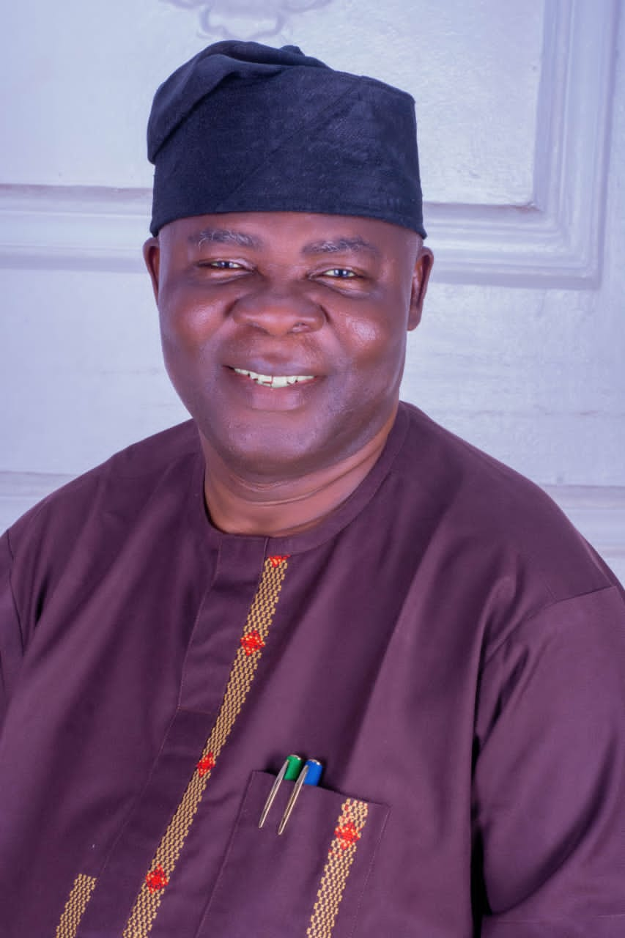

**PROFILE OF HONOURABLE COMMISSIONER FOR MINISTRY OF COOPERATIVES AND EMPOWERMENT**

**BIOGRAPHY OF PRINCE BAYO OGUNGBANGBE**

Prince Adebayo Femi Ogungbangbe was born into the Royal Family of Ajagbusi - Ekun ruling House Iloko Ijesa, on the 16th of June 1967, in Oriade Local Government. He attended Methodist Primary School Iragbiji, Holy Michael Grammar School Ikirun, and was a Graduate of History and Yoruba Studies. Skilled in the Course of Parliamentary Administration and Contemporary Practice. Confident and Articulate, Multifaceted Politician with years of experience. Passionate about Social Justice, Political Science, and Management influencing a tangible societal difference and resolving problems

Prince ***BAYO OGUNGBANGBE*** has held several positions in politics ever since 1993 such as:

* Social Democratic Party (SDP) **1993**

Financial Secretary Ward 10, Oriade Local Government.

* United Nigerian Congress Party (UNCP) **1997 – 1998 e.t.c**

Vice Chairman and Supervisory Councilor for Health,

Oriade Local Government, Ijebu-IJesa.

* People’s Democratic Party (PDP) **1998**

Foundation Member and Leader, Oriade Local Government.

Chairman Peoples Democratic Party. **2003-2010**

* Part-time Member – Osun State Project

Advisory Committee. **2004-2008**

* Governing Council Member Osun State

Polytechnic Iree. **2008-2010**

* Director Osun State Polytechnic

Microfinance Bank, Iree. **2009-2010**

* Chairman – PDP Caretaker Committee,

Oriade Local Government**.** **2017**

* Member – PDP Transition Committee. **July 2022**

However, Prince ***BAYO OGUNGBANGBE*** has also worked in various organizations and establishments.

He is happily married to ***Ogungbangbe Clara Oyenike*** and blessed with Children.

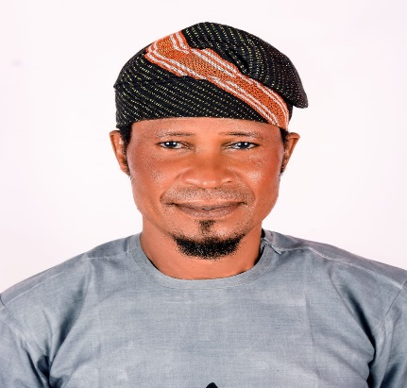

**PROFILE OF SPECIAL ADVISER**

**PROFILE OF HON DUROJAYE ISAAC KOLAWOLE**

**SPECIAL ADVISER TO THE GOVERNOR ON COOPERATIVES AND EMPOWERMENT**

A. PERSONAL DATA

Full Name: **DUROJAYE Isaac Kolawole**

Date of Birth:5th April, 1966

Contact Details: Residential Address: Durojaye street, Ifeoluwa Quarters, Ita-Osa, Ondo Road, Ile-IfeE-mail Address (es): [sikomole66@gmail.com](mailto:sikomole66@gmail.com) Mobile Telephone 08034071728, 08163445000 Nationality: Nigerian .State of Origin: Osun State. Senatorial District: Osun East Local Government Area: Ife-East Marital Status: Married

B. EDUCATIONAL BACKGROUND

Educational Institutions Attended with Dates:

1. Salvation Army Primary School Oke-Atan, Ile-Ife 1975-1981

2. St. John Grammar School, Ile-Ife 1982-1986

3. Community High School, Oyere-Apamun, Via Ile-Ife 1986-1987

4. Ministry of Commerce and Industry School, Omiru, Ilesa 1988

Academic/ Professional Qualifications and Distinctions Obtained with Dates:

1. Primary School Leaving Certificate 1981

2. West African Senior School Certificate Examination 1987

3. Ministry of Commerce Certificate 1988

C. WORK EXPERIENCE WITH DATES:

(i) Assistant Secretary, Ife Cooperative Produce and Marketing Society Limited Ile-Ife 1998-1991

(ii) Secretary, Aba-Oba, Aba-Iwo CPMS LTD 1991-1994

(iii) Managing Director, Laughter Cocoa Produce Merchant. 1994-1998

(iv) Managing Director,. Laughter Communications, Mayfair, Ile-Ife. 2002-2003

(v) Personal Assistant to the Chairman, Ife-East Local Government, Oke-Ogbo. 2003-2006

(vi) Supervisor for Works and Transport, Ife-East Local Government, Oke-Ogbo. 2006-2007

(vii) Managing Director, Laughter Paints, Moore, Ile-Ife. 2008-2014

(viii) Youth Leader, Ife-East Peoples Democratic Party (PDP). 2013-2017

(ix) Chairman: Ife-East Peoples Democratic Party (PDP). 2017-2022

(x) Managing Director,. Laughter Hotels and Suites, Ita-Osa, Ile-Ife. 2015-2022

**PROFILE OF PERMANENT SECRETARY**

Mr Sunday Olugbenga Fadele Permanent Secretary, Ministry of Cooperative and Empowerment, Osun State, Osogbo. Born on 14th June, 1969, to the family of Michael Olabode Fadele (Father) and Mrs Felicia Bamidele Fadele (Mother). Young Sunday Olugbenga Fadele began his educational pursuit at the holy Apostle Catholic Primary school, Aagba in 1973. He later joined his (now late) uncle who was a classroom teacher at Local Authority primary school at Oyi Ayegunle via ila Orangun where he eventually got his first school leaving certificate in 1980. He attended Methodist High school Aagba where he obtained the West African School Certificate (WASC) in 1985. He later proceeded to the Prestigious University of Ilorin, kwara State where he bagged B.sc (Hons) Economics in 1994. He did his one year mandatory National Youth Service in Uyo, Akwa ibom State between 1994 and 1995. Additional Educational Qualifications include a Master in Business Administration (MBA) Financial Management from LadOKE Akintola University of Technology, LAUTECH Ogbomoso.

* Master of Science (M.sc) in procurement and supply chain Management from lead city University Ibadan.
* He joined the Osun State public service in October, 1998 into the highly referred Administration Officer II GL.08
* He was appointed Secretary, State Tenders Board, Ministry of Budget and Economic Planning 2013 to 2016.
* Acting General Manager, Public Procurement Agency, (PPA) Office of the Governor, May 2016 to June, 2020.
* Director General, Sustainable Development Goals (SDG) 2020 to 2023.
* Permanent Secretary, Bureau of human Resources and Capacity Building May, 2023 to April 2024.
* Permanent Secretary, Ministry of Co-operative and Empowerment, April, 2024 to date.
* Certified Management Professional (CMP) London Bridge Business

School, UK Distinguished. Fellow of the Africa institute (DFAI) of the African institute

of Public Administration.

* Member, Osogbo Tennis Club,
* Member, Elite Club, Aagba
* Participant, Leaderchip Retreat for Executives of Osun State Government.
* Assistant Pastor the Redeemed Christian Church of God, RCCG, Next Level Chapel, Osogbo
* Happily married to a wonderful wife and beautiful children.

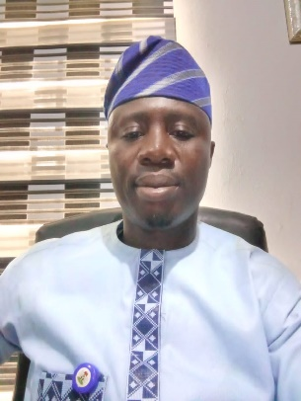

**PROFILE OF SENIOR SPECIAL ASSISITANT TO THE GOVERNOR ON COOPERATIVES AND EMPOWERMENT**

NAME: Oyeniyi Rssheed Adeyemi SSA1 Ministry of Co-operatives and Empowerment

Born on 5th of April 1982 to the family of Alhaji Wahab Oyeniyi and Mrs S. Oyeniyi of Agbangudu compound Ede, Ede South Local Government Ede. I attended L.A Primary school Agbongbe Ede, Baptist high school and Agbonran grammar school for secondary Education and Oscotech Esa Oke to study quality survey. Formal National deputy president federation of Ede youths. Publicity Secretary Ede day 2015 Secretary TNN. (Senior Special Assistant to the Governor of Osun State on Co-operatives and Empowerment SSA1).

**PROFILE OF DIRECTOR OF ADMINISTRATION AND SUPPLIES**

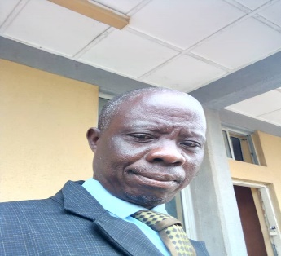 **Name: Adegoke Diekola Isiaka**

Mr. Diekola Isiaka Adegoke Director of Administration Ministry of Cooperative and Empowerment Osun State. Born on 17th June, 1966 to the family of kareem Adejumobi Adegoke (Father) and Mrs Juwerast Odeyoyin Adegoke (Mother). Young Diekola Isiaka Adegoke began his educational pursuit at AUD School Ileogbo. He attended papa Community Grammar School , Iwo where he obtained the west African school certificate (WASC) in 1985. In the service, he later proceeded to the University of Ado Ekiti (UNAD) where he bagged (Bsc Business Administration) in 2006.

Schedule of Duties:

* Oversees and manage the Administration operators of the organization including administrations staff and office procedures.
* Develop and implement policies and procedures to ensure efficient and effective’s administration operations.
* Manage and coordinate the procurement and inventory of office supplies equipment, and services.
* Ensure compliance with organizational policies and procedures as well as federal, State and Local regulations.



**PROFILE OF DIRECTOR OF FINANCE AND ACCOUNT:**

**Name: AFOLABI MICHEAL ABIODUN**

DATE OF BIRTH: 1ST JANUARY, 1968

Institution- The Polytechnic Ibadan, University of Ado- Ekiti and

Highest Qualification: MBA

Designation: Director Finance and Accounts

Schedule of Duties: Supervising the Officers in charge of:

* Revenue
* Payment of Salary
* Payment of funds
* Raising of Vouchers
* Issue of cheques



Name: **BABATUNDE ADIO OGUNJIDE**

DATE OF BIRTH: 2nd August, 1967

Institution- Professional Diploma in Cooperative studies 2001

Highest Qualification: B.SC (Hons) Agricultural Economics

Academic Qualification: Fellow institute of Cooperative Professional of Nigeria.

Schedule of Duties: Supervising the Officers in charge of:

* Reporter of cooperative Societies
* Principal Reporter of cooperative Societies



Name: **ELIJAH BABATUNDE OLOWOYEYE**

DATE OF BIRTH: 15TH September, 1966

Institution- Obafemi Awolowo University, Ile-Ife

Highest Qualification: B.Agric (Hons) 1991

Rank: Deputy Director of Cooperative Service

Designation: Director/Principal Osun State Cooperative College, Ode Omu

Schedule of Duties: Supervising the Officers in charge of:

* Overseeing all Administrative and Academic activities in the Osun State Cooperative College.



Name: **MARGARET OLAPEJU OGINNI (MRS)**

DATE OF BIRTH: 20TH May,1966

Institution- Obafemi Awolowo , Ile ife

Highest Qualification: MBA

Designation: Director of Empowerment

Schedule of Duties: Supervising the Officers in charge of:

* Facilities and organize appropriate activities to enhance skill acquisition for poverty reduction and sustainable
* Facilities diverse job creation opportunities for poverty reduction
* Facilities activities to raise the level of production and reduction of unemployment

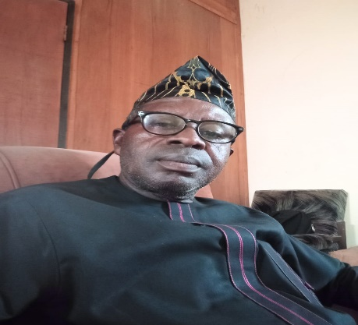

**PROFILE OF DIRECTOR OF COOPERATIVE EXTENSION SERVICES AND EDUCATION**

NAME : ADENIRAN ADELANI MUKAILA

DATE OF BIRTH: 13TH March, 1969

Institution Attended- Federal University of Agric of Abeokuta

Highest Qualification: B.SC AGRIC

Schedule of Duties: Supervising the Officers in charge of:

* Facilitate of cooperative propaganda Giming at creating and forming more cooperative societies
* Nurturing those newly-firmed cooperative to maturity and advise them to get registered under the State government for more economic development.
* Impacting cooperative education through organization of seminars, workshops and symposium with the of increasing know how on per cooperative management among cooperative entities

**PROFILE OF DIRECTOR OF AGRIC. PRODUCTION MARKETING AND S.M.U MINISTRY OF N**

**COOPERATIVE AND EMPOWERMENT OSOGBO.**

 Name: **OLAYEMI BASIR OLAWALE**

Date of Birth: 28th November, 1970

School Attended with Date:

* Manpower Junior School 1976-1981
* Federal Government College Odogbonu 1981-1986
* University of Ibadan 1990-1995
* Cooperative College Ibadan 1999-2000

Certificate Obtained:

* Primary School Leaving Certification 1976
* WAEC 1986
* Post-Graduate Diploma in Cooperative Studies 2000.
* B.Sc Agric (1995)

**PROFILE OF DIRECTOR OF COOPERATIVE LOAN RECOVER AND DISPUTE SETTLEMENT:**

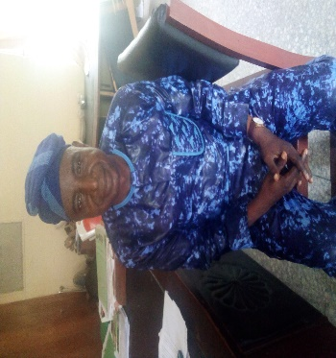 **Name: MICHEAL GBADEBO ADELEKE (MR)**

DATE OF BIRTH: 15TH August, 1965

Institution Attended- LAUTECH

Highest Qualification: MBA

Schedule of Duties: Supervising the Officers in charge of:

* Adequate monitoring the responsiveness’ of members on loan granted them at their responsiveness societies
* Making inquiry on bothering issue related to outcome of rejected account by members at the Annual general meeting
* Conduct research on report of overdue loans and misappropriation of found by committee, employed staff of cooperative societies
* Ensuring prohibition of cases of sit-tight syndrome of elected Officers
* Facilities diverse activities on cooperative policies as stipulated by law and government in power.