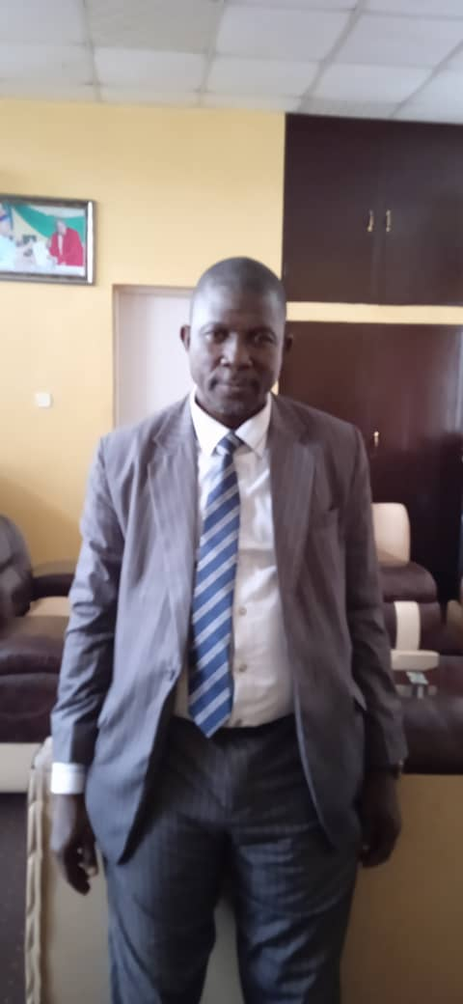Mr. Surajudeen Adebayo Raji was born to the family of Late Mr. & Mrs. Buhari Raji of Apomu town in Isokan Local Government of Osun State on 10th August 1965. He practiced Islam religion.

He attended Community High School, Ayepe-Apomu where he obtained West Africa Examination Certificate. Later in 1986 he proceeded to Oyo State College of Arts and Science, Ile – Ife in 1987 – 1989.

He was awarded with Bachelor of Linguistics at the University of Ilorin, Kwara State in the Year 1995, also Master in Public Administration at Obafemi Awolowo University in Year 2018.

As a Student at Secondary School and University, he was a Health Prefect and Secretary Linguistics Student Association respectively. He was awarded with the Fellow Member of Certified Pension Institute of Nigeria.

Moreover, in the Year 1998 he was employed by the Osun State Government as an Administrative Officer II.

He served in the following capacity as an Administrative Officer.

* Protocol Officer: Office of the Governor 1998 – 1999
* Cabinet Officers
* : Office of the Governor 1999 -2004
* Senior Administrative Officer: Osun Internal Revenue Service 2004 – 2005
* Acting Director: Osun Internal Revenue Service 2005 – 2006
* Principal Administrative Officer: Ministry of Local Governments and Chieftaincy affairs 2006 – 2009
* Chief Administrative Officer: Bureau of Policy Coordination Political and Security 2009 – 2011
* Assistant Director: Osun State Emergency Agency 2011 – 2012
* Director Operation: Osun State Emergency Agency 2012 – 2013
* Director Administration and Supply: Teachers Establishment & Pension Office 2013 - 2015
* Director Pension: Bureau of Public Service Pension 2015 – 2018
* Coordinating Director: Bureau of Public Service Pension 2018 – Till Date

He likes football, Travelling, Reading and Community Development. He is Married and the Marriage was blessed with Children.

The objective of the Bureau are to;

* ensure that officers who leave the service under pensionable circumstances continue to be rewarded for their past service through prompt payment of their retirement benefits under Defined Benefits Scheme;
* assist all persons in the employment of the State Government to save towards their retirement under Contributory Pension Scheme
* ensure that persons who leave or retire from the public service of the State, receive terminal or retirement benefits as and when due under Contributory Pension Scheme;
* establish and implement an act of rules and regulations for the administration and payment of Retirement benefits in the public service of the State;
* maintaining comprehensive and up-to-date Personnel Records for Pensioners in the State Public Service;
* process the retirement benefits of the staff of statutory corporations and Institutions in the State.

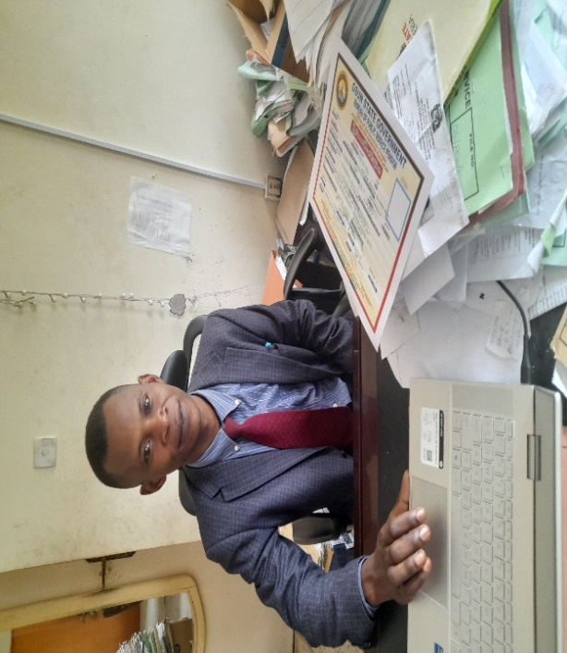 I am Olaremi Abayomi Arayombo, born on 20th February, 1986 at Ile-Ife, Ife Central Local Government Area, Osun State.

I attended Ethiopian Primary School Ile-Ife, I proceeded to Seventh Day Adventist Grammar School for my Junior Secondary School and School of Science Ile – Ife for my Senior Secondary School, I was admitted to Eminence University in Nigeria Obafemi Awolowo University with award of Bsc Sociology and Anthropology on May 2010, in the same vein I was awarded Masters of Public Administration on December, 2023. I am also an Associate member of Certified Pension Institute of Nigeria on 2022.

I was employed into civil service as an Administration Officer on 14th June 2013 and served in different capacity serving our dear State in different Agency of Government and presently the Director, Pension Administration of the Bureau of Public Service Pension with a schedule of duty is to advise the Accounting Officer on prompt report on payment of all retirees in the State, supervising activities of all State approved Pension Fund Administrators in compliance to the Osun State Pension Law, regular payments of remittance to retirees and overseeing and resolving complaint from both active workers on their Retirement Savings Accounts and retirements benefits from the retirees while all this is supervised under the amiable leadership of the Office of the Permanent Secretary Mr. S. A Raji the Accounting Officer of the Bureau and the approving authority.

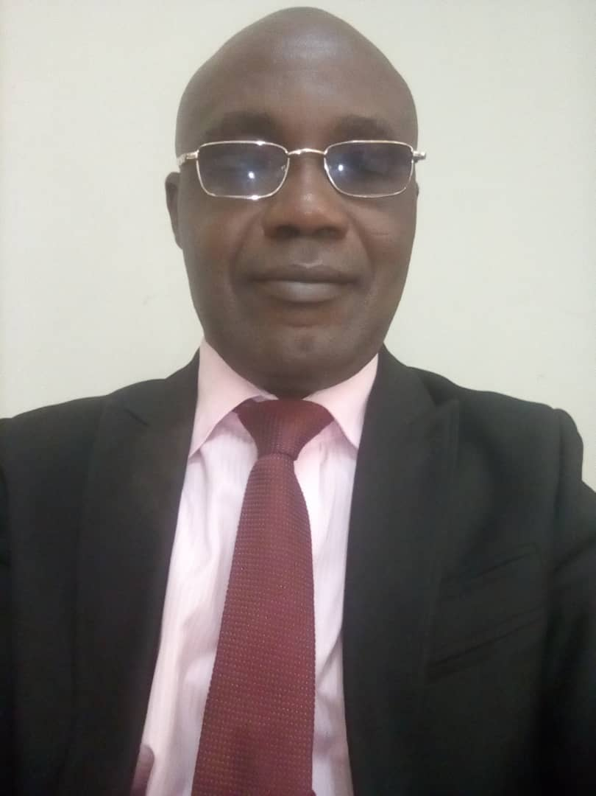

Solomon Akinjide Akintunde is my name. I was born on the 9th August, 1972 in Igbajo to the family of Late Mr. and Mrs. Folorunso Akinola Akintunde of Olawole’s Compound, Oke oja in Boluwaduro Local Government Area, Osun State.

I started my Primary School Education at Methodist Primary School, Agodi- Ibadan and completed in the year 1985.I attended Ikolaba Grammar School, Agodi- Ibadan and had my West African Examination Council Certificate, in the year 1990. I latter proceeded to the prestigious Obafemi Awolowo University, Ile- Ife where bag Bachelor of Science Degree in Economics in the year 1997. I am also an Associate member of Certified Pension Institute of Nigeria in the year 2022.

I joined the Service of Osun State in the year 2004 as a Clerical Officer and Converted to the post of Higher Executive Officer (Audit) in the year 2011. I latter Converted to the Administrative Officer Cadre in the year 2016. I was posted to the Bureau of Public Service Pension in the year 2020 and became a Director of Administration and Supplies of the Bureau in the Year 2023.

My responsibilities as Director, Administration and Supplies is to advise the Accounting Officer on Establishment Matters, maintaining discipline in the Agency, preparation of Annual Budget and any other assignment as directed by the Accounting Officer.

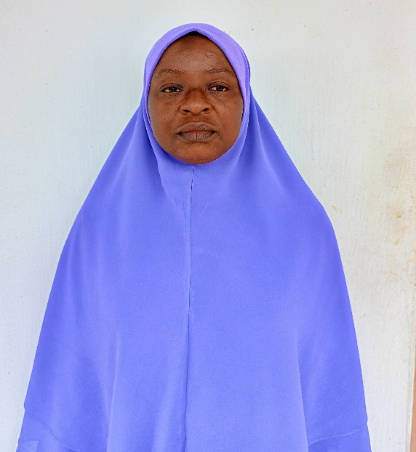

I am Muibat Omowumi Hakeem, born on 27th May, 1976 at Ibadan Oyo State. My State of origin is Osun State, Olorunda Local Government, attended Primary and Secondary School at Ibadan Oyo State, I attended Ladoke Akintola University of Technology, Ogbomoso awarded with Bsc. Accounting and proceeded to Osun State University with award of Msc. Accounting, and other professional qualifications like Fellow Chartered Accountant, Associate Chartered Accountant and Certified Forensic Accountant.

I was employed by the Osun State Government on 2004 and work in different capacity in various Agencies of Government and currently serving as the Director, Finance and Account of Bureau of Public Service Pension.

My responsibility as Director, Finance and Account is to advise the Accounting Officer and other departmental Head on financial matters, taking charge of accounting duties as directed by the Accounting Officer, responsible for the development and installation of efficient account system and performing any other duties as may be assigned by the Accounting Officer.