INFORMATION OF OSUN STATE BUREAU FOR PEOPLE WITH DISABILITIES TO POPULATE THE OFFICIAL WEBSITE OF THE AGENCY

1. BRIEF HISTORY OF THE BUREAU

Osun State Bureau for People with Disabilities was established on 2nd January, 2025 as a result of the passage of the bill into law “Osun State Discrimination Against Persons with Disabilities (Prohibition) Law, 2024” by the Osun State House of Assembly and assented to by the Executive Governor of the state, Senator, Ademola Jackson Nurudeen Adeleke on the 10th day of June, 2024. This led to the appointment of the Executive Secretary to the Bureau as the Accounting Officer.

The Agency is to provide for the integration and full inclusion of Persons with Disabilities into the society and ensure the responsibilities for their education, health care, social, economic and civic rights and for other matters related therewith as stipulated in the Law.

1. OBJECTIVES, VISION AND MISSION OF THE BUREAU

**Objectives**

1. Formulate and implement policies and guidelines as appropriate for the Education and Social development of People with Disabilities;
2. To prepare schemes designed to promote social welfare of Persons with disabilities and estimate of cost of implementing such schemes;
3. To promote and uplift the general social well-being of Persons with Disabilities by encouraging the public to change their attitude towards them;
4. To make available not less than 5% of the workforce to qualified People with Disabilities;
5. To enlighten the public and encourage people with disabilities;
6. To collect data and records on education of people living with disabilities, which shall be a regular exercise so that persons with disabilities are identified and enumerated for planning and treatment;
7. To ensure the monitoring, evaluation and realization of Osun State government policy objectives on people with disabilities;
8. To facilitate the procurement of scholarship award for people with Disabilities up to university level;
9. Establish and promote inclusive schools, vocational and rehabilitation centers for the development of people with disabilities;
10. Liaise with the public and private sectors and other bodies to ensure that the peculiar interest of persons with disabilities are taken into consideration in every government policy program/activity;
11. Issue insignia of identification of people with disabilities;
12. Also in collaboration with other relevant agencies and professional bodies in the building industry, enforce compliance of public buildings codes and impose necessary sanctions and make appropriate orders;
13. To receive complaints of people with Disabilities on violation of their rights;
14. Support individuals’ right to seek redress in court, investigation prosecution or sanctioning in appropriate cases, the violation of the provision of this act;
15. To ensure research, development and education on disabilities issues and disabled people;
16. To collaborate with the media to make information available is accessible format for people living with disability;
17. To procure assistive device for all disability types.

**THE VISION**

To promote an inclusive society where rights, privileges, aspiration, development and equality of opportunities of persons with disabilities are guaranteed in line with Osun State discrimination law against persons with disability, Act 2018.

**THE MISSION**

An institution working to promote an inclusive society/ Environment for persons with Disabilities through research, advocacy, engagement, mainstreaming, policy development and enforcement.

1. **PRIMARY RESPONSIBILITY OF THE BUREAU**

To ensure that People with disabilities are fully included and integrated in all spheres such as Education, Health care, political, social, economic, civil rights and other matters related herewith. The Bureau will also ensure that no Person with Disability is discriminated against in any form.

1. **PHOTOGRAPHS AND BIOGRAPHY OF PRINCIPAL OFFICERS**

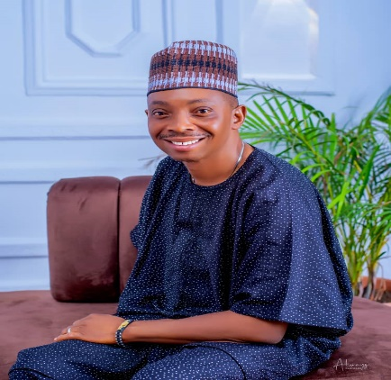

***Executive Secretary***

Rotarian Ayobami Oyewumi Oyetunde, FCPA is the Executive Secretary, Osun State Bureau for People with Disabilities. He graduated from Delta State University, Abraka with a degree in Marketing in the year 2003, he has Masters in Business Administration from Ladoke Akintola University of Technology (LAUTECH) Ogbomoso, Oyo State in year 2008. As a versatile and well experienced administrator, he bagged his Professional Masters Degree in Public Administration (MPA) from National Open University of Nigeria (NOUN) and Masters of Science (MSc) in Public Administration from Adeleke University, Ede, Osun State as well as Ph.D. in view. Prior to his appointment as the Executive Secretary, he was a Director of Administration and General Services at the Osun State Local Government Service Commission.

Rotarian Oyetunde is a person with Physical Disability and a member of National Association of Persons with Physical Disability (NAPWPD). A former Public Relations Officer (PRO) of Osun State Joint National Association of Persons with Disabilities (JONAPWD).

He has received numerous meritorious awards within and outside the state especially on humanitarian services. He is also a member of different professional bodies.

He is an Associate Member, Nigerian Institute of Management (Chartered), Fellow Chartered Public Administrators. His email address is [es.bpwd@osunstate.gov.ng](mailto:es.bpwd@osunstate.gov.ng)



Mrs. Victoria Anuoluwa Olatunji is the Director, Administration and Supplies of the Agency and her email address is [anuoluwapoaderanti5@gmail.com](mailto:anuoluwapoaderanti5@gmail.com)

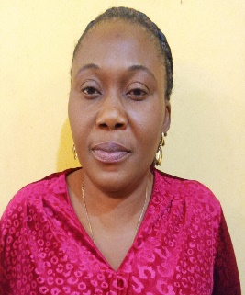

Mrs. Adeola Agnes Oluwole is the Director, Finance and Accounts. Her email address is [adeolaagnes9@gmail.com](mailto:adeolaagnes9@gmail.com)



Mrs. Olajumoke Femi Ojetola is the Director, Social Integration and Education. Her email address is [femiolajumoke3@gmail.com](mailto:femiolajumoke3@gmail.com)

1. **EVENTS PHOTOGRAPHS**

ADVOCACY VISIT TO RAVE 91.7FM

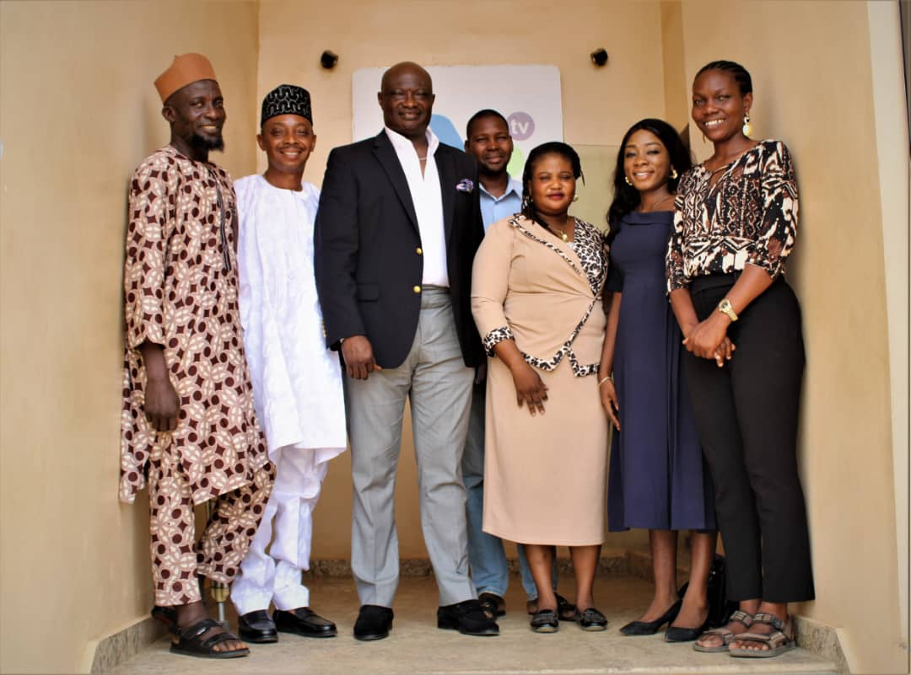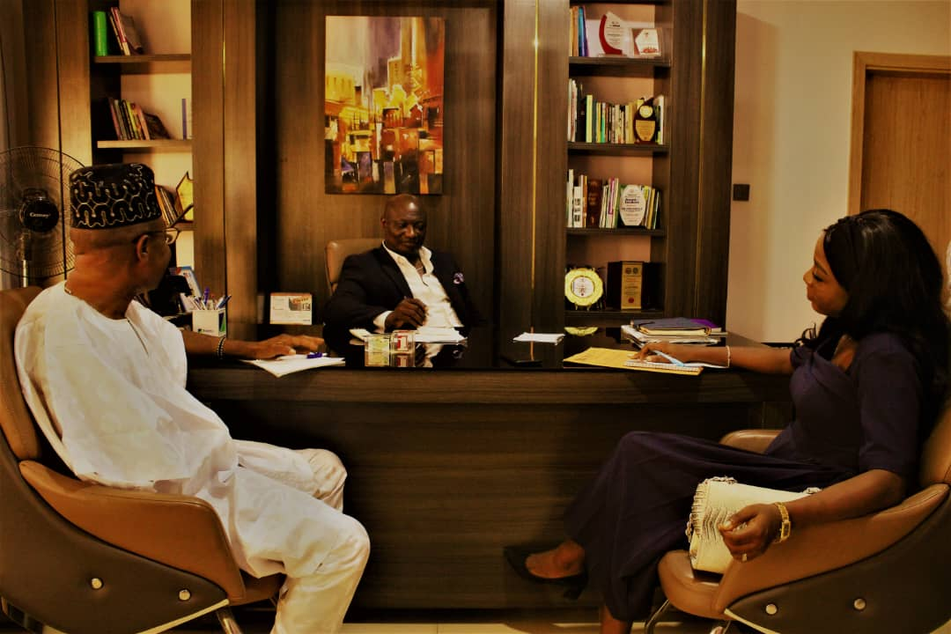

ADVOCACY VISIT TO INDEPENDENT NATIONAL ELECTORAL COMMISSION (INEC)

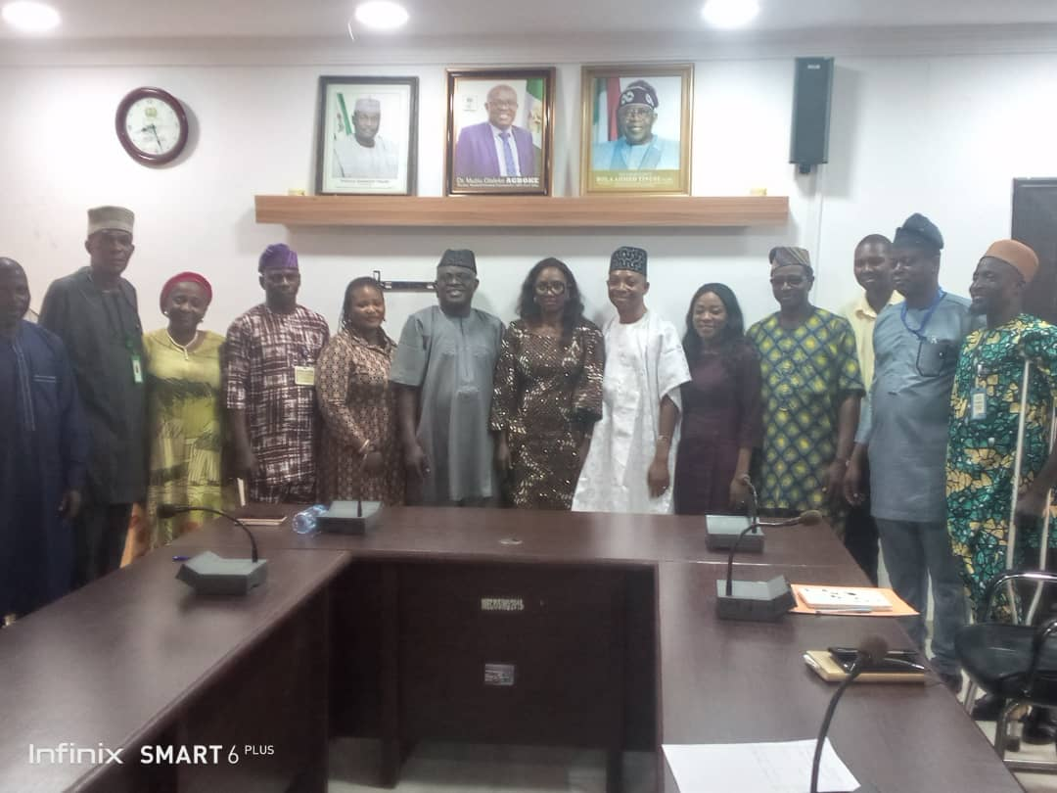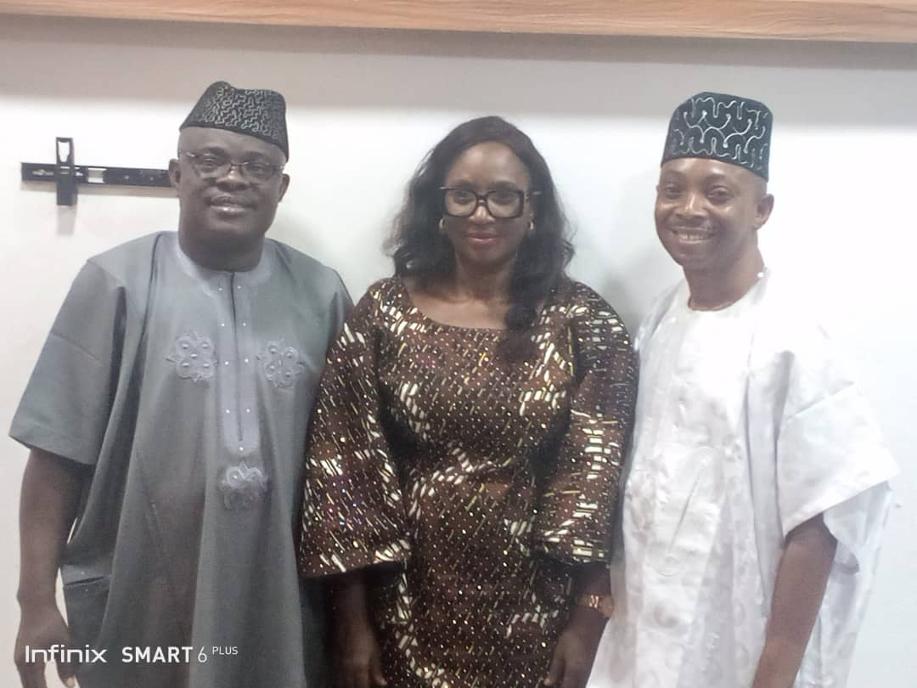

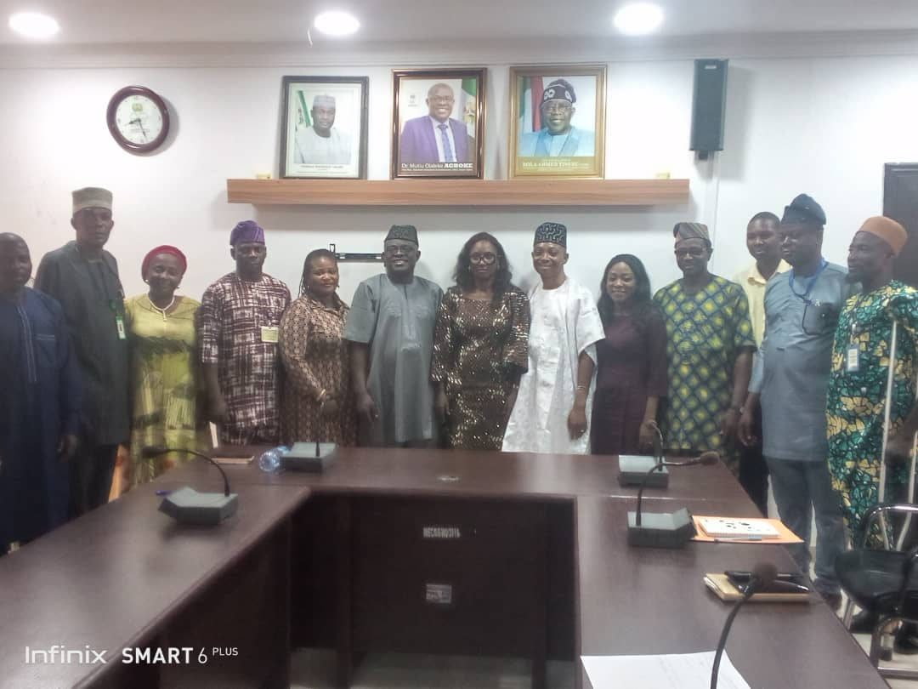

ADVOCACY VISIT TO NIGERIAN SECURITY AND CIVIL DEFENCE CORP (NSCDC)

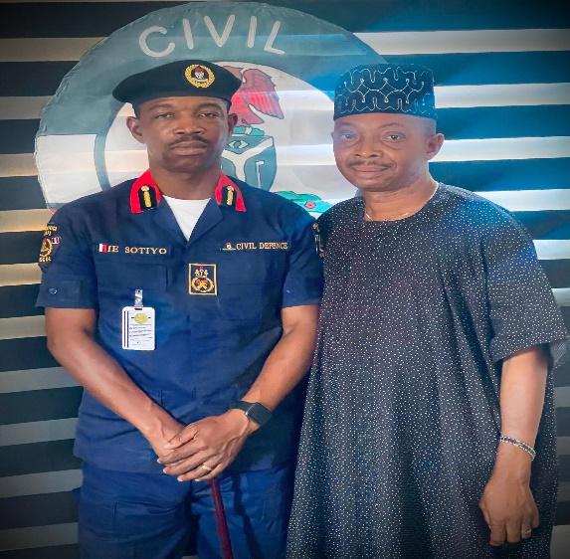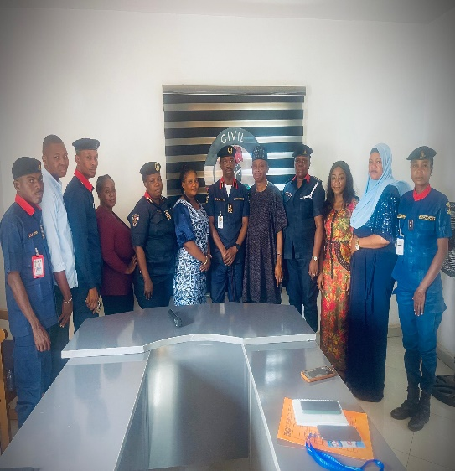

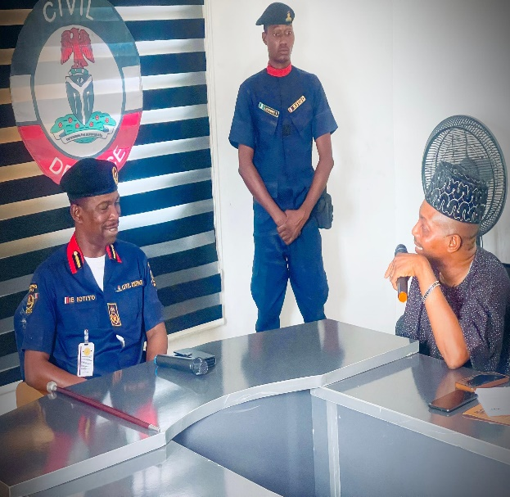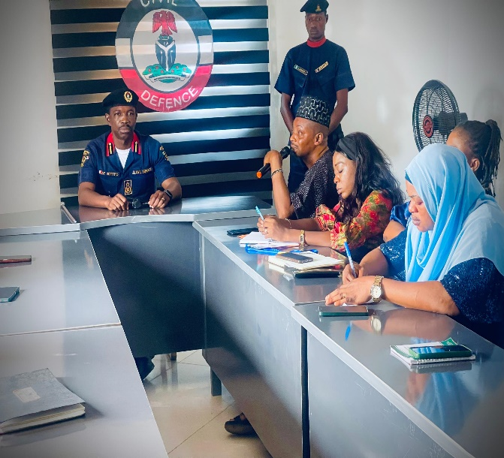

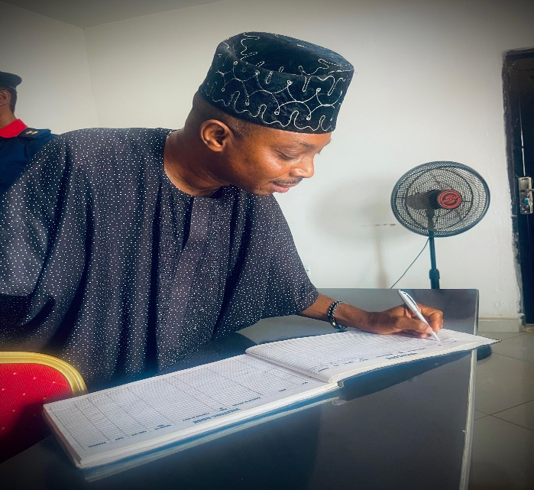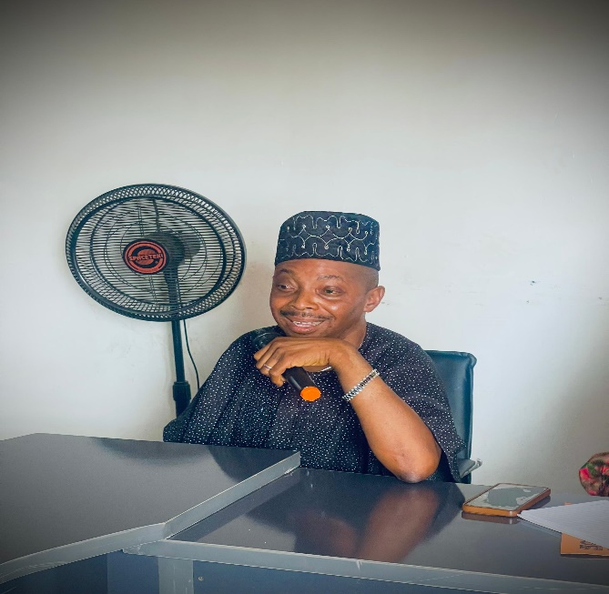

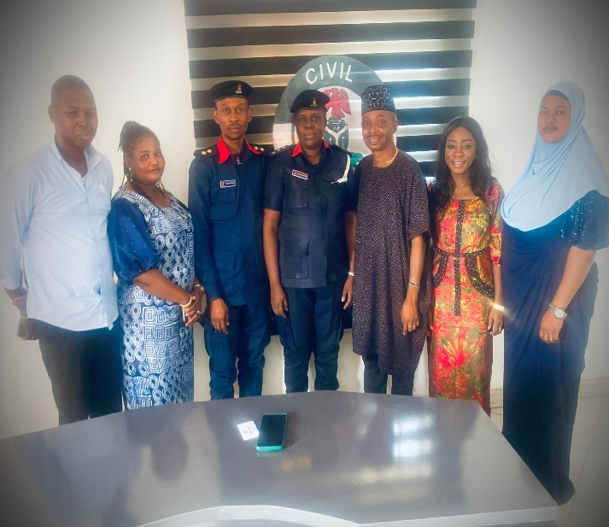

PRESENTATION OF GRINDING MACHINE, TEXTBOOKS AND BRAIL TO SPECIAL SCHOOLS BY LIONS CLUB INTERNATIONAL

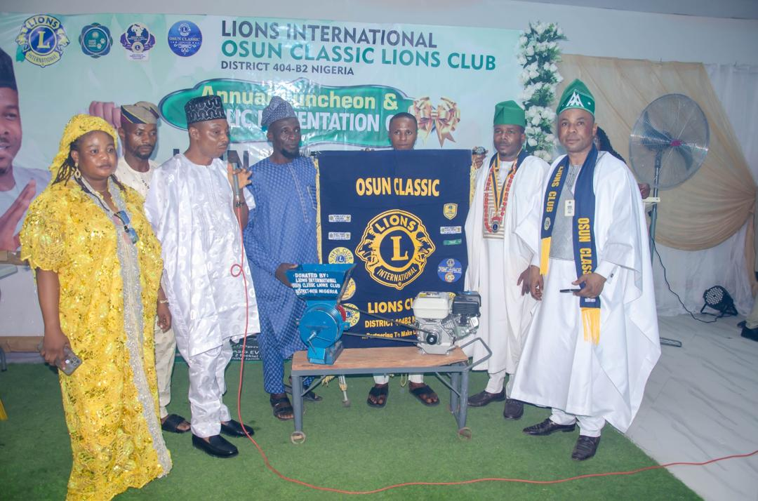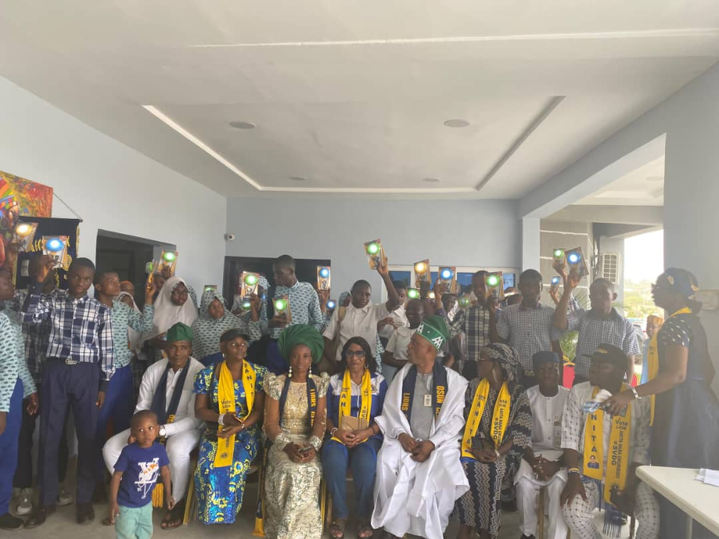

ADVOCACY VISIT TO WESTERN SPRING TELEVISION ON STARTIMES CHANNEL 190 IN COMMEMORATION OF INTERNATIONAL WHEEL CHAIR DAY

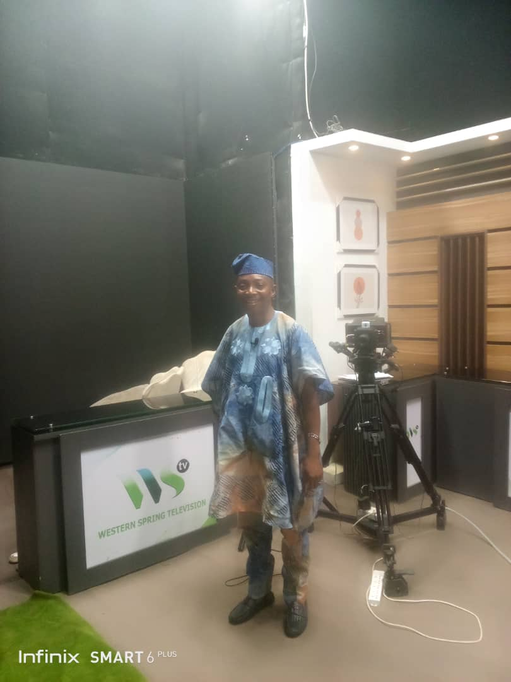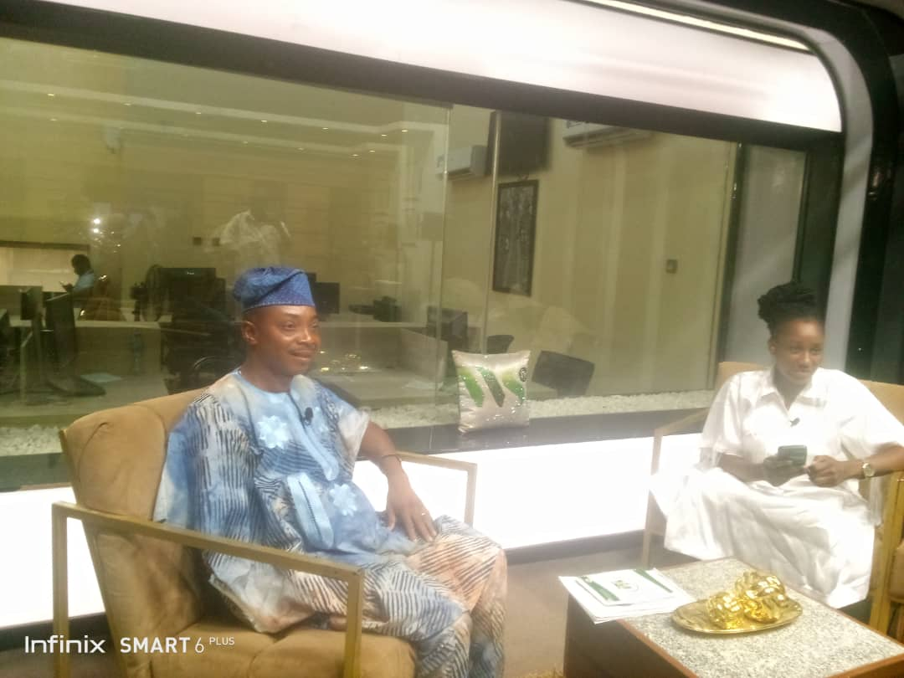

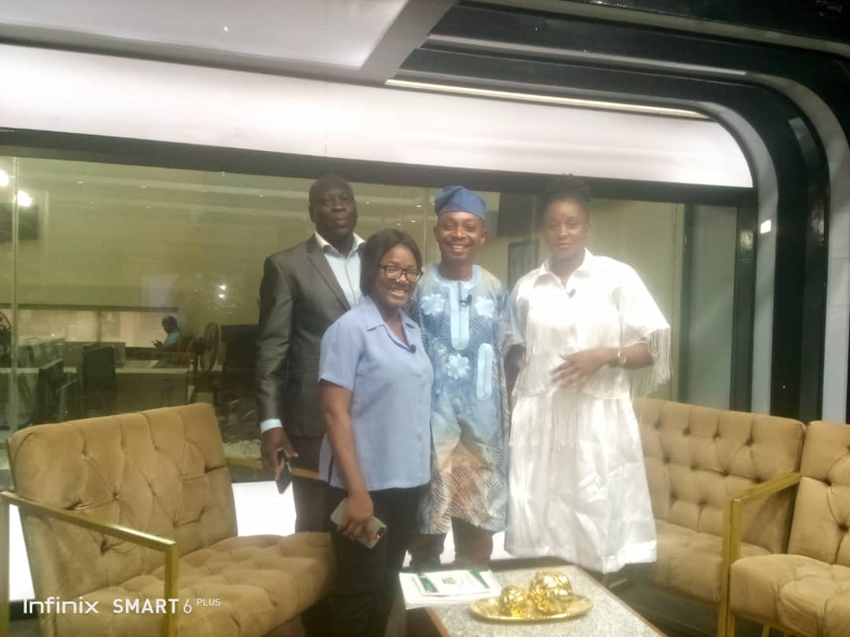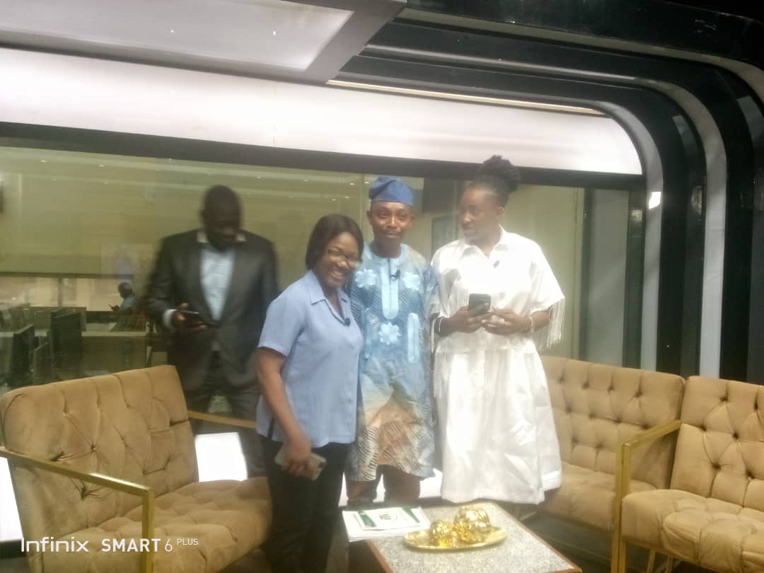

CELEBRATION OF INTERNATIONAL WHEEL CHAIR DAY

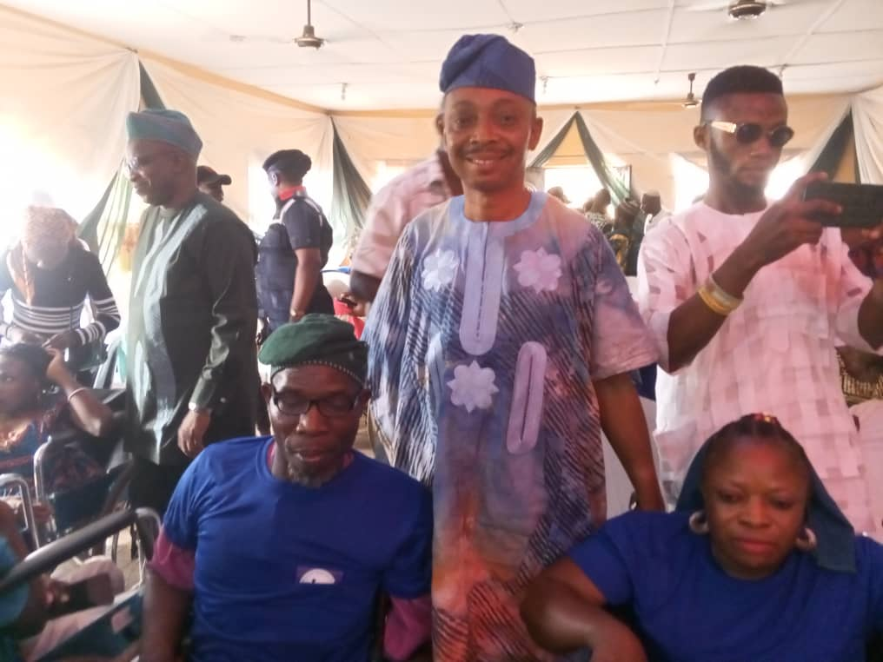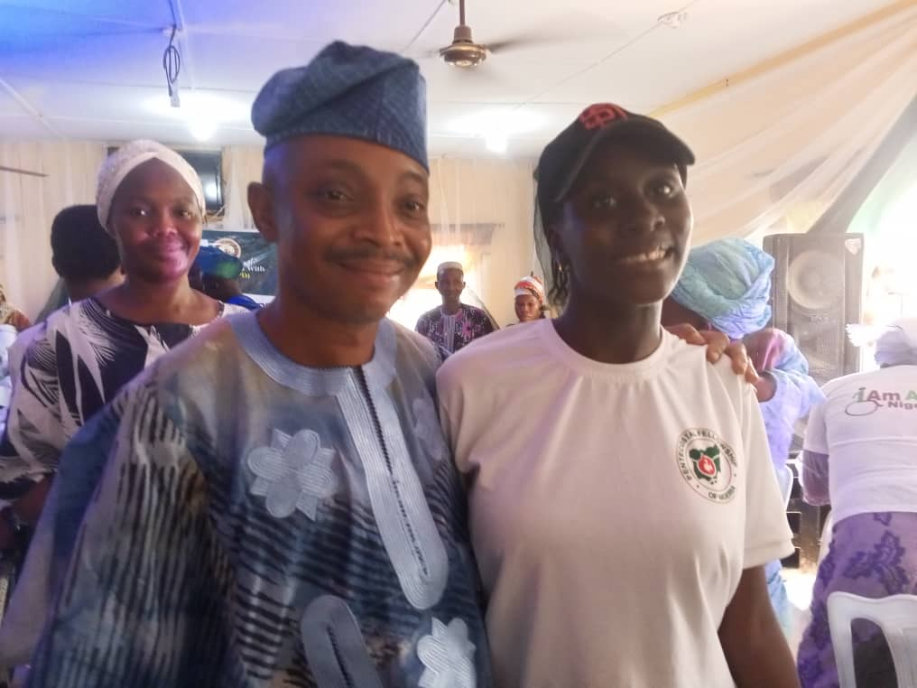

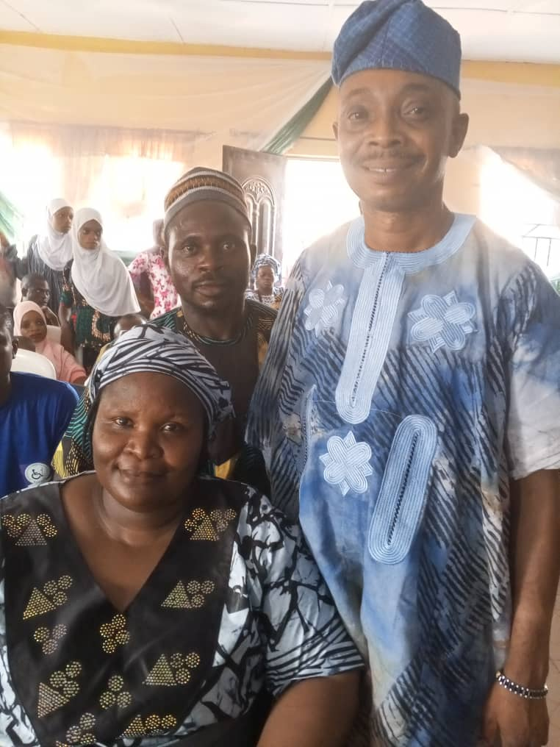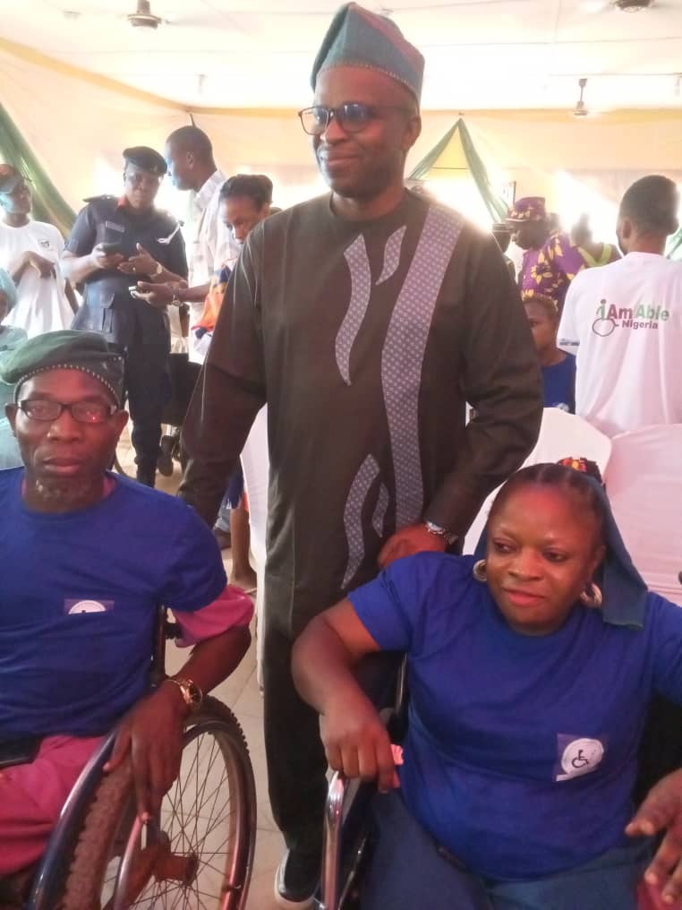

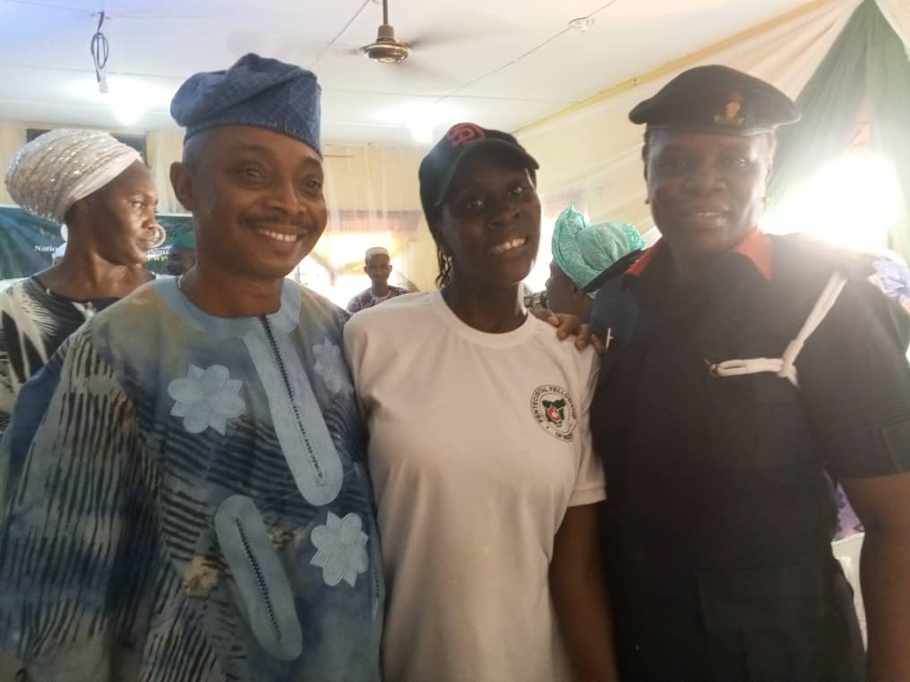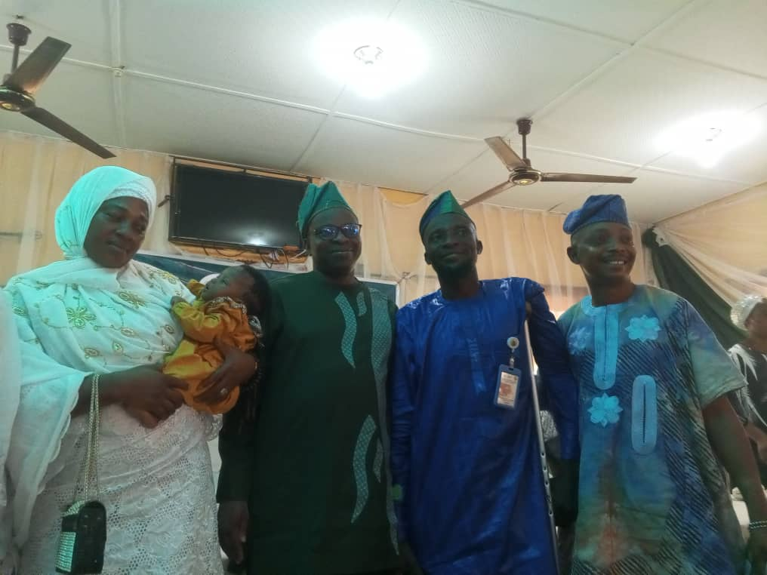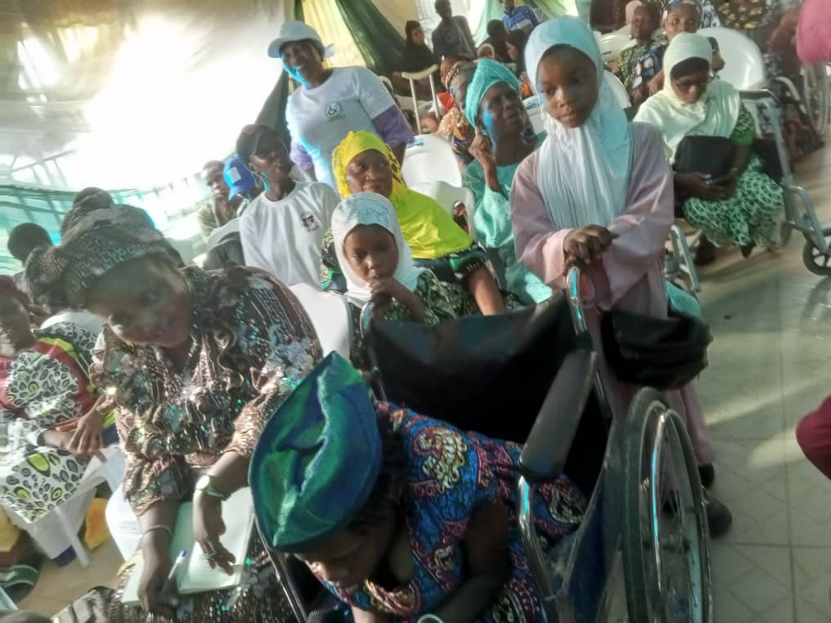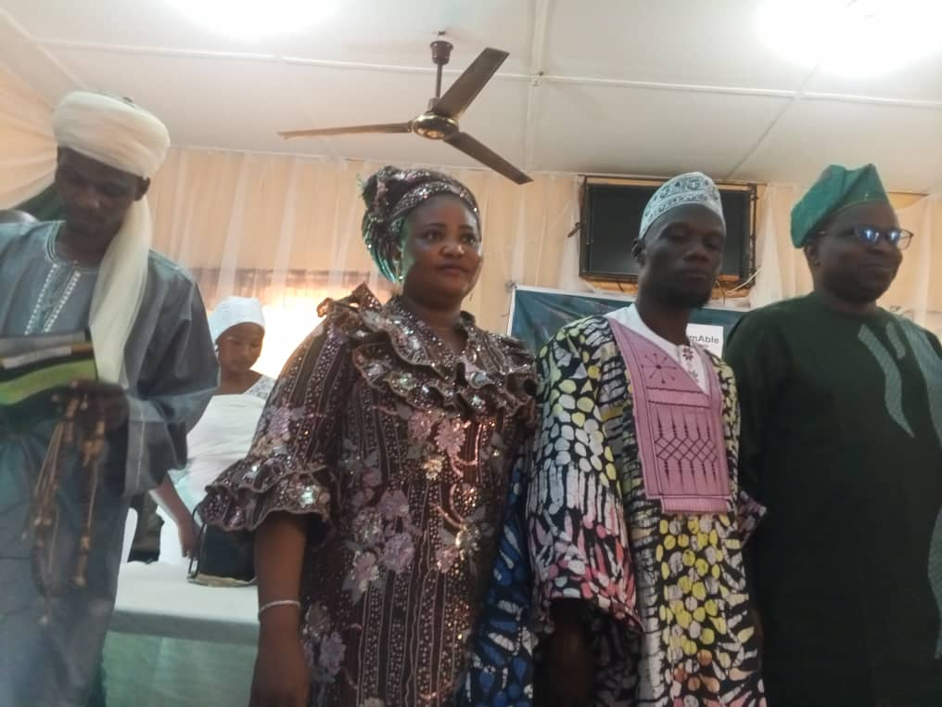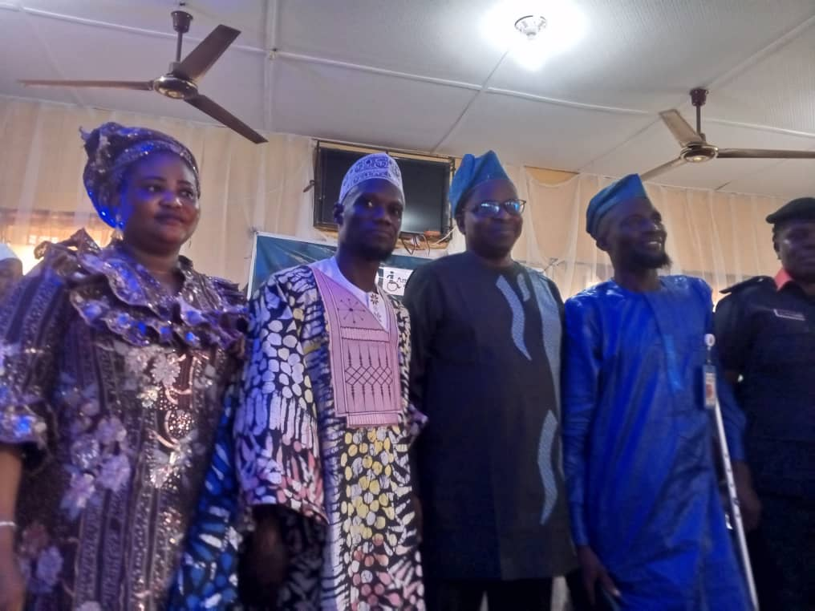

POLICY DIALOGUE ON STRENGHTENING ACCOUNTABILITY FRAMEWORKS ON THE POST-MORATORIM CYCLE OF THE DISCRIMINATION AGAINST PERSONS WITH DISABILITIES (PROHIBITION) ACT IN NIGERIA, HELD AT AENON SUITES, OSOGBO

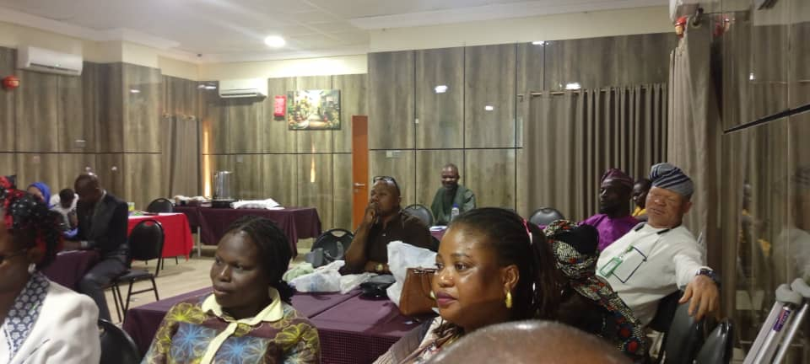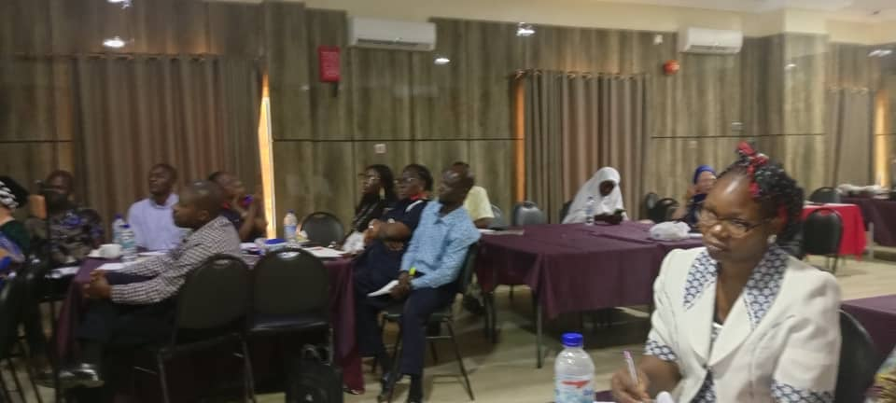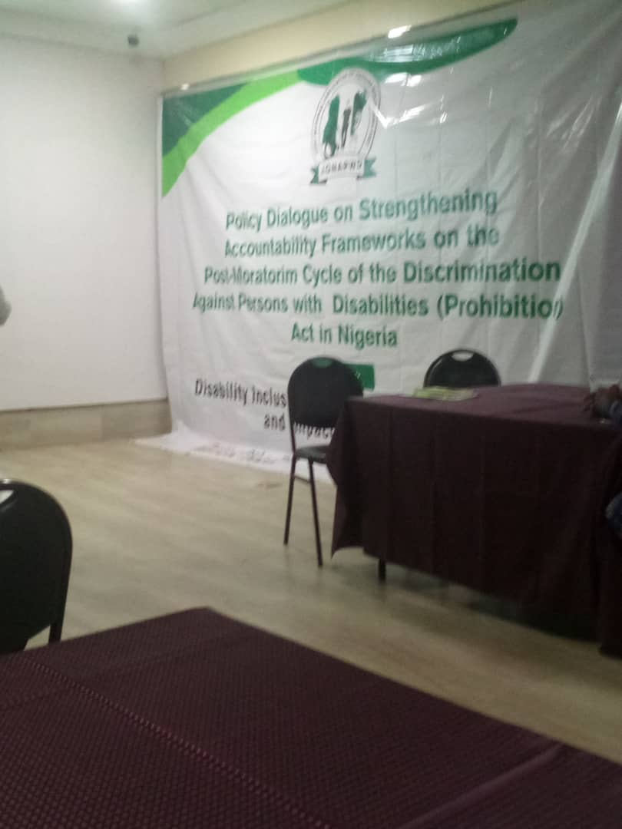

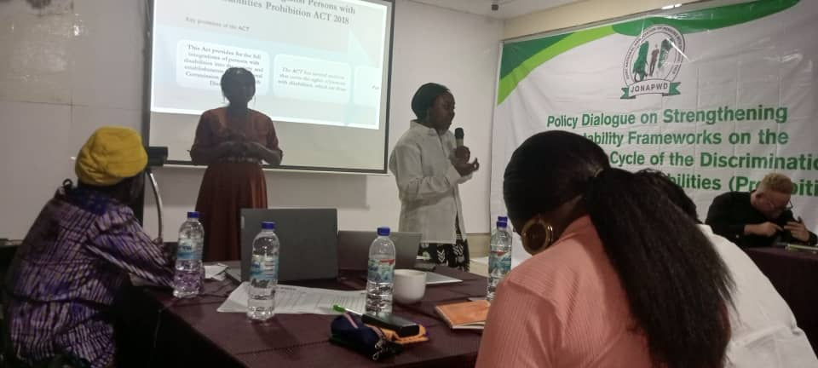

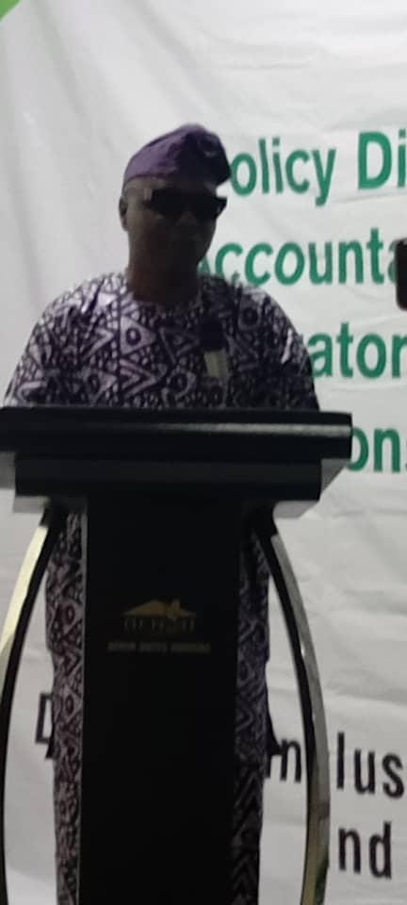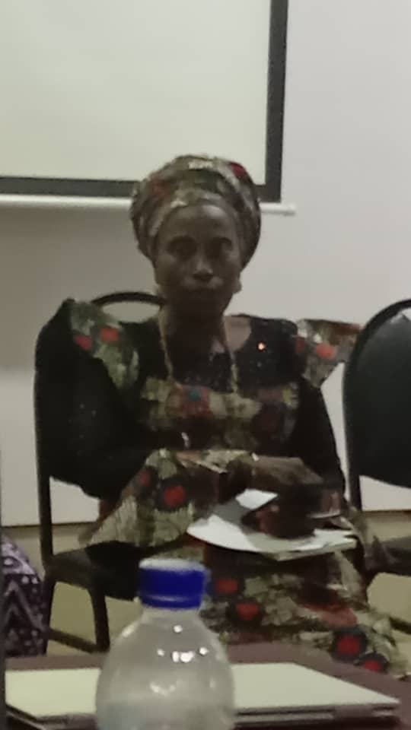

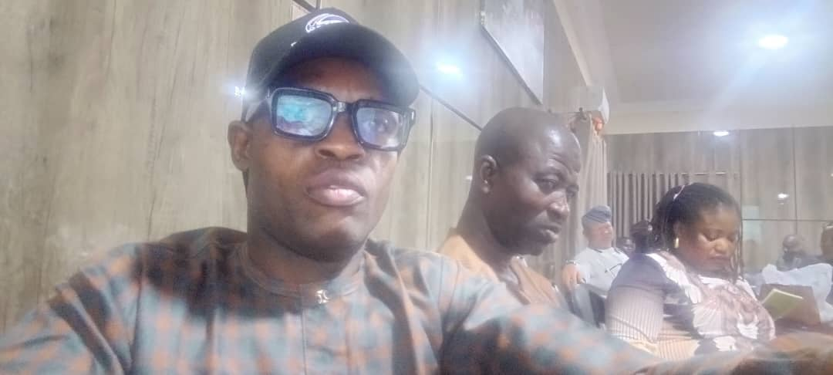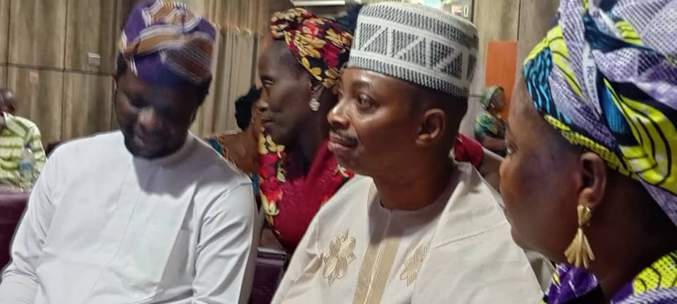

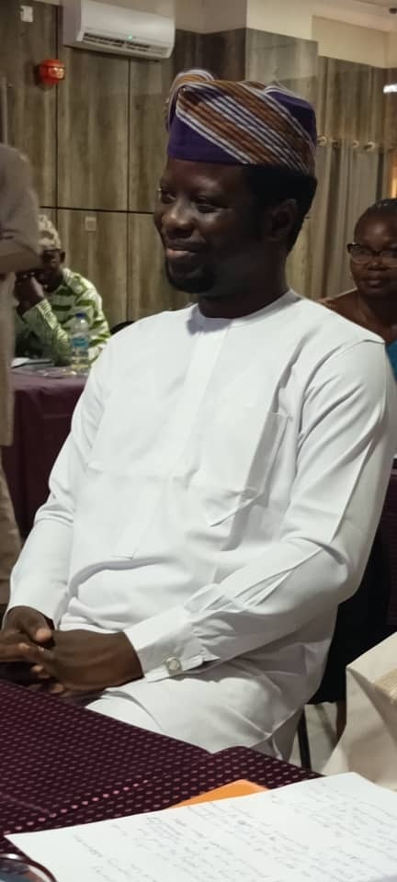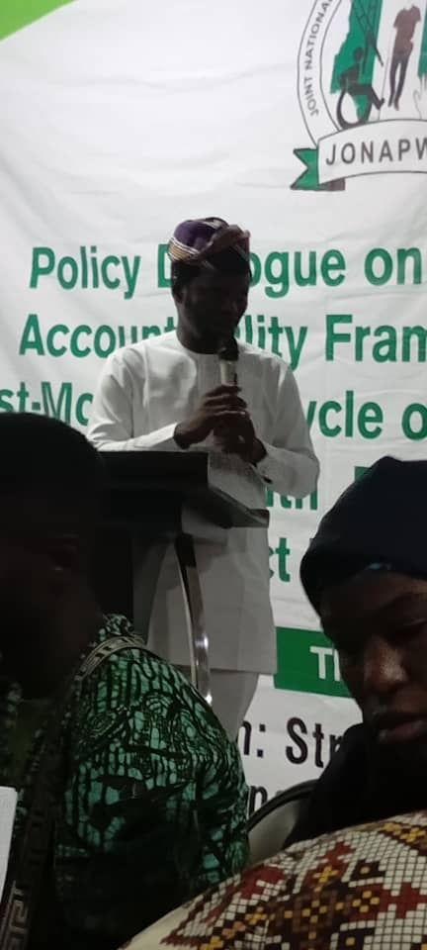

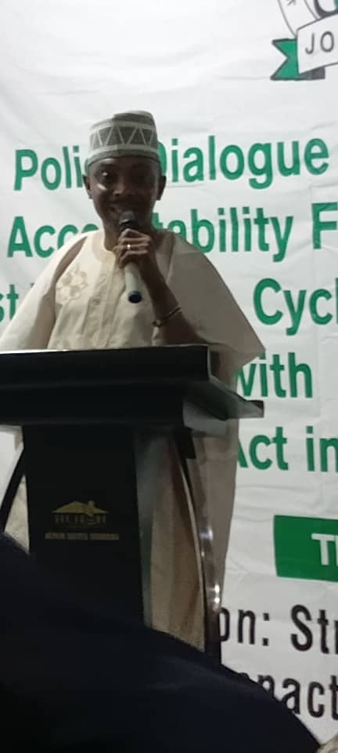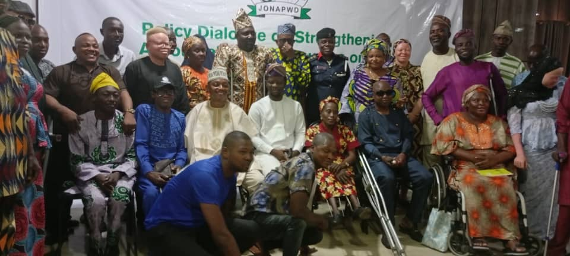

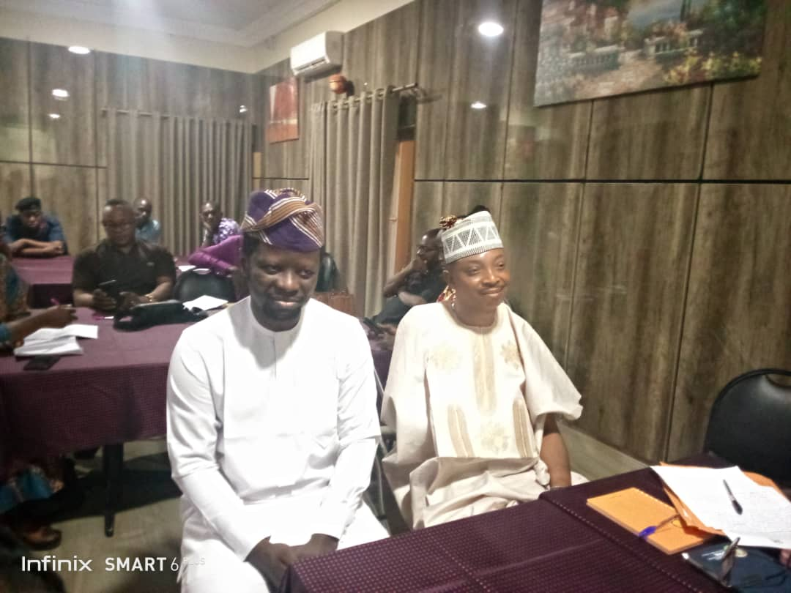



COURTESY VISIT OF ONE HOUSE DEVELOPMENT INITIATIVE TO THE EXECUTIVE SECRETARY

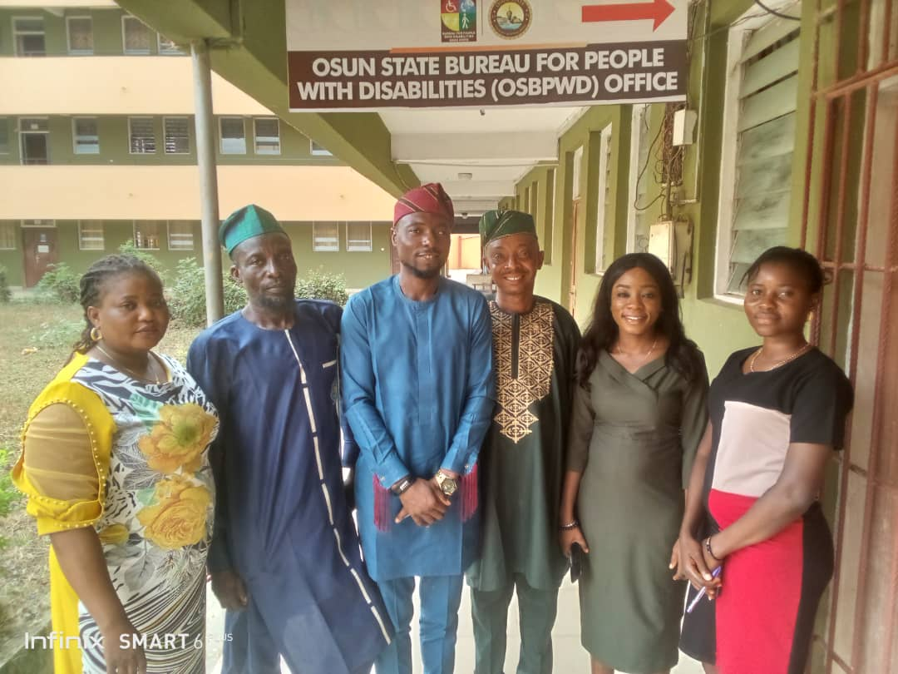

VISIT OF OSUN STATE JONAPWD CHAIRMAN TO THE BUREAU

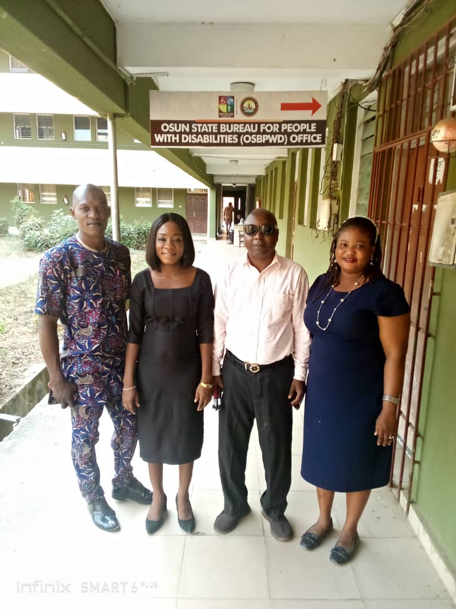

THE VISIT OF ITEC CONSULTANCY, ABUJA TO THE BUREAU

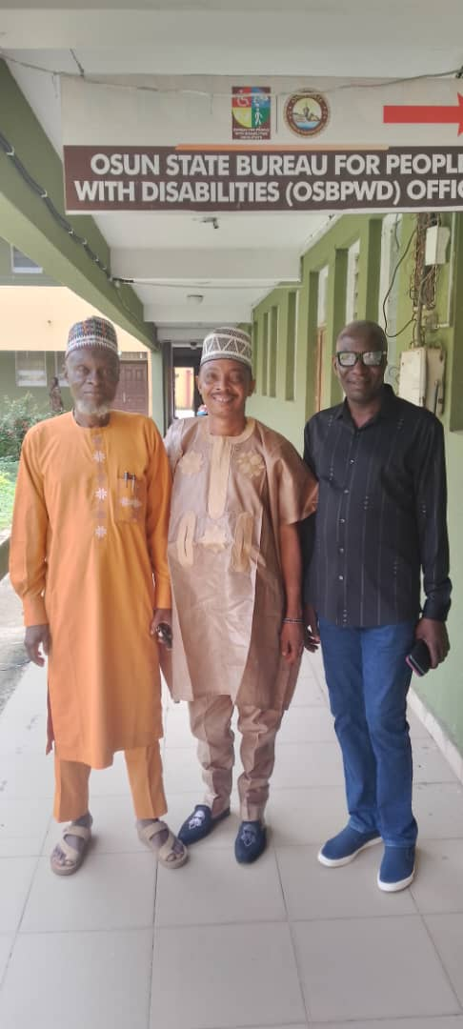

COURTESY VISIT OF EXECUTIVES OF JONAPWD, OSUN STATE CHAPTER TO THE EXECUTIVE SECRETARY

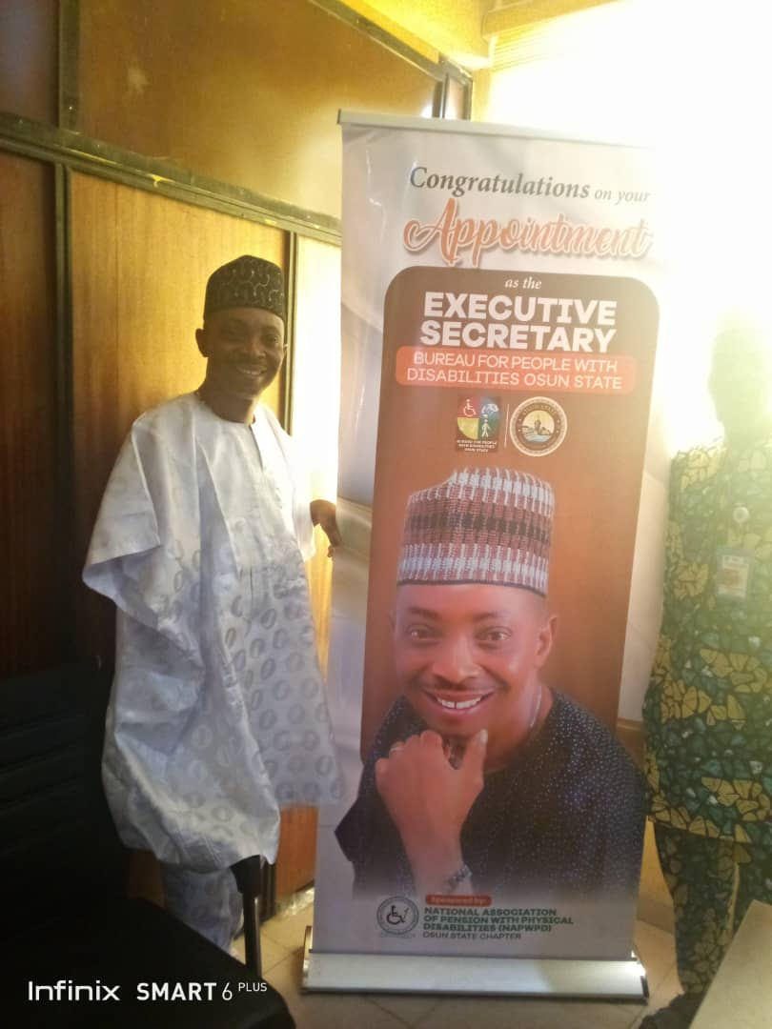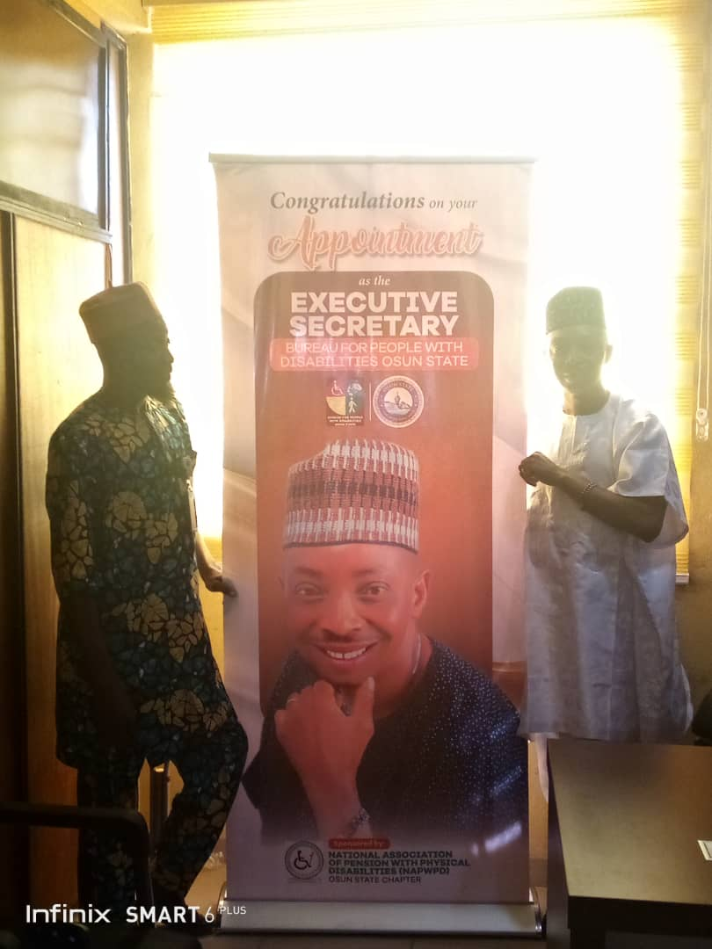

ADVOCACY VISIT TO NATIONAL TELEVISION AUTHORITY (NTA)

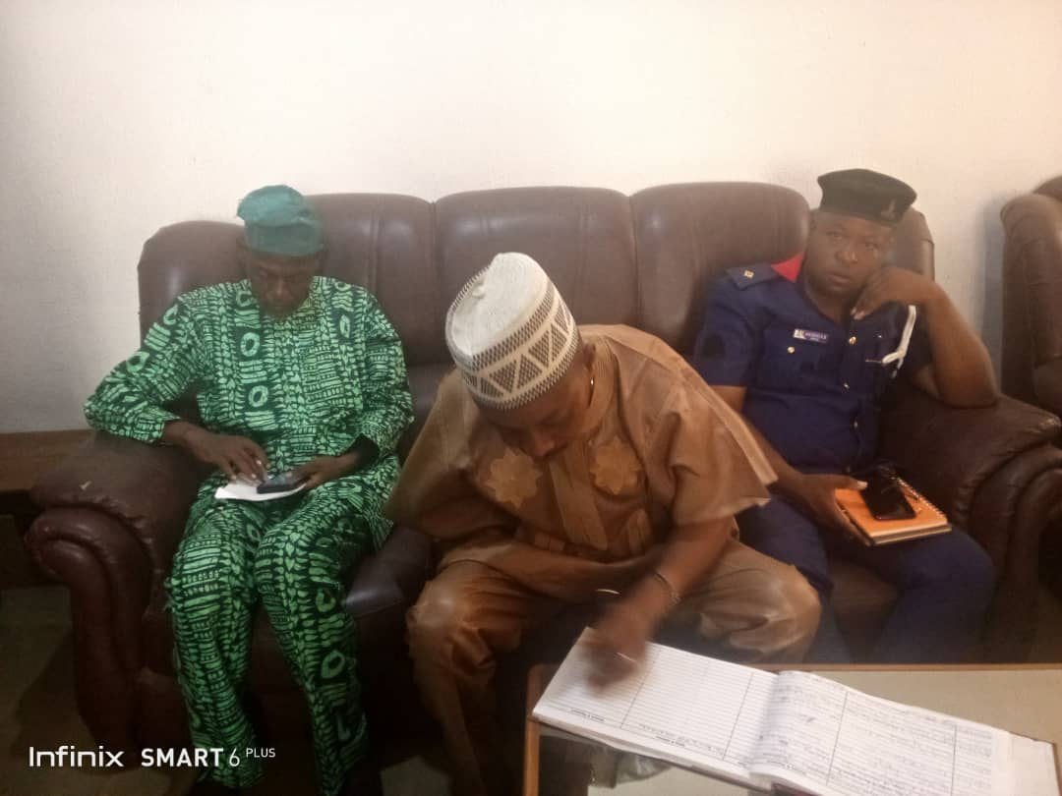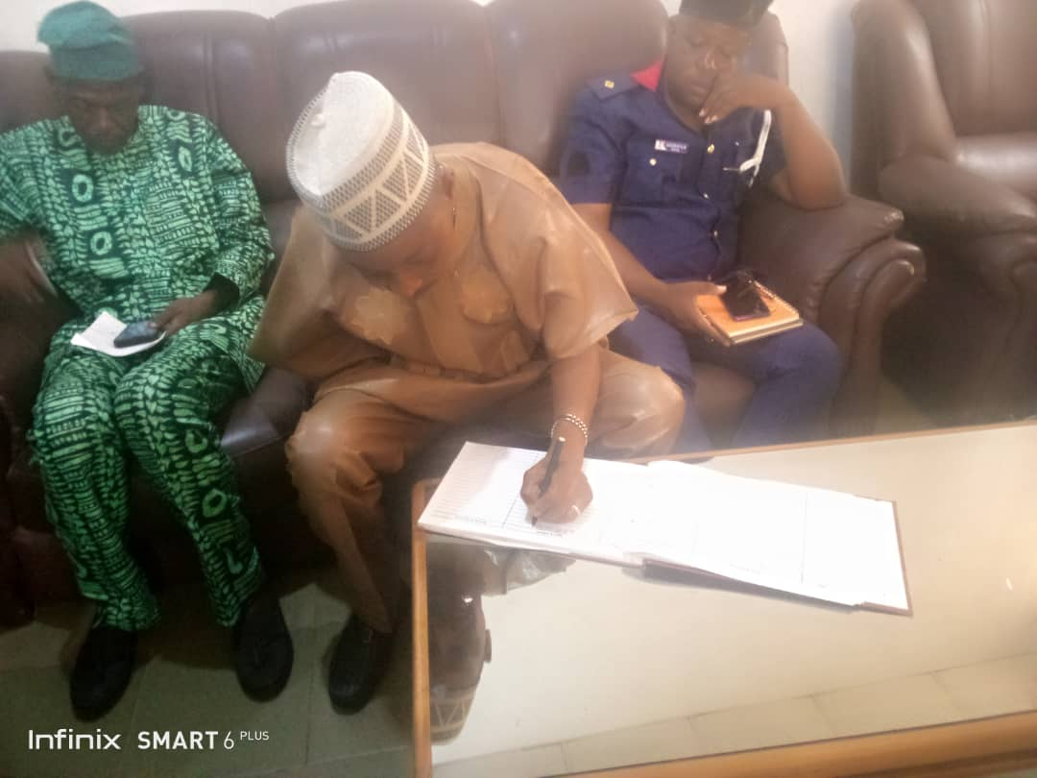

VISIT OF DMJ-GLOBAL CONSULTING LIMITED

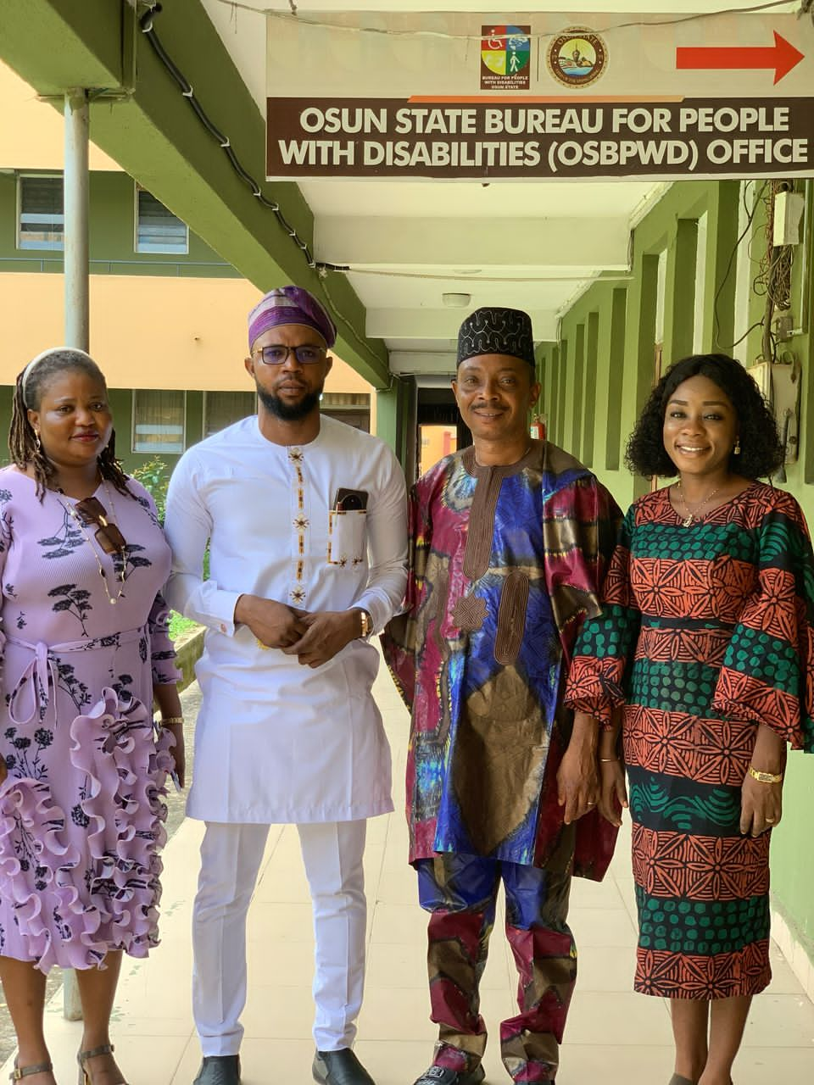

VISIT OF FESTUS FAJEMILO FOUNDATION TO THE BUREAU

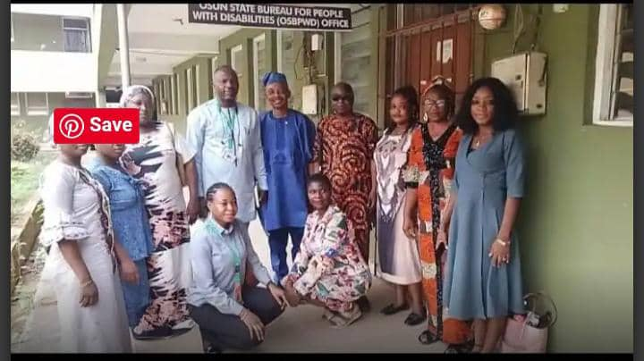

COURTESY VISIT TO THE EXECUTIVE SECRETARY, SUBEB

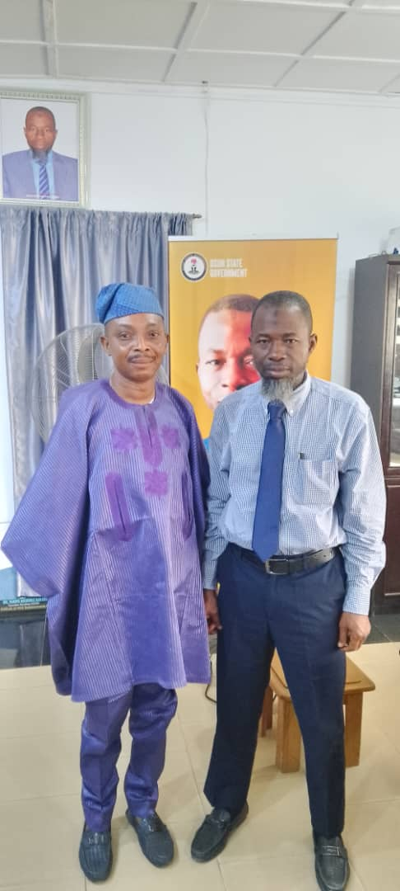

THE EXECUTIVE SECRETARY AT AN EDUCATIONAL INCLUSIVE PROGRAMME ORGANISED BY THE MINISTRY OF EDUCATION AT SCHOOL FOR THE HANDICAPPED, OSOGBO

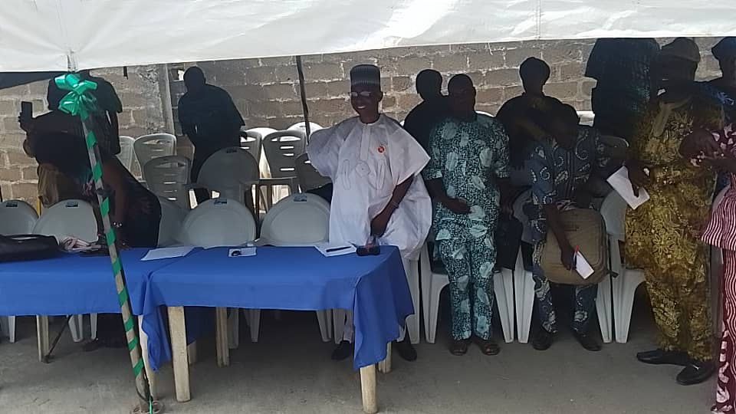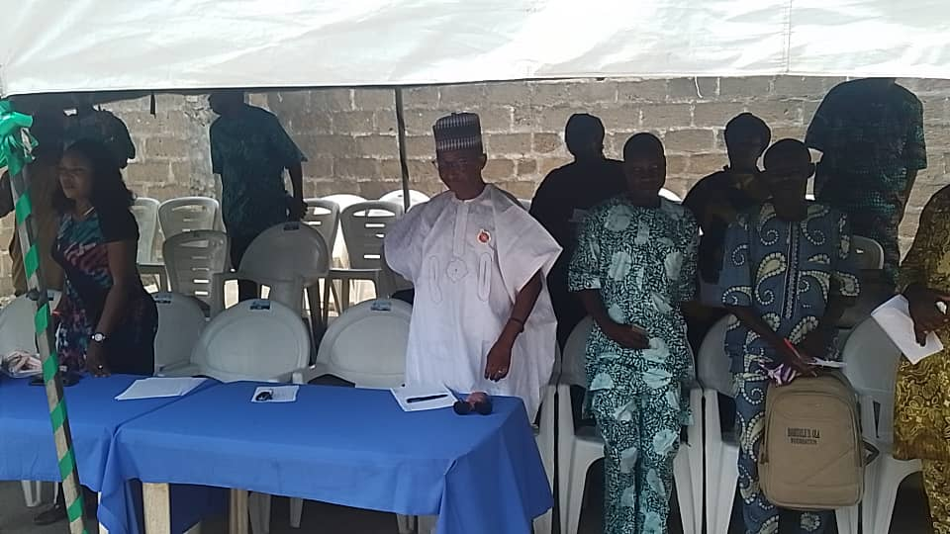

ADVOCACY VISIT TO UNIQ 103.1 FM, ILESA

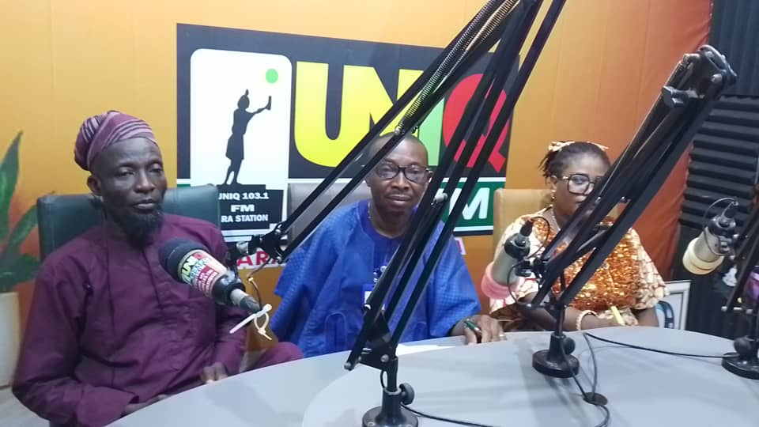



ADVOCACY VISIT TO OSBC 104.5FM RADIO, ILE AWIYE, OSOGBO

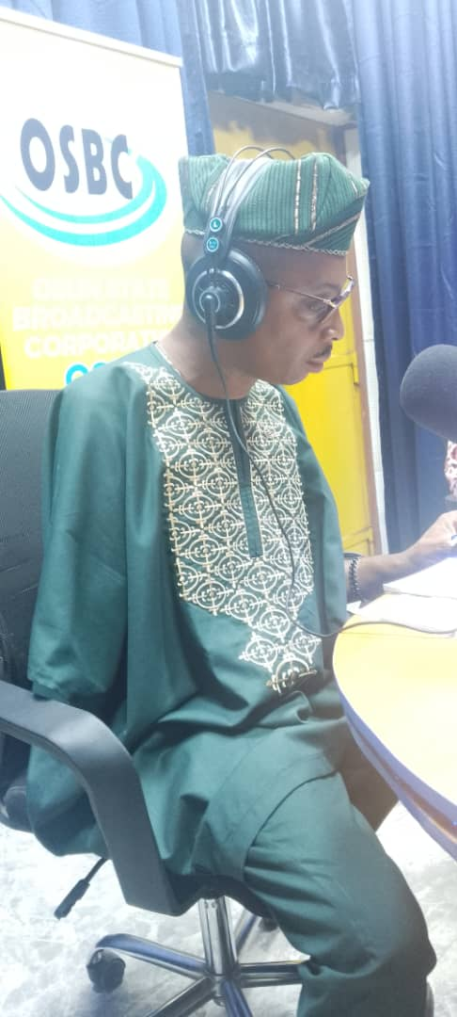

COURTESY VISIT OF THE EXECUTIVE SECRETARY TO DIRECTOR GENERAL, OYO STATE AGENCY FOR PERSONS WITH DISABILITIES

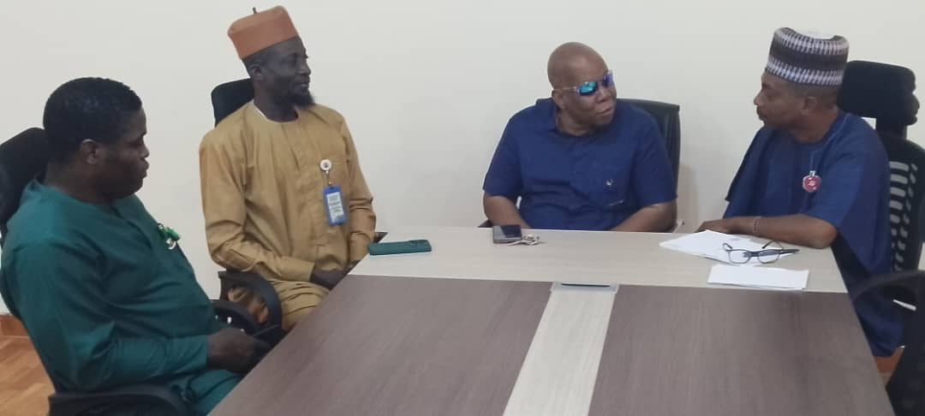

ADVOCACY VISIT TO FRESH FM 104.5FM, OSOGBO

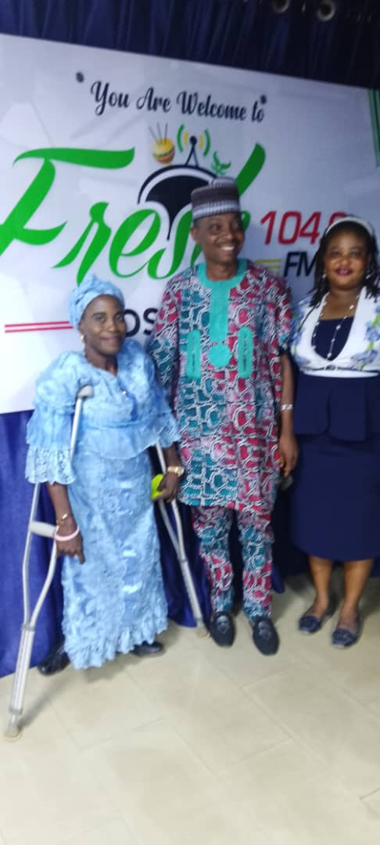

THE EXECUTIVE SECRETARY CELEBRATING THE NEW YEAR WITH JONAPWD MEMEMBERS

