**Personal profile**

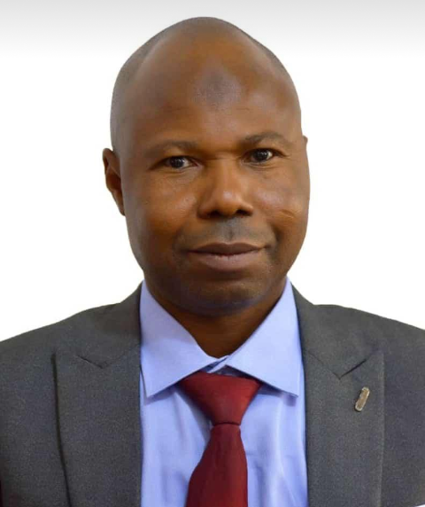

Mr. kolawole Najeem Akintola was born into the family of Pa Akintola of Eesa Compound, Oyan, Odo-Otin Local Government Area of Osun State. He holds Mater Degree in Public Administration of the Obafemi Awolowo University, Ile-Ife. Having spent over twenty years in active service of the state, he is an astute Administrator with wealth of experience. He is courageous, brilliant, dexterous and goal-oriented. He has headed several departments of various Ministries and Agencies of government. He has attended conferences and seminars and has risen to become a Member of the National Institute (*mni*) of the Institute for Policy and Strategic Studies, Kuru, Plateau State. K.N. Akintola, *mni*, is the PERMANENT SECRETARY, Public Service Office (PS, PSO). He is blessed with wife and children.

**Career Responsibilities**

The PS (PSO), K.N. Akintola, *mni*, is the Accounting Officer of the Agency and oversees all affairs of the Agency. He coordinates all activities of the Agency and reports directly to the Head of Service. In his responsibilities, he deals with career management of Permanent Secretaries, Executive Secretaries, General-Managers, Directors-General, and those in the equivalent position within the state public service. As such, he sees to the guiding principles of government policies and decisions within the service, he generates and disseminates government information within the service, and oversees the welfare of all Officers of the public service. As a tradition and duty, he discusses issues relating to his Agency and the entire public service to the Head of Service on daily basis.

K.N.Akintola, *mni*, also sees to the career management of all Administrative Officers in the mainstream of the Civil Service and all Officers in the Management Cadre, on salary GL.13 and above. Upon the consent of Head of Service, he approves deployment, preferment, training nominations, discipline, promotions, etc., of Officers. PS, PSO also banks on the consent of the Head of Service to approve leave of absence, as well as the release clearance to public Officers to travel or spend leave abroad.

The astute Administrator and Permanent Secretary, K.N.Akintola, *mni*, communicates intention of Officers, as well as the readiness of government to the Civil Service Commission, on Officers’ push for Conversion/Inter-cadre Transfer to GL.06 post in the General Executive Officer (General Duties, Tax, Audit and Stores), Confidential Secretary and Secretariat Assistant Cadre and Drivers.

As part of mandates of his office, and considering his tenacity, courage and wealth of experience, K.N.Akintola, *mni*, initiates, organises and supervises training and seminars for Officers within the service. He initiates and coordinates activities of committees serving as mechanism for dispute resolution within the service. He is also a member of the Senior Management Services, the highest body in the Civil Service of Osun State. As such, he is a leading figure of the advisory body to the Head of Service. PS, PSO is the Head of Secretariat and member of the Forum of Head of Service and Accounting Officers (FOHSAO). K.N.Akintola, *mni*, communicates government’s appointment of top career officers within the Public Service of the State.

Personal profile:

………………………………

Mr. John Oyetade Amusan was born into the family of Pa E.A. Amusan of Oosa’s Compound, Ogbaagba town, Ola-Oluwa Local Government Area of Osun State on the 10th August, 1977. He holds Master Degree in Public Administration of the Ladoke Akintola University of Technology, Ogbomoso. J.O. Amusan has spent over eighteen (18) years in the civil service of Osun State. He is an excellent administrator, well-reputed for his wealth of knowledge, especially on establishment matters. He speaks truth to its face and his courage to set things right has won him attention and recognition. He is the Director, Staff Welfare Department, Public Service Office, Office of the Head of Service. D (SWD) had earlier worked in various capacities within the service. He has attended conferences and seminars. J.O. Amusan is blessed with wife and children.

**Career Responsibilities**

As Director, Staff Welfare Department, J.O.Amusan is directly responsible to the Permanent Secretary, Public Service Office. In his capacity, he sees to the welfare of staff on issues such as accommodation to Accounting Officers, convenience, mobility, office equipment and furniture, safety at workplace. He advises and recommends to the Permanent Secretary on various administrative matters, including posting, deployment, preferment, training nominations, discipline, promotion, dispute management, conversion/ inter-cadre transfer and other related issues.

The Director, J.O.Amusan receives, interprets and processes mails for the PS of his Agency. He is also a member of advisory body to the Permanent Secretary, Public Service Office. J.O. Amusan coordinates activities in his department; he represents his department at official gatherings, as well as the office of the Permanent secretary when he is delegated to.

**Personal profile**

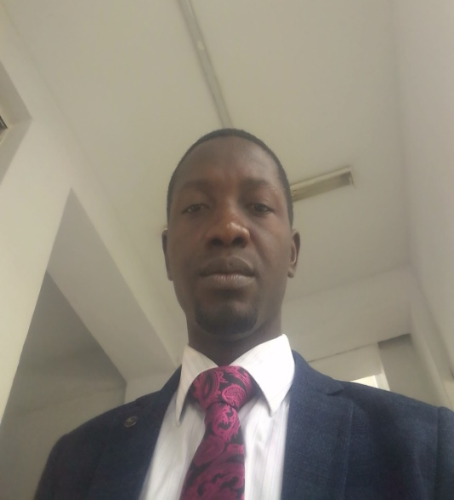

Mr. Abayomi Emmanuel Omoyemi was born into the family of Elder O.A. Omoyemi of the Apamodari’s Compound, Osogbo town in Olorunda local government area of Osun State. He holds Mater Degree in English language of the University of Ibadan. He has spent over ten years in the civil service of Osun state. A.E. Omoyemi is well read; he has attended conferences and seminars where scholarly papers were presented. He has published a good number of storybooks and several of his articles are published in reputable national and international journals. He is an excellent administrator, he is hardworking and diligent. A.E. Omoyemi is a Principal Administrative Officer at Public Service Office, office of the Head of Service.

**Career Responsibilities**

As Principal Administrative Officer, he is directly responsible to the Director, Senior Management Services and, the Director, Staff Welfare Department, Public Service Office. In his capacity, he receives, interprets and processes incoming mails of the Agency, such as Leave of Absence of Officers. He documents and keeps records related to his duty post. A.E. Omoyemi represents the two departments stated above at official gatherings when he is delegated to.

Personal profile:

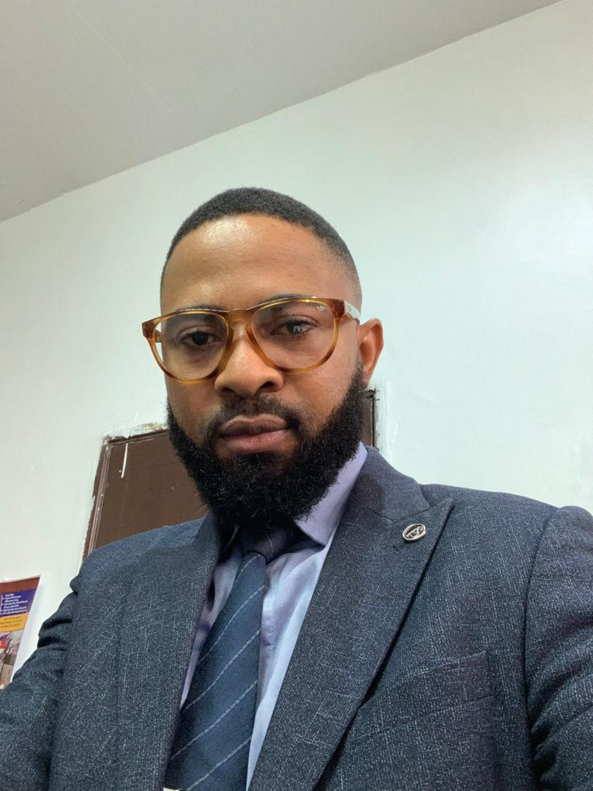

Mr. Oluwaseun Michael Adedoyin hails from Erin-Osun town in Irepodun local government area of Osun State. He holds Bachelor of Science in Sociology and Anthropology from Obafemi Awolowo University, Ile-Ife, as well as a Master Degree in Public Administration from Ladoke Akintola University of Technology, Ogbomoso. He has spent over ten years in the civil service of Osun state. S.M. Adedoyin is a socialist; he is selective and always settles for the best. He is an astute administrator and a prolific writer. He loves to adhere to the traditions of how things are done and his respect for the rule of law is commendable. He is reputed for punctuality and confidential management of official information. He is courageous and never desperate for material possession. In his career progression, Mr. Adedoyin is an Assistant Chief Administrative Officer, he is also the Special Assistant to the Head of Service, Office of the Head of Service, Osun State. Mr. Adedoyin is happily married and the marriage is blessed with children.

**Career Responsibilities**

As the Chief Administrative Officer and Special Assistant (SA) to the Head of Service, he is directly responsible to the Head of Service (HOS) of the Osun State Civil Service. In his capacity, he receives, interprets and processes incoming mails of the HOS. He documents and keeps records related to his duty post. He advises the HOS and facilitates the link and processes between the Office of the HOS and other government agencies. S.M. Adedoyin represents the Office of the Head of Service at official gatherings when he is delegated to.

Personal profile:



Mr. Abiodun Moses Omotayo was born into the family of Chief & Mrs Daniel Oyebiyi Omotayo of the Eesa’s Compound, Ororuwo in Boripe Local Government area of Osun State. He holds Higher National Diploma in Accountancy at Osun State College of Technology, Esa-Oke and a Bachelor of Science in Accounting at Redeemer’s University, Ede. He is a member of professional bodies like Association of National Accountants of Nigeria (ANAN). He has spent over ten years in the civil service of Osun state. Abiodun Moses Omotayo is a brilliant Accountant. This has been attested to in places he had worked. He has attended conferences and seminars. He is hardworking, diligent and always punctual. Abiodun Moses Omotayo is the Director, Finance and Account, Public Service Office, office of the Head of Service.

**Career Responsibilities**

As Director of Finance and Account, he reports to the Head of Service through the Permanent Secretary, Public Service Office. He oversees all affairs of the Department. He coordinates all activities of the Department and reports directly to PS, PSO. In his responsibilities, he deals with salaries payment, as well as processes and payment of other matters related to the Public Service Office, Office of the Head of Service. As such, he generates and disseminates information relating to his Office for the Office of the Head of Service. He also serves as link between the Public Service Office and the Office of the Accountant-General, Ministry of Finance, Ministry of Economic Planning, Budget and Development, and other government Agencies.

In his capacity, he receives, interprets and processes incoming mails of the Department. He documents and keeps records related to his duty post. Mr. Abiodun Moses Omotayo represents his Department at official gatherings. As the manager of human and material resources of the Department, he supervises, as well allocates duties to other staff of the Department.